Supplementary Information
Evolution characteristics of micromechanics provides insights into the microstructure of pharmaceutical tablets fabricated by bimodal mixtures
Mengtao Zhaoª, Anqi Luoª, Yu Zhouª, Zeng Liuª, Yuting Wangª, Linxiu Luoª, Yanling Jiangª, Jingcao Tangª, Zheng Luª, Tianbing Guanª, Libo Chenª, Huimin Sun^{b}, Chuanyun Daiª
ª Chongqing Key Laboratory of Industrial Fermentation Microorganisms, College of Chemistry and Chemical Engineering, Chongqing University of Science and Technology, Chongqing, 401331, China
^{b} NMPA Key Laboratory for Quality Research and Evaluation of Pharmaceutical Excipients,
National Institutes for Food and Drug Control, Beijing 100050, China
*Corresponding author. Email address: sunhm@126.com (H. Sun) and cydai@126.com (C. Dai); Tel: 86-10-53852486(H. Sun) and 86-23-65022212(C. Dai).

Table S1. Optimal Latin hypercube test sample and optimization target results (PGS).
Number | A | B | C | D | E | F | Hardness-  compressive force | Volume reduction-compressive force
1 | 0.3034 | 4.45 | 0.238 | 59.03 | 1 | -0.00759 | 774.1 | 1147.32
2 | 0.3517 | 1.28 | 0.155 | 76.1 | 35.14 | -0.00672 | 724.76 | 517.83
3 | 0.3586 | 2.66 | 0.266 | 41.97 | 96.59 | -0.00586 | 924.53 | 1028.38
4 | 0.2345 | 2.1 | 0.348 | 96.59 | 14.66 | -0.00862 | 508.5 | 851.71
5 | 0.2069 | 3.34 | 0.597 | 24.9 | 93.17 | -0.00655 | 862.7 | 1167.14
6 | 0.2 | 1.55 | 0.845 | 55.62 | 41.97 | -0.00793 | 421.22 | 832.54
7 | 0.2897 | 4.86 | 0.321 | 28.31 | 52.21 | -0.00517 | 996.72 | 1231.61
8 | 0.37 | 3.21 | 0.21 | 65.86 | 55.62 | -0.00983 | 504.62 | 1017.21
9 | 0.34 | 4.31 | 0.79 | 69.28 | 21.48 | -0.00948 | 558.45 | 1353.91
10 | 0.25 | 1.14 | 0.293 | 45.38 | 79.52 | -0.00845 | 314.99 | 302.76
11 | 0.39 | 1.83 | 0.734 | 72.69 | 65.86 | -0.00810 | 528.48 | 1086.72
12 | 0.28 | 2.52 | 0.128 | 1.00 | 28.31 | -0.00741 | 794.51 | 630.82
13 | 0.23 | 2.24 | 0.376 | 52.21 | 24.90 | -0.00500 | 952.54 | 951.14
14 | 0.22 | 4.59 | 0.679 | 79.52 | 38.55 | -0.00690 | 814.88 | 1349.71
15 | 0.26 | 3.48 | 0.762 | 11.24 | 11.24 | -0.00707 | 805.25 | 1297.97
16 | 0.34 | 3.90 | 0.9 | 48.79 | 62.45 | -0.00534 | 1040.64 | 1495.91
17 | 0.28 | 4.17 | 0.183 | 14.66 | 89.76 | -0.00897 | 699.92 | 1040.45
18 | 0.21 | 3.62 | 0.459 | 35.14 | 31.72 | -0.01000 | 449.22 | 1138.74
19 | 0.24 | 3.76 | 0.1 | 82.93 | 69.28 | -0.00724 | 890.87 | 958.86
20 | 0.26 | 2.93 | 0.652 | 93.17 | 82.93 | -0.00966 | 412.5 | 1203.36
21 | 0.32 | 2.38 | 0.817 | 86.34 | 4.41 | -0.00638 | 814.23 | 1199.5
22 | 0.27 | 1.97 | 0.624 | 89.76 | 86.34 | -0.00569 | 850.07 | 1038.18
23 | 0.39 | 1.69 | 0.403 | 4.41 | 72.69 | -0.00879 | 464.13 | 895.16
24 | 0.30 | 3.07 | 0.872 | 21.48 | 76.10 | -0.00931 | 420.52 | 1271.26
25 | 0.32 | 5.00 | 0.569 | 62.45 | 100.00 | -0.00776 | 681.88 | 1393.88
26 | 0.3793 | 4.72 | 0.514 | 7.83 | 45.38 | -0.00828 | 670.05 | 1343.4
27 | 0.331 | 1.41 | 0.541 | 38.55 | 7.83 | -0.00914 | 308.18 | 779.56
28 | 0.3724 | 4.03 | 0.431 | 100 | 48.79 | -0.00621 | 880.86 | 1248.28
29 | 0.4 | 2.79 | 0.486 | 31.72 | 18.07 | -0.00552 | 927.53 | 1200.35
30 | 0.3103 | 1 | 0.707 | 18.07 | 59.03 | -0.00603 | 600.13 | 602.56
Table S2. Optimal Latin hypercube test sample and optimization target results (MCC).
Number | A | B | C | D | E | F | Hardness - compressive force | Volume reduction-compressive force
1 | 0.3379 | 79.52 | 0.707 | 1.93 | 9.07 | -0.0329 | 321.86 | 272.43
2 | 0.3103 | 45.38 | 0.1 | 6.59 | 7.83 | -0.0081 | 684.6 | 99.94
3 | 0.3586 | 14.66 | 0.817 | 2.24 | 3.48 | -0.0314 | 104.74 | 41.66
4 | 0.3172 | 41.97 | 0.128 | 9.69 | 2.55 | -0.0345 | 286.41 | 96.16
5 | 0.2414 | 69.28 | 0.238 | 1 | 3.79 | -0.019 | 527.61 | 173.95
6 | 0.2 | 65.86 | 0.403 | 4.1 | 10 | -0.0283 | 373.69 | 192.24
7 | 0.3655 | 18.07 | 0.266 | 3.48 | 8.76 | -0.0376 | 0.58 | -0.46
8 | 0.3793 | 20 | 0.486 | 8.14 | 5.34 | -0.0205 | 112.3 | 74.38
9 | 0.2759 | 40 | 0.597 | 4.41 | 7.21 | -0.005 | 579.06 | 179.05
10 | 0.2897 | 28.31 | 0.459 | 5.34 | 1.62 | -0.0066 | 668.3 | 113.04
11 | 0.2552 | 35.14 | 0.541 | 1.31 | 5.97 | -0.05 | 85.15 | 140.6
12 | 0.2276 | 24.9 | 0.624 | 9.38 | 7.52 | -0.0159 | 449.62 | 99.74
13 | 0.2828 | 11.24 | 0.569 | 2.55 | 8.14 | -0.0112 | 472.1 | -52.05
14 | 0.331 | 93.17 | 0.734 | 3.17 | 1.93 | -0.0267 | 430.88 | 280.31
15 | 0.3241 | 89.76 | 0.155 | 4.72 | 6.28 | -0.0407 | 327.03 | 187.83
16 | 0.4 | 55.62 | 0.376 | 1.62 | 5.66 | -0.0128 | 607.19 | 210.33
17 | 0.3448 | 76.1 | 0.514 | 9.07 | 9.69 | -0.0252 | 417.58 | 238.31
18 | 0.2966 | 62.45 | 0.79 | 10 | 2.24 | -0.0236 | 462.37 | 247.85
19 | 0.2069 | 48.79 | 0.845 | 3.79 | 4.1 | -0.0221 | 419.5 | 215.79
20 | 0.3931 | 59.03 | 0.652 | 6.9 | 4.72 | -0.0469 | 132.62 | 239.77
21 | 0.2345 | 72.69 | 0.431 | 5.66 | 1 | -0.0453 | 140.07 | 210.02
22 | 0.2621 | 38.55 | 0.321 | 8.76 | 8.45 | -0.0484 | 37.01 | 128.27
23 | 0.3517 | 31.72 | 0.21 | 2.86 | 1.31 | -0.036 | 187.01 | 90.31
24 | 0.3724 | 52.21 | 0.9 | 5.97 | 6.59 | -0.0097 | 652.08 | 257.59
25 | 0.2138 | 82.93 | 0.293 | 8.45 | 4.41 | -0.0174 | 557.58 | 200.6
26 | 0.3862 | 86.34 | 0.348 | 7.83 | 3.17 | -0.0143 | 604.68 | 221.46
27 | 0.2483 | 96.59 | 0.762 | 7.21 | 6.9 | -0.0422 | 196.3 | 269.72
28 | 0.3034 | 21.48 | 0.872 | 6.28 | 9.38 | -0.0391 | 36.01 | 114.58

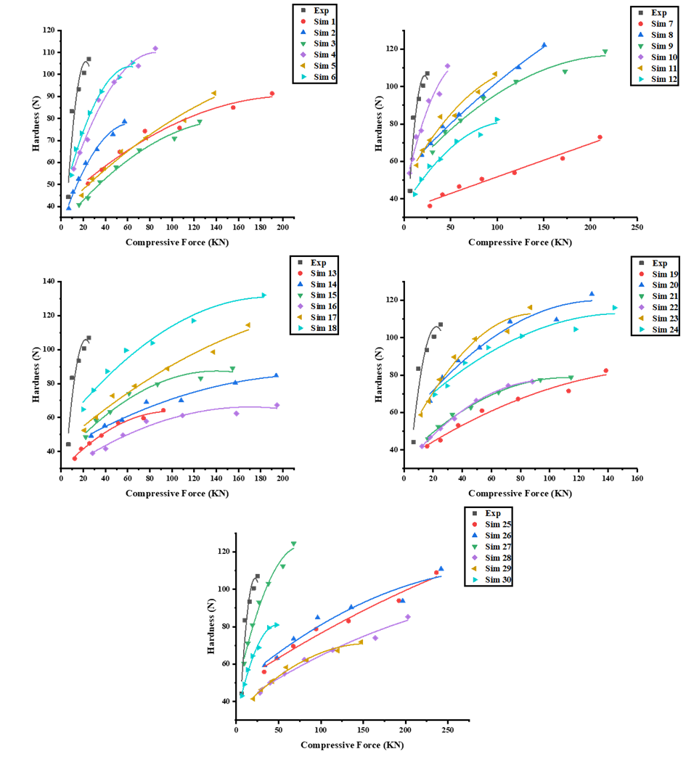
Fig. S1 The curve of hardness versus compressive force for experimental and DEM simulations (PGS).

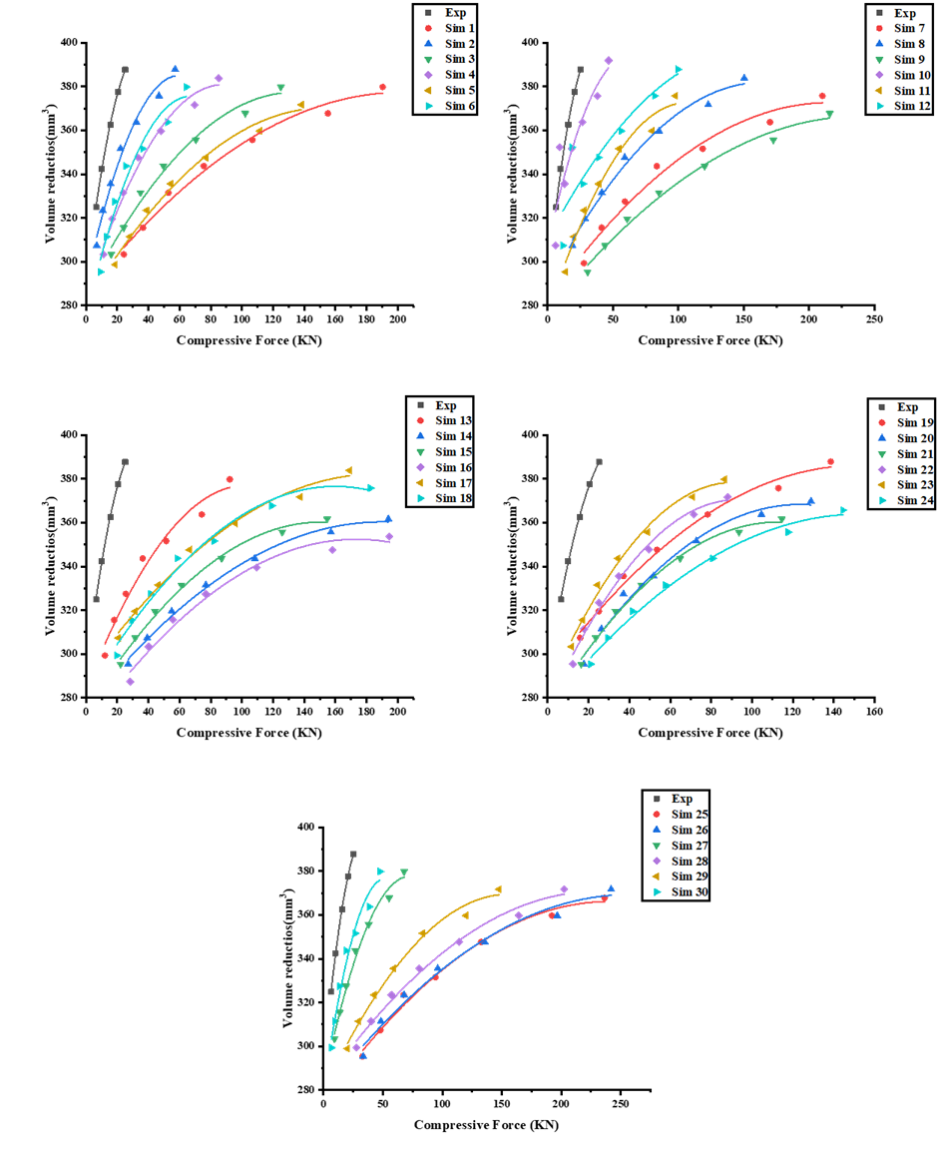
Fig. S2 The curve of volume reduction versus compressive force for experimental and DEM simulations (PGS).
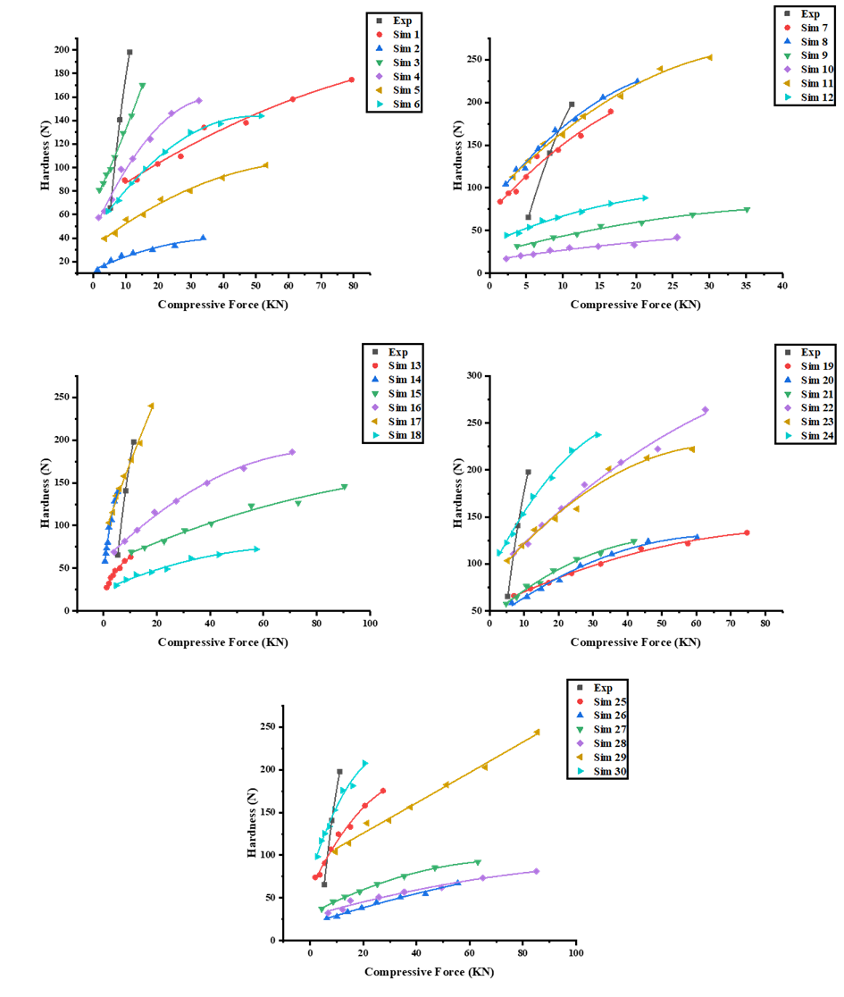
Fig. S3 The curve of hardness versus compressive force for experimental and DEM simulations (MCC).
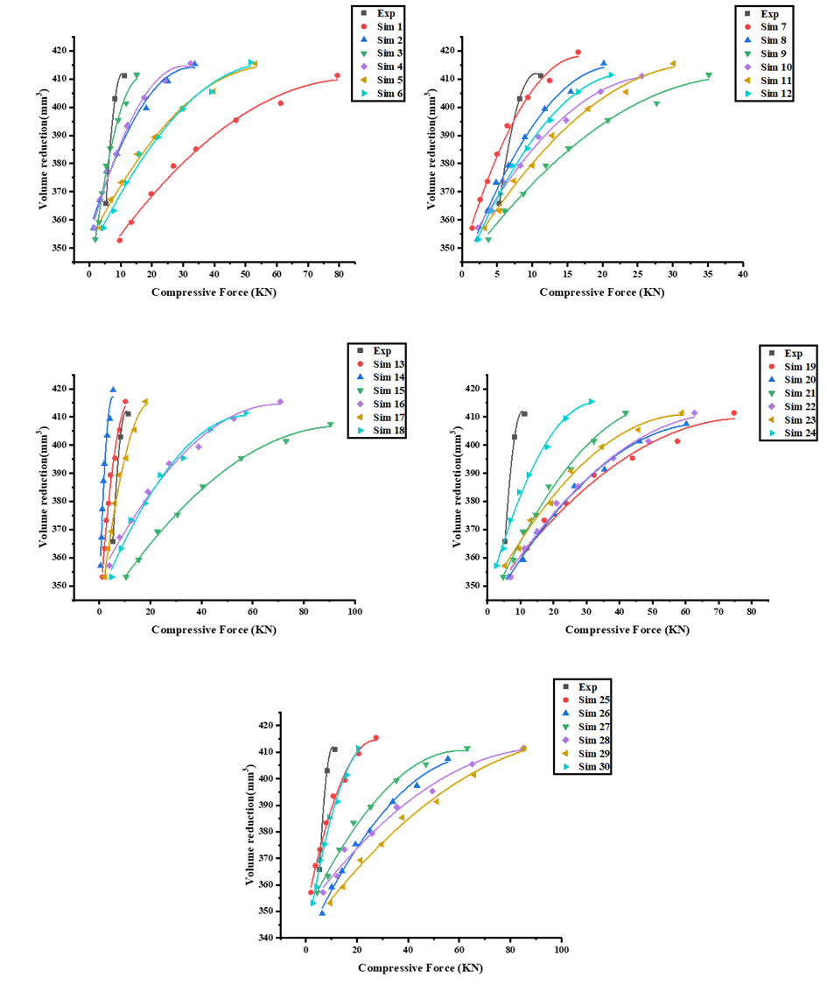
Fig. S4 The curve of volume reduction versus compressive force for experimental and DEM simulations (MCC).
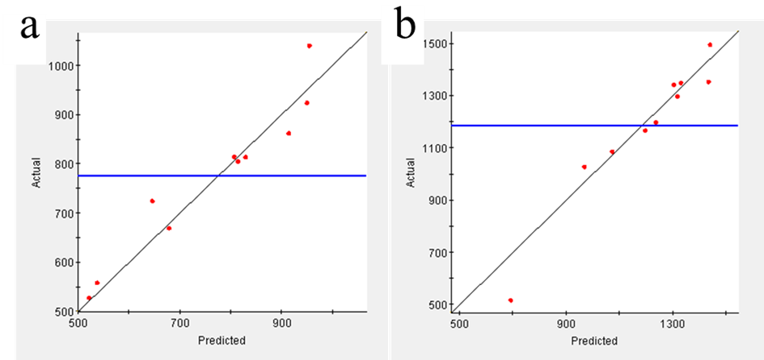
Fig. S5 Kriging model accuracy validation results (PGS).
(a: Hardness-compressive force; b: Volume reduction-compressive force)
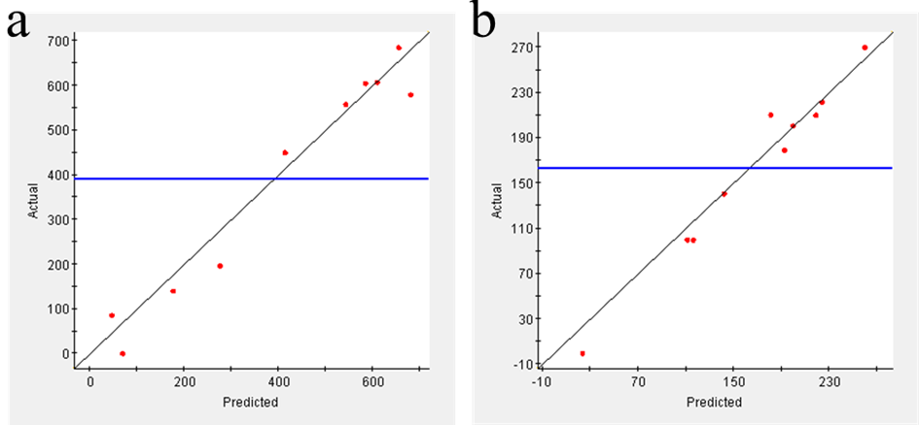
Fig. S6 Kriging model accuracy validation results (MCC).
(a: Hardness-compressive force; b: Volume reduction-compressive force)

