Figure1 B
METTL3 METTL14

WTAP ALKBH5

FTO GAPDH

Figure2 B
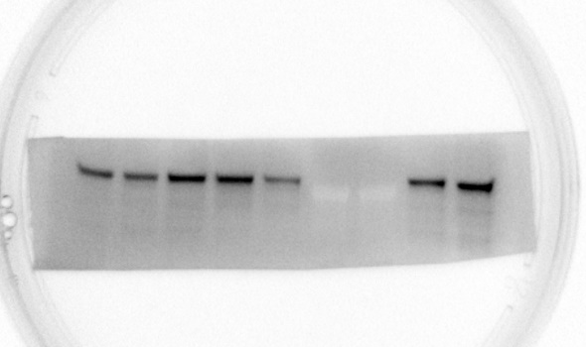
SCC15-METTL3 CAL27-METTL3

GAPDH GAPDH

Figure2 E

si-METTL3 GAPDH

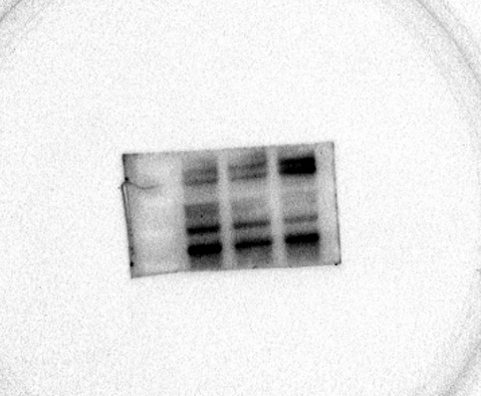
siMETTL3-SOX2 siMETTL3-Nanog

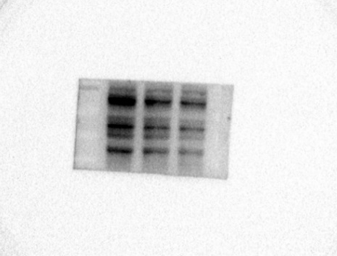
siMETTL3-OCT4 siMETTL3-c-MYC

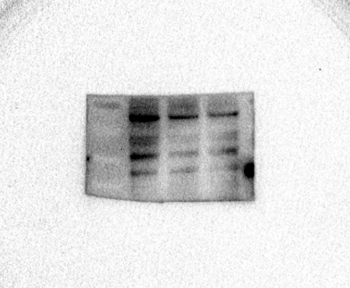

siMETTL3-BMI1 siMETTL3-GAPDH

OE-METTL3 OE-METTL3-SOX2
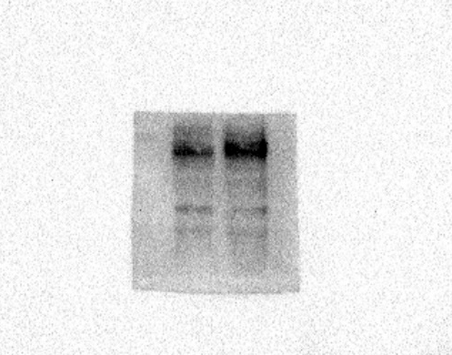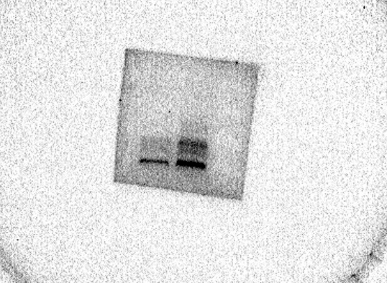
OE-METTL3-Nanog OE-METTL3-OCT4

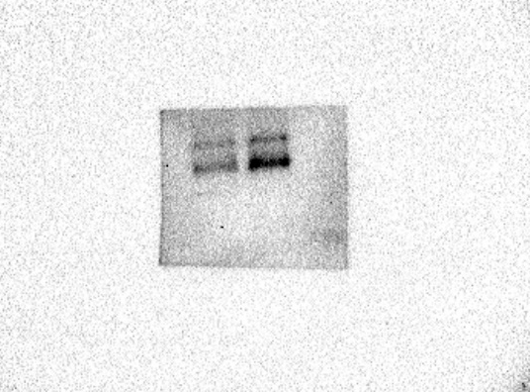
OE-METTL3-c-MYC OE-METTL3-BMI1
OE-METTL3-GAPDH

Figure3 B

SALL4 GAPDH

Figure3 E

SCC15-SALL4 CAL27-SALL4
GAPDH GAPDH

Figure3 G
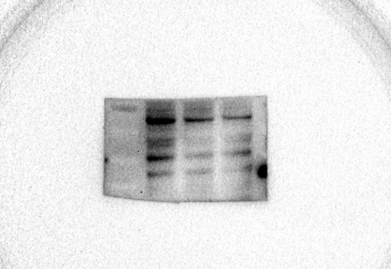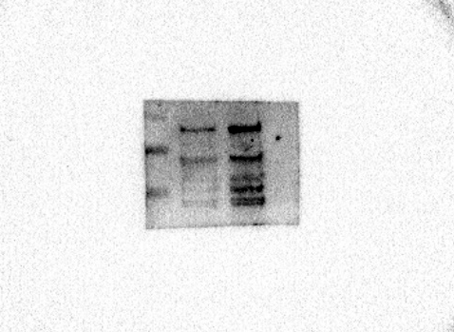
siMETTL3-SALL4 OE-METTL3-SALL4

Figure3 J
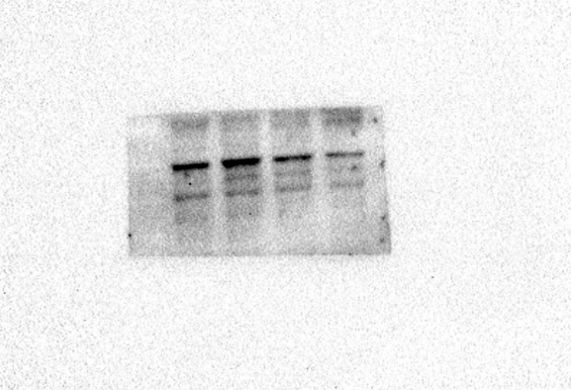
siSALL4-SOX2 siSALL4-Nanog

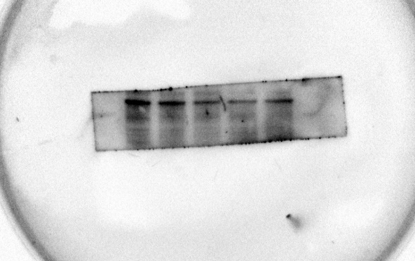
siSALL4-OCT4 siSALL4-cMYC

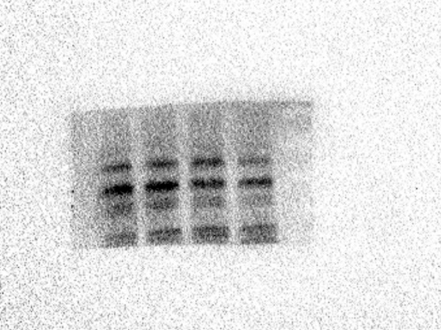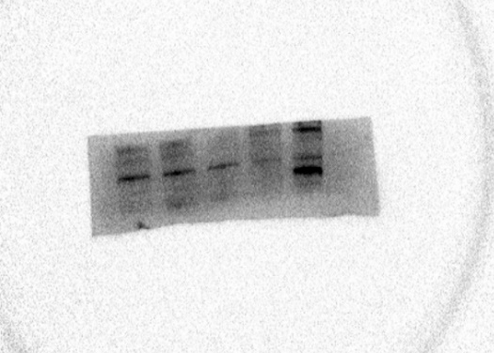
siSALL4-BMI1 siSALL4
siSALL4-GAPDH OE-SALL4

OE-SALL4-SOX2 OE-SALL4-Nanog

OE-SALL4-OCT4 OE-SALL4-BMI1

OE-SALL4-GAPDH
Figure4 F
siNC-H2AX siSALL4#2-H2AX

siNC-GAPDH siSALL4#2-GAPDH

Vector-H2AX SALL4-H2AX

Vector-GAPDH SALL4-GAPDH

Figure4 G

β-catenin LaminB
GAPDH

Supplementary Figure2 G
β-catenin LaminB

GAPDH

Figure4 I

β-catenin Wnt3a

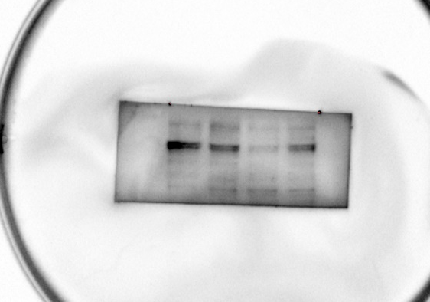
TCF1 MMP9

c-MYC GAPDH

Figure4 J

β-catenin Wnt3a

TCF1 MMP9

c-MYC GAPDH

Figure5 E
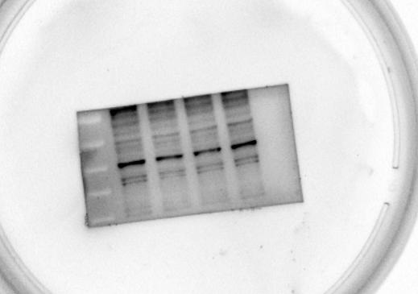
SOX2 Nanog

OCT4 c-MYC

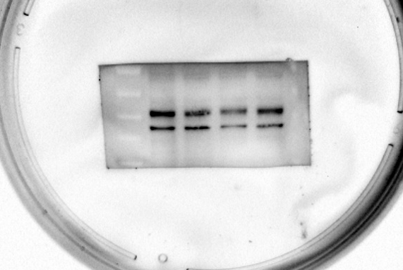
BMI1 GAPDH

Figure5 I

γ-H2AX GAPDH

