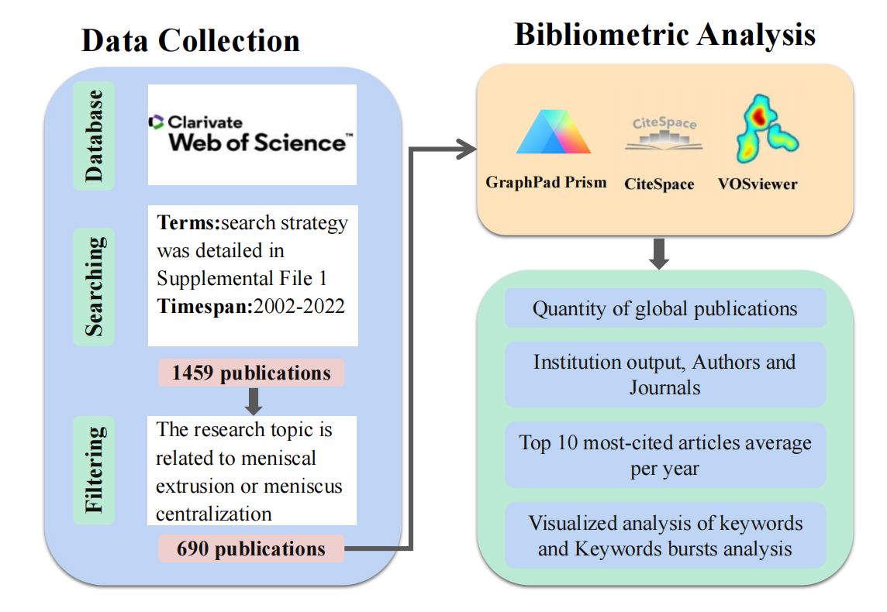
Appendix Figure 1 The comprehensive overview of the literature inclusion and analysis process

Appendix Figure 2 Author of posting top 10 according by the posts number (blue-North America, green-Asia, yellow-Europe)

