Supplementary Materials

Figure S1. Parallel analysis scree plot for women
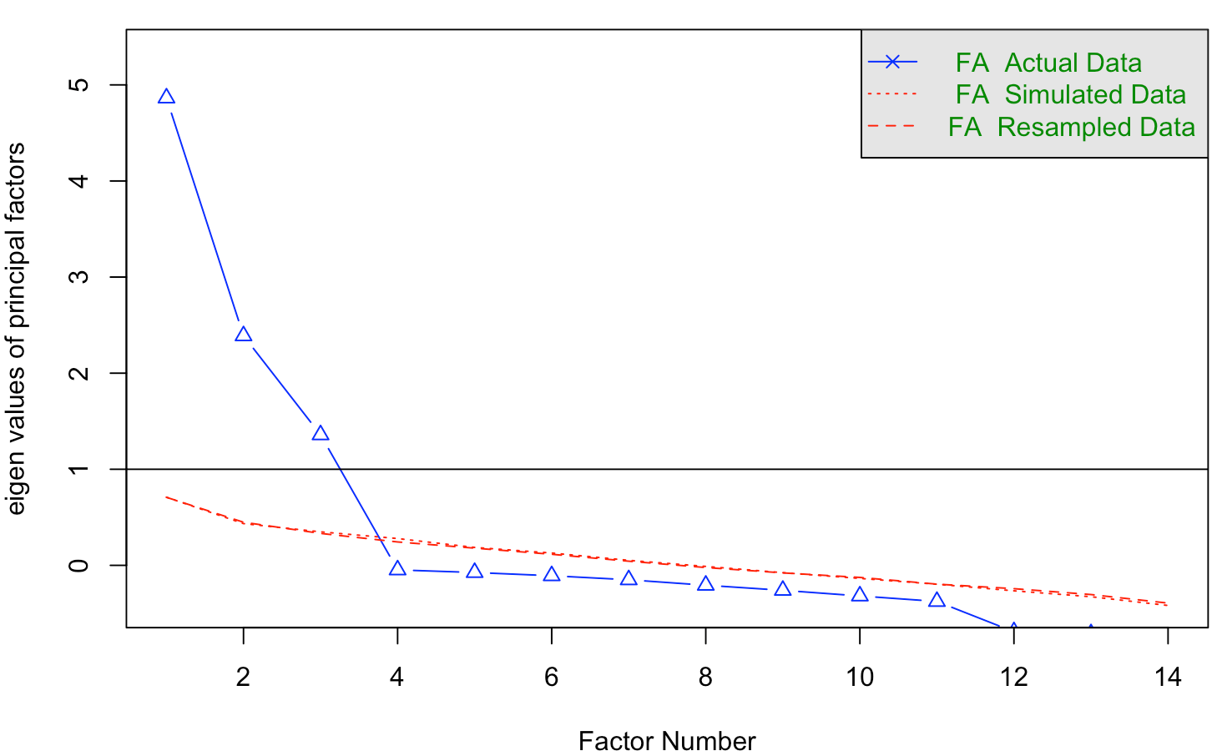

Figure S2. Parallel analysis scree plot for men
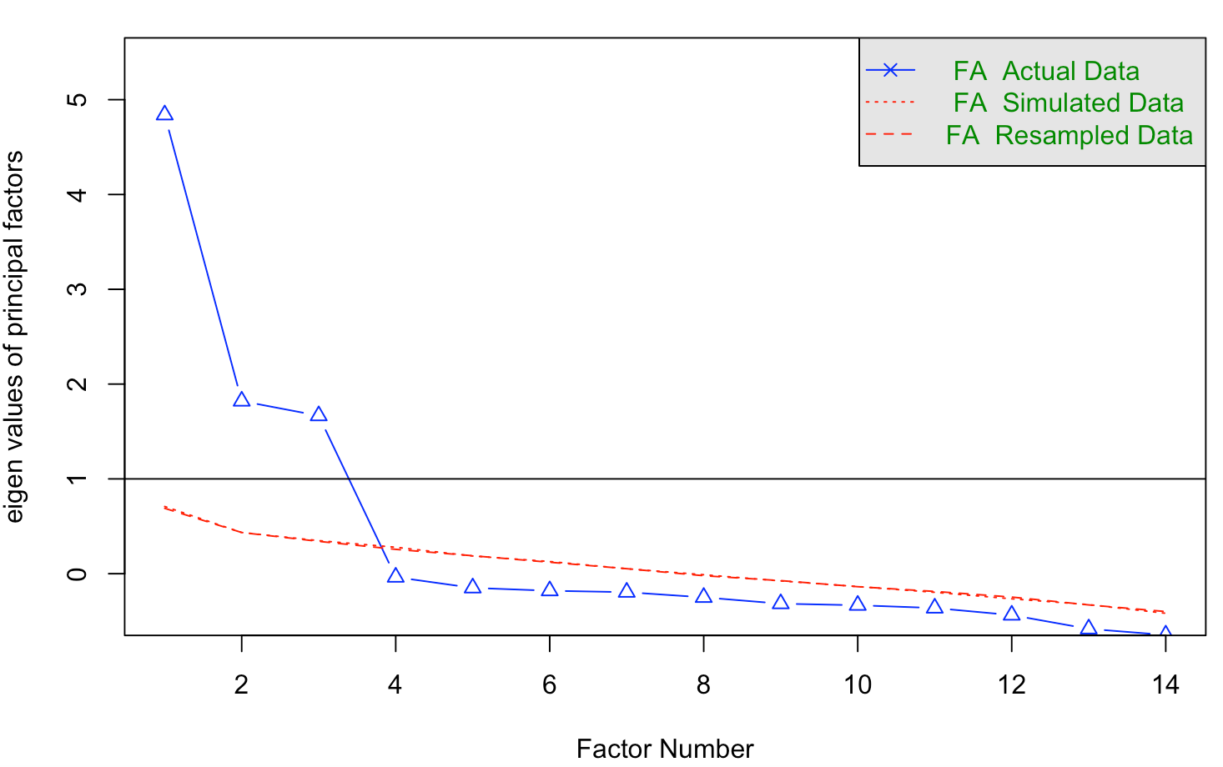

Table S1. Hierarchical linear regressions using the Body Talk Scale to describe unique variance in body dissatisfaction and disordered eating in women (N = 300)

 | F | Total R² | $Δ$ R² | $β$
Criterion 1: EDI-BD-Body fat dissatisfaction
Step 1 | 152.53*** | .60*** | -
Age |  |  |  | -.11**
BMI |  |  |  | .37***
NBTS-Negative body talk |  |  |  | .57***
Step 2 | 150.58*** | .75*** | .15***
Age |  |  |  | -.05
BMI |  |  |  | .25***
NBTS-Negative body talk |  |  |  | .29***
BTS-Negative fat talk |  |  |  | .14**
BTS-Negative muscle talk |  |  |  | -.01
BTS-Positive body talk |  |  |  | -.44***
Criterion 2: FMS-Drive for muscularity
Step 1 | 14.93*** | .12*** | -
Age |  |  |  | .10
BMI |  |  |  | -.13*
NBTS-Negative body talk |  |  |  | .38***
Step 2 | 56.36*** | .53*** | .40***
Age |  |  |  | .05
BMI |  |  |  | -.11*
NBTS-Negative body talk |  |  |  | .33***
BTS-Negative fat talk |  |  |  | .05
BTS-Negative muscle talk |  |  |  | .63***
BTS-Positive body talk |  |  |  | .09
Criterion 3: EDE-QS-Thinness-oriented disordered eating
Step 1 | 88.53*** | .47*** | -
Age |  |  |  | -.07
BMI |  |  |  | .11*
NBTS-Negative body talk |  |  |  | .64***
Step 2 | 48.79*** | .50*** | .03**
Age |  |  |  | -.06
BMI |  |  |  | .04
NBTS-Negative body talk |  |  |  | .49***
BTS-Negative fat talk |  |  |  | .25**
BTS-Negative muscle talk |  |  |  | -.04
BTS-Positive body talk |  |  |  | .004
Criterion 4: MOET-muscularity-oriented disordered eating
Step 1 | 54.43*** | .35*** | -
Age |  |  |  | .05
BMI |  |  |  | -.09
NBTS-Negative body talk |  |  |  | .62***
Step 2 | 39.50*** | .44*** | .09***
Age |  |  |  | .03
BMI |  |  |  | -.12*
NBTS-Negative body talk |  |  |  | .51***
BTS-Negative fat talk |  |  |  | .26**
BTS-Negative muscle talk |  |  |  | .21***
BTS-Positive body talk |  |  |  | .16**
Criterion 5: BAS-2-Body appreciation
Step 1 | 55.37*** | .35*** | -
Age |  |  |  | .13**
BMI |  |  |  | -.19***
NBTS-Negative body talk |  |  |  | -.50***
Step 2 | 81.22*** | .62*** | .27***
Age |  |  |  | .07
BMI |  |  |  | -.09*
NBTS-Negative body talk |  |  |  | -.25***
BTS-Negative fat talk |  |  |  | .05
BTS-Negative muscle talk |  |  |  | -.05
BTS-Positive body talk |  |  |  | .62***
Criterion 6: FAS-Functionality appreciation
Step 1 | 7.26*** | .06*** | -
Age |  |  |  | .09
BMI |  |  |  | -.10
NBTS-Negative body talk |  |  |  | -.20**
Step 2 | 7.91*** | .12*** | .07***
Age |  |  |  | .05
BMI |  |  |  | -.05
NBTS-Negative body talk |  |  |  | -.11
BTS-Negative fat talk |  |  |  | .05
BTS-Negative muscle talk |  |  |  | .05
BTS-Positive body talk |  |  |  | .31***
Criterion 7:BI-AAQ-Body image flexibility
Step 1 | 86.66*** | .47*** | -
Age |  |  |  | .13**
BMI |  |  |  | -.17**
NBTS-Negative body talk |  |  |  | -.60***
Step 2 | 45.32*** | .48*** | .01
Age |  |  |  | .12**
BMI |  |  |  | -.12*
NBTS-Negative body talk |  |  |  | -.50***
BTS-Negative fat talk |  |  |  | -.08
BTS-Negative muscle talk |  |  |  | .02
BTS-Positive body talk |  |  |  | .12*
Notes: BTS = Body Talk Scale, NBTS = Negative Body Talk Scale, EDI-BD = Body Dissatisfaction subscale of the Eating Disorder Inventory, FMS = Female Muscularity Scale, EDE-QS = Short Form of the Eating Disorder Examination Questionnaire, MOET = Muscularity-Oriented Eating Test, BAS-2 = Body Appreciation Scale-2, BI-AAQ = Body Image Acceptance and Action Questionnaire. * p < .05, ** p < .01, *** p < .001.

Table S2. Hierarchical linear regressions using the Body Talk Scale to describe unique variance in body dissatisfaction and disordered eating in men (N = 300)

 | F | Total R² | $Δ$ R² | $β$
Criterion 1: EDI-BD-Body fat dissatisfaction
Step 1 | 89.30*** | .54*** | -
Age |  |  |  | -.15***
BMI |  |  |  | .10
MBTS-Fat talk |  |  |  | .70***
MBTS-Muscle talk |  |  |  | -.12**
Step 2 | 126.26*** | .75*** | .20***
Age |  |  |  | -.05
BMI |  |  |  | .24***
MBTS-Fat talk
MBTS-Muscle talk |  |  |  | .31***
BTS-Negative fat talk |  |  |  | .12*
BTS-Negative muscle talk |  |  |  | -.004
BTS-Positive body talk |  |  |  | -.43***
Criterion 2: DMS-Drive for muscularity
Step 1 | 130.19*** | .63*** | -
Age |  |  |  | -.02
BMI |  |  |  | -.06
MBTS-Fat talk |  |  |  | .16***
MBTS-Muscle talk |  |  |  | .74***
Step 2 | 105.51*** | .71*** | .08***
Age |  |  |  | .01
BMI |  |  |  | -.04
MBTS-Fat talk |  |  |  | .11
MBTS-Muscle talk |  |  |  | .44***
BTS-Negative fat talk |  |  |  | -.03
BTS-Negative muscle talk |  |  |  | .42***
BTS-Positive body talk |  |  |  | -.09*
Criterion 3: EDE-QS-Thinness-oriented disordered eating
Step 1 | 98.07*** | .57*** | -
Age |  |  |  | -.07
BMI |  |  |  | .12*
MBTS-Fat talk |  |  |  | .65***
MBTS-Muscle talk |  |  |  | .14**
Step 2 | 71.47*** | .62*** | .06***
Age |  |  |  | -.06
BMI |  |  |  | .07
MBTS-Fat talk |  |  |  | .30***
MBTS-Muscle talk |  |  |  | .16**
BTS-Negative fat talk |  |  |  | .38***
BTS-Negative muscle talk |  |  |  | .03
BTS-Positive body talk |  |  |  | -.12**
Criterion 4: MOET-muscularity-oriented disordered eating
Step 1 | 94.97*** | .56*** | -
Age |  |  |  | .04
BMI |  |  |  | -.01
MBTS-Fat talk |  |  |  | .55***
MBTS-Muscle talk |  |  |  | .41***
Step 2 | 56.89*** | .57*** | .01*
Age |  |  |  | .04
BMI |  |  |  | -.02
MBTS-Fat talk |  |  |  | .42***
MBTS-Muscle talk |  |  |  | .33***
BTS-Negative fat talk |  |  |  | .14
BTS-Negative muscle talk |  |  |  | .12
BTS-Positive body talk |  |  |  | -.02
Criterion 5: BAS-2-Body appreciation
Step 1 | 21.42*** | .22*** | -
Age |  |  |  | .22***
BMI |  |  |  | -.04
MBTS-Fat talk |  |  |  | -.43***
MBTS-Muscle talk |  |  |  | .13*
Step 2 | 61.39*** | .59*** | .37***
Age |  |  |  | .14**
BMI |  |  |  | -.02
MBTS-Fat talk |  |  |  | -.02
MBTS-Muscle talk |  |  |  | -.10
BTS-Negative fat talk |  |  |  | -.13
BTS-Negative muscle talk |  |  |  | -.08
BTS-Positive body talk |  |  |  | .65***
Criterion 6: FAS-Functionality appreciation
Step 1 | 2.78*** | .02* | -
Age |  |  |  | .12
BMI |  |  |  | .03
MBTS-Fat talk |  |  |  | -.12
MBTS-Muscle talk |  |  |  | .14*
Step 2 | 7.65*** | .14*** | .12***
Age |  |  |  | .06
BMI |  |  |  | .03
MBTS-Fat talk |  |  |  | .06
MBTS-Muscle talk |  |  |  | .26***
BTS-Negative fat talk |  |  |  | -.02
BTS-Negative muscle talk |  |  |  | -.21*
BTS-Positive body talk |  |  |  | .34***
Criterion 7:BI-AAQ-Body image flexibility
Step 1 | 55.26*** | .42*** | -
Age |  |  |  | .05
BMI |  |  |  | -.08
MBTS-Fat talk |  |  |  | -.54***
MBTS-Muscle talk |  |  |  | -.22***
Step 2 | 41.84*** | .49*** | .07***
Age |  |  |  | .03
BMI |  |  |  | -.03
MBTS-Fat talk |  |  |  | -.19*
MBTS-Muscle talk |  |  |  | -.29***
BTS-Negative fat talk |  |  |  | -.33***
BTS-Negative muscle talk |  |  |  | .03
BTS-Positive body talk |  |  |  | .20***
Notes: BTS = Body Talk Scale, NBTS = Negative Body Talk Scale, EDI-BD = Body Dissatisfaction subscale of the Eating Disorder Inventory, FMS = Female Muscularity Scale, EDE-QS = Short Form of the Eating Disorder Examination Questionnaire, MOET = Muscularity-Oriented Eating Test, BAS-2 = Body Appreciation Scale-2, BI-AAQ = Body Image Acceptance and Action Questionnaire. * p < .05, ** p < .01, *** p < .001.
The Chinese version of the Body Talk Scale

《身体谈论量表中文版》

指导语：
下面陈述是一些有关人们对自己身体评价或态度的话。请仔细阅读后圈出您在与他人交谈时说这些话（或者表达类似意思的话）的频率。数字越大代表频率越高，请参考：1-从不，2-很少（每隔几个月1次），3-有时（每月1-3次），4-经常（每周1-3次），5-频繁（每天），6-总是（每天数次）

请记住，我们不关注您产生类似想法的频率，我们感兴趣的是您在与他人交谈时您说出这样的话（或者表达类似意思的话）的频率。
 | 从  不 | 很  少 | 有  时 | 经常 | 频  繁 | 总  是
1.我需要减肥。 | 1 | 2 | 3 | 4 | 5 | 6
2.我觉得自己胖。 | 1 | 2 | 3 | 4 | 5 | 6
3.我的衣服对我现在的体型来说太紧了。 | 1 | 2 | 3 | 4 | 5 | 6
4.我应该停止吃让我发胖的食物了。 | 1 | 2 | 3 | 4 | 5 | 6
5.我需要加强运动来减肥。 | 1 | 2 | 3 | 4 | 5 | 6
6.我要是有更多肌肉就好了。 | 1 | 2 | 3 | 4 | 5 | 6
7.我要是更加强壮就好了。 | 1 | 2 | 3 | 4 | 5 | 6
8.我应该吃能够促进肌肉生长的食物。 | 1 | 2 | 3 | 4 | 5 | 6
9.我需要更频繁地进行举重来锻炼我的肌肉。 | 1 | 2 | 3 | 4 | 5 | 6
10.我喜欢我现在的样子。 | 1 | 2 | 3 | 4 | 5 | 6
11.我对自己的身体感觉良好。 | 1 | 2 | 3 | 4 | 5 | 6
12.我为我的身体所能做到的感到骄傲。 | 1 | 2 | 3 | 4 | 5 | 6
13.我对自己的饮食习惯感到满意。 | 1 | 2 | 3 | 4 | 5 | 6
14.我对自己的运动习惯感到满意。 | 1 | 2 | 3 | 4 | 5 | 6

