Supporting Information
Co-CNT/TiO₂ composites effectively improved the photocatalytic degradation of malachite green
Meifang Zhang, Xiangfei Liang, Yi Liu*
Dr M. Zhang, X. Liang, Asso. Prof. Y. Liu
Institute of Carbon Neutral New Energy Research
Yuzhang Normal University
Nanchang 330031, P. R. China
E-mail: mfzhang@whu.edu.cn; xfliang96@163.com;
Prof. Y. Liu
Hubei Key Laboratory of Radiation Chemistry and Functional Materials
Hubei University of Science and Technology
Xianning 437100, P. R. China
Prof. Y. Liu
School of Chemical and Environmental Engineering
Wuhan Polytechnic University
Wuhan, 430023, P. R. China
E-mail: yiliuchem@whu.edu.cn
Experimental section
Chemicals and materials. Crystalline MWCNT powder of 95.9% purity was purchased from Shenzhen Nanoport Co. Ltd., (Shenzhen, China). P25 (Degussa, Germany), Ethanol solvent, cobalt chloride hexahydrate (CoCl2·6H2O) and titanium (IV)-n-butoxide (Ti(OBu)₄) were obtained from Sinopharm Chemical Reagent Co. Ltd., Shanghai, China and used without further puriﬁcation. Malachite green (MG) were purchased from Sigma Aldrich (St. Louis, MO, USA). All other materials were of analytical reagent grade. All experiments were performed with deionized water and double-distilled water.
Synthesis of Co-CNT/TiO₂ composite. The cobalt and MWCNT co-doped catalyst were prepared by two steps process. At first, to prepare the oxidizing MWCNT, the m-chloroperbenzoic acid (MCPBA) was employed as described by W.C. Oh et al. [1]. The as-obtained material is denoted as Ox-CNT. And then, the cobalt and MWCNT co-doped TiO₂ nanoparticles were prepared. A certain amount of Ox-CNT was dispersed in 10 mL of anhydrous ethanol, then added to a given amount of CoCl₂·6H₂O, so various mass fractions of Co-CNT/TiO₂ sol-gel nanocomposite solutions were prepared. After stirring for 6h at room temperature, the solution became dark by adding 20 mL Ti(OBu)₄. This mixture was aged for 12 h to get the precursor after stirring for 7 h. The precursor was maintained at 300, 400, 500 and 600 ℃ separately for 2 hours to complete the reaction before allowing to cool to ambient temperature. CNT/TiO₂ was also prepared following the same approach but without adding Ti(OBu)₄. To deposit cobalt on the CNT/TiO₂ surface, we used the synthesized CNT/TiO₂ as a support for the immobilization of cobalt. Cobalt was deposited by impregnation in the aqueous solution with different concentrations under ultrasonic agitation.

Catalysts characterization. Powder X-ray diffraction patterns were captured using a Shimadzu XRD-6000 diffractometer with Cu K radiation (λ = 1.54056Å) in a 2θ range of 10-80º at a scan speed of 6ºmin⁻¹. The XPS measurements were carried out with a scanning X-ray photoelectron spectroscopy (Perkin-Elmer PHI 5000C, Al Kα). The contaminant carbon (C1s) (284.6 eV) was used as a reference for all binding energies. The surface state and structure of samples were determined by a scanning electron microscopy (SEM, Hitachi, S-570, Japan). Transmission electron microscopy (TEM; JEM-2100F STEM/EDS) was used to determine the apparent morphologies of the materials. The TiO₂ samples' BET surface area and BJH pore distribution were determined using a Micromeritics Tristar-3000 surface area and porosity analyzer from nitrogen adsorption and desorption isotherms at 77 K after the sample had been degassed in a flow of N₂ at 120 °C for 5 hours. The linear component of the BET plot (p/p₀, 0.1-0.25) was used to determine the results. UV-vis diffuse reflectance spectra (DRS) were measured on a Cary 5000 UV-vis spectrometer and transformed from reflection to absorbance using the Kubelka-Munk method. The FT-IR spectra were recorded on a Perkin-Elmer spectrum 2000 FT-IR spectrometer.

Electrochemical experiments. All electrochemical experiments were performed on a CHI660C electrochemical system (Shanghai Chenhua, China) using a standard three-electrode cell with a working electrode (gold film), a platinum wire was used as the counter electrode, and the Ag/AgCl was used as reference electrode. The electrochemical impedance spectroscopies (EIS) were carried out in a electrolyte solution (pH=7.4) in the presence of 5 mM Fe [CN]₆^{3-/4-} and 0.1 M KCl with the open circuit potential of 0.24V. The detailed experiment steps can be seen as followed. Firstly, In order to prepare the gold film, we have used the fisher BK7 (catalog no. 12-540-A) glass slides as the glass substrates, which has been described in the reference [2] by our group. Then several tiny drops of pristine TiO₂, CNT/TiO₂ and Co-CNT/TiO₂ solution (500 mg/mL) were dropped to cover the surface of the bare gold film electrodes separately. After several hours, the electrodes were washed by ultrapure water several times and dried in nitrogen flow. At last, the immobilization of catalyst tiny layer was fabricated and the electrodes can be used in the experiments followed.

Photocatalytic effect. Photocatalytic activities were evaluated by MG degradation in aqueous media under visible light irradiation. For visible light irradiation, a 450 W halogen-tungsten lamp was placed beside the reaction cell, which was positioned vertically in a double-wall U-tube inside the cylindrical reactor surrounded by a circulating water system to maintain reaction isothermally. The permeating light was focused onto a 300 mL pyrex reactor with a quartz window, which was filled with minimized headspace and stirred magnetically. The initial MG concentration was 4 mg·L⁻¹. The amount of suspended Co-CNT/TiO₂ composites was kept at 0.0006 g/mL. Before turning on illumination, the suspension containing MG and the catalysts was stirred in the dark condition for 15 minutes to establish an adsorption-desorption equilibrium. The suspension was irradiated with visible light as a function of irradiation time. After specific intervals, about 4mL liquid was taken and centrifuged. The supernatant liquid was analyzed by recording the absorbance at 617 nm of the solution using a UV-vis spectrophotometer (Unico-4802). According to the standard curve of concentration and absorption, the value of Δc/c₀ was calculated and the decomposition efficiency was indicated.

Photocatalytic degradation began after turning on the visible light lamp. The concentration of the MG solution was analyzed at specific times (in all 5 h) to determine the photocatalytic degradation efficiency for each composite. The typical reference TiO₂ was used for comparison. The following equation was used to compute the deterioration efficiency:
(1)

where is the MG solution's rate of degradation, c₀ is the dye's initial concentration, and c is the dye concentration after degradation.

The photocatalytic degradation is supposed to follow pseudo-first-order reaction kinetics in the studied concentration range. Reaction kinetics has often been described in terms of Langmuir-Hinshelwood model, which can be expressed as [3]:
(2)

where r is the oxidation rate, c in the concentration of the reactant, t is the illumination time, (-dc/dt) is the degradation rate of MG, k_{r} is a reaction rate constant; K_{a} is the adsorption coefficient of the reactant. At low initial dye concentration (c₀ is small), the rate was proportional to the dye concentration and the rate constant was observed to be a pseudo-first-order constant [4]. Accordingly, Eq. 2 can be changed to Eq. 3.
(3)

where k_{app} is the apparent rate constant, used as the basic kinetic parameter for different photocatalysts, since it makes it possible to calculate the concentration of residual MG in the solution as well as the photocatalytic activity independent of the preceding adsorption period in the dark.

Fig. S1. SEM micrographs of cobalt and MWCNT-doped-TiO₂ nanocomposites at different calcined temperatures. (a) 300℃; (b) 400℃; (c) 500℃; (d) 600℃.

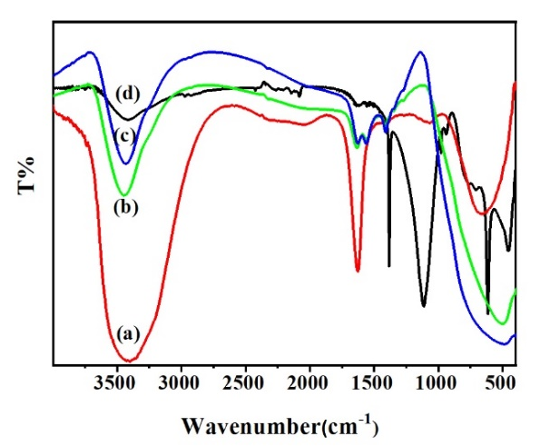
Fig. S2. FT-IR spectra of the prepared samples. (a) CoCl₂·6H₂O; (b) CNT/TiO₂; (c) 0.5wt%-Co-CNT/TiO₂-500℃; (d) P25.

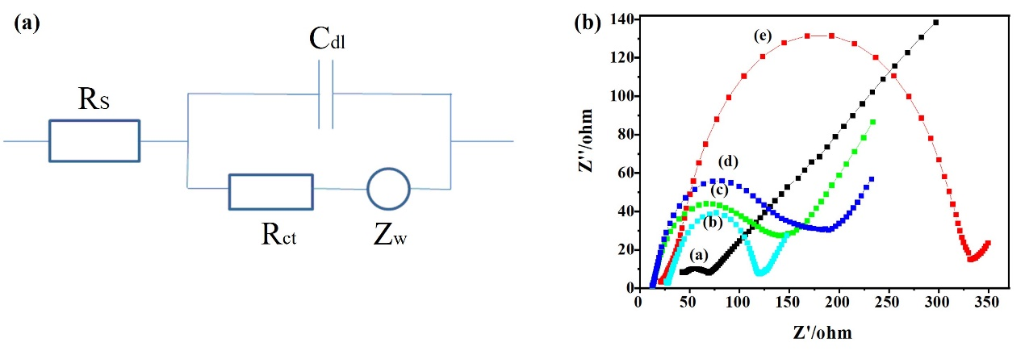
Fig. S3 (a) Diagram showing the equivalent circuit for the electrochemical impedance spectroscopy measurement. R_{s}: electrolyte resistance; R_{ct}: charge transfer resistance; Z_{w}: warburg impedance; C_{dl}: double-layer capacitance. (b) EIS Nyquist plots of the modified Au film electrodes under various doping mode in 0.1 M KCl containing 5.0 mM K₃Fe(CN)₆/K₄(CN)₆ (1:1), (a) bare Au film, (b) Co-CNT/TiO_{2,} (c) CNT/TiO₂, (d) MWCNT and (e) Pristine TiO₂.

Mechanism of photodegradation.

Fig. S4. The photocatalytic schematic illustration of the composites.

Given that carbon nanotubes are semiconductive, UV irradiation of MWCNT may allow the photo-induced electron (e⁻) to enter the TiO₂ particle's conduction band. The conduction band in the TiO₂ particles is thought to have received the electrons from the MWCNT. When O₂ and the electrons in the conduction band interact at this moment, a highly reactive superoxide radical ion (•O₂⁻) may arise. A positive charged hole (h⁺) may simultaneously arise when an electron is transported from the valence bond in TiO₂ to the MWCNT. The OH⁻ created from H₂O may react with the charged hole (h⁺) positively. With this knowledge, the role played by MWCNT may be demonstrated by introducing electrons into the TiO₂ conduction band while being exposed to visible light and initiating the development of the material. Consequently, both radical groups are responsible for the degradation of the organic compound. The as-suggested electron transfer between carbon and TiO₂ was experimentally supported by the early investigation [5].
Table S1 Results of curve fitting of the high-resolution XPS spectra for Ti2p, Co2p, O1s and C1s regions.
Name | Start BE  eV | Peak BE  eV | End BE  eV | FWHM eV | Area (P) CPS.eV | Area (N) KE^0.6 | At. %
C1s | 290.7 | 284.61 | 281.25 | 2.18 | 16378.43 | 6447.21 | 17.49
O1s | 533.75 | 529.76 | 526.85 | 1.64 | 157165.8 | 21602.11 | 58.61
Ti2p | 467.35 | 458.49 | 455.85 | 1.49 | 168882.4 | 8536.77 | 23.16
Co2p | 800.7 | 781.29 | 776.78 | 1.41 | 12402.3 | 268.76 | 0.73

Table S2 The BET results of catalyst samples
Sample | A_{BET}  (m²/g) | Langmuir surface area (m²/g) | t-Plot micro pore area (m²/g) | V_{BJH} (cm³/g) | Pore size  (4V/A(nm))
Controlled TiO₂ | 11.09 | 14.35 | 25.31 | 0.063 | 22.84
Original MWCNT | 264 | - | - | 2.42 | -
Co-CNT-TiO₂-500ºC | 119 | 97.31 | 10.06 | 0.14 | 8.50
Co-TiO₂-500ºC | 5.09 | 6.78 | 7.79 | 0.043 | 338.37
CNT-TiO₂-500ºC | 84 | 50.23 | 8.16 | 0.08 | 15.30

Table S3 Kinetics parameters of photocatalytic degradation of MG at different doped Co concentrations in TiO₂ nanoparticles.
Doped Co (wt%) | Y=ln(c₀/c)=k_{app}t |  | k_{app}(h⁻¹) | Rª | S.D.^{b}
1.5 | Y=-0.0527+0.1719t |  | 0.1719 | 0.9565 | 0.1016
1.0 | Y=-0.0007+0.2354t |  | 0.2354 | 0.9734 | 0.1003
0.5 | Y=0.0568+0.3547t |  | 0.3547 | 0.9968 | 0.0514
0.005 | Y=-0.0149+0.2168t |  | 0.2168 | 0.9659 | 0.1053
0.05 |  | Y=0.0470+0.2771t | 0.2771 | 0.9956 | 0.0473
0 |  | Y=-0.0134+0.2010t | 0.2010 | 0.9719 | 0.0883
Pirstine TiO₂ |  | Y=-0.0382+0.0996t | 0.0996 | 0.9687 | 0.0463

Table S4 Kinetics parameters of photocatalytic degradation of MG at different calcined temperatures.
Calcined temperatures (℃) | Y=ln(c₀/c)=k_{app}t | k_{app}(h⁻¹) | Rª | S.D.^{b}
300 | Y=0.0221+0.0515t | 0.0515 | 0.9828 | 0.0175
400 | Y=0.0337+0.3157t | 0.3157 | 0.9974 | 0.0411
500 | Y=0.0568+0.3547t | 0.3547 | 0.9968 | 0.0514
600 | Y=0.0372+0.2499t | 0.2499 | 0.9924 | 0.0560

References
- Oh WC, Zhang FJ, Chen ML, Preparation of MWCNT/TiO₂ composites by using MWCNTs and titanium (IV) alkoxide precursors in benzene and their photocatalytic effect and bactericidal activity, Bull. Korean Chem. Soc. 30, 2637-2642 (2009)
- Li YS, Jiang FL, Xiao Q, Li R, Li K, Zhang MF, A.Q. Zhang, S.F. Sun, Y. Liu, Enhanced photocatalytic activities of TiO₂ nanocomposites doped with water-soluble mercapto-capped CdTe quantum dots, Appl. Catal. B 101, 118-129 (2010)
- AI-Ekabi H, Serpone N, Kinetic studies in heterogeneous photocatalysis. 1. Photocatalytic degradation of chlorinated phenols in aerated aqueous solutions over TiO₂ supported on a glass matrix, J. Phys. Chem. 92, 5726-5731 (1988)
- Wang XH, Li JG, Kamiyama H, Moriyoshi Y, Ishigaki T, Wavelength-sensitive photocatalytic degradation of methyl orange in aqueous suspension over Iron(III) doped TiO₂ nanopowders under UV and visible light irradiation, J. Phys. Chem. B. 110, 6804-6809 (2006)
- Khalil A, Nasser WS, Osman TA, Toprak MS, Muhammed M, Uheida A, Surface modified of polyacrylonitrile nanofibers by TiO₂/MWCNT for photodegradation of organic dyes and pharmaceutical drugs under visible light irradiation, Environ. Res. 179, 108788 (2019)

