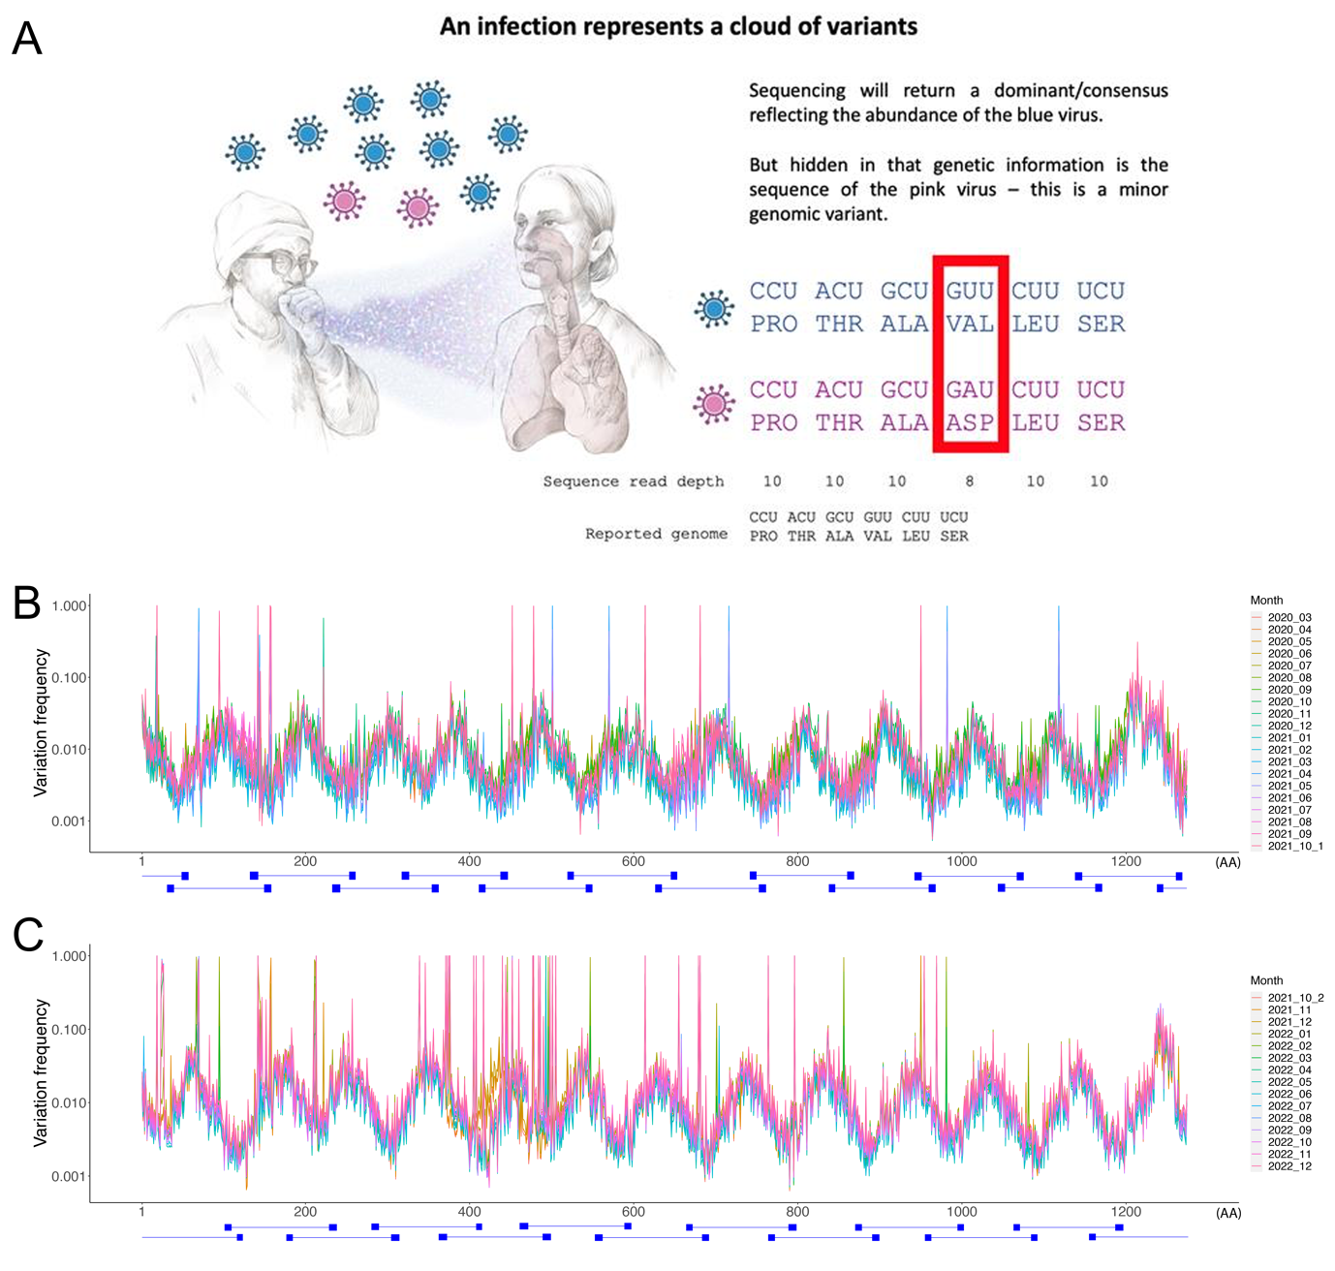

Extended Data Fig. 1. (A) Diagram illustrating the concept of minor variant genomes (images of people from BioRender). Viruses exist as populations that are transmitted between individuals, and these can be sampled using swabs and then sequenced. The consensus/dominant viral sequence is normally reported but under that is information about minor variant genomes that can be at a ratio of 51:49 if only two amino acids or 85:10:5 if three amino acids. (B) Average variation frequency of each amino acid site along the spike protein for each month from 1st March 2020 to 15th October 2021 and (C) 16th October 2020 to 31th December 2022. ARTIC primers sets are indicated using blue boxes below the x-axis, and paired primers were linked by blue lines. 2021_10_1 strands for October (1st to 15th) 2021 and 2021_10_2 strands for (16th to 31st) 2021.

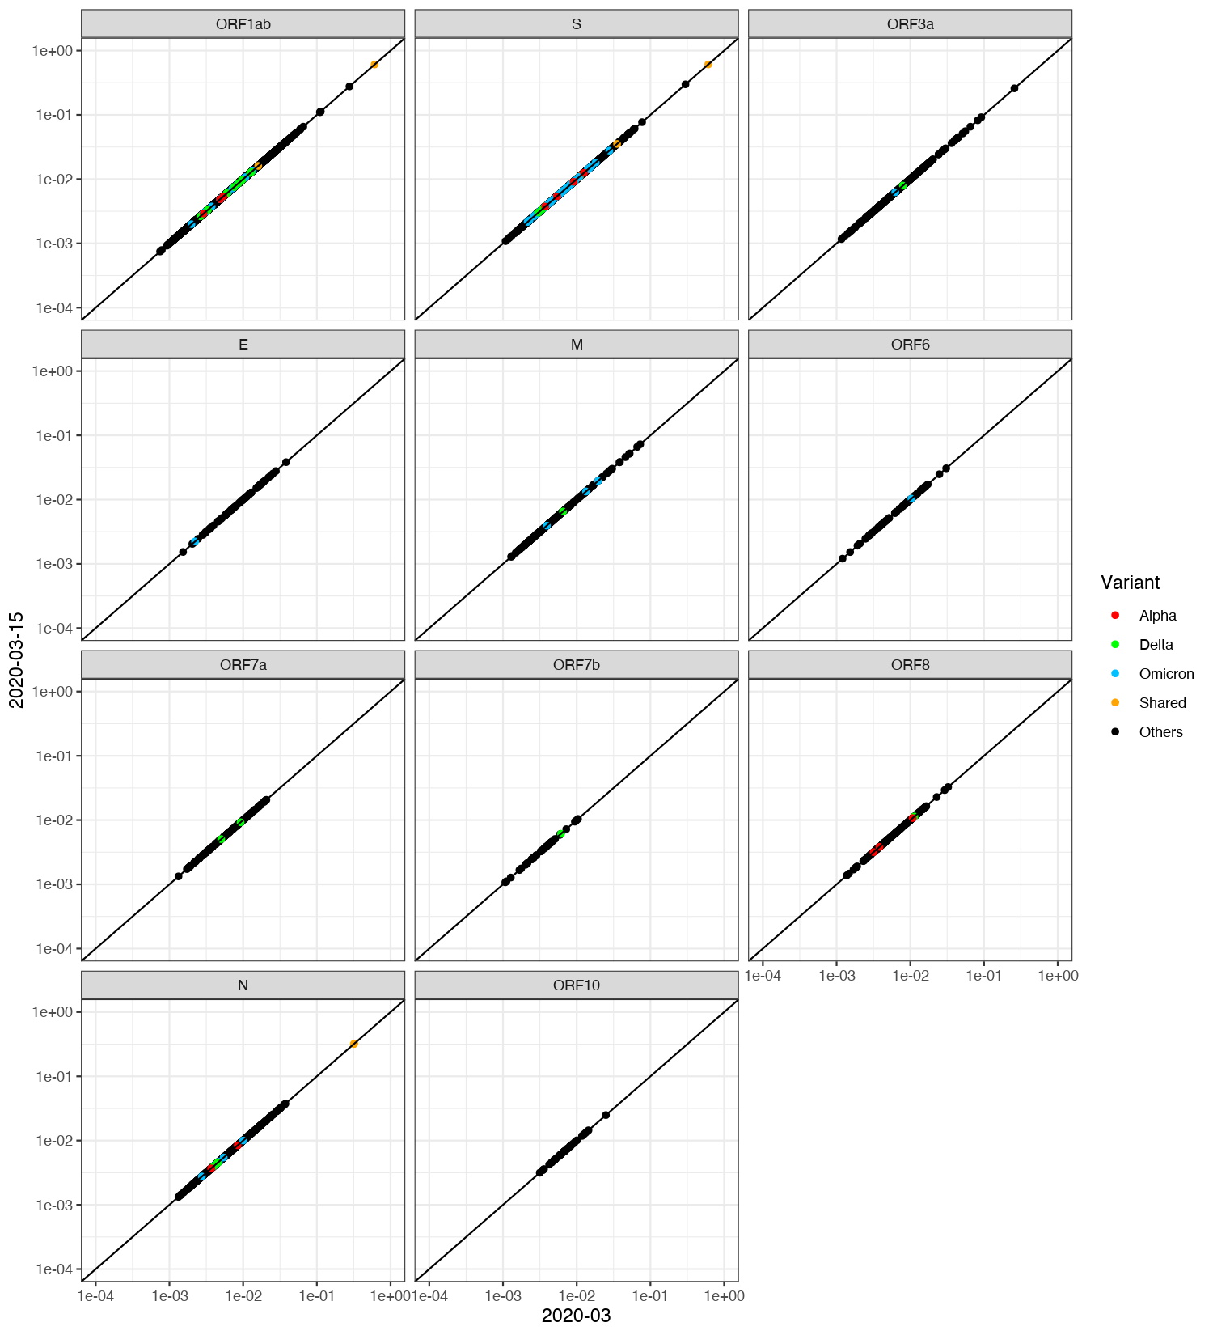
Extended Data Fig. 2. Animation of all gene data animating of (A-S) monthly average variation frequency of each amino acid site from April 2020 to October (1st to 15th) 2021 was plotted against that of March 2020, and (T-AG) monthly average variation frequency of each amino acid site from November 2021 to December 2022 was plotted against to that of October (16th to 31st) 2021. “shared” indicates the amino acid mutation was shared by different variants.

Extended Data Fig. 3. (A-S) Monthly average variation frequency of each amino acid site in spike protein from April 2020 to October (1st to 15th) 2021 was plotted against that of March 2020. (T-AG) Monthly average variation frequency of each amino acid site in spike protein from November 2021 to December 2022 was plotted against to that of October (16th to 31st) 2021. “shared” indicates the amino acid mutation was shared by different variants. For example, as referred to in the main text, the spike:D614G substitution is shown and maintained in the top right corner.

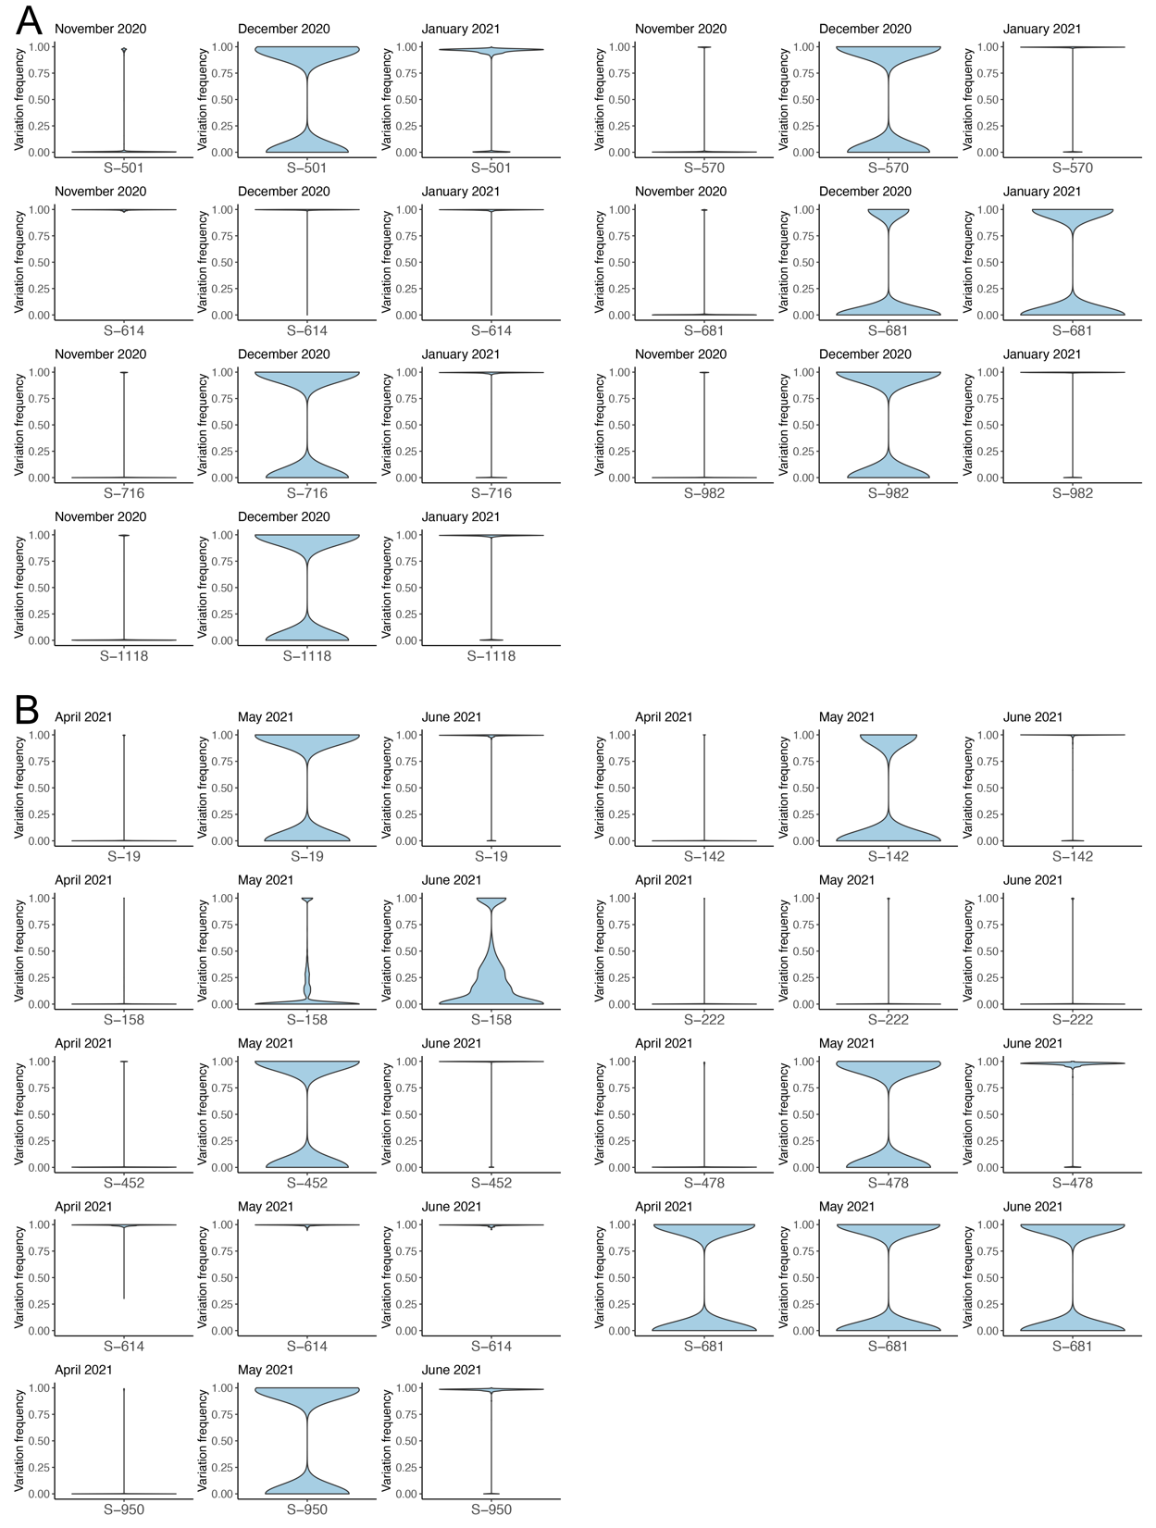
Extended Data Fig. 4. (A) The transition of N501Y, A570D, D614G, P681H, T716I, S982A and D1118H of Alpha variant and (B) T19R, G142D, R158G, A222V, L452R, T478K, D614G, P681R and D950N of Delta variant on spike protein over time in the minor genomic variants. The width of the violin plot indicates the number of samples with the frequency on the y-axis. Samples with variation frequency = 1.00 indicates complete transition of the mutation.
Extended Data Fig. 5. W value plotted against average variation frequency for each amino site in each month.

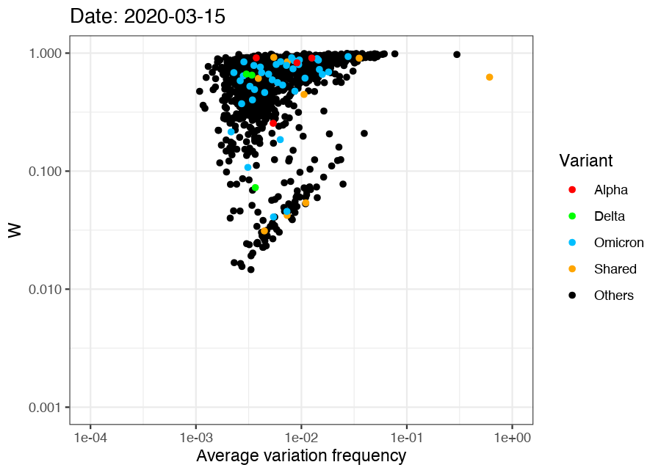

Extended Data Fig. 6. Animation and sound file of the data shown in Extended Data Fig. 5. For the animation the average variation frequency is shown on the x axis and the W value on the Y axis. These values are shown over the sampling period (March 2020 to December 2022). Each dot represents an individual amino acid on the spike protein with those amino acids that form part of VoCs coloured as described in the key. The sound file (Dong’s sonata of SARS2 spike.midi) is an interpretation of the W value by converting the data into music with Python (https://github.com/SYSTEMSounds/sonification-tutorials). Inspiration for this was taken from Project Hail Mary by Andy Weir where Rocky sees in sound.

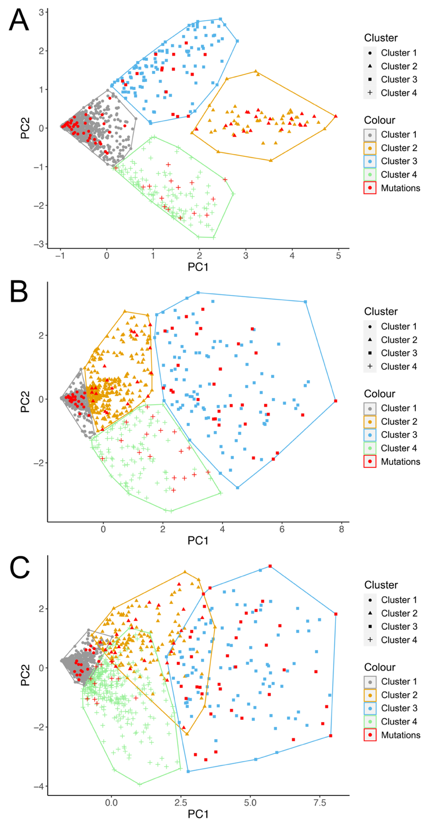
Extended Data Fig. 7. Scatter plots of pam clusters with colouring and shaping each data point according to its cluster assignment for (A) March 2020 to May 2020 (pam12), (B) March 2020 to December 2022 (pam34). Mutation sites used for test were coloured in red.

Extended Data Table 1. Summary of mutations tested by the cluster models.

Months | Cluster | Average W value | Number of AA sites in cluster | Mutations (interested) | Mutations (freq > 0.005) | Mutations (freq > 0.001) | Mutations (all pango lineage) | Mutations (all pango lineage after 2021-03)
1-3 | Cluster 1 | 0.75308 | 958 | 41(44.57%) | 35(48.61%) | 56(36.60%) | 229(55.45%) | 160(52.29%)
1-3 | Cluster 2 | 0.16662 | 69 | 21(22.83%) | 15(20.83%) | 40(26.14%) | 54(13.08%) | 43(14.05%)
1-3 | Cluster 3 | 0.43323 | 121 | 15(16.30%) | 11(15.28%) | 23(15.03%) | 60(14.53%) | 50(16.34%)
1-3 | Cluster 4 | 0.42764 | 126 | 15(16.30%) | 11(15.28%) | 34(22.22%) | 70(16.95%) | 53(17.32%)
1-6 | Cluster 1 | 0.8225 | 691 | 25(27.17%) | 21(29.17%) | 27(17.65%) | 132(31.96%) | 94(30.72%)
1-6 | Cluster 2 | 0.62296 | 337 | 20(21.74%) | 16(22.22%) | 36(23.53%) | 122(29.54%) | 85(27.78%)
1-6 | Cluster 3 | 0.27735 | 129 | 30(32.61%) | 17(23.61%) | 69(45.10%) | 101(24.46%) | 78(25.49%)
1-6 | Cluster 4 | 0.53879 | 117 | 17(18.48%) | 18(25.00%) | 21(13.73%) | 58(14.04%) | 49(16.01%)
1-9 | Cluster 1 | 0.79224 | 656 | 17(18.48%) | 13(18.06%) | 19(12.42%) | 111(26.88%) | 82(26.80%)
1-9 | Cluster 2 | 0.53973 | 167 | 25(27.17%) | 21(29.17%) | 41(26.80%) | 99(23.97%) | 70(22.88%)
1-9 | Cluster 3 | 0.26138 | 136 | 38(41.30%) | 28(38.89%) | 76(49.67%) | 111(26.88%) | 87(28.43%)
1-9 | Cluster 4 | 0.62497 | 315 | 12(13.04%) | 10(13.89%) | 17(11.11%) | 92(22.28%) | 67(21.90%)
1-12 | Cluster 1 | 0.77498 | 760 | 12(13.04%) | 12(16.67%) | 18(11.76%) | 113(27.36%) | 78(25.49%)
1-12 | Cluster 2 | 0.57421 | 345 | 35(38.04%) | 29(40.28%) | 49(32.03%) | 162(39.23%) | 124(40.52%)
1-12 | Cluster 3 | 0.27257 | 169 | 45(48.91%) | 31(43.06%) | 86(56.21%) | 138(33.41%) | 104(33.99%)
1-34 | Cluster 1 | 0.7657 | 636 | 2(2.17%) | 1(1.39%) | 3(1.96%) | 51(12.35%) | 29(9.48%)
1-34 | Cluster 2 | 0.55819 | 169 | 25(27.17%) | 23(31.94%) | 35(22.88%) | 95(23.00%) | 77(25.16%)
1-34 | Cluster 3 | 0.28194 | 166 | 44(47.83%) | 34(47.22%) | 89(58.17%) | 139(33.66%) | 117(38.24%)
1-34 | Cluster 4 | 0.59439 | 303 | 21(22.83%) | 14(19.44%) | 26(16.99%) | 128(30.99%) | 83(27.12%)

