Title: “Unveiling the therapeutic potential of Ponatinib and Imatinib against Aurora Kinase A in gastric cancer cells”

Authors: Nidhi Varshneyª, Dharmendra Kashyapª, Vaishali Sainiª, Siddharth Singhª, Sachin Kumar^{b}, Manivannan Elangovan^{c}, Natércia F. Brás^{d}, Hem Chandra Jhaª*

Affiliations: a = Department of Biosciences and Biomedical Engineering, Indian Institute of Technology Indore, India
b = Himalayan School of Biosciences, Swami Rama Himalayan University, Swami Ram Nagar, Jolly Grant, Dehradun, Pin-248 016. Uttarakhand, India
c = School of Pharmacy, Devi Ahilya Vishwavidyalaya, Indore, India
d = LAQV, REQUIMTE, Departamento de Química e Bioquímica, Faculdade de Ciências, Universidade do Porto, Rua do Campo Alegre s/n, 4169-007 Porto, Portugal
* Corresponding author
Author for correspondence: Hem Chandra Jha, Infection Bio-engineering group, Lab No. POD 1B 602, Infection Bio-engineering Group, Department of Biosciences and Biomedical Engineering Indian Institute of Technology Indore. Madhya Pradesh, PIN 453552, 0732-4306581,
E-mail: hemcjha@iiti.ac.in
Phone: +91-9971653189
Supplementary tables
Supp. table 1: Sequence similarity of various serine-threonine and tyrosine kinases with AURKA
S. No. | Kinase Name | Gene | Group | Similarity in percentage with AURKA
1 | Ribosomal protein S6 kinase beta-2 | RPS6KB2 | Serine/threonine kinase | 39.00
2 | Serine/threonine-protein kinase greatwall | MASTL | Serine/threonine kinase | 37.33
3 | Serine/threonine-protein kinase PLK4 | PLK4 | Serine/threonine kinase | 37.00
4 | 3-phosphoinositide-dependent protein kinase 1 | PDK1 | Serine/threonine kinase | 36.73
5 | RAC-alpha serine/threonine-protein kinase | AKT1 | Serine/threonine kinase | 36.65
6 | Serine/threonine-protein kinase ULK2 | ULK2 | Serine/threonine kinase | 36.24
7 | Serine/threonine-protein kinase Sgk1 | SGK1 | Serine/threonine kinase | 36.21
8 | RAC-beta serine/threonine-protein kinase | AKT2 | Serine/threonine kinase | 35.89
9 | Serine/threonine-protein kinase MRCK beta | CDC42BPB | Serine/threonine kinase | 35.16
10 | SNF-related serine/threonine-protein kinase | SNRK | Serine/threonine kinase | 35.00
11 | Serine/threonine-protein kinase Sgk2 | SGK2 | Serine/threonine kinase | 34.98
12 | cGMP-dependent protein kinase | PRKG1 | Serine/threonine kinase | 34.96
13 | cAMP-dependent protein kinase catalytic subunit PRKX | PRKX | Serine/threonine kinase | 34.84
14 | Serine/threonine-protein kinase ULK3 | ULK3 | Serine/threonine kinase | 34.80
15 | Serine/threonine-protein kinase DCLK3 | DCLK3 | Serine/threonine kinase | 34.70
16 | Serine/threonine-protein kinase PRKY | PRKY | Serine/threonine kinase | 34.63
17 | Serine/threonine-protein kinase DCLK2 | DCLK2 | Serine/threonine kinase | 34.60
18 | cGMP-dependent protein kinase 2 | PRKG2 | Serine/threonine kinase | 34.47
19 | Serine/threonine-protein kinase 38 | STK38 | Serine/threonine kinase | 34.40
20 | Serine/threonine-protein kinase SIK2 | SIK2 | Serine/threonine kinase | 34.39
21 | MAP/microtubule affinity-regulating kinase 4 | MARK4 | Serine/threonine kinase | 34.25
22 | Serine/threonine-protein kinase SIK3 | SIK3 | Serine/threonine kinase | 34.10
23 | MAP/microtubule affinity-regulating kinase 4 | MARK4 | Serine/threonine kinase | 34.00
24 | Serine/threonine-protein kinase SIK3 | SIK3 | Serine/threonine kinase | 34.00
25 | Serine/threonine-protein kinase SIK2 | SIK2 | Serine/threonine kinase | 34.00
26 | Serine/threonine-protein kinase 36 | STK36 | Serine/threonine kinase | 33.85
27 | Serine/threonine-protein kinase DCLK1 | DCLK1 | Serine/threonine kinase | 33.58
28 | Serine/threonine-protein kinase ULK1 | ULK1 | Serine/threonine kinase | 33.46
29 | Serine/threonine-protein kinase Sgk3 | SGK3 | Serine/threonine kinase | 33.46
30 | Serine/threonine-protein kinase MARK1 | MARK1 | Serine/threonine kinase | 33.20
31 | Serine/threonine-protein kinase PLK1 | PLK1 | Serine/threonine kinase | 33.20
32 | RAC-gamma serine/threonine-protein kinase | AKT3 | Serine/threonine kinase | 33.10
33 | Serine/threonine-protein kinase MARK2 | MARK2 | Serine/threonine kinase | 33.00
34 | Serine/threonine-protein kinase 38-like | STK38L | Serine/threonine kinase | 32.98
35 | Serine/threonine-protein kinase Chk2 | CHEK2 | Serine/threonine kinase | 32.96
36 | Serine/threonine-protein kinase N3 | PKN3 | Serine/threonine kinase | 32.79
37 | Serine/threonine-protein kinase MRCK alpha | CDC42BPA | Serine/threonine kinase | 32.77
38 | Serine/threonine-protein kinase N2 | PKN2 | Serine/threonine kinase | 32.73
39 | Serine/threonine-protein kinase MRCK gamma | CDC42BPG | Serine/threonine kinase | 32.67
40 | Serine/threonine-protein kinase N1 | PKN1 | Serine/threonine kinase | 32.62
41 | Serine/threonine-protein kinase D3 | PRKD3 | Serine/threonine kinase | 32.55
42 | Serine/threonine-protein kinase 33 | STK33 | Serine/threonine kinase | 32.51
43 | MAP kinase-activated protein kinase 2 | MAPKAPK2 | Serine/threonine kinase | 32.29
44 | Mitogen-activated protein kinase kinase kinase 3 | MAP3K3 | Serine/threonine kinase | 32.18
45 | Serine/threonine-protein kinase Nek2 | NEK2 | Serine/threonine kinase | 32.09
46 | Death-associated protein kinase 2 | DAPK2 | Serine/threonine kinase | 31.99
47 | Serine/threonine-protein kinase 25 | STK25 | Serine/threonine kinase | 31.94
48 | Serine/threonine-protein kinase tousled-like 2 | TLK2 | Serine/threonine kinase | 31.88
49 | Serine/threonine-protein kinase PLK3 | PLK3 | Serine/threonine kinase | 31.87
50 | MAP/microtubule affinity-regulating kinase 3 | MARK3 | Serine/threonine kinase | 31.80
51 | Serine/threonine-protein kinase D1 | PRKD1 | Serine/threonine kinase | 31.76
52 | Mitogen-activated protein kinase 12 | MAPK12 | Serine/threonine kinase | 31.70
53 | Serine/threonine-protein kinase TAO2 | TAOK2 | Serine/threonine kinase | 31.54
54 | Serine/threonine-protein kinase MST4 | STK26 | Serine/threonine kinase | 31.44
55 | Serine/threonine-protein kinase SIK1 | SIK1 | Serine/threonine kinase | 31.42
56 | Serine/threonine-protein kinase Nek8 | NEK8 | Serine/threonine kinase | 31.40
57 | Serine/threonine-protein kinase TAO1 | TAOK1 | Serine/threonine kinase | 31.37
58 | Serine/threonine-protein kinase TAO3 | TAOK3 | Serine/threonine kinase | 31.30
59 | Testis-specific serine/threonine-protein kinase 3 | TSSK3 | Serine/threonine kinase | 31.23
60 | Death-associated protein kinase 1 | DAPK1 | Serine/threonine kinase | 31.21
61 | Serine/threonine-protein kinase D2 | PRKD2 | Serine/threonine kinase | 31.21
62 | Serine/threonine-protein kinase PLK2 | PLK2 | Serine/threonine kinase | 31.20
63 | Mitogen-activated protein kinase 13 | MAPK13 | Serine/threonine kinase | 31.19
64 | Serine/threonine-protein kinase 24 | STK24 | Serine/threonine kinase | 31.18
65 | Serine/threonine-protein kinase 32A | STK32A | Serine/threonine kinase | 31.18
66 | Mitogen-activated protein kinase kinase kinase 1 | MAP3K1 | Serine/threonine kinase | 31.07
67 | Testis-specific serine/threonine-protein kinase 2 | TSSK2 | Serine/threonine kinase | 31.03
68 | Serine/threonine-protein kinase Nek10 | NEK10 | Serine/threonine kinase | 31.01
69 | Serine/threonine-protein kinase 17A | STK17A | Serine/threonine kinase | 30.94
70 | Serine/threonine-protein kinase LATS1 | LATS1 | Serine/threonine kinase | 30.83
71 | Protein kinase domain-containing protein | PKDCC | Serine/threonine kinase | 30.77
72 | Serine/threonine-protein kinase tousled-like 1 | TLK1 | Serine/threonine kinase | 30.70
73 | MAP kinase-activated protein kinase 3 | MAPKAPK3 | Serine/threonine kinase | 30.60
74 | Serine/threonine-protein kinase TBK1 | TBK1 | Serine/threonine kinase | 30.45
75 | Serine/threonine-protein kinase 32B | STK32B | Serine/threonine kinase | 30.43
76 | Serine/threonine-protein kinase 10 | STK10 | Serine/threonine kinase | 30.40
77 | Cyclin-dependent kinase-like 4 | CDKL4 | Serine/threonine kinase | 30.35
78 | Cyclin-dependent kinase 9 | CDK9 | Serine/threonine kinase | 30.32
79 | Microtubule-associated serine/threonine-protein kinase 2 | MAST2 | Serine/threonine kinase | 30.22
80 | Serine/threonine-protein kinase 17B | STK17B | Serine/threonine kinase | 30.19
81 | Serine/threonine-protein kinase PAK 7 | PAK7 | Serine/threonine kinase | 30.16
82 | Serine/threonine-protein kinase Nek3 | NEK3 | Serine/threonine kinase | 30.12
83 | Serine/threonine-protein kinase LATS2 | LATS2 | Serine/threonine kinase | 30.11
84 | STE20-like serine/threonine-protein kinase | SLK | Serine/threonine kinase | 30.10
85 | Cyclin-dependent kinase 18 | CDK18 | Serine/threonine kinase | 30.04
86 | Serine/threonine-protein kinase BRSK1 | BRSK1 | Serine/threonine kinase | 30.04
87 | Serine/threonine-protein kinase 3 | STK3 | Serine/threonine kinase | 29.34
88 | Serine/threonine-protein kinase 4 | STK4 | Serine/threonine kinase | 29.33
89 | Vascular endothelial growth factor receptor 2 | VEGFR2 | Tyrosine kinase | 28.95
90 | Fibroblast growth factor receptor 1 | FGFR1 | Tyrosine kinase | 26.85
91 | Platelet-derived growth factor receptor alpha | PDGFRA | Tyrosine kinase | 26.75
92 | Vascular endothelial growth factor receptor 3 | VEGFR3 | Tyrosine kinase | 25.93
93 | Proto-oncogene tyrosine-protein kinase Src | SRC | Tyrosine kinase | 22.91
94 | Receptor-type tyrosine-protein kinase FLT3 | FLT3 | Tyrosine kinase | 22.22

Supp. table 2: Structural similarity of filtered kinases with AURKA
S. No. | Kinase Gene Name | PDB id | RMSD (Å)
1 | PLK1 | 4O6W | 0.536
2 | PKN1 | 4OTH | 0.623
3 | MAP3K1 | 6WHB | 0.627
4 | AKT2 | 1O6K | 0.651
5 | ULK3 | 6FDY | 0.736
6 | PAK 7 | 2F57 | 0.737
7 | AKT3 | 2X18 | 0.771
8 | AKT1 | 6HHG | 0.783
9 | MASTL | 5LOH | 0.796
10 | PKN2 | 4RRV | 0.813
11 | STK 32A | 4FR4 | 0.822
12 | Sgk1 | 2R5T | 0.846
13 | TLK2 | 5O0Y | 0.848
14 | MARK2 | 5EAK | 0.862
15 | MAPK12 | 1CM8 | 0.867
16 | MARK4 | 5ES1 | 0.869
17 | PLK2 | 4I5P | 0.873
18 | DCLK1 | 6KYQ | 0.881
19 | PDK1 | 1UU3 | 0.883
20 | STK 10 | 2J7T | 0.887
21 | SLK | 6HVD | 0.905
22 | STK 24 | 7B32 | 0.917
23 | PLK3 | 4B6L | 0.936
24 | MAPK13 | 4YNO | 0.941
25 | Nek2 | 2W5A | 0.944
26 | Src | 1FMK | 0.955
27 | ULK2 | 6QAV | 0.960
28 | Chk2 | 2YCF | 0.967
29 | MAPKAPK3 | 3FHR | 0.976
30 | STK 38 | 6BXI | 0.980
31 | MRCK beta | 5OTE | 1.000
32 | STK 25 | 2XIK | 1.000
33 | MARK3 | 3FE3 | 1.020
34 | PDGFRA | 5GRN | 1.034
35 | SNRK | 5YKS | 1.059
36 | VEGFR 2 | 2XIR | 1.063
37 | TAO3 | 6BDN | 1.068
38 | PLK4 | 3COK | 1.101
39 | MARK1 | 6C9D | 1.126
40 | FLT3 | 1RJB | 1.156
41 | FGFR 1 | 3JS2 | 1.199
42 | VEGFR 3 | 4BSJ | 1.293

Supp. table 3: Binding energy of the ligand molecule with 2J4Z structure of AURKA
S.No. | Compound Name | PubChem ID | Binding energy (kcal/mol)
1 | Mk2 inhibitor 3 | 25163932 | -9.6
2 | CFI-400945 | 58486178 | -8.7
3 | Imatinib | 5291 | -8.4
4 | Midostaurin | 9829523 | -8.3
5 | Mk2 inhibitor 4 | 75059709 | -8.2
6 | GSK2334470 | 46215815 | -8.1
7 | Vemurafenib | 42611257 | -8.1
8 | Ponatinib | 24826799 | -8.1
9 | MLN8054 | 11712649 | -8.0
10 | Cobimetinib | 16222096 | -7.9
11 | Danusertib | 11442891 | -7.9
12 | Linarin | 5317025 | -7.8
13 | Palbociclib | 5330286 | -7.8
14 | Sorafenib | 216239 | -7.8
15 | Dabrafenib | 44462760 | -7.8
16 | Abemaciclib | 46220502 | -7.7
17 | Axitinib | 6450551 | -7.7
18 | Trametinib | 11707110 | -7.7
19 | Vandetanib | 3081361 | -7.7
20 | Regorafenib | 11167602 | -7.6
21 | YLT-11 | 134821508 | -7.6
22 | Alisertib | 24771867 | -7.6
23 | Galuteolin | 5280637 | -7.5
24 | Ruxolitinib | 25126798 | -7.5
25 | Pazopanib | 10113978 | -7.5
26 | Orantinib | 5329099 | -7.4
27 | Onvansertib | 49792852 | -7.3
28 | Ribociclib | 44631912 | -7.3
29 | BI2536 | 11364421 | -7.3
30 | Donepezil | 3152 | -7.3
31 | Niclosamide | 4477 | -7.2
32 | VX-680 | 5494449 | -7.2
33 | Lenvatinib | 9823820 | -7.1
34 | Dasatinib | 3062316 | -7.1
35 | Prexasertib | 46700756 | -7.1
36 | Centrinone | 91801159 | -7.1
37 | Binimetinib | 10288191 | -7.1
38 | Lapatinib | 208908 | -7.0
39 | Afatinib | 10184653 | -7.0
40 | Selumetinib | 10127622 | -7.0
41 | VX-689 | 24748204 | -6.9
42 | Sunitinib | 5329102 | -6.8
43 | Gefitinib | 123631 | -6.8
44 | Bosutinib | 5328940 | -6.6
45 | Erlotinib | 176870 | -6.6
46 | Tofacitinib | 9926791 | -6.6
47 | Nintedanib | 135423438 | -6.5
48 | Osimertinib | 71496458 | -6.4
49 | Methiazole | 6604471 | -6.3
50 | Parbendazole | 26596 | -6.2

Supp. table 4: Binding energy kcal/mol of the ligand molecule with different PDB structures of AURKA
S.No. | Compound Name | 5G15 | 4C3P | 4JAJ
1 | Imatinib | -09.7 | -08.7 | -10.6
2 | Mk2 inhibitor 3 | -08.2 | -08.7 | -10.2
3 | CFI-400945 | -07.7 | -09.9 | -08.7
4 | GSK2334470 | -08.1 | -08.8 | -10.9
5 | Vemurafenib | -07.3 | -08.1 | -07.1
6 | Ponatinib | -08.3 | -09.0 | -10.2
7 | Midostaurin | -08.6 | -09.1 | -09.2
8 | Onvansertib | -07.6 | -08.2 | -09.8
9 | Abemaciclib | -09.2 | -08.6 | -10.9
10 | Linarin | -09.5 | -10.3 | -10.4
11 | Mk2 inhibitor 4 | -09.3 | -09.2 | -09.6
12 | Axitinib | -07.5 | -08.4 | -09.8
13 | Regorafenib | -06.5 | -08.2 | -07.4
14 | Palbociclib | -08.5 | -08.4 | -09.6
15 | Ribociclib | -06.5 | -07.2 | -08.6
16 | Lapatinib | -08.6 | -08.8 | -10.0
17 | Nintedanib | -07.2 | -08.7 | -08.1
18 | Sorafenib | -09.2 | -07.9 | -09.8
19 | YLT-11 | -08.4 | -08.1 | -09.9
20 | Galuteolin | -08.2 | -09.4 | -09.6
21 | Dabrafenib | -07.2 | -08.4 | -09.7
22 | BI2536 | -06.6 | -07.3 | -07.3
23 | Trametinib | -07.1 | -07.3 | -08.4
24 | Lenvatinib | -07.5 | -07.8 | -08.5
25 | Dasatinib | -07.1 | -08.1 | -09.7
26 | Prexasertib | -06.9 | -06.9 | -07.9
27 | centrinone | -09.0 | -07.9 | -10.1
28 | Osimertinib | -07.8 | -07.7 | -09.9
29 | Ruxolitinib | -07.2 | -07.4 | -08.3
30 | Bosutinib | -07.2 | -06.8 | -08.9
31 | Afatinib | -05.8 | -07.5 | -07.1
32 | Orantinib | -07.3 | -07.1 | -08.2
33 | Donepezil | -07.7 | -07.4 | -08.8
34 | Erlotinib | -07.3 | -07.1 | -07.7
35 | Pazopanib | -07.8 | -07.5 | -09.8
36 | Vandetanib | -06.4 | -06.9 | -08.8
37 | Niclosamide | -06.8 | -07.1 | -07.8
38 | Cobimetinib | -06.5 | -07.6 | -08.0
39 | Sunitinib | -05.9 | -06.4 | -07.9
40 | Tofacitinib | -06.4 | -07.2 | -07.6
41 | Gefitinib | -06.3 | -06.7 | -07.9
42 | Binimetinib | -05.7 | -06.6 | -06.2
43 | Selumetinib | -05.4 | -06.5 | -07.5
44 | Methiazole | -05.8 | -05.7 | -05.8
45 | Parbendazole | -05.4 | -05.7 | -07.1
46 | Alisertib | -08.7 | -08.8 | -08.1
47 | Danusertib | -07.0 | -08.1 | -07.7
48 | Mln8054 | -08.3 | -09.7 | -08.1
49 | Vx-680 | -08.6 | -07.7 | -08.5
50 | vx-689 | -06.1 | -06.5 | -07.1
Supp. table 5. Average Backbone RMSD values for protein backbone and, Binding Pocket ligands RMSD around Ligand, as well as the Radius of Gyration (Rg) for the screened complexes during the last 50 ns of each simulation.
System | RMSD (Å) | RMSD_ligand (Å) | Rg (Å)
Apo | 3.01 ± 0.0001 |  | 19.63 ± 0.003
AurA: ponatinib | 3.42 ± 0.004 | 3.00 ± 0.005 | 19.55 ± 0.001
AurA: imatinib | 2.71 ± 0.003 | 1.30 ± 0.006 | 19.56 ± 0.003
AurA: GSK-2334470 | 2.52 ± 0.002 | 2.09 ± 0.013 | 19.39 ± 0.003
AurA:MK2i3 | 2.49 ± 0.003 | 1.64 ± 0.010 | 19.52 ± 0.003
AurA: CFI-400945 | 2.44 ± 0.003 | 2.61 ± 0.003 | 19.56 ± 0.002
AurA: vemurafenib | 2.88 ± 0.006 | 2.55 ± 0.008 | 19.49 ± 0.002

Supp. table 6. Binding energy values (kcal/mol) for the various AURKA: ligand complexes.

Protein: ligand | Van der Waals | Electrostatic | Polar Solvation | Non-Polar Solvation | ΔG_{binding} | ΔΔG_{binding}
AURKA: ponatinib | -52.52 ± 0.31 | -3.51 ± 0.08 | 8.18 ± 0.10 | 26.61 ± 0.21 | -21.24 ± 0.30 | 0.00 ± 0.43
AURKA: imatinib | -65.28 ± 0.28 | -7.24 ± 0.11 | 16.72 ± 0.12 | 34.83 ± 0.14 | -20.97 ± 0.41 | 0.27 ± 0.51
AURKA: GSK-2334470 | -50.46 ± 0.42 | -5.98 ± 0.10 | 11.15 ± 0.16 | 28.16 ± 0.26 | -17.13 ± 0.43 | 4.11 ± 0.53
AURKA:MK2i3 | -37.25 ± 0.27 | -2.42 ± 0.16 | 5.86 ± 0.10 | 19.98 ± 0.20 | -13.83 ± 0.32 | 7.41 ± 0.44
AURKA: CFI-400945 | -43.45 ± 0.27 | -2.21 ± 0.10 | 7.70 ± 0.11 | 26.04 ± 0.23 | -11.92 ± 0.28 | 9.32 ± 0.41
AURKA: vemurafenib | -37.20 ± 0.34 | -3.16 ± 0.19 | 6.54 ± 0.12 | 22.30 ± 0.24 | -11.52 ± 0.40 | 9.72 ± 0.51

Supp. table 7: Calculated molecular properties of small molecule serine-threonine kinase inhibitors
Drugs/Compds. | miLogP | TPSA | natoms | MW | nON | nOHNH | nrotb | Volume
Ponatinib | 4.24 | 065.77 | 39 | 532.57 | 7 | 1 | 5 | 464.59
Imatinib | 3.89 | 086.28 | 37 | 493.62 | 8 | 2 | 7 | 461.44
GSK-2334470 | 4.11 | 124.85 | 34 | 462.60 | 9 | 5 | 5 | 436.16
MK2-inhibitor 3 | 2.68 | 070.67 | 26 | 340.39 | 5 | 2 | 2 | 301.67
CFI-400945 | 5.38 | 079.49 | 40 | 534.66 | 7 | 2 | 6 | 492.59
Vemurafenib | 5.56 | 091.92 | 33 | 489.93 | 6 | 2 | 7 | 388.06

Supp. table 8: Interacting residues of each AURKA: ligand complex observed throughout the MD simulations (only the interactions with frequency higher than 5% were considered). Residues highlighted in bold are those that establish hydrogen bonds with the potential inhibitors.
Ligand | AURKA residues
ponatinib | Leu139, Val147, Tyr212, Ala213, Pro214, Leu215, Gly216, Arg220, Glu260, Asn261, His280, Pro282
imatinib | Leu139, Gly140, Lys162, Tyr212, Ala213, Gly216, Asp256, Asn261, Leu263, Asp274, Ser278, Val279, His280, Pro282
GSK-2334470 | Leu139, Ala160, Lys162, Leu194, Leu210, Glu211, Tyr212, Ala213, Gly216, Arg220, Leu263, His280, Pro282
MK2i3 | Leu139, Val147, Ala160, Leu194, Leu210, Glu211, Tyr212, Ala213, Gly216, Arg220, Leu263
CFI-400945 | Leu139, Ala160, Leu194, Tyr212, Pro214, Gly216, Arg220, Arg239, Glu260, Asn261, Leu26
vemurafenib | Arg137, Leu139, Ala160, Lys162, Leu194, Tyr212, Gly216, Thr217, Arg220, Leu263

Supplementary figures

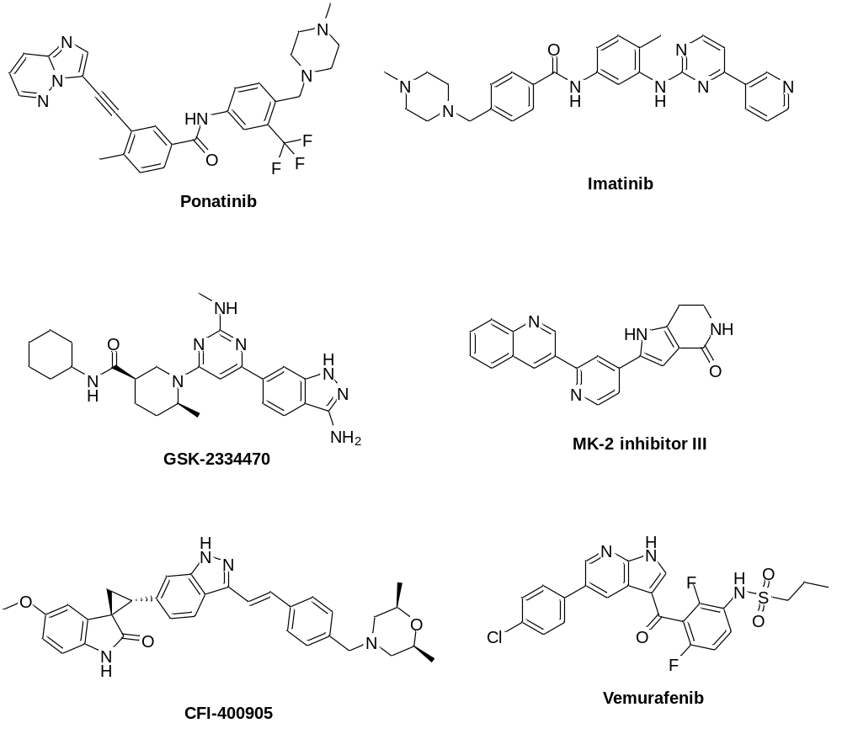
Figure S1: Small molecule serine-threonine kinase inhibitors docked with AurA selected for MD simulations
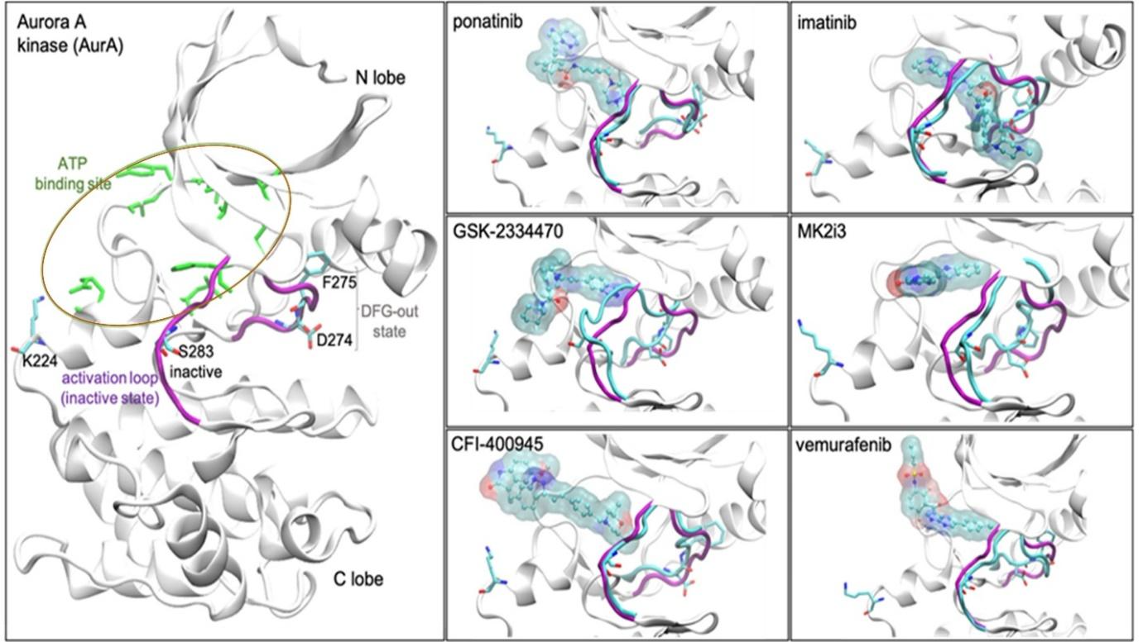
Figure S2. Illustration of the representative geometry of the prevalent binding poses. AURKA is depicted in white cartoons, while the ATP-binding site and key catalytic residues are in sticks and colored as orange and by atom type, respectively. The activation loop and DFG motif are colored at purple and blue in the apo-kinase and bound-kinases respectively. Ligands are depicted in balls-and-sticks and surfaces and colored by atom type.
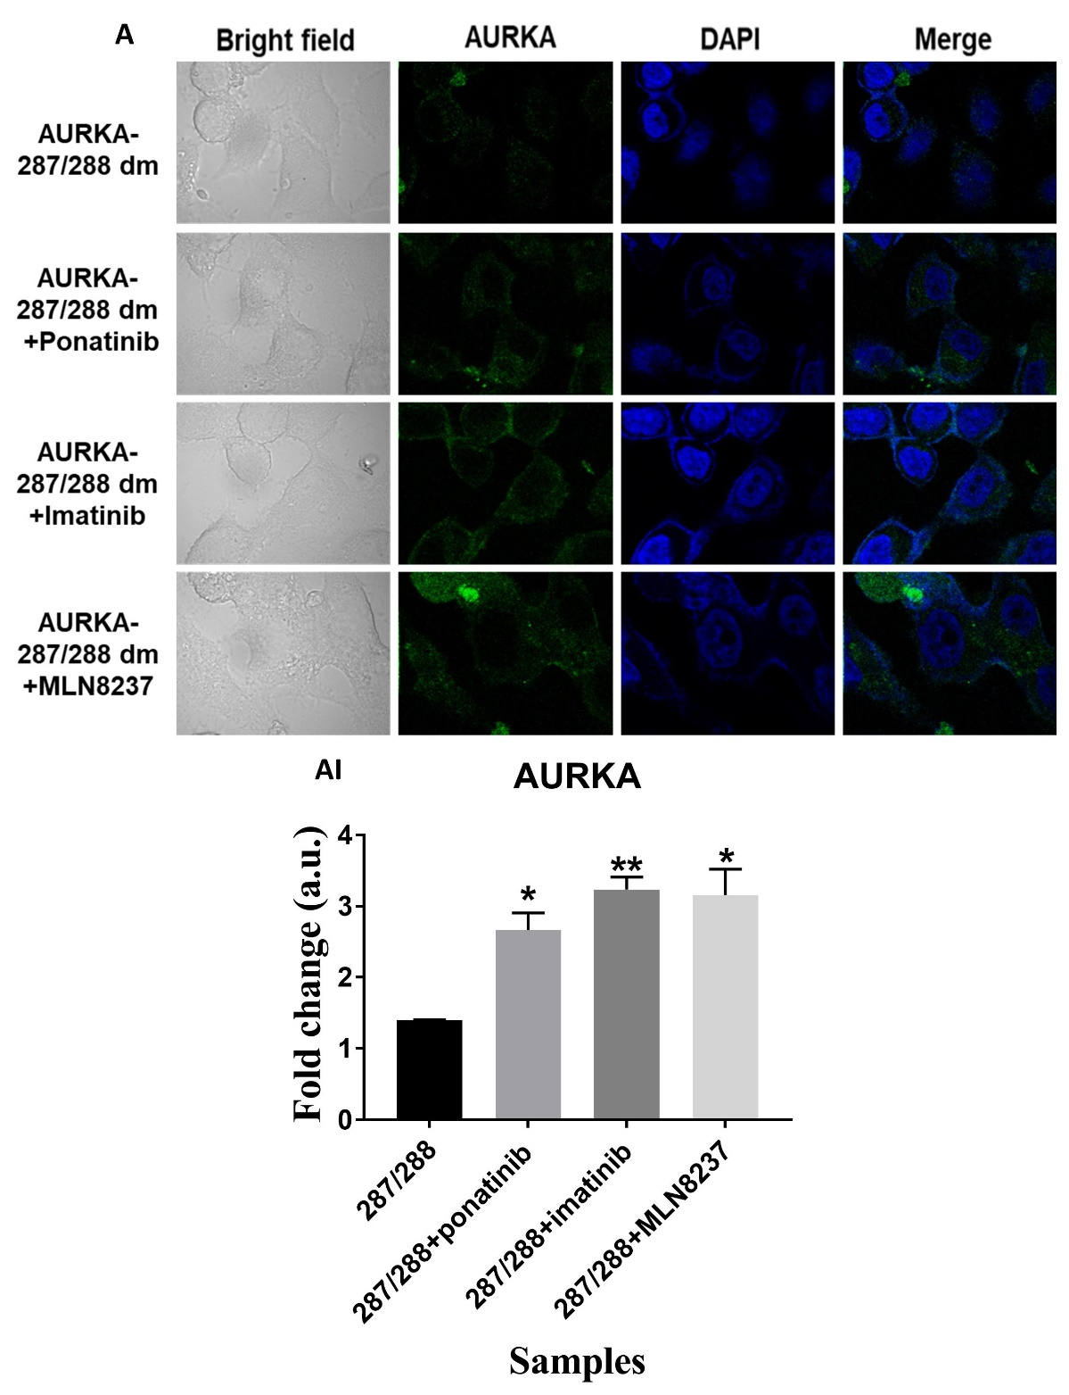
Figure S3. 287/288 double mutant of AURKA rescue the AGS cells from the inhibitory effect of compounds on AURKA expression. (A) Representative fluorescence image showing AURKA, (AI) Quantification of fluorescence intensity of AURKA post 287/288 double mutant of AURKA transfection for 24 hrs followed by inhibitor treatment on AGS cells for 24 hrs. The experiment was performed for two biological and two technical replicates, and the results are shown as the mean ± SD for two independent experiments. Data were statistically analyzed using an unpaired t-test. p values were estimated using GraphPad Prism version 7, and p values of 0.05, 0.01, and 0.001 were considered statistically significant and represented by */#, **/##, and ***/###, denoting upregulation/downregulation respectively.

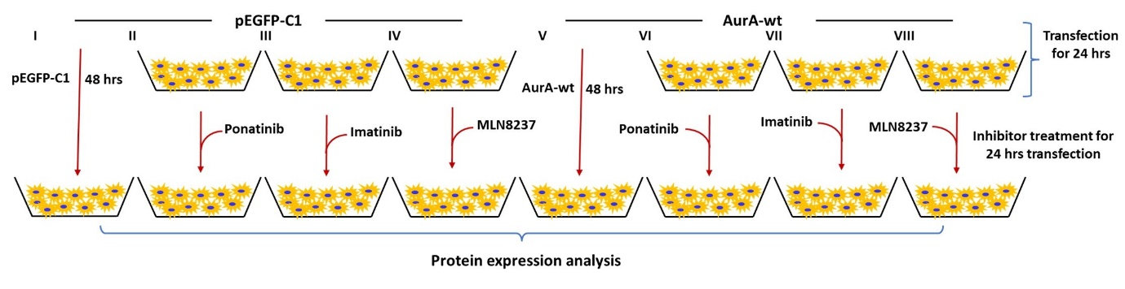
Figure S4. Treatment schemes to depict the inhibitory action of different compounds on AURKA in gastric cancer. Illustration of selected studied treatment strategy-I to VIII. AGS cells were seeded in a 6-well plate. (I) AGS cells transfected with pEGFP-c1 vector control for 48 hrs. (II - IV) pEGFP-c1 transfection on AGS cells for 24 hrs followed by Ponatinib, Imatinib, and MLN8237 compound treatment respectively for 24 hrs. (V) the AGS cells transfected with AURKA-wt for 48 hrs. (VI - VIII) Transfection of AURKA-wt for 24 h followed by exposure to Ponatinib, Imatinib, and MLN8237 compound respectively for 24 h.

