Extended Data Figures
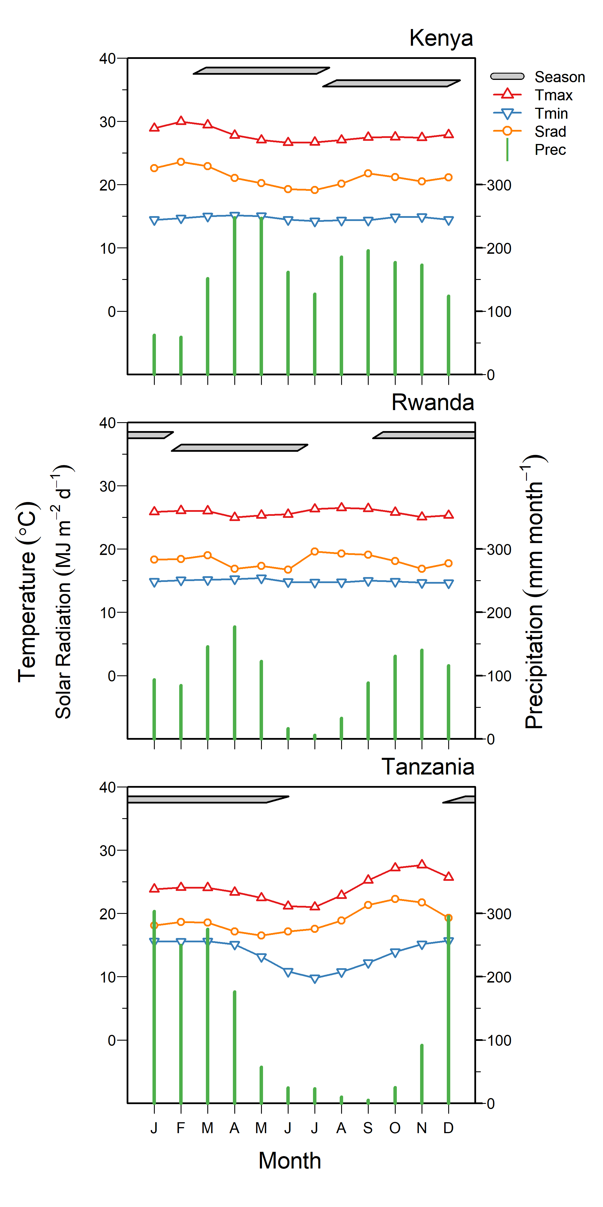
Extended Data Fig. 1. Seasonal weather patterns in the three regions of study. The horizontal parallelograms show maize growing seasons. There are two seasons per year in Kenya and Rwanda and only one in Tanzania. Weather data was retrieved from the GYGA database for Kenya (Kakamega) and Tanzania (tan_rfmz9) and from CHIRPS (precipitation) and WorldClim (temperature) for Rwanda.

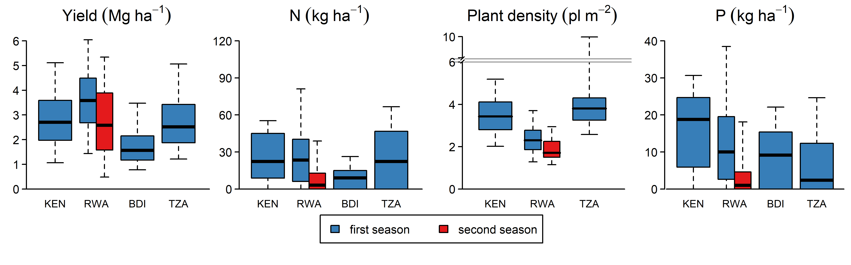
Extended Data Fig. 2. Distribution of main variables for each country: Kenya (KEN), Rwanda (RWA), Burundi (BDI), and Tanzania (TZA). Rwanda data was divided by season: first season (“season A”) and second season (“season B”). N and P rates were calculated from inorganic fertilizers without considering compost. Plant density data was not available in BDI.

