Supporting Information for “Sub-Saharan Africa needs better agronomy to meet maize demand without massive cropland expansion and imports” by Aramburu-Merlos et al.

CONTENTS

Text
Text S1. Conditional Inference Trees Information 2
Tables
Table S1. 4
Table S2. 5

Figures
Fig. S1.. 7
Fig. S2. 8
Fig. S3.. 9
Fig. S4.. 10
Fig. S5.. 11
Fig. S6. 12
Fig. S7 – S27. Conditional inference trees 13-31

Text S1. Conditional Inference Trees Information

Management and environmental variables included in the conditional inference tree analysis are shown in Table S1 and Table S2. The conditional inference trees describing the management and environmental factors affecting smallholders’ maize yields in each climate zone cluster are shown in Fig. S7 to S27. The country, climate zone properties, season, and years with data for each cluster are shown in the top left corner of each figure. GDD is the growing degree days range, and AI is the aridity index range (x 10,000) (see van Wart et al., 2013). Boxplots show the yield distribution observed at each environmental and crop management combination. In each boxplot, the whiskers span from 0.1 to 0.9 quantiles of the yield distribution, and the number of observations (n) and average maize yield are shown. n and the p-value of the variable’s effect on yield are also indicated at each node (data partition). Model fit statistics (R² and root mean square error, RMSE) are shown in the top right corner.

Table S1. List of survey-derived variables included in the analysis. The statistic column indicates the variable average ± its standard deviation (continuous variables), the percentage of positive (yes) answers (binary variables), or the percentage of observations in each category (categorical variables). Missing values were ignored to compute these quantities, but nil input rates were included. The NA column indicates the percentage of missing values for each variable.
Category | Name | Type | Unit | Description | Statistic | NA%*
Crop establishment | plant_date_dev | discrete | days | sowing date deviation from cluster average | 0 ± 20 | 32
Crop establishment | pl_m2 | continuous | # m⁻² | plant density (plants per area) | 3.9 ± 2.1 | 31
Crop establishment | row_spacing | continuous | cm | distance between rows | 79 ± 12 | 42
Cultivar | hybrid | binary | - | Was a commercial hybrid seed used? | 78% | 11
Cultivar | hyb_mat | ordinal | - | hybrid maturity (early, medium, late) | 17-18-64 | 30
Cultivar | hyb_yor | continuous | - | Year of release of the cultivar | 2000 ± 8 | 55
Cultivar | hyb_tol_mln | binary | - | Tolerance to maize lethal necrosis | 2% | 52
Cultivar | hyb_tol_msv | binary | - | Tolerance to maize streak virus | 20% | 52
Cultivar | hyb_tol_gls | binary | - | Tolerance to gray leaf spot | 65% | 52
Cultivar | hyb_tol_nclb | binary | - | Tolerance to northern corn leaf blight | 26% | 52
Cultivar | hyb_tol_rust | binary | - | Tolerance to rust | 11% | 52
Cultivar | hyb_tol_ear_rot | binary | - | Tolerance to ear rot | 48% | 52
Nutrients | N_kg_ha | continuous | kg ha⁻¹ | N fertilization rate | 31 ± 28 | 0
Nutrients | P_kg_ha | continuous | kg ha⁻¹ | P fertilization rate | 16 ± 13 | 0
Nutrients | K_kg_ha | continuous | kg ha⁻¹ | K fertilization rate | 0.1 ± 1.3 | 32
Nutrients | compost | binary | - | Was compost applied? | 36% | 43
Nutrients | comp_kg_ha | continuous | t ha⁻¹ | compost rate | 1.2 ± 4.4 | 53
Nutrients | manure | binary | - | Did the compost contain manure? | 78% | 70
Nutrients | fert_in_hole | binary | - | Was the fertilizer applied in a hole? | 34% | 0
Liming | lime_kg_ha | continuous | kg ha⁻¹ | lime rate | 6 ± 70 | 5
Adversities | weeding | discrete | # | number of times the plot was weeded | 1.7 ± 0.6 | 31
Adversities | pesticide | binary | - | Was any pesticide applied? | 36% | 37
Adversities | disease | binary | - | Was yield affected by diseases? | 3% | 0
Adversities | pest | binary | - | Was yield affected by pests? | 27% | 0
Adversities | striga | binary | - | Was yield affected by the Striga weed? | 35% | 84
Adversities | water_excess | binary | - | Was yield affected by water excess (heavy rain or flooding)? | 8% | 0
* The percentage of missing values was calculated considering the observations for which an answer was expected (e.g., for hybrid maturity, considering only farmers who used hybrids)

Table S2. List of environmental variables included in the analysis.
Category | Name | Unit | Description | Source
Climatic | GDD | °C days | Growing degree days | www.worldclim.org  www.yieldgap.org
Climatic | AI | unitless | Aridity Index (annual precipitation over potential evapotranspiration) | www.worldclim.org  www.yieldgap.org
Climatic | TS | °C | Temperature seasonality | www.worldclim.org  www.yieldgap.org
Weather | season_prec | mm | Total rainfall during the maize season (10% of planting to 50% of the harvest) | https://www.chc.ucsb.edu/data/chirps
Weather | season_prec_1 | mm | Rainfall during the first third of the season | https://www.chc.ucsb.edu/data/chirps
Weather | season_prec_2 | mm | Rainfall during the second third of the season | https://www.chc.ucsb.edu/data/chirps
Weather | season_prec_3 | mm | Rainfall during the third third of the season | https://www.chc.ucsb.edu/data/chirps
Elevation | elev | m.a.s.l. | Elevation (altitude) above sea level | registry.opendata.aws/terrain-tiles
Soil | soil_rzpawhc | mm | Root zone plant-available water holding capacity | www.isric.org
Topography | twi | unitless | Topographic Wetness Index | calculated from elevation data

Fig. S1. Regions with similar environmental conditions to those in the field-level farmer database. The red stripe regions comprise areas with homologous Climate Zones (CZ) to the ones included in the analysis (Fig. 2). CZs are defined based on Growing Degree Days (GDD), Aridity Index (AI), and Temperature Seasonality (TS). The blue stripe regions comprise regions with comparable AI but different GDD or TS. The CZs in which the maize fields in the farmer database are located cover 41% of the total maize area in Sub-Saharan Africa (SSA). The range of Aridity Indexes (AI) explored by the maize fields in the database comprises 85% of SSA maize area. CZs were retrieved from the Global Yield Gap Atlas (www.yieldgap.org). Maize area distribution for rainfed crops was retrieved from SPAM (https://doi.org/10.7910/DVN/FSSKBW).

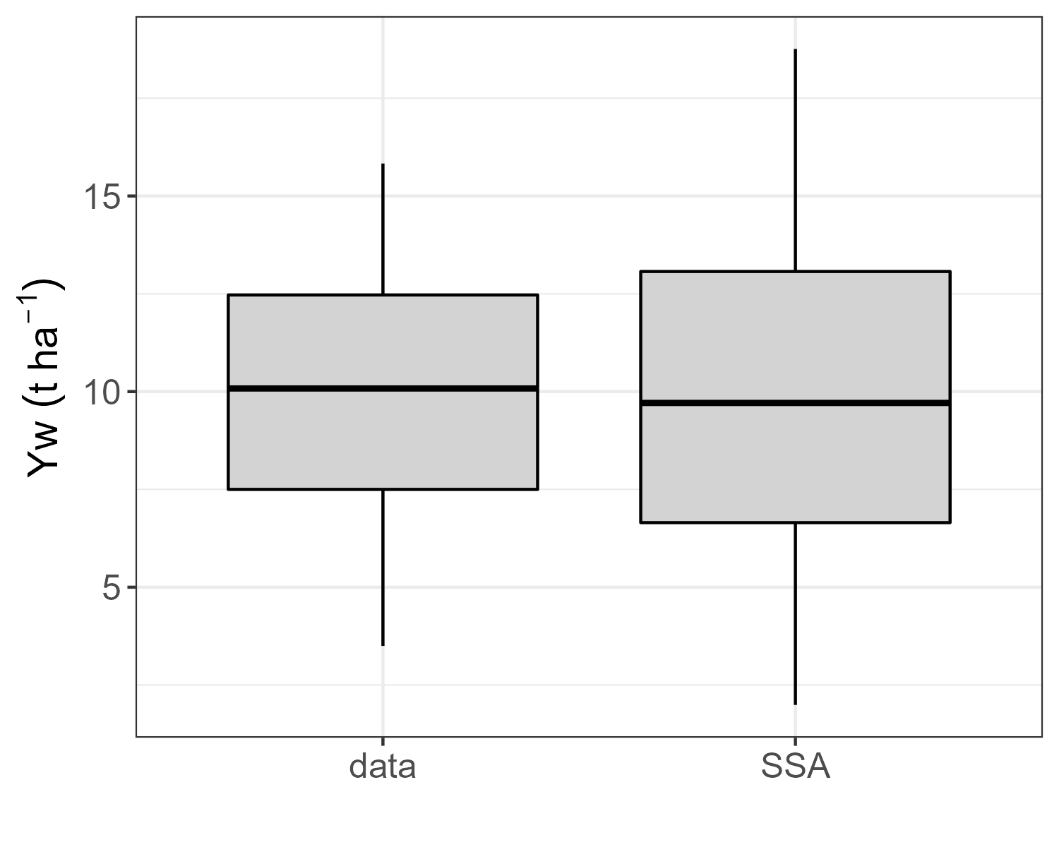
Fig. S2. Comparison of the distribution of maize water-limited yield potentials (Yw) of the 13,364 maize fields included in the field-level farmer database (“data”) vs. the Yw distribution across Sub-Saharan Africa (SSA) maize area. Yw data was retrieved from the Global Yield Gap Atlas (www.yieldgap.org).

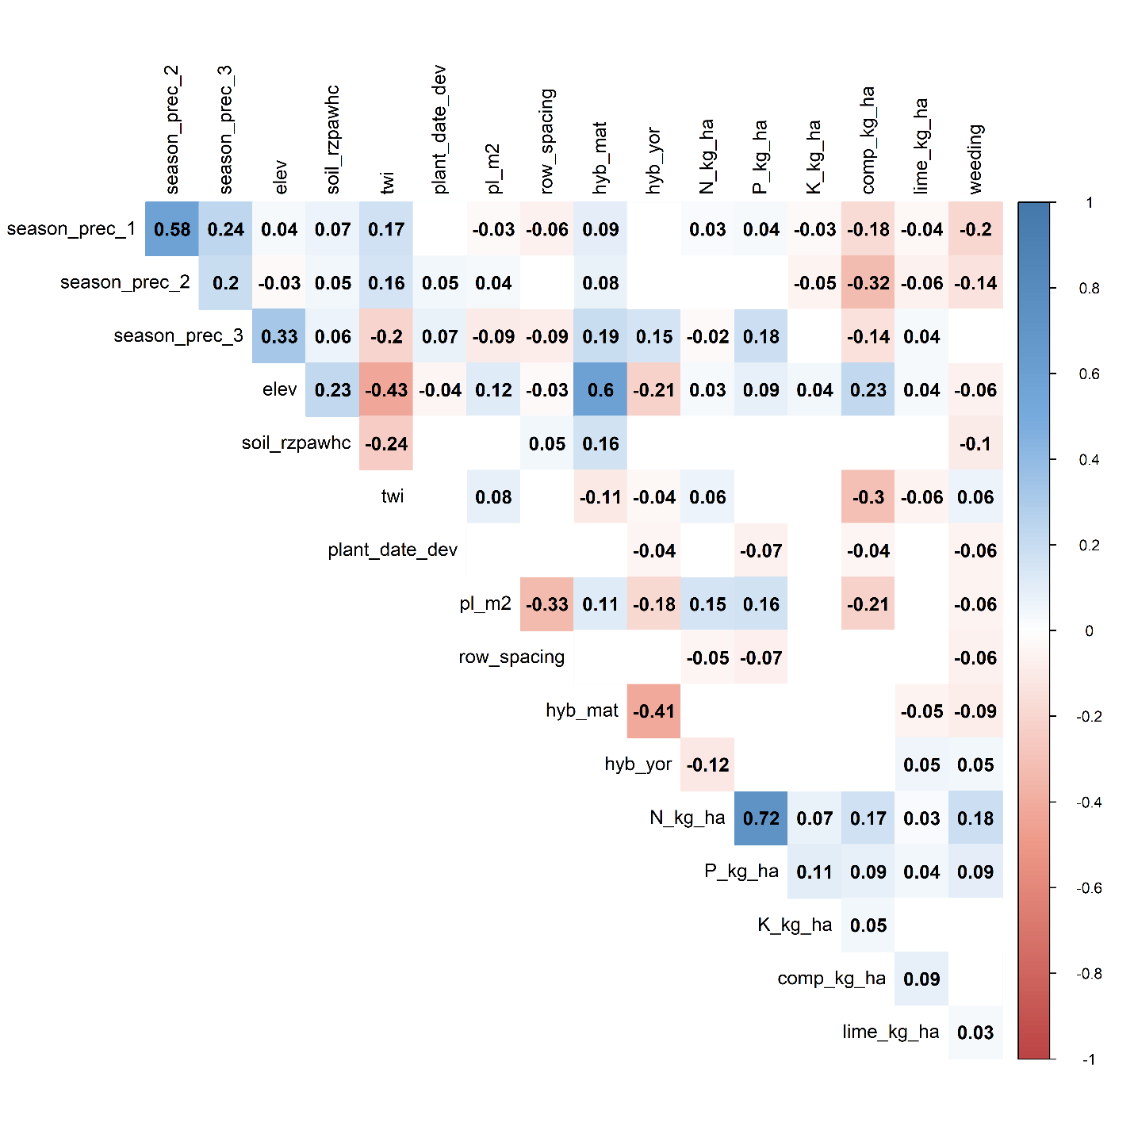
Fig. S3. Pearson’s correlation coefficients between all pairs of continuous predictor variables used for the conditional inference tree analysis. Empty squares indicate non-significant correlations (Pearson’s correlation test P-value >0.01). Variables descriptions are shown in Table S1 and Table S2.
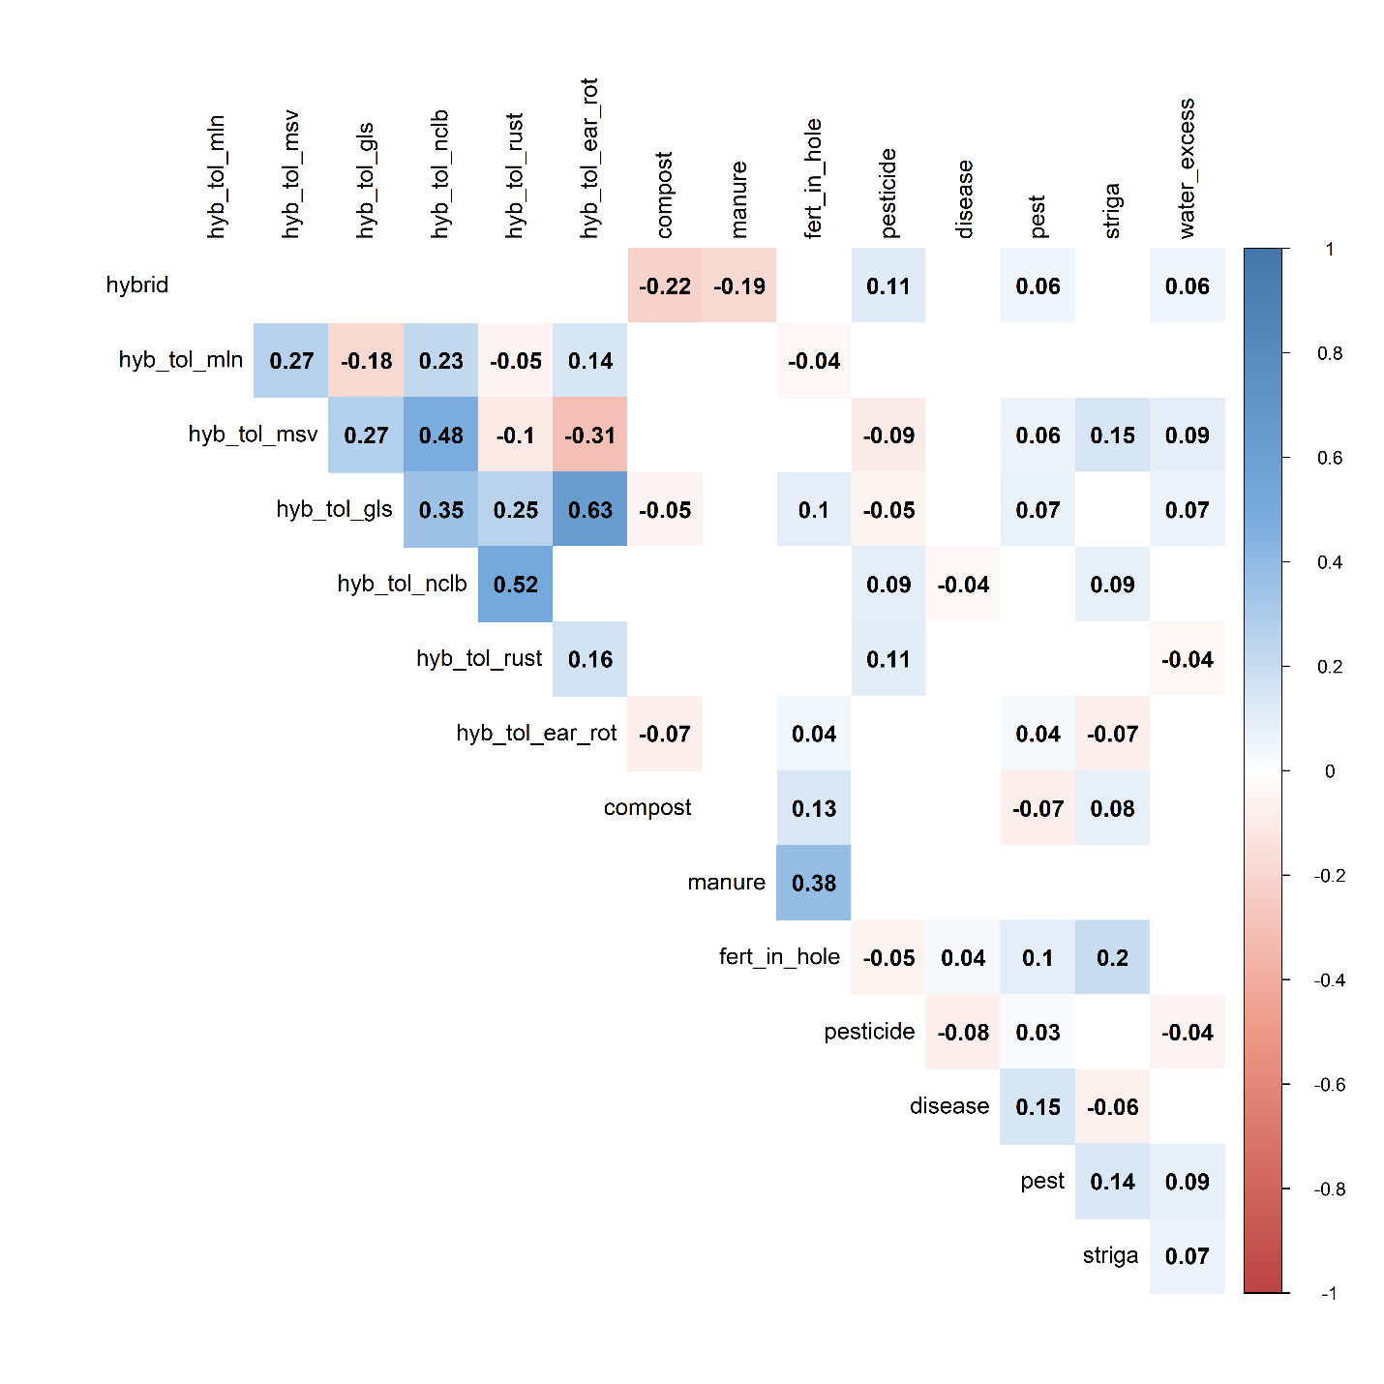
Fig. S4. Phi correlation coefficients between all pairs of binary predictor variables used for the conditional inference tree analysis. Empty squares indicate non-significant correlations (Chi-square test P-value >0.01). Variables descriptions are shown in Table S1 and Table S2.
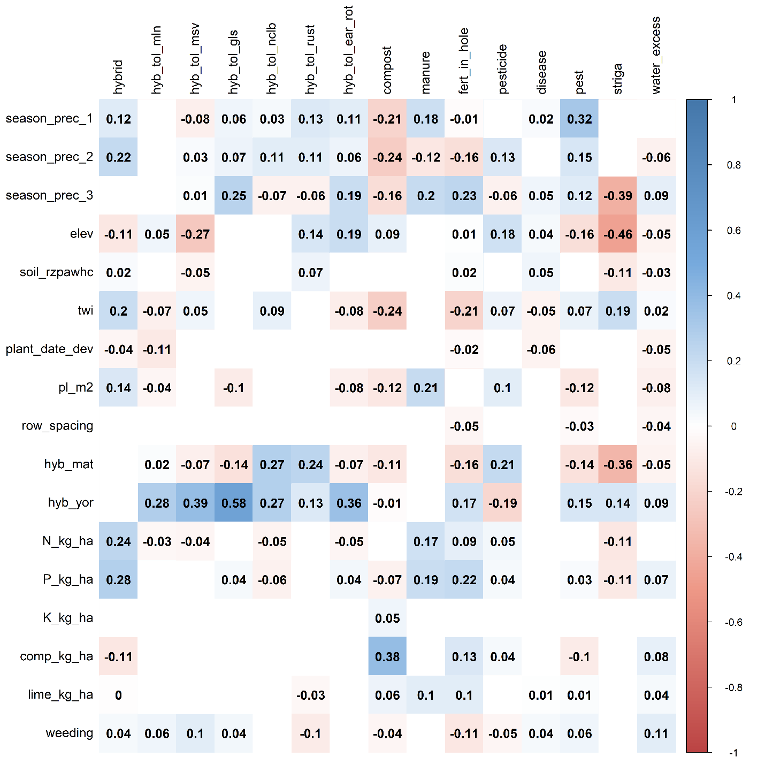
Fig. S5. Point-biserial correlation coefficients between all combinations of binary (columns) and continuous (rows) predictor variables used for the conditional inference tree analysis. Empty squares indicate non-significant correlations (Kruskal-Wallis’ test P-value >0.01). Variables descriptions are shown in Table S1 and Table S2.
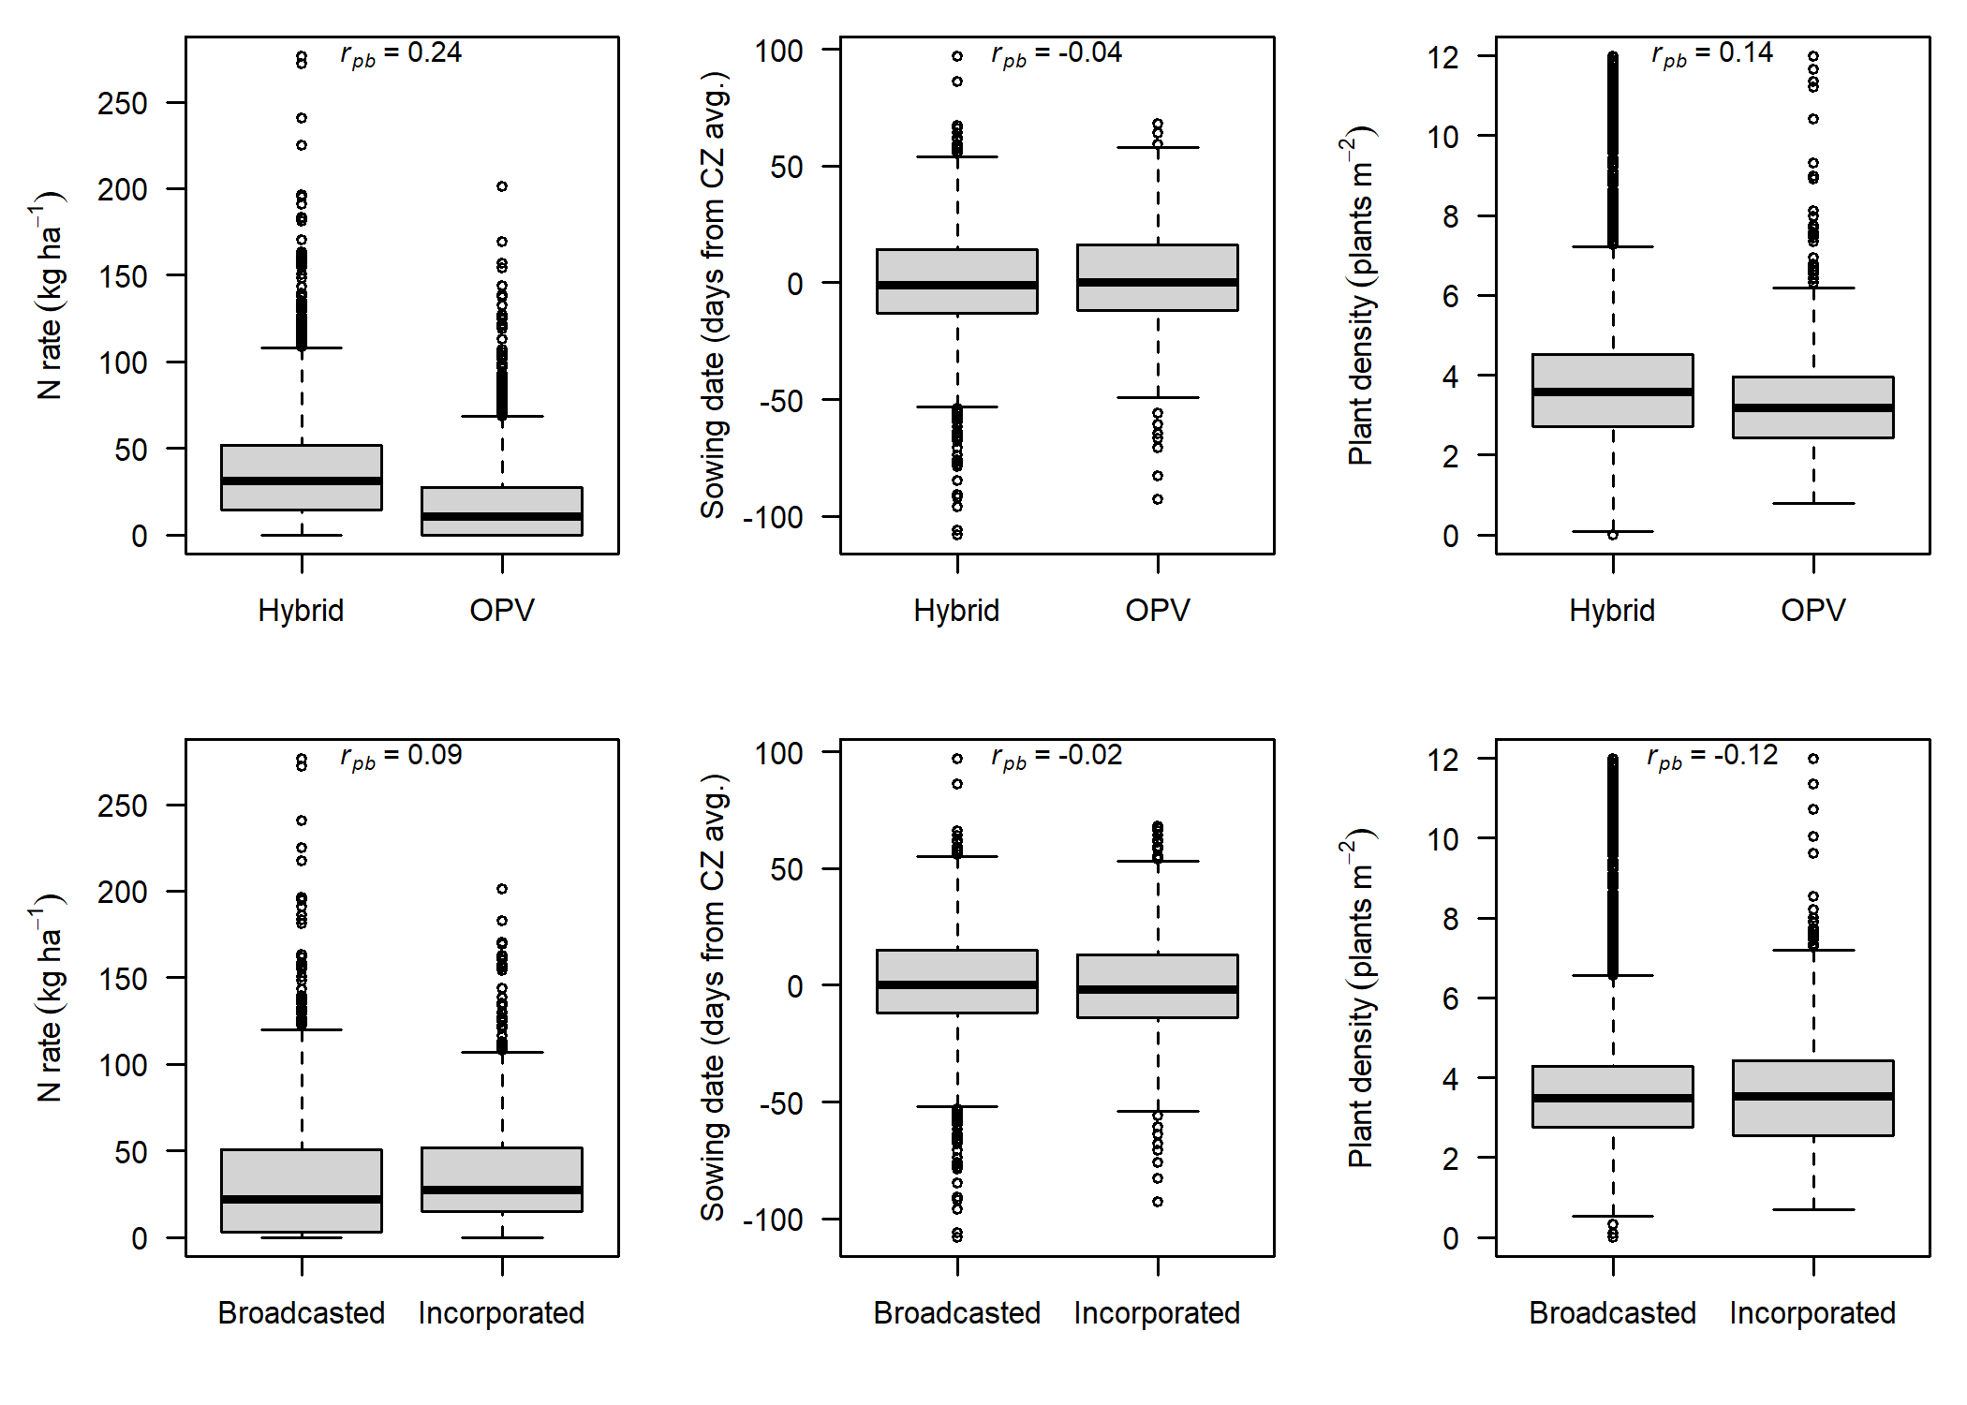
Fig. S6. Association between key binary management variables (hybrid seed use and fertilization application method) and key continuous management variables (N fertilization rate, sowing date deviation, and plant density). The point-biserial correlation coefficient (r_{pb}) for each pair of variables is shown.

Fig. S7 – S27. Conditional inference trees for each of the climate zones included in the analysis
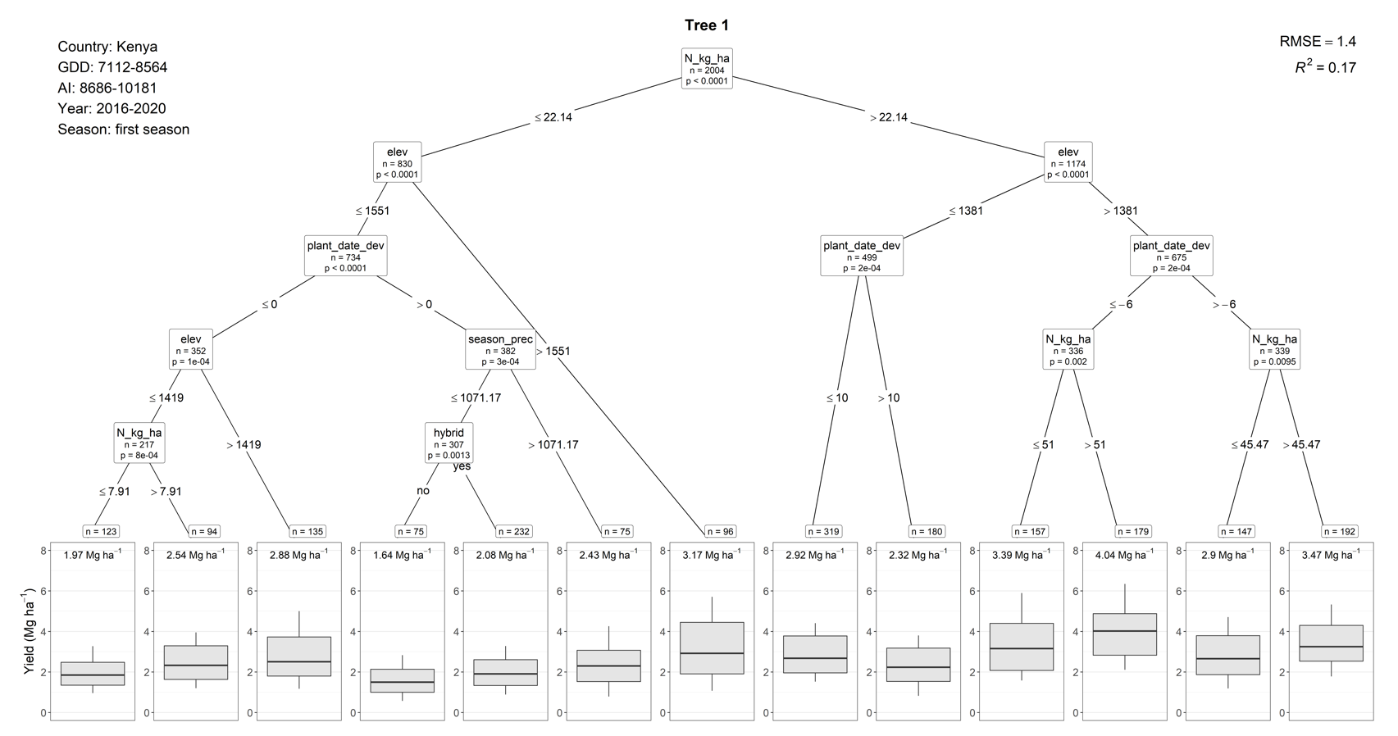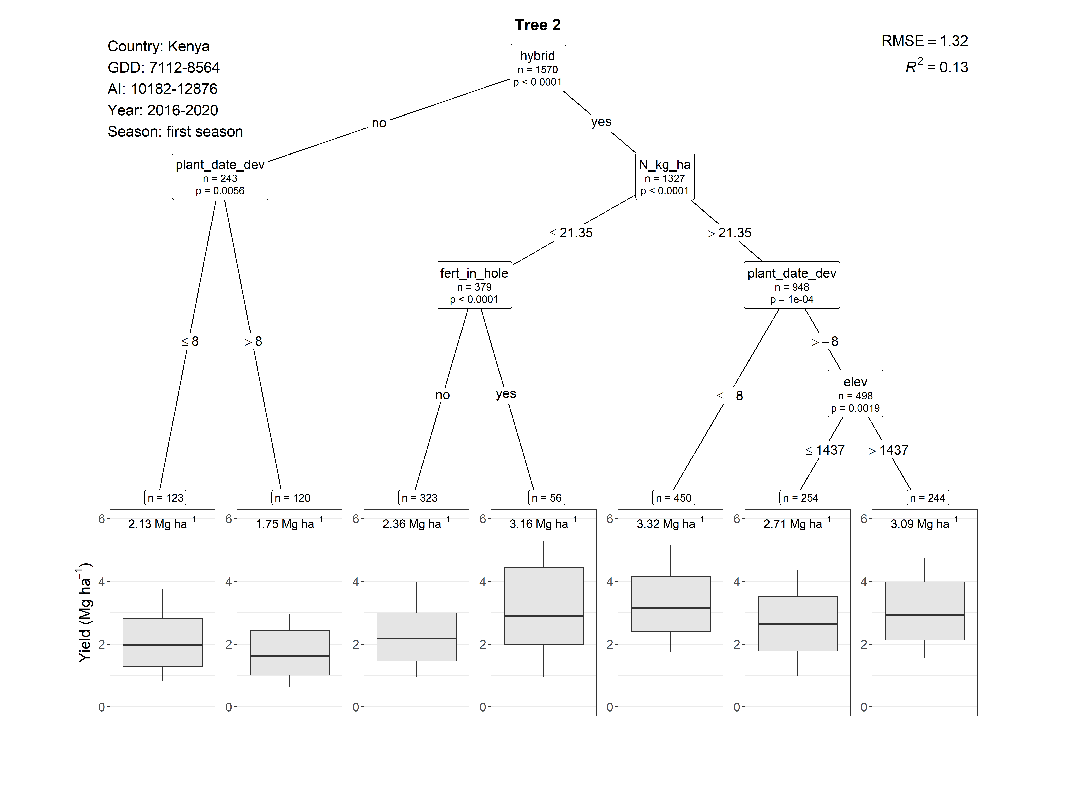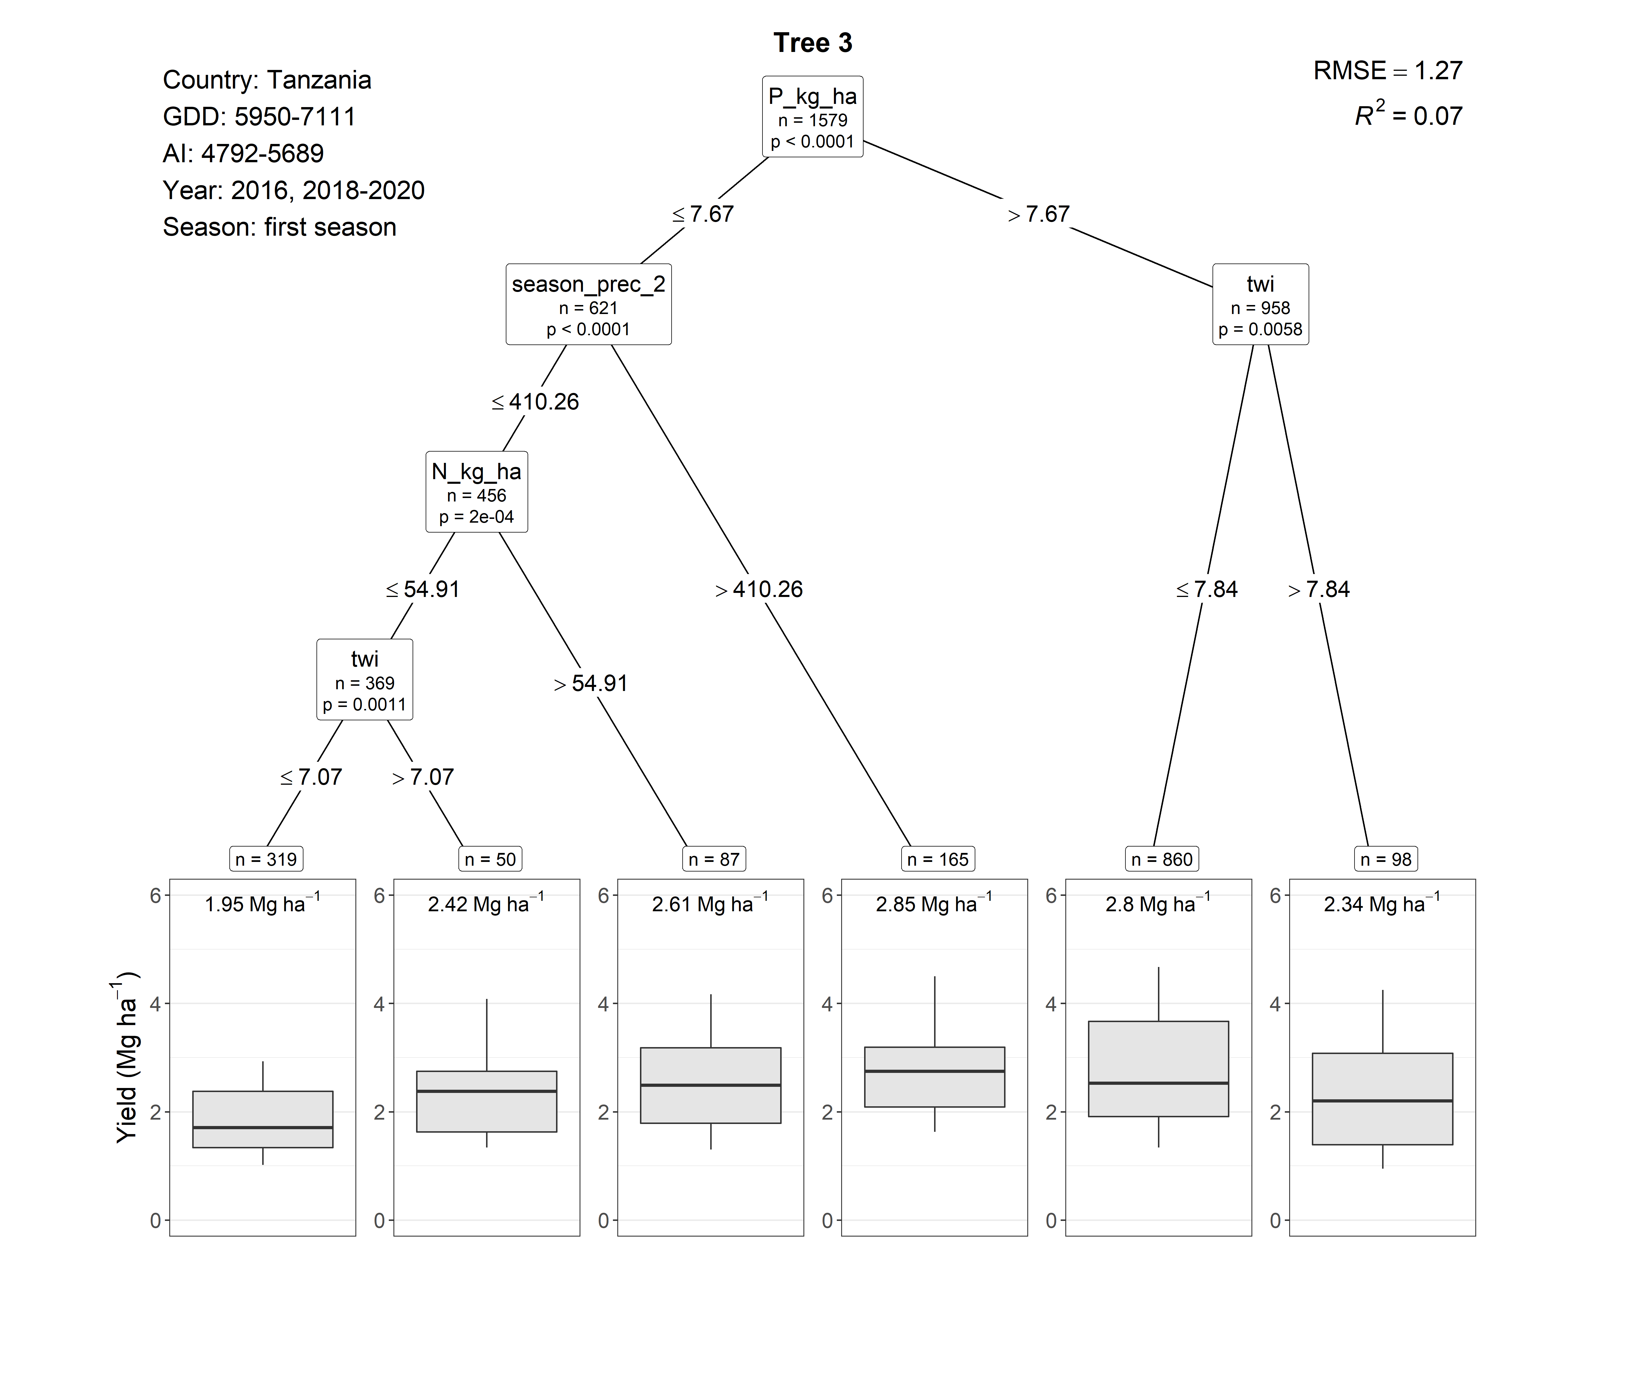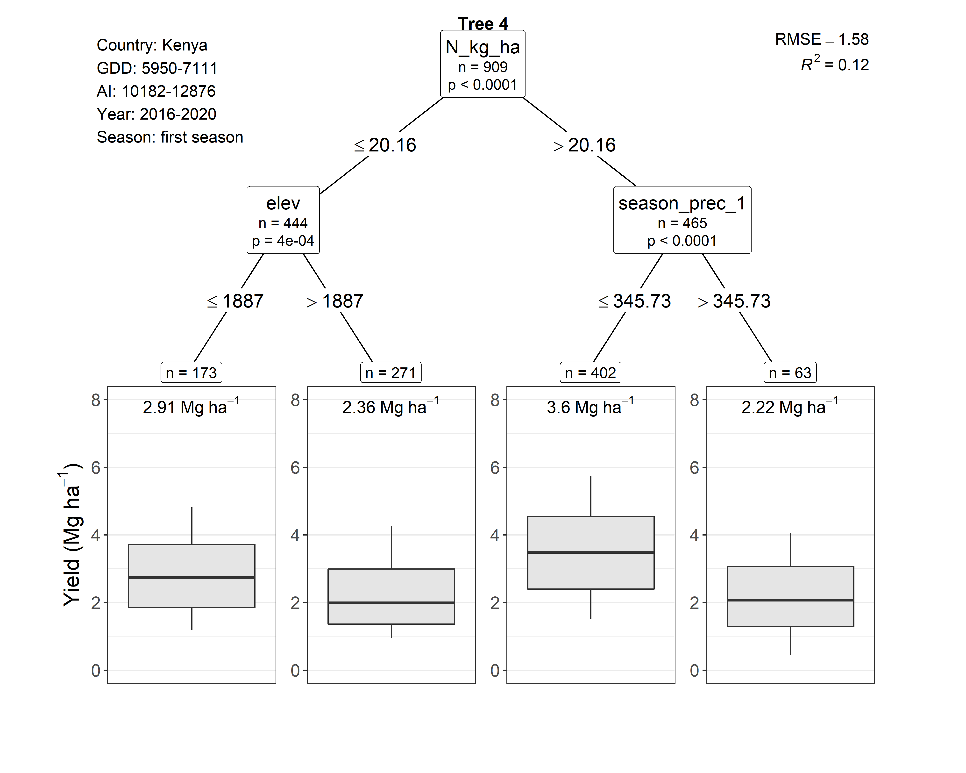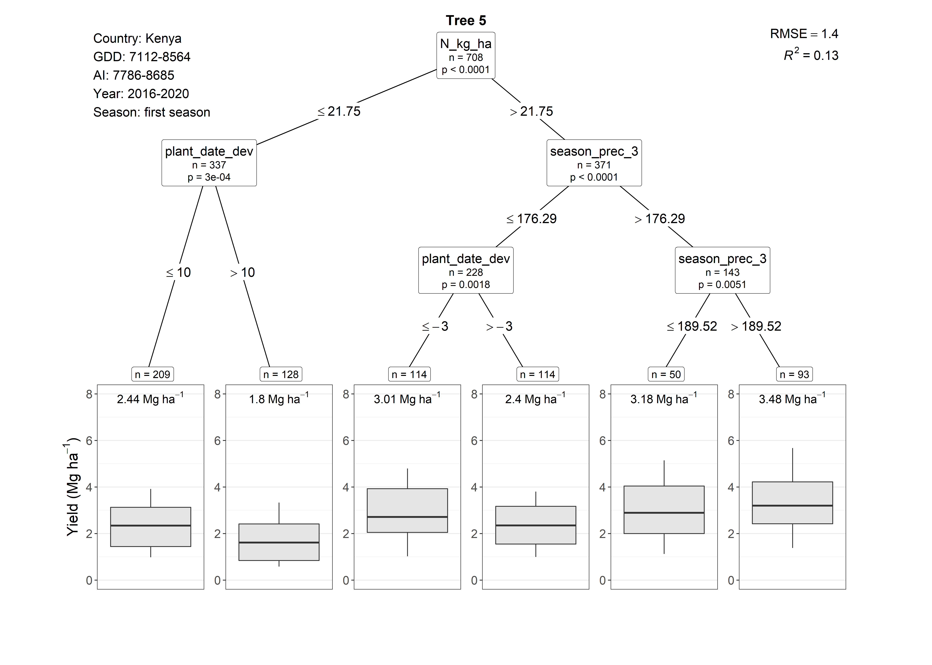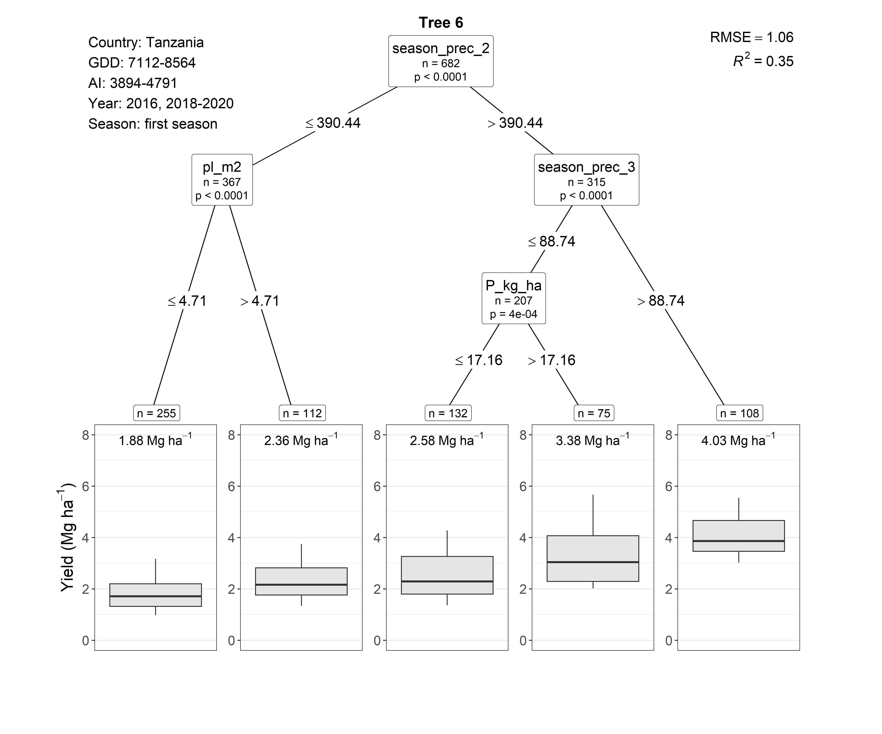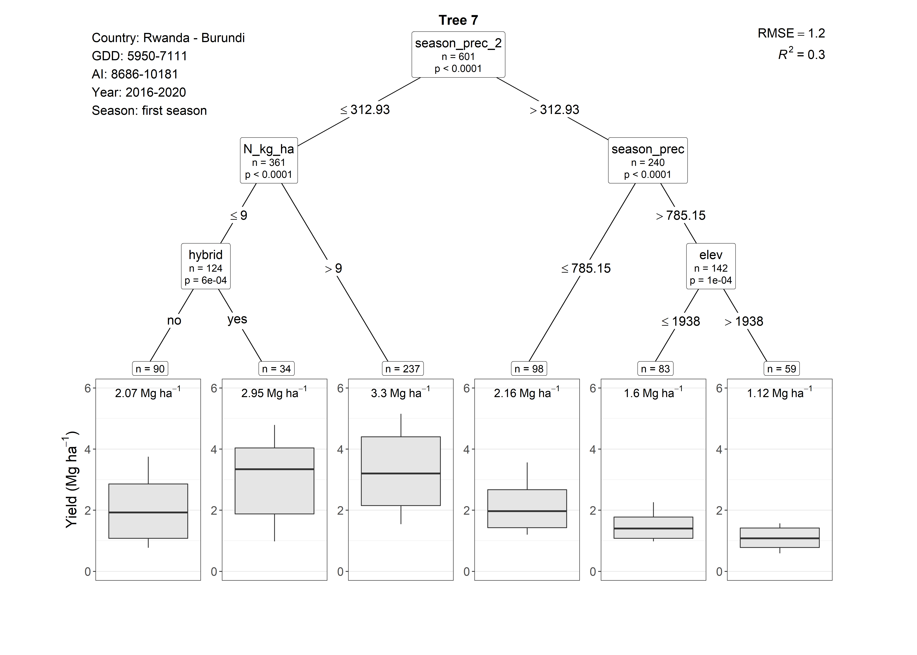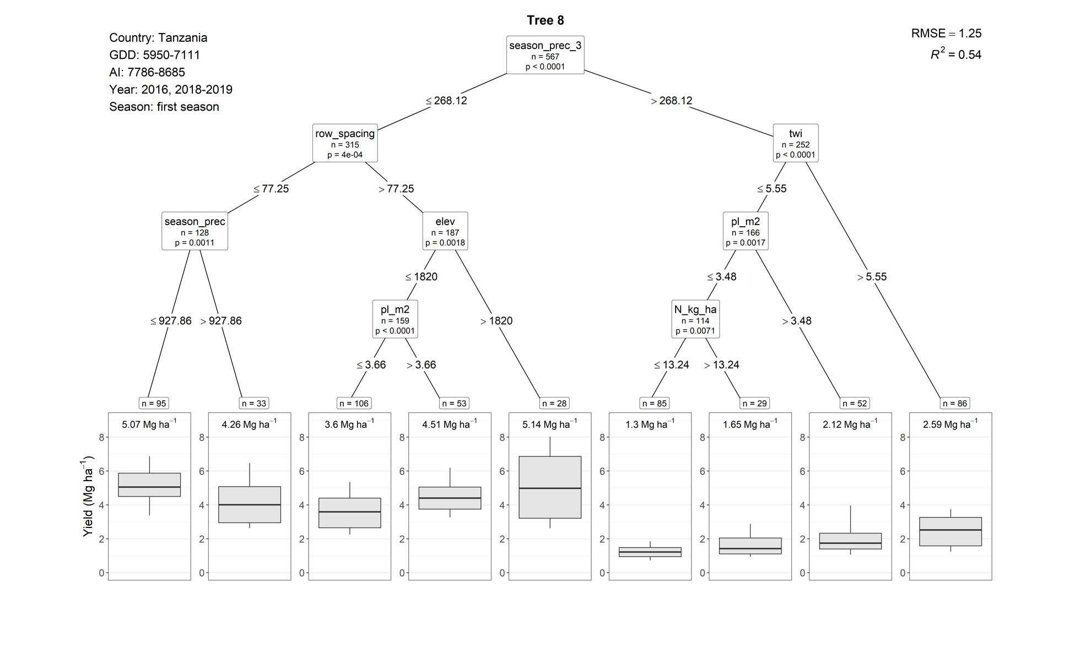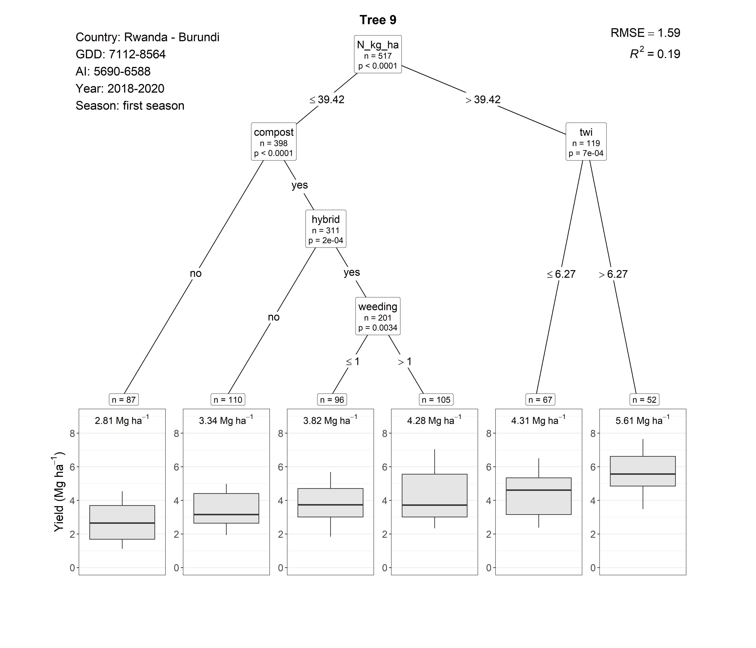
Tree 17. (The conditional inference tree analysis did not detect any management practices as having a significant effect on farmers maize yield in this region).
