NK-92 cells labeled with Fe₃O₄-PEG-CD56/Avastin@Ce6 nanoprobes for the targeted treatment and noninvasive therapeutic evaluation of breast cancer

supplementary materials

Sup 1
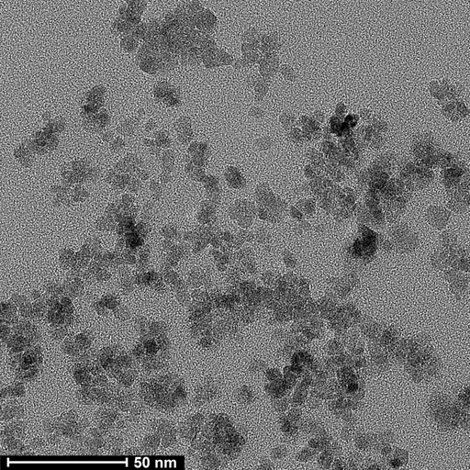
A B

Fig. S1. Characterization of the Fe₃O₄-PEG-CD56/Avastin@Ce6 NPs after two weeks. (A) TEM image of the synthesized Fe3O4-PEG-CD56/Avastin@Ce6 NPs. (B) Size distribution of the Fe₃O₄-PEG-CD56/Avastin@Ce6 NPs determined from the TEM images.

Sup 2

Fig. S2. TGA analysis of the Fe₃O₄ NPs.

Sup 3

Fig. S3. Viability of NK-92 cells after incubation with various concentrations of Fe₃O₄-PEG-CD56/Avastin@Ce6 NPs.

Sup 4

Fig. S4. Viability of NK-92 cells after incubation with various concentrations of Fe₃O₄-PEG-CD56/Avastin@Ce6 NPs.

