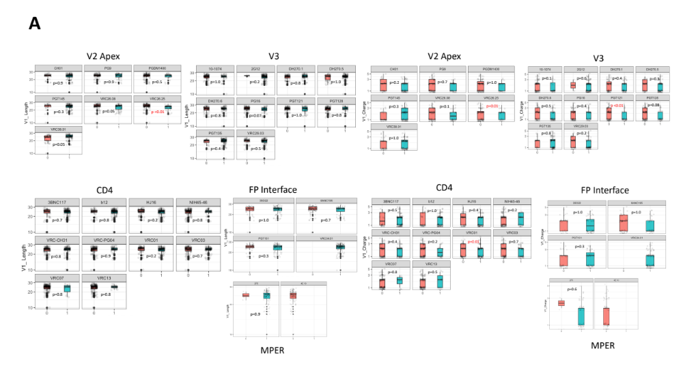
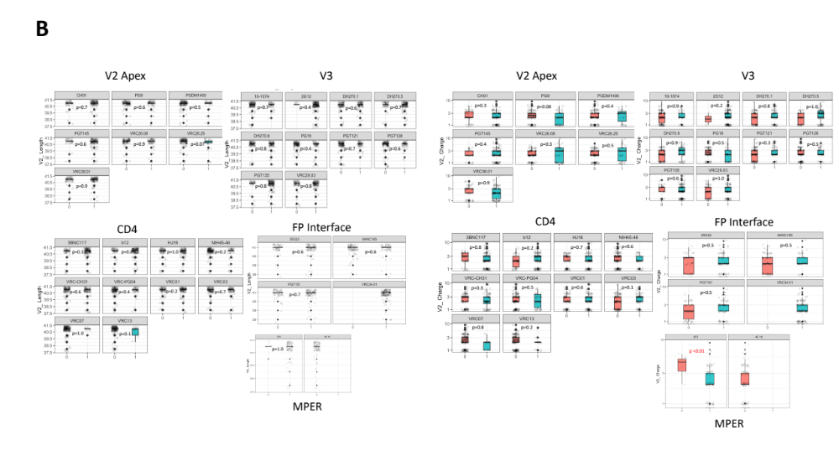
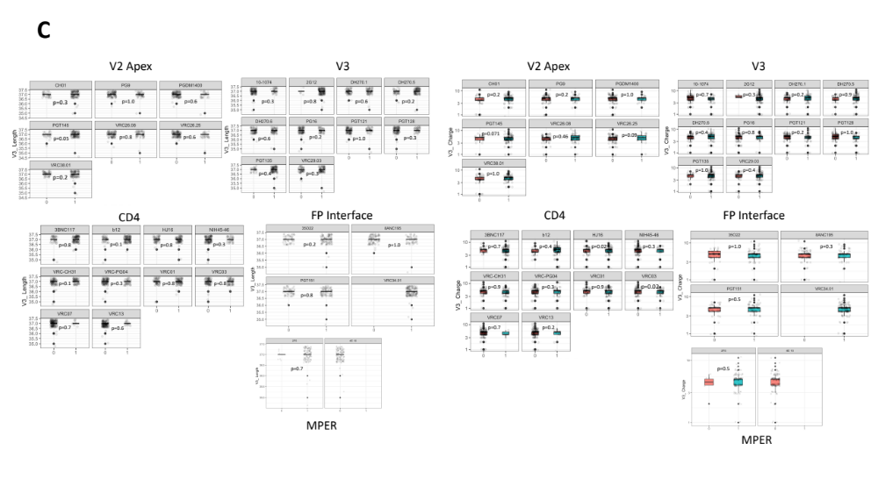
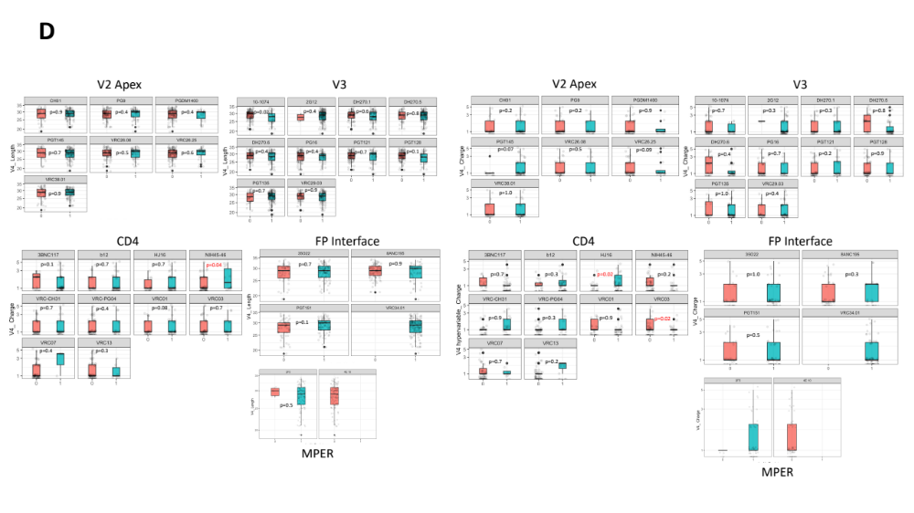

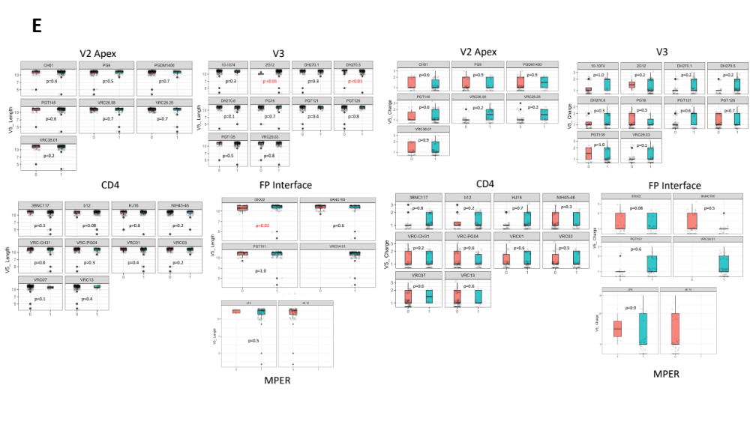
Figure S1: gp120 variable regions (V1-V5) loop lengths and net charge by predicted bnAb resistance
Boxplots showing HIV-1C env characteristics; V1 to V5 loop lengths and net charge (A-E) in the y axis against predicted bnAb resistance (1/pink) or susceptibility (0/blue) for all 33 bnAbs of interest. bnAbs are grouped by binding site. P values indicated were generated by Wilcoxon Ranksum Test to compare characteristics by predicted resistance, p values less that 0.05 were considered significant and highlighted in red.

