Supplementary Material

Notopterol Protects against Heart Failure Post-myocardial Infarction via GSK3β-dependent Pathway
Qing Shan, Chen-mei Yang, Li-jia Wen
* Correspondence: Jin-Min Guo: gjm90h@126.com

Supplementary Tables and Figures
Table S1. Effect of notopterygiol (NOT) pretreatment (0.5h-pMI and 12h-pMI) on weight of heart, liver, lung and kidney in mice suffered from myocardial infarction.
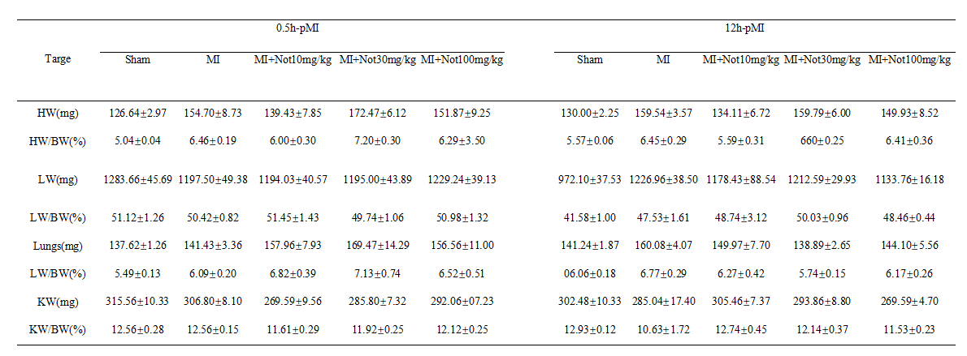
HW, Heart weight; LW, Liver weight; LW, Lung weight, liver; BW, Body weight; KW, Kidney weight.

Table S2. Effect of NOT pretreatment (0.5h-pMI and 12h-pMI) on liver and kidney function in mice with myocardial infarction.
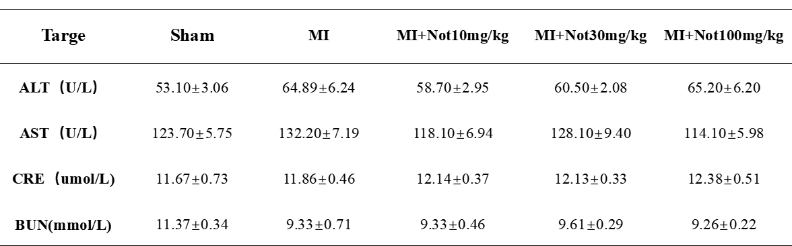
ALT, alanine aminotransferase; AST, aspartate aminotransferase; CRE, creatinine; BUN, urea nitrogen.

Table S3. Effect of NOT treatment on body weight in HF mice.
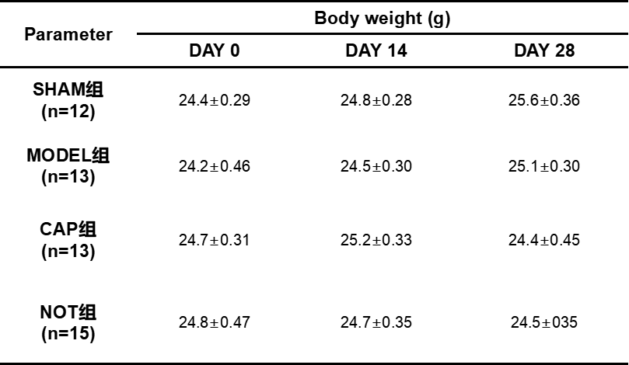
CAP, captopril; NOT, notopterol.

Table S4. Effect of notopterol on the heart, liver, lung and kidney in HF mice.
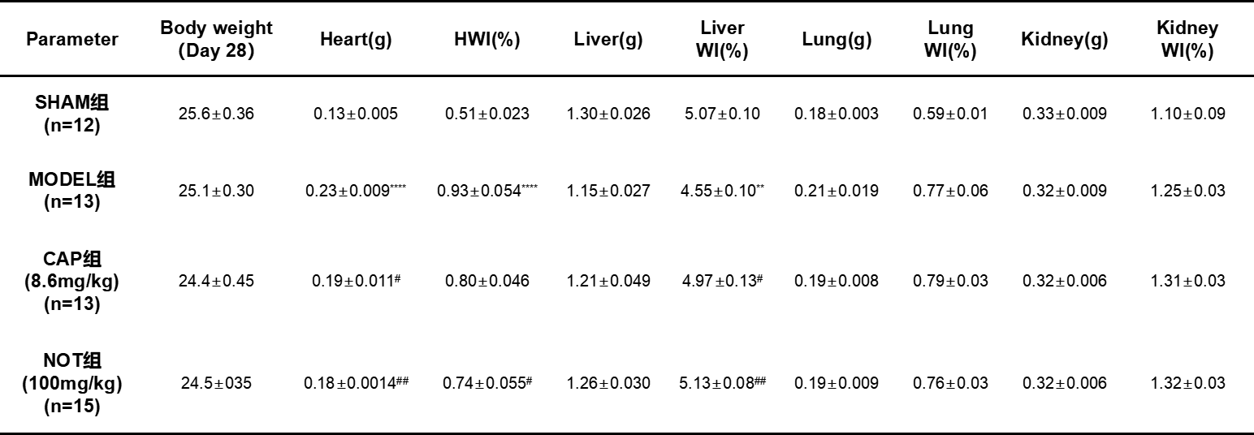
Data represent the mean±SEM. versus sham, *P < 0.05, **P < 0.01; versus MODEL, #P < 0.05, ##P < 0.01. n=12, 13, 13, 15 in sham, model, captopril (CAP) and notopterol (NOT), respectively.

Figure S1. Effect of NOT treatment on GSK3β in mice suffered from LAD.
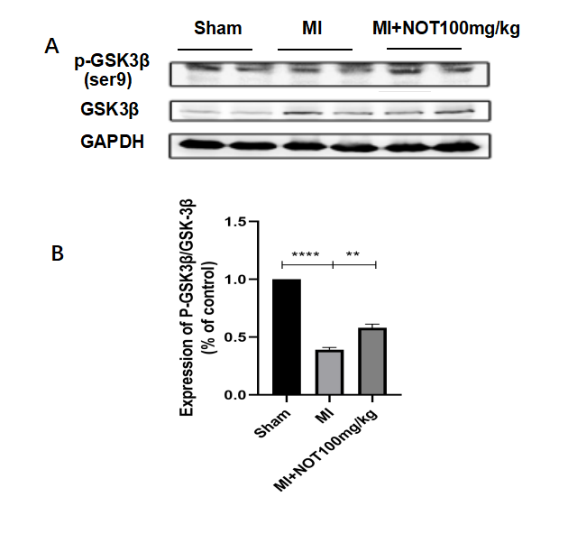
Representative images and quantitative analysis of p-GSK3β, GSK3β and GAPDH in the heart of MI mice. Data represent the mean ± SEM. *P < 0.05, **P < 0.01, ns. no significance. n = 3.

