Flexible and customizable three-dimensional woven fabrics using dielectric-magnetic coupled polyamide-66 composite fibers for efficient and controllable electromagnetic wave absorption

Shuang Gao ¹, Xiuyan Deng ¹, Xiaoming Qi ², Hongbo Dai ¹, Shaoyun Fu ³,
Yaqin Fu ¹ *

¹ Key Laboratory of Advanced Textile Materials and Manufacturing Technology Ministry of Education, Zhejiang Sci-Tech University, Hangzhou 310018, P.R. China
² Zhejiang Provincial Innovation Center of Advanced Textile Technology, Shaoxing, Zhejiang, 312030, P. R. China
³ College of Aerospace Engineering and State Key Laboratory of Power Transmission Equipment and System Security and New Technology, Chongqing University, Chongqing, 400044, P.R. China

*Corresponding author
Yaqin Fu (Email: fyq01@zstu.edu.cn)

Section S1: Design Parameters and Weaving Process of 3D Fabric Absorbers
1.1 Design parameters of 3D fabric absorbers
The experiment uses the 3D orthogonal fabric as its weaving structure. A 4-layer structure makes up the 3D orthogonal fabric. R_{j} and R_{w} represent the number of warp and weft yarns that make up a tissue cycle, respectively. The fabric has R_{j} = 5, R_{w} = 8 according to the formula R_{j} = (n-1) + 2, R_{w} = 2n (n is the number of fabric layers).
1.2 Weaving process
The looming draft is entered into the loom and the weft density is established, and the weaving process of the 3D fabric absorbers was completed through the following processes:
Step 1: Drawing in
To create a fabric with a 20 cm width, the four hundred 2-m long warp yarns are arranged in parallel on the warp beam under a certain tension. Over the whole warp beam, the tension should be as consistent as feasible. The warp yarns are distributed on the warp beam in a uniform density.
Step 2: Weft insertion
Weft insertion refers to the process of introducing weft yarn from one side of the loom into the open warp layer. The shuttle serves as the weft carrier as the weft yarn is steered through the open warp layer to interlace with the warp yarn to create the fabric.
Step 3: Beating-up
During the beating-up procedure, the reed is used to push the weft yarn to the fell where it is woven with the warp yarn to create the fabric.
Step 4: Finished weaving
The machine is returned to its pre-warping state after weaving is finished, and the power is shut off. Cut the fabric.
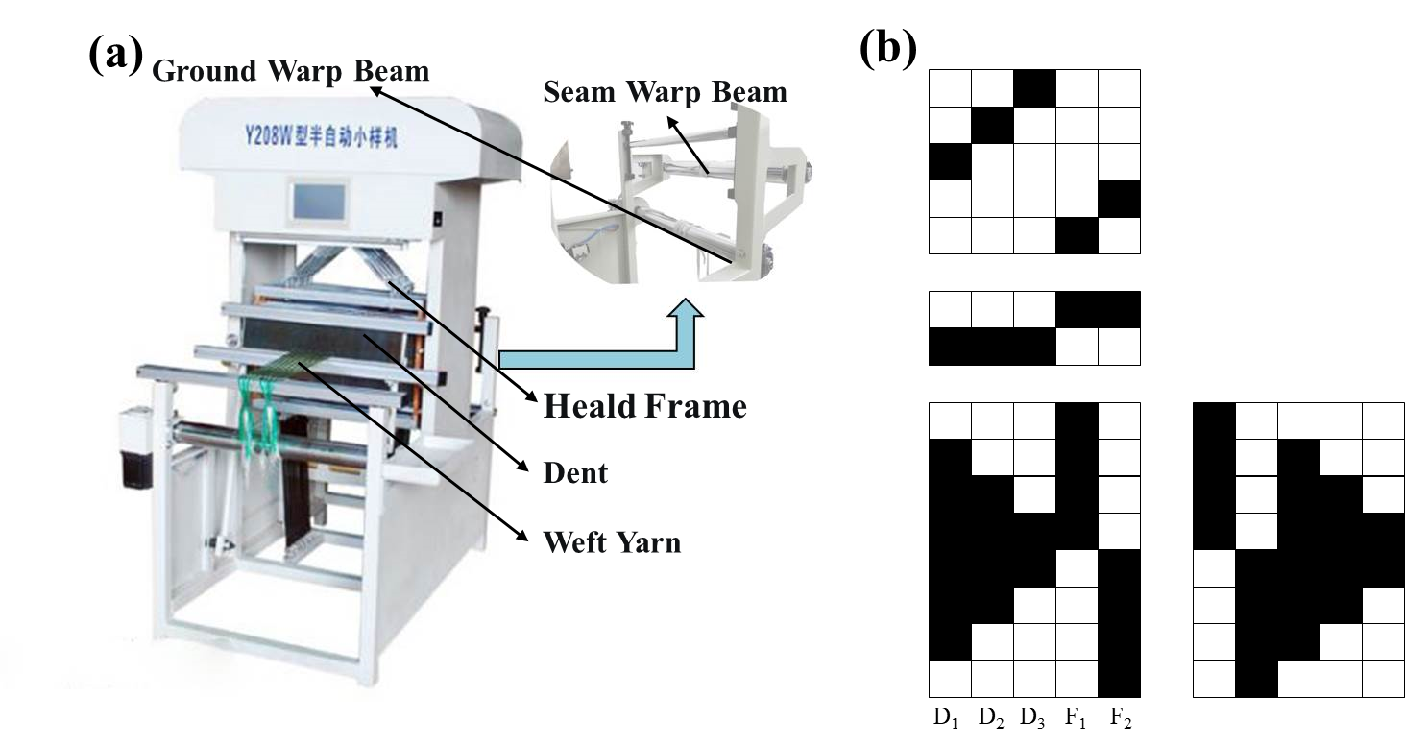
Fig. S1: Photographs showing (a) the modified loom machine and (b) the applied looming draft.
Section S2: Supplementary Data of Microwave Absorption Properties for the 3D Fabric Absorbers

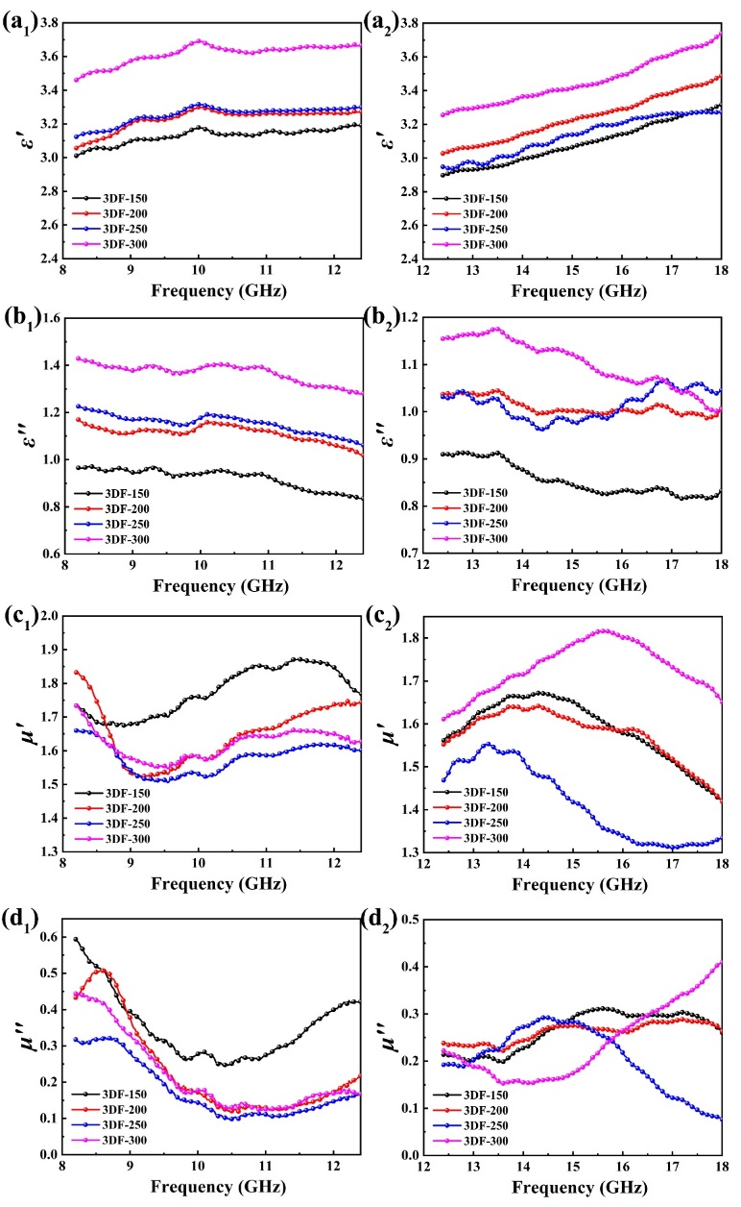
Fig. S2 Electromagnetic parameter curves of the proposed 3D fabric absorbers with four different weft densities during (a₁-d₁) X-band and (a₂-d₂) Ku-band.
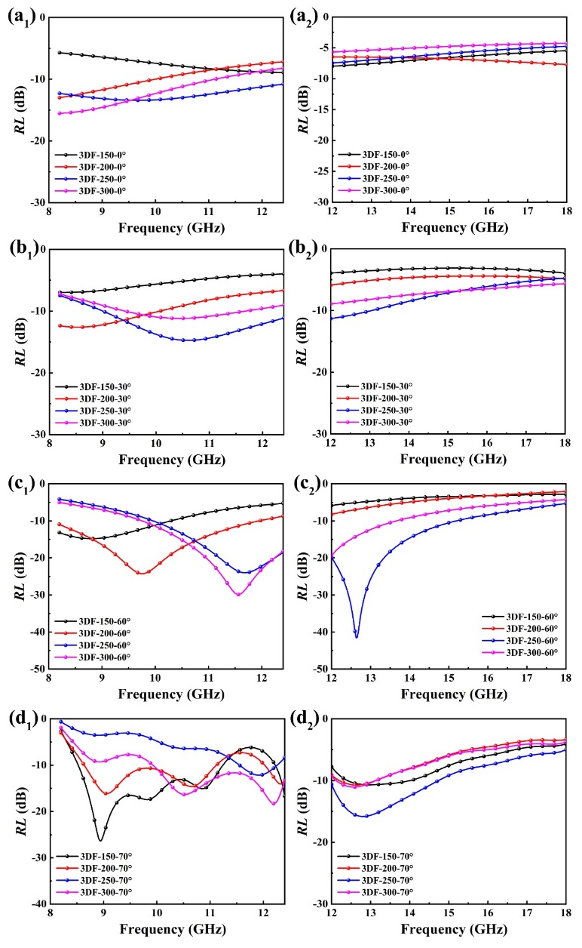
Fig. S3 RL curves of the folded 3D fabric absorbers with four different weft densities during (a₁-d₁) X-band and (a₂-d₂) Ku-band when the test angle at (a₁-a₂) 0°, (b₁-b₂) 30°, (c₁-c₂) 60°, (d₁-d₂) 70°.

