The Ethanol-Producing Enterocloster bolteae, Limosilactobacillus fermentum, Are Enriched in Non-alcoholic Steatohepatitis.
Babacar MBAYE¹, Reham MAGDY WASFY ¹, Patrick BORENTAIN², Maryam TIDJANI ALOU¹, Giovanna MOTTOLA^{3,4}, Vincent BOSSI⁵, Aurelia CAPUTO¹, Didier RAOULT¹, Rene GEROLAMI^{1,2}, Matthieu MILLION^{1*}
¹ Aix-Marseille Université, IRD, APHM, MEPHI, IHU Méditerranée Infection, Marseille, France
²Assistance Publique-Hôpitaux de Marseille (AP-HM), Hôpital de la Timone, Unité d’hépatologie, Marseille, France
³Assistance Publique-Hôpitaux de Marseille (AP-HM), Hôpital de la Timone, Laboratoire de Biochimie, Marseille, France
⁴C2VN, INSERM 1263, INRAE 1260, Team 5, Aix-Marseille Université, 13005 Marseille, France
⁵IHU Méditerranée Infection, Marseille, France
*Corresponding author: Matthieu Million; Institut Hospitalo-Universtaire Méditerranée Infection, 19-21 Boulevard Jean Moulin, 13385, Marseille cedex 05, France ; email : matthieumillion@gmail.com
Supplementary figure 1: Alpha and beta diversity between groups

Supplementary figure 2: Frequency difference between groups in metagnomics for culturomics samples

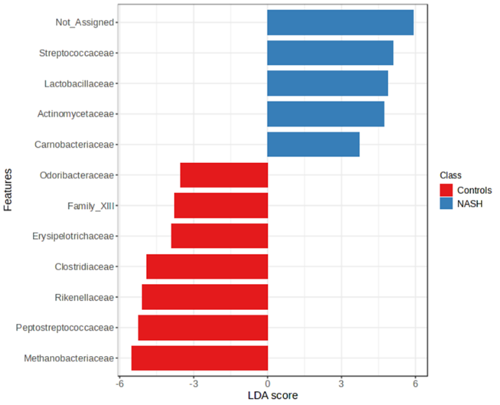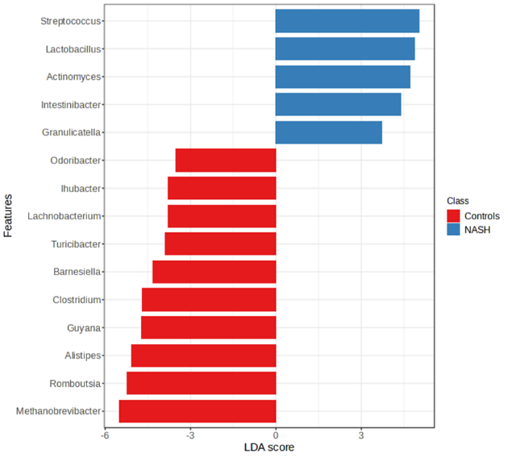
Supplementary figure 3: Linear discriminant analysis between 14 NASH and 10 Controls

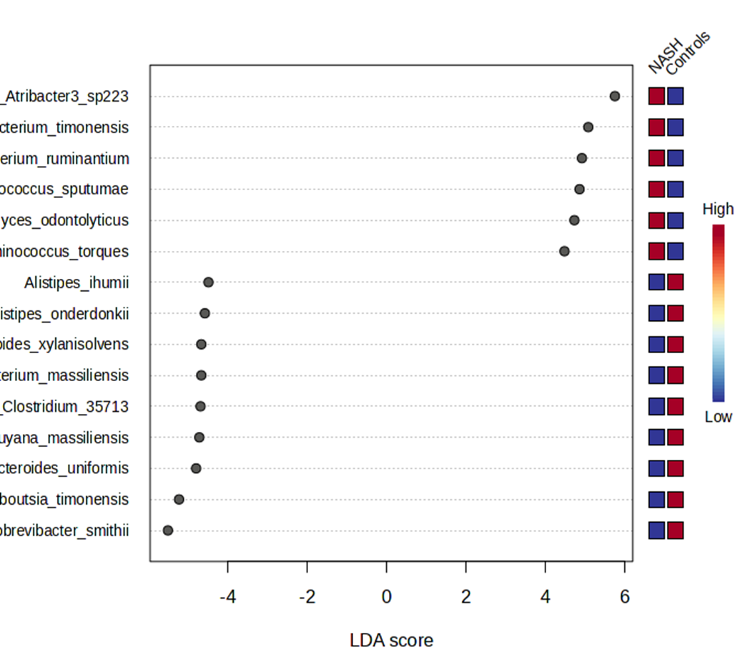
Supplementary figure 4: relative abundance at species level between 16 NASH and 10 Controls

Species enriched in NASH | Culturomics (N=24) | 16s Frequency difference (N=24) | 16s LDA (N=24) | 16S Frequency difference (N=65) | LDA (N=65)
Limosillactobacillus fermentum
Ruminococcus_torques
Streptococcus_australis^{OTU1}
Faecalibacterium_timonensis
Ruminococcus_gnavus
Thomasclavelia_ramosa
Bifidobacterium_adolescentis^{OTU2}
Enterocloster bolteae
Facklamia hominis
Holdemanella biformis
Streptococcus_salivarius^{0TU3}
Limosilactobacillus_panis^{OTU4}
Streptococcus_mutans
Supplementary table: æ Species enriched in NASH patients with different approaches used:
4

