Supplementary FIG1
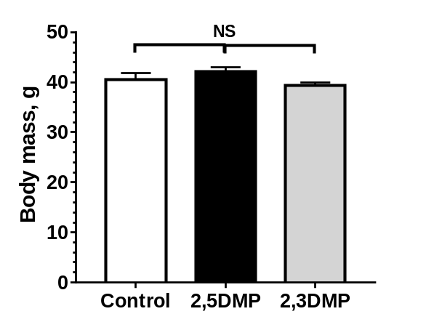

Supplementary Figure 1. Mean weight changes of body mass of male CD-1 mice after 30 days exposure to 2,5-DMP (black column), 2,3-DMP (gray column) or control H₂O (white column). (n = 7 Control, n = 9 2,5-DMP, n = 7 2,3-DMP). ANOVA with Dunnett’s multiple comparison post hoc test. Not significant (NS) = P > 0.05.

Supplementary FIG 2
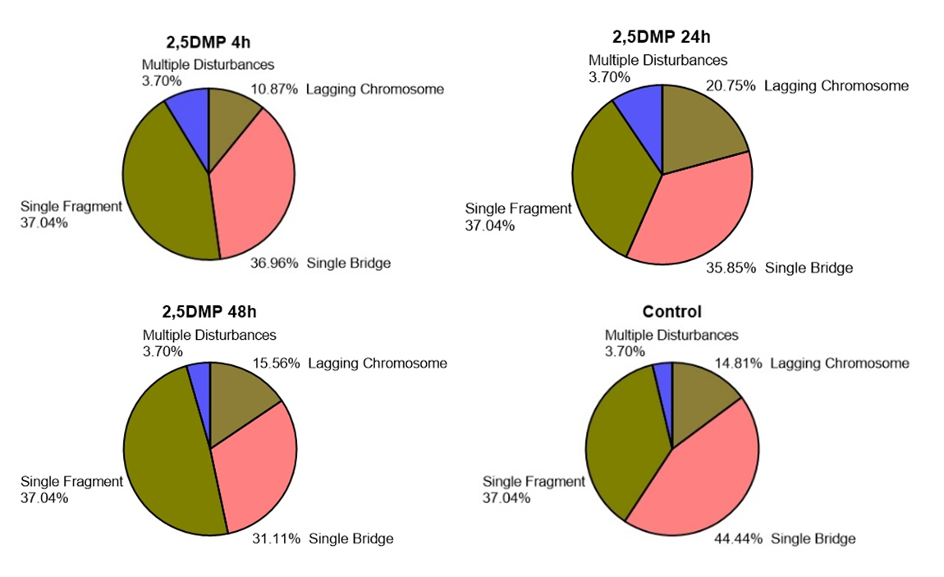
Supplementary Figure 2a. Frequency of different types of chromosome disturbances (lagging chromosome, single fragment, single bridge and multiple disturbances) in bone marrow cells of male mice after 4 h, 24 h, 48 h of 2,5-DMP or control H₂O exposure. (n= 6 per group). Chi-squared test, not significant difference between treatments.
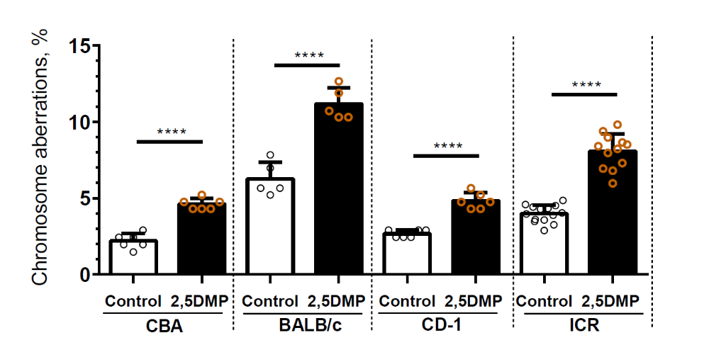
Supplementary Figure 2b. Percentage of bone marrow cells with chromosome aberrations after 24 h of 2,5-DMP exposure (or control H₂O exposure) in CBA, BALB/c, CD-1 and ICR mice. (n=6/6/5/5/6/6/14/12 respectively). Mean ± s.d. Student’s t test, **** P value <0,0001.

Supplementary FIG 3
MA plot Restraint stress
Log2 (Mean Expression)
Log2 (Fold Change)
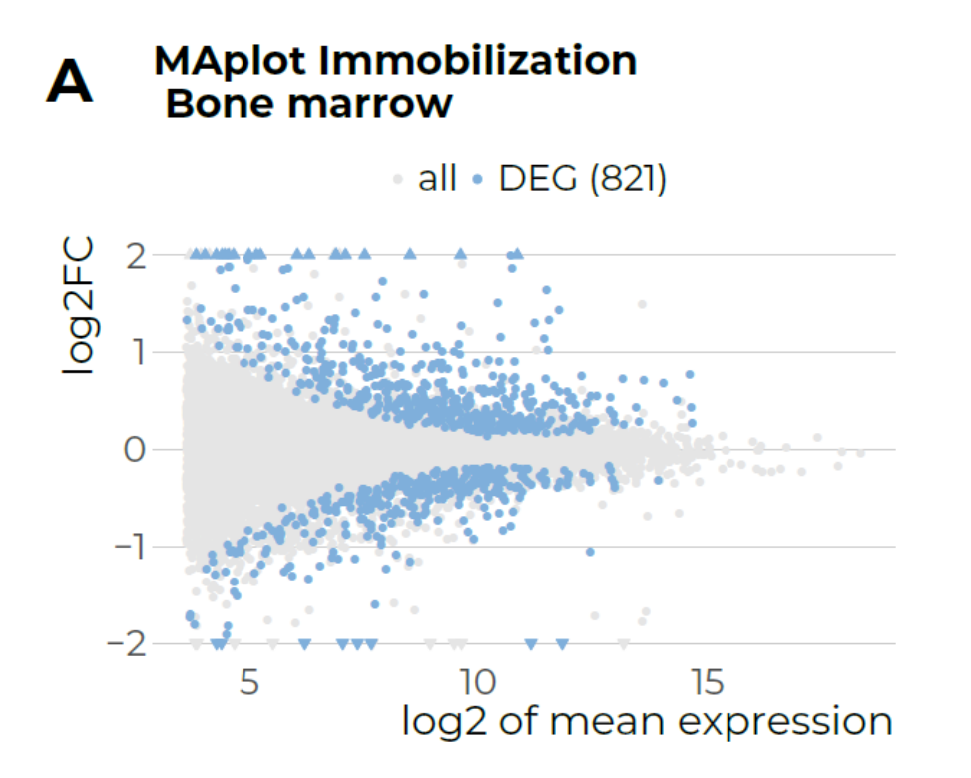

Supplementary Figure 3a. Minus average plot (MA-plot) of genes from bone marrow RNA-seq data of mice restrained for 2 h, compared to control. The binary logarithm of the mean of normalized counts across all bone marrow samples for each gene is plotted versus the binary logarithm of gene expression fold change. Blue points represent differentially expressed genes (DEG) (FDR < 0,05). Points which are fall out of the y-axis range are plotted as triangles.
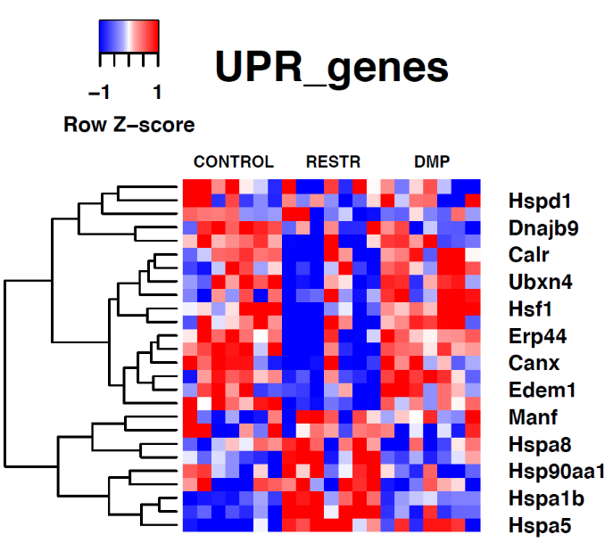
Supplementary Figure 3b. Heatmap displays the relative gene expression of bone marrow cells of mice subjected to restraint stress (Restr), 2,5-DMP (DMP) and H₂O (control), that overlap with “Response to unfolded protein” GO term.

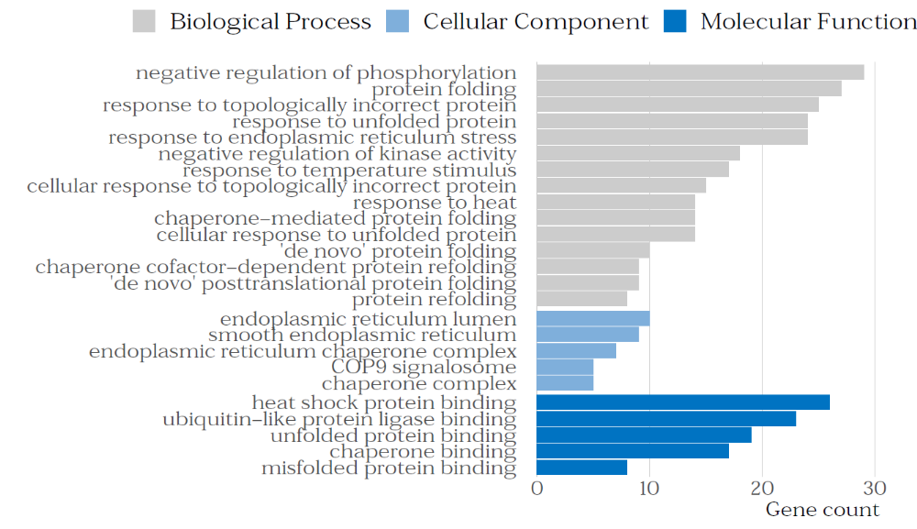
c
Supplementary Figure 3c. The top 25 Gene Ontology terms associated with biological process, cellular component, and molecular function of 482 cluster 1 (upregulated) DEGs after restraint stress.

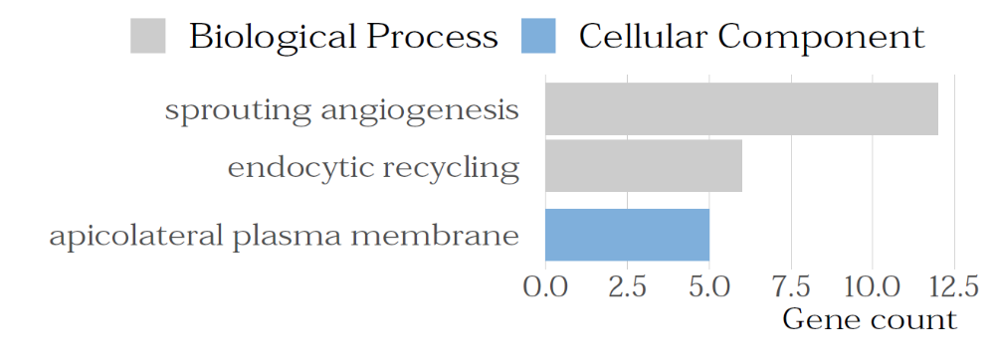
d
Supplementary Figure 3d. The top 3 Gene Ontology terms associated with biological process, cellular component, and molecular function 339 cluster 2 (downregulated) DEGs after restraint stress.

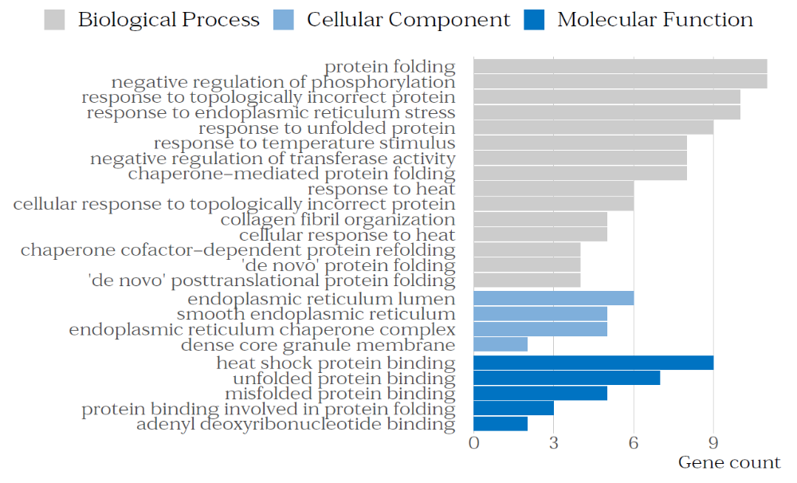
Supplementary Figure 3e. The top 24 Gene Ontology terms associated with biological process, cellular component, and molecular function of upregulated genes cluster of CORR genes (genes correlated between restraint stress and 2,5-DMP treatment).

