Supporting information:
Revealing the degradation pathways of layered Li-rich oxide cathodes
Zhimeng Liu^{1,12}, Yuqiang Zeng^{2,12}, Juanyang Tan^{3,12}, Hailong Wang^{1,4,12}, Yudong Zhu⁴, Xin Geng¹, Peter Guttmann⁵, Xu Hou⁶, Yang Yang^{7,8}, Yunkai Xu⁹, Peter Cloetens⁸, Yinping Wei³, Jun Lu⁹*, Jie Li^{6,10*}, Bilu Liu³, Martin Winter⁶, Robert Kostecki², Yuanjing Lin^{4*}, Xin He^{1,11*}
^{1,} School of Chemical Engineering, Sichuan University, Chengdu, 610065, China
^{2,} Energy Storage & Distributed Resources Division, Lawrence Berkeley National Laboratory, 1 Cyclotron Rd, Berkeley, 94720, United States
³, Shenzhen Geim Graphene Center, Tsinghua-Berkeley Shenzhen Institute and Institute of Materials Research, Shenzhen International Graduate School, Tsinghua University, Shenzhen
518055, China
^{4,} School of Microelectronics, Southern University of Science and Technology, Shenzhen 518055, China
^{5,} Helmholtz-Zentrum Berlin, Department X-ray Microscopy, Albert-Einstein-Str. 15, 12489 Berlin, Germany
^{6,} Helmholtz-Institute Muenster (HI MS), IEK-12, Forschungszentrum Juelich GmbH, and MEET Battery Research Center, University of Muenster, Corrensstr. 46, Muenster, 48149, Germany
^{7,} ESRF-The European Synchrotron Radiation Facility, Grenoble, 38043, France
^{8,} National Synchrotron Light Source II, Brookhaven National Laboratory, 98 Rochester Rd, Upton, 11733, United States
^{9,} College of Chemical and Biological Engineering, Zhejiang University, Hangzhou 310027, China
^{10,} Department of Energy, Politecnico di Milano, Via Lambruschini 4, Milano, 20156, Italy
^{11,} College of Electrical Engineering, Sichuan University, Chengdu, 610065, China
^{12,} These authors contributed equally: Zhimeng Liu, Yuqiang Zeng, Juanyang Tan, Hailong Wang
*e-mail: jie1.li@polimi.it; junzoelu@zju.edu.cn; linyj2020@sustech.edu.cn; xinhe@scu.edu.cn

Methods
Materials synthesis
Li_{1.2}Mn_{0.56}Ni_{0.16}Co_{0.08}O₂ (LRTMO) was prepared by a continuous stirring/co-precipitation method followed by a high-temperature annealing process. The mixed solution of Li₂CO₃ and NH₄OH was pumped into the mixed solution of dissolved NiSO₄·6H₂O, CoSO₄·7H₂O, and MnSO₄·4H₂O (2:1:7 in molar) in a tank reactor (CSTR) at 25 °C. The precipitate was washed several times with distilled water and dried in a vacuum oven at 100 ºC for over 12 h, Then, stoichiometric amounts of (Ni_{0.2}Co_{0.1}Mn_{0.7})CO₃ precipitate and Li₂CO₃ were thoroughly mixed to form the precursor powder. At first heated at 500 ºC for 5h and then annealed at 850 ºC in the air for 15h, LRTMO was obtained after naturally cooled to room temperature.
Electrode preparation and electrochemical measurements.
Electrodes were prepared by casting a slurry with the composition of 80 wt% LRTMO active material, 10 wt% Super C65 and 10 wt% PVdF on aluminum foil. The slurry used to prepare electrode samples were prepared by magnetic stirring process. The electrodes were tested with two-electrodes T-cells which assembled by LRTMO electrode against pre-activated Li foil. 60µl 1M LiPF₆ in 1:1(wt %) ethylene carbonate (EC): dimethyl carbonate (DMC) was added as electrolyte. The Li foil was first electro-deposited in a symmetric cell at 0.2 mA cm⁻² for 5 hours to lower the influence of solid electrolyte interphase (SEI)³⁹ formation on the Li. The cells were suspended and disassembled at representative SOCs. After washed twice with DMC solvent, the electrodes were dried at 60°C under vacuum and then kept at Ar atmosphere for further measurements.
Materials characterization.
Nano-resolution X-Ray Spectro-microscopy
Soft X-ray spectro-microscopic were conducted for the scanning of LRTMO particles at different electrochemical states on the undulator beamline U41-XM at the electron storage ring BESSY II (Helmholtz-Zentrum Berlin für Materialien und Energie, Germany). The samples were selected from particles which located on the top surface of electrode, and then loaded on a TEM grid enabling rotation with an angular increment step size of 1° at a pixel size of 9.8 nm (25 nm zone plate objective) for soft X-ray nano-tomography. All the samples were measured at specific photon energies (shown in Table.S1) to resolve the elemental distribution, whereas the projection images of selected samples were started at a tilt angle of 0°. The irradiation dose was set to prevent structural information loss due to irreversible radiation damage.
Reconstruction and segmentation
In order to correct all the projection images under different beam current and exposure times through the tilting angles, the projection images for each sample were first pre-processed by flat-field correction and then normalized. The measured absorption at each pixel and X-ray photon energies of each element were converted for computing quantitative 3D chemical composition with voxel size of 25 nm³ (spatial resolution) by alignment of the corrected tilt series. Based on the reconstructed 3D views of the chemical distribution, segmentation of the particles was processed automatically with the variation of stoichiometric ratio between transition metal cations and oxygen anion. The oxidation state mapping of same samples was measured absorption spectrum at each pixel was matched to the standard element oxidation states (shown in Table.S2) to quantify the projected oxidation state mapping of selected element.
X-ray phase contrast tomography
Hard X-ray nano-tomography based on phase contrast with high spatial resolution were conducted at the ID16A-NI nanoimaging beamline of the European Synchrotron Radiation Facility (ESRF) in Grenoble, France. The holotomography measurements offers a unique nano-focus with very high photon flux (up to 10¹² photons s⁻¹ at ΔE/E ≈ 1%). The free space in particle allows propagation of the X-ray beam, the contrast in the images is dominated by phase contrast, related to the real part of the complex refractive index, which is determined by the electron density of corresponding material. The sample particle was placed downstream of the KB focus and magnified radiographs were recorded onto an X-ray detector using a FReLoN charged-coupled device (CCD) with a 2048 × 2048 binned pixels array. The 2D phase maps retrieved from the angular projections and then used as input for 3D tomographic reconstruction based on the filtered back projection (FBP) algorithm method (ESRF PyHST software package).
sXAS and mRIXS measurements.
Soft XAS and mRIXS measurements were carried out at Advanced Light Source (ALS) in Lawrence Berkeley National Laboratory (LBNL). The Ni, Co, and Mn L-edge spectra were collected at room temperature under an ultrahigh vacuum (10⁻⁹ Torr) using total electron yield (TEY) via the drain current and fluorescence yield (TFY) via Silicon Photodiodes. The spectra were normalized to the beam flux and resolution of the excitation energy was 0.15 eV. The mRIXS maps were acquired after energy calibration and normalization, and mRIXS-sPFY profiles were obtained after integrate the mRIXS intensity in the range of emission energy from 523 to 524 eV. More analysis details have been reported previously.⁴⁰
NPD
Neutron powder diffraction results were collected at the VULCAN instrument in Oak Ridge National Laboratory. Powder sample was collected from electrode and then loaded into a vanadium sample can in glove box. An incident beam (5 mm × 12 mm) of 0.7 to 3.5 Å bandwidth, allowing 0.5∼2.5 Å d-space in the diffracted pattern of the ±90◦ 2θ detector banks, was selected using the double-disk choppers at 30 Hz frequency. The high-resolution mode was employed with delta d/d ∼0.25%. Powder neutron diffraction data were collected in the high-resolution mode for a duration of 3 h and processed using VDRIVE software. The data were normalized to a vanadium rod. Rietveld refinement of the neutron diffraction data was performed using GSAS software with EXPGUI interface.
TOF-SIMS measurements
Cross-sections of cycled cathodes were prepared by focused ion beams (FIB-SEM, TESCAN Amber GMH). TOF-SIMS results were carried on TESCAN Amber GMH SEM/FIB microscope. The FIB column provides the primary ion source for the TOF-SIMS technique, where the bombardment of the Ga-ions on the sample surface, and the resulting collision cascade will eject surface atoms. The ejected atoms, called secondary species, can be neutral, electrons, molecules and ions. The ionized particles (single elements or molecules) produced secondary ions (SI) that were collected in the mass analyzer by applying a potential difference. An area of 17.2×17.2 μm² was analyzed using Ga-ions with 30 keV energy and 11 pA current.
STEM measurement
The cross-sectional TEM specimen was prepared by focused ion beam (FIB, FEI Helios 600i) cutting. HAADF and iDPC images were performed on a cold-field-emission spherical aberration corrected transmission electron microscope (FEI Spectra 300) operating at 300 kV. To resolve the structure of electrode materials, low dose was carried out for imaging to reduce the electron-beam damage. The collective semi angle of HAADF and iDPC was 62-200 mrad and 7-29 mrad, respectively.
EELS
EELS spectra were acquired using Titan Themis G2 60-300 in STEM mode. Dual EELS was used to collect both the low-loss and high-loss spectra, and the low-loss spectra were utilized to correct the drift of the zero-loss peak. Based on the full-width at half-maximum (FWHM) of the zero-loss peak, the optimal energy resolution of EELS is about 4.7 eV. The EELS data were analyzed and processed with Gatan3.0 software.
Particle charge-discharge simulation
A simplified cell model is used to simulate the concentration distribution and diffusion induced gravity distribution of Li rich particles with voids in the center during charging and discharging. The Faradaic current density (i), responsible for Li⁺ (de)intercalation on the Li-rich particles and deposition/dissolution on lithium metal. The cathode is modeled through Butler–Volmer kinetics.
$$i=i_{0,ref}(\exp\left(\frac{α_{a}Fη_{c}}{RT}\right)-\exp\left(\frac{-α_{c}Fη_{c}}{RT}\right))$$
i_{0,ref} is exchange current density, i_{0_li-rich} = i_{0,ref_li-rich}, α_{a} and α_{c} are anode and cathode charge transfer coefficient, F is Faraday contest, η_{c} is the cathode overpotential.
The anode is modeled through Lithium metal kinetics.
$$i=i_{0,ref}{(\frac{C_{l}}{C_{l,ref}})}^{α_{a}}(\exp\left(\frac{α_{a}Fη_{a}}{RT}\right)-\exp\left(\frac{-α_{c}Fη_{a}}{RT}\right))$$
C_{l} is electrolyte salt concentration, C_{l,ref} is reference electrolyte salt concentration, η_{a} the anode overpotential.
For the lithium-ion transport in particles, it includes migration driven by an electric field, diffusion driven by the concentration gradient. The net flux density J_{Li} is the sum of two part.
$$∇·J_{Li}=R_{Li}$$
$$J_{Li}=-D_{Li}∇C_{Li}-z_{Li}u_{Li}FC_{Li}V$$
$$D_{Li}=5e^{-13}(1200(\frac{1}{T_{ref}}-\frac{1}{T_{2}}))$$
Where the first term representing diffusion kinetics is the product of diffusion coefficient D_{Li} and gradient of Lithium-ion concentration. the second term is representing migration kinetics is the product of charge number z_{Li}, mobility u_{Li} (u=Di/RT), Faraday constant F, Lithium-ion concentration C_{Li}, and gradient of electrolyte potential V. T_{ref} = 298[k], T₂ = min (393.15, max(T,223.15)). A zero Li flux boundary condition is applied to the void surface inside the particle.
We assume that the cathode particles, binder, and diaphragm are linearly elastic materials in the battery, and that the internal stresses in the particles are mainly caused by the intercalation strain resulting from the lithium-ion de-intercalation process.
In a geometrically nonlinear context, the intercalation strain is represented by a deformation gradient,
$$F_{ic}={(1+\frac{∆V}{V_{0}})}^{1/3}·I$$
where ΔV is the change in cell volume due to de-intercalation, and V₀ is the pristine cell volume, I is the identity tensor.
$$V=a^{2}·b·sin⁡(\frac{π}{3})$$
$$∆V={V-V}_{0}$$
The data of ΔV/V₀ are come from Operando Neutron Diffraction by Liu H..⁴¹
The meanings and values of other parameters in above equations are listed in Table S8. The model is solved by the finite-element method implemented in COMSOL Multiphysics 6.0 assuming the system to be 2D axisymmetric.
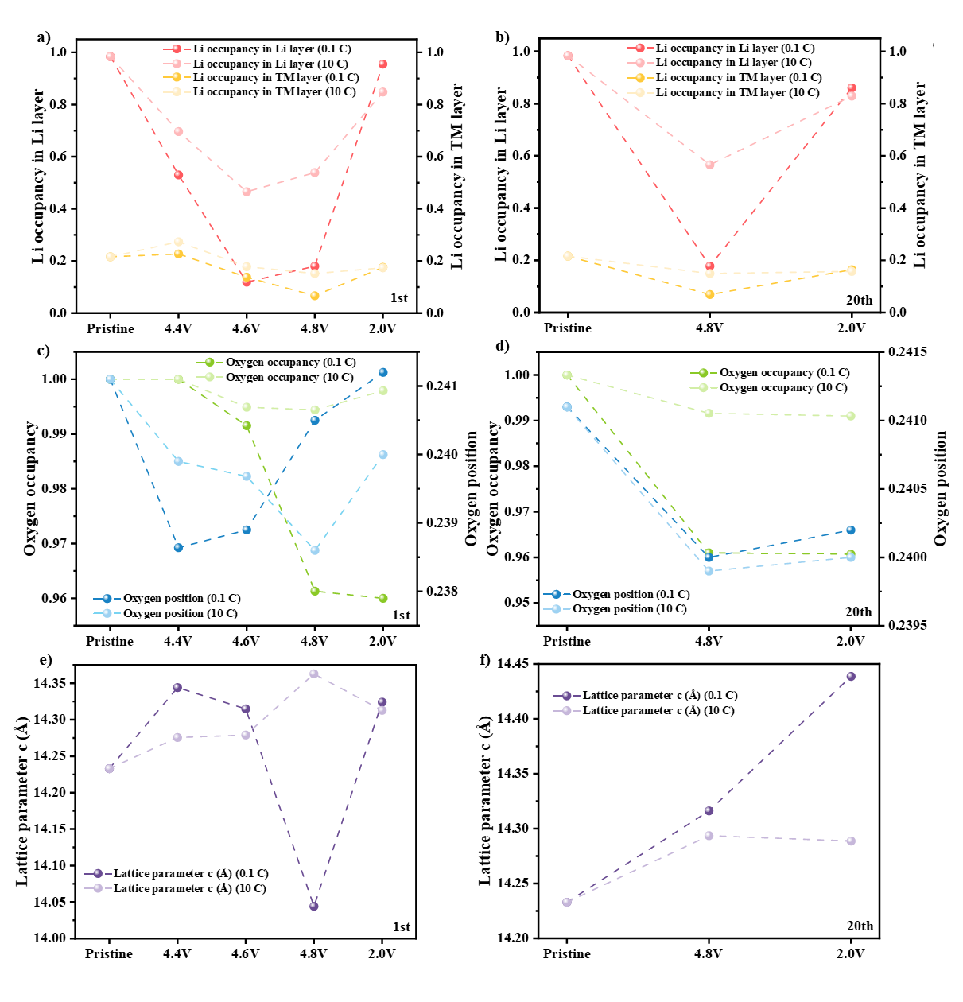
Fig. S1 Refinement results of the 1st cycle and 20th cycle of a,b) Li occupancy in the Li layer and Li in the TMO layer, c,d) O occupancy and O position, and e,f) lattice parameter c at different operation states with current rates of 0.1C and 10C, respectively.
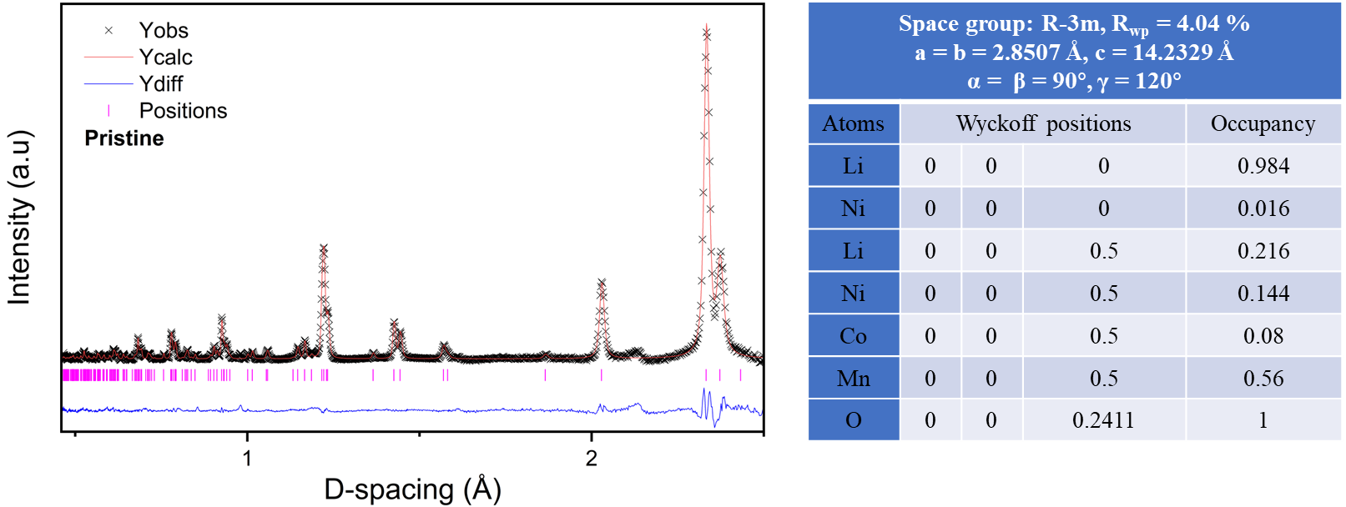
Fig. S2 Refined neutron powder diffraction pattern and lattice parameters of LRTMO at pristine state.
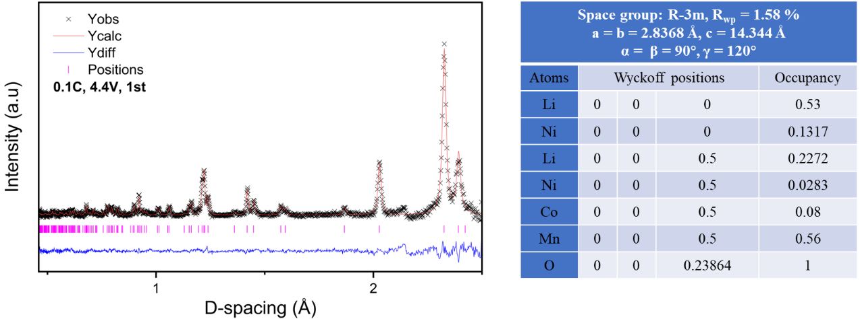
Fig. S3 Refined neutron powder diffraction pattern and lattice parameters of LRTMO at 4.4V with a rate of 0.1C.
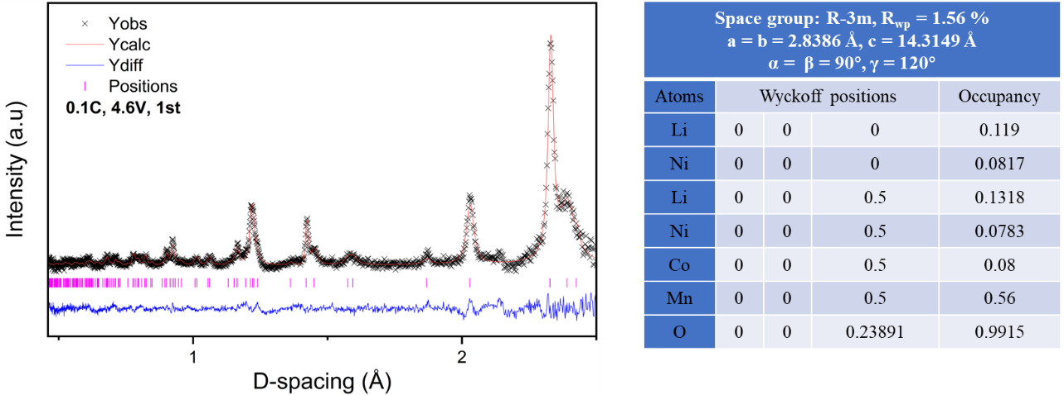
Fig. S4 Refined neutron powder diffraction pattern and lattice parameters of LRTMO at 4.6V with a rate of 0.1C.
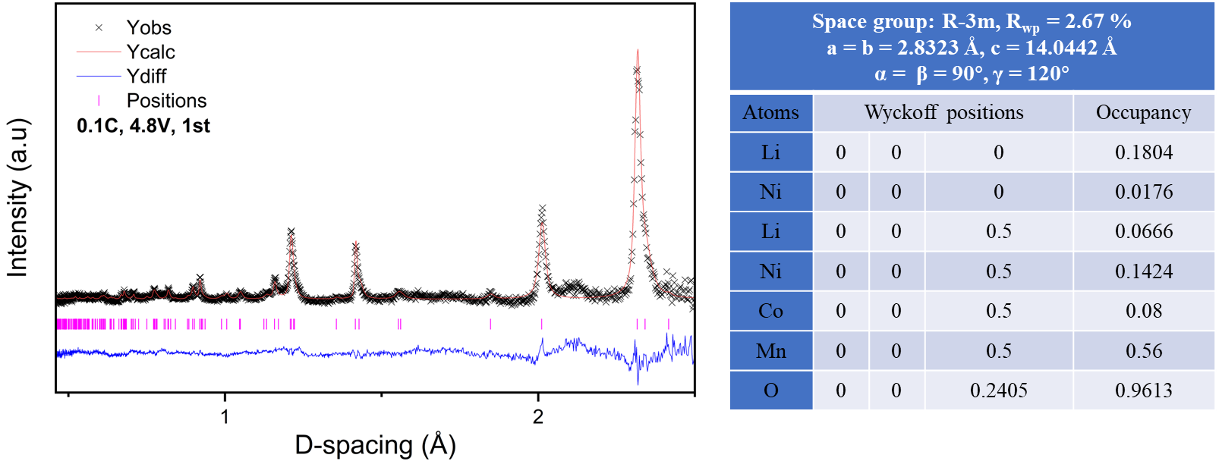Fig. S5 Refined neutron powder diffraction pattern and lattice parameters of LRTMO at 4.8V with a rate of 0.1C.
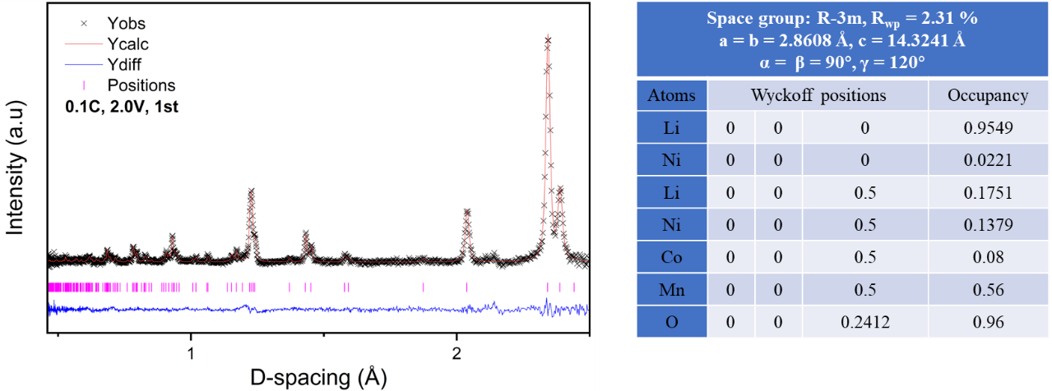
Fig. S6 Refined neutron powder diffraction pattern and lattice parameters of LRTMO at 2.0V with a rate of 0.1C.
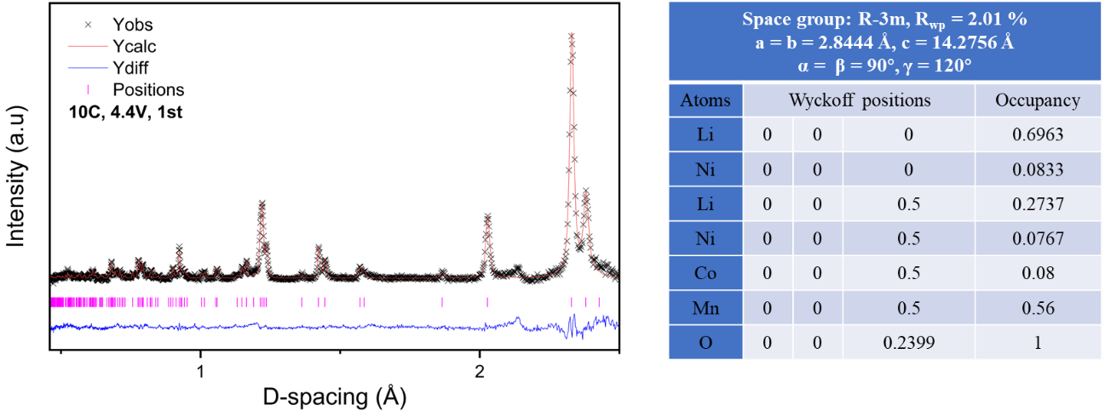
Fig. S7 Refined neutron powder diffraction pattern and lattice parameters of LRTMO at 4.4V with a rate of 10C.
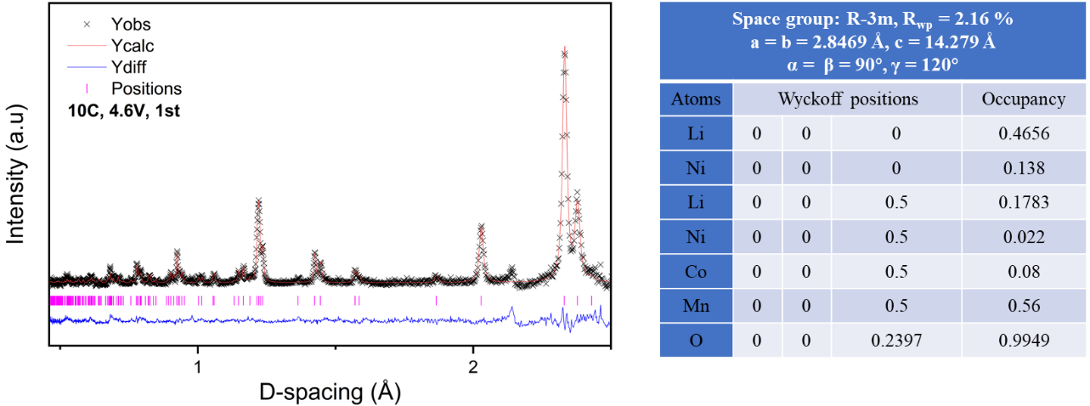
Fig. S8 Refined neutron powder diffraction pattern and lattice parameters of LRTMO at 4.6V with a rate of 10C.
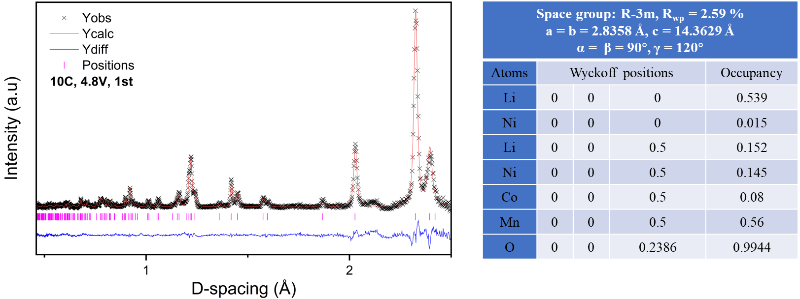
Fig. S9 Refined neutron powder diffraction pattern and lattice parameters of LRTMO at 4.8V with a rate of 10C.
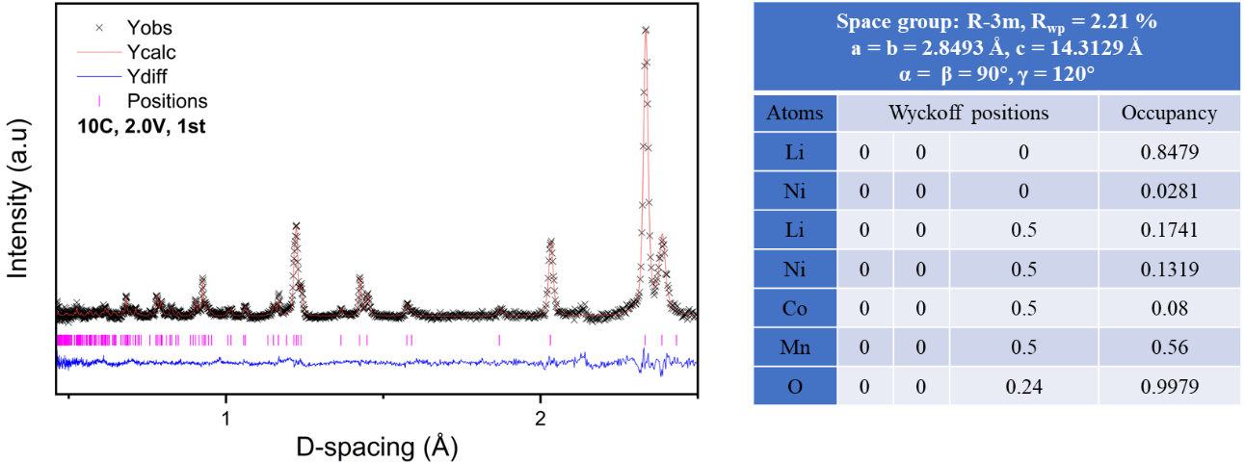
Fig. S10 Refined neutron powder diffraction pattern and lattice parameters of LRTMO at 2.0V with a rate of 10C.
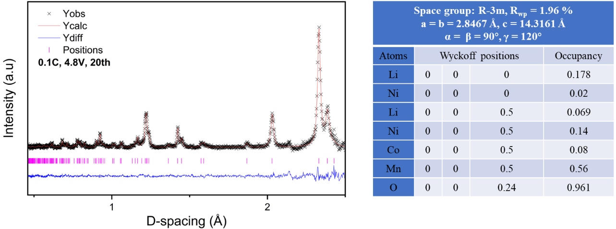
Fig. S11 Refined neutron powder diffraction pattern and lattice parameters of LRTMO for 20th cycle at 4.8V with a the rate of 0.1C.
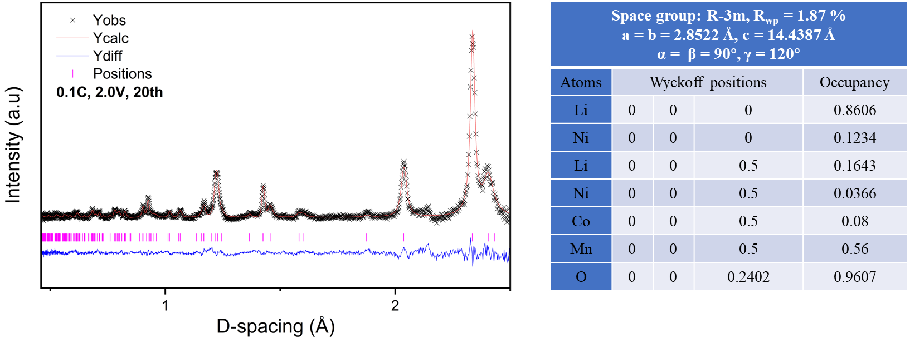
Fig. S12 Refined neutron powder diffraction pattern and lattice parameters of LRTMO for 20th cycle at 2.0V with a rate of 0.1C.
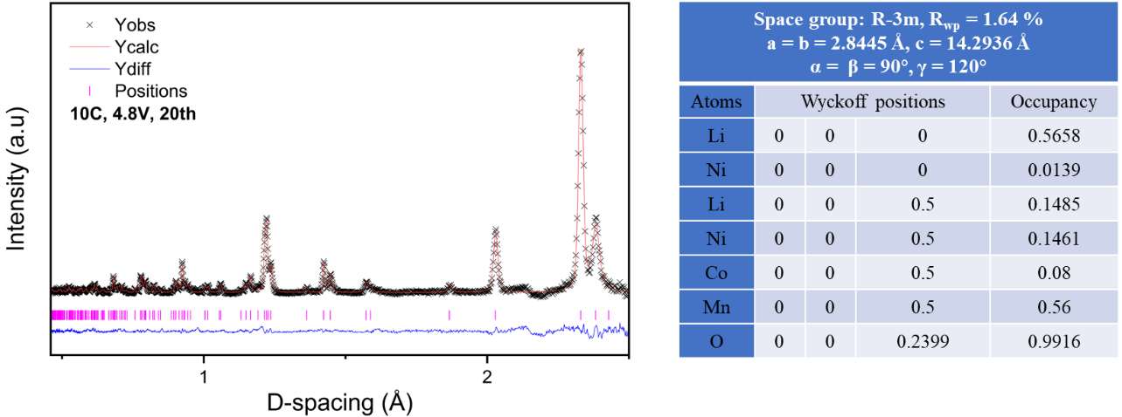
Fig. S13 Refined neutron powder diffraction pattern and lattice parameters of LRTMO for 20th cycle at 4.8V with a rate of 10C.
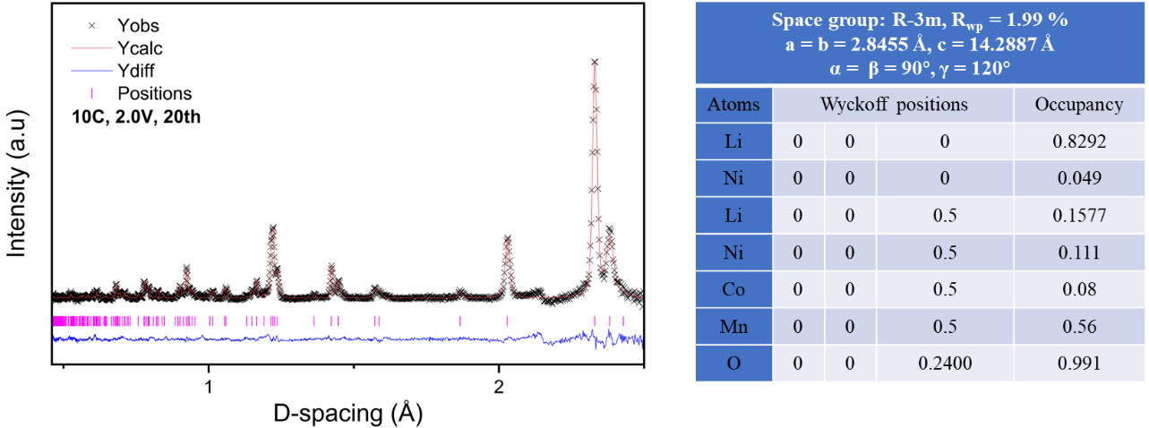
Fig. S14 Refined neutron powder diffraction pattern and lattice parameters of LRTMO for 20th cycle at 2.0V with a rate of 10C.
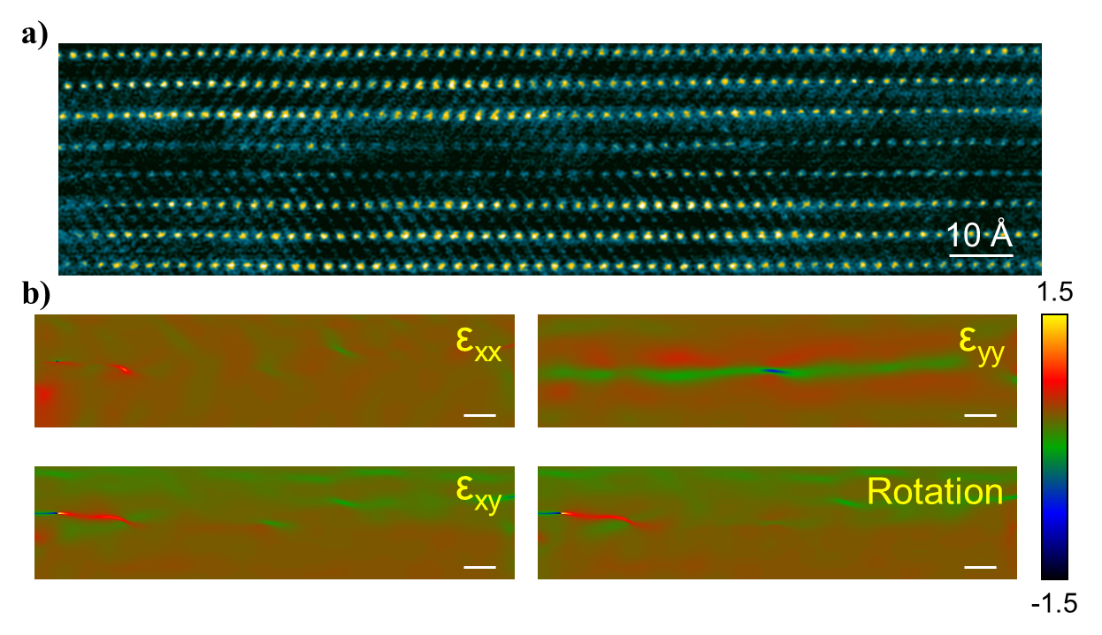
Fig. S15 The GPA in the interlayer with TMs dissolution and lattice displacement for LRTMO after 20th cycle with the rate of 10C shown in Fig.1h.

Fig. S16 Reference soft X-ray absorption spectra of Mn, Co⁴², Ni and sPFY profiles of O extracted from the emission energy window shown in mRIXS mapping ⁴⁰.
Fig. S17 Full range mRIXS mapping of LRTMO electrodes at a) 4.8V and b) 2.0V in 20th cycle with 0.1C, and c) 4.8V and d) 2.0V in 20th cycle with 10C.

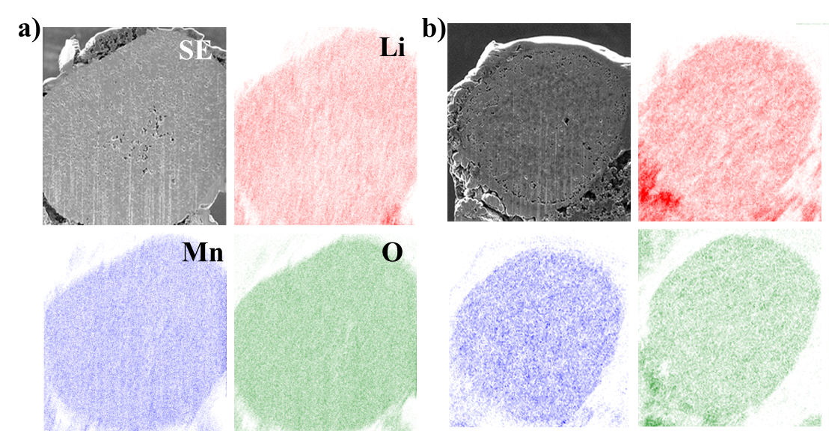
Fig. S18 The FIB-SEM secondary electron cross-sectional image and TOF-SIMS maps of the normalized elemental distribution for ⁷Li, ⁵⁵Mn and ¹⁶O in charged to 4.8V at 1st cycle with the current of (a) 0.1C and (b) 10C, respectively.

Table S1. Experimental details for 3D chemical associations of LRMO particles collected at the representative SOCs in the initial cycle using soft X-ray nano-tomography:
Sample |  | O |  | Mn |  | Co |  | Ni
Pristine |  | -50° to 60° at 525eV | -50° to 60° at 555eV | -50° to 60° at 635eV | -50° to 60° at 665eV | -50° to 60° at 775eV | -50° to 60° at 805eV | -50° to 60° at 848eV | -50° to 60° at 880eV
0.1C | CC 4.4V | -65° to 65° at 525eV | -65° to 65° at 555eV | -65° to 65° at 635eV | -65° to 65° at 665eV | -65° to 65° at 775eV | -65° to 65° at 805eV | -65° to 65° at 848eV | -65° to 65° at 880eV
0.1C | CC 4.6V | -65° to 65° at 525eV | -65° to 65° at 555eV | -65° to 65° at 635eV | -65° to 65° at 665eV | -65° to 65° at 775eV | -65° to 65° at 805eV | -65° to 65° at 848eV | -65° to 65° at 880eV
0.1C | CC 4.8V | -65° to 65° at 525eV | -65° to 65° at 555eV | -65° to 65° at 635eV | -65° to 65° at 665eV | -65° to 65° at 775eV | -65° to 65° at 805eV | -65° to 65° at 848eV | -65° to 65° at 880eV
0.1C | CC 4.8V DC 2.0V | -65° to 65° at 525eV | -65° to 65° at 555eV | -65° to 65° at 635eV | -65° to 65° at 665eV | -65° to 65° at 775eV | -65° to 65° at 805eV | -65° to 65° at 848eV | -65° to 65° at 880eV
10C | CC 4.4V | -65° to 65° at 525eV | -65° to 65° at 555eV | -65° to 65° at 635eV | -65° to 65° at 665eV | -65° to 65° at 775eV | -65° to 65° at 805eV | -65° to 65° at 848eV | -65° to 65° at 880eV
10C | CC 4.6V | -65° to 65° at 525eV | -65° to 65° at 555eV | -65° to 65° at 635eV | -65° to 65° at 665eV | -65° to 65° at 775eV | -65° to 65° at 805eV | -65° to 65° at 848eV | -65° to 65° at 880eV
10C | CC 4.8V | -65° to 65° at 525eV | -65° to 65° at 555eV | -65° to 65° at 635eV | -65° to 65° at 665eV | -65° to 65° at 775eV | -65° to 65° at 805eV | -65° to 65° at 848eV | -65° to 65° at 880eV
10C | CC 4.8V DC 2.0V | -65° to 65° at 525eV | -65° to 65° at 555eV | -65° to 65° at 635eV | -65° to 65° at 665eV | -65° to 65° at 775eV | -65° to 65° at 805eV | -65° to 65° at 848eV | -65° to 65° at 880eV

Table S2. Experimental details for the oxidation states mapping of LRMO particles collected at the representative SOCs in the initial cycle using soft X-ray nano-tomography:
O |  | Mn |  | Co |  | Ni
Energy range | Increasing rate | Energy range | Increasing rate | Energy range | Increasing rate | Energy range | Increasing rate
525-540eV | 0.1eV | 635-648eV | 0.1eV | 775-788eV | 0.1eV | 848-851eV | 0.5eV
540-555eV | 0.2eV | 648-665eV | 0.2eV | 788-794eV | 0.5eV | 851-860eV | 0.2eV
 |  |  |  | 794-805eV | 0.2eV | 860-870eV | 0.5eV
 |  |  |  |  |  | 870-875eV | 0.3eV
 |  |  |  |  |  | 875-880eV | 0.5eV

Parameter | Symble | Value | Reference
Maximum Li-ions concentration in Li-rich | C_{max} | 49000 mol m⁻³
Maximum particle lithiation level | SOC_{max} | 0.942 | NPD refinement in this work
Minimum particle lithiation level | SOC_{min} | 0.228 | NPD refinement in this work
Li-ions concentration in electrolyte | C_{l} | 1000 mol m⁻³ | Electrolyte used in this work
Young's modulus | E | 169.08 GPa | ⁴³
Poisson ratio | ν | 0.29 | ⁴³
Reference exchange current density for Li-ions intercalation into Li-rich | i_{0,ref_Li-rich} | 10 A m⁻²
Reference exchange current density for Lithium deposition/dissolution | i_{0,ref_Li-metal} | 100 A m⁻²
Charge transfer coefficient | α | 0.5 | assumed
Gas constant | R | 8.314 J mol⁻¹
Faraday constant | F | 96485 C mol⁻¹
Li-rich particle radius | r_{p_pos} | 8*10⁻⁶ m | SEM image in this work
Central void radius | r_{c_void} | 6*10⁻⁷ m | X-ray tomography in this work
Outer void radius | r_{o_void} | 2*10⁻⁷ m | X-ray tomography in this work
Table S3 The simulation parameters of single LRTMO particle, which couples the Li-ions diffusion with solid mechanics to predict the stress evolution with the particle during the de-lithiation process.

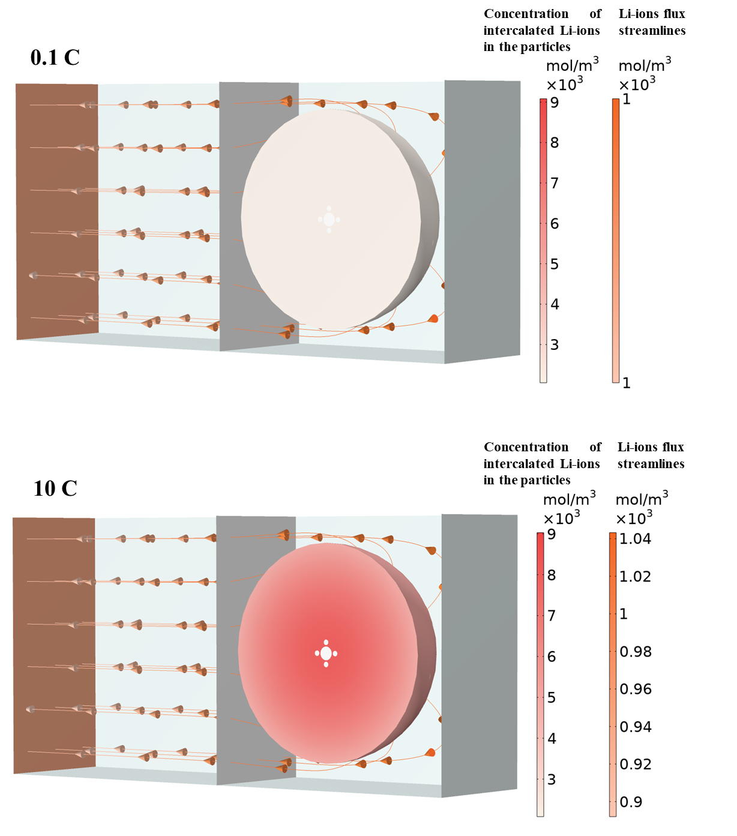
Fig. S19 The simulation of single LMRO particle (r= 8 μm) with simplified central spherical void (r= 0.5μm) and outer pores (r= 0.2μm) in the Li-ions flux streamlines.

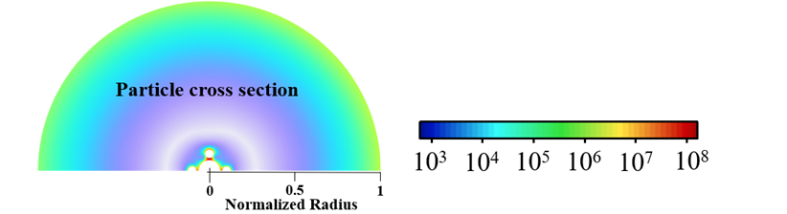
Fig. S20 The distribution of Li-ions concentration and von-Mises stress within LMRO particle simulated at representative stages.
Fig. S21 The evolution of hoop stress at the bridge edge between central void and neighbor pore during discharge process at different rates.

