Supplementary Figure 1 Raw data for the study
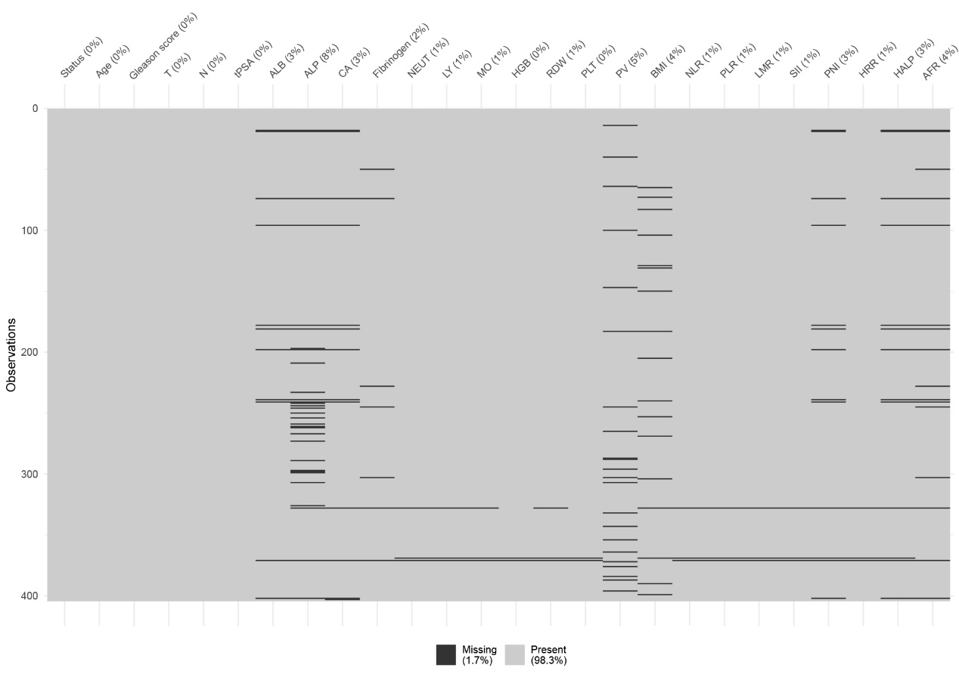

Supplementary Figure 2 Data filled by the MissForest algorithm.
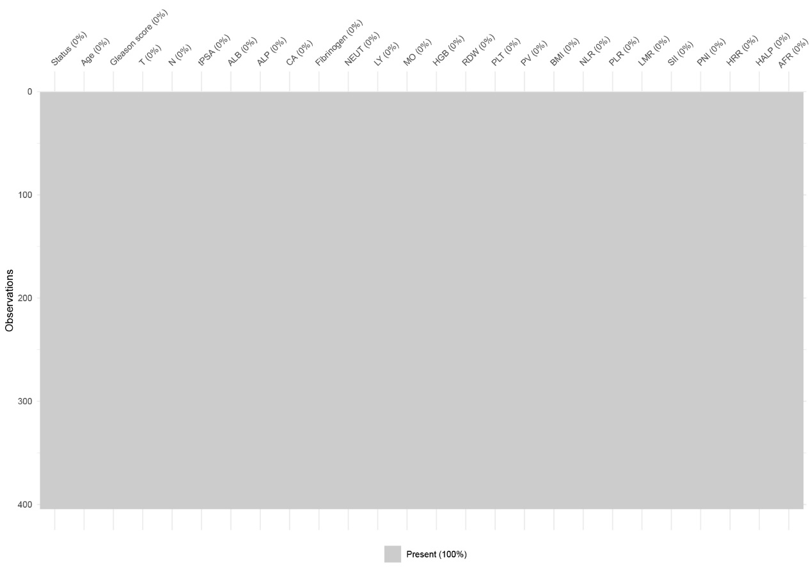

Supplementary Table 1 Relationship between training set and test set and bone metastasis
Variables | Training set |  | P | Test set |  | P
Variables | Positive  （n=124） | Negative  （n=199） | P | Positive  （n=34） | Negative  （n=47） | P
Age | 72.258 ± 8.011 | 71.070 ± 7.525 | 0.179 | 71.029 ± 8.959 | 71.872 ± 8.999 | 0.678
Gleason score |  |  | ＜0.001 |  |  | 0.003
≤7 | 20 | 71 |  | 2 | 18
8 | 35 | 62 |  | 14 | 15
≥9 | 69 | 66 |  | 18 | 14
T stage |  |  | ＜0.001 |  |  | ＜0.001
T1~T2 | 29 | 136 |  | 6 | 35
T3~T4 | 95 | 63 |  | 28 | 12
N stage |  |  | ＜0.001 |  |  | ＜0.001
N0 | 34 | 139 |  | 12 | 35
N1 | 90 | 60 |  | 22 | 12
PSA (ng/ml) |  |  | ＜0.001 |  |  | ＜0.001
≤20 | 4 | 83 |  | 2 | 15
20~100* | 33 | 88 |  | 7 | 26
≥100 | 87 | 28 |  | 25 | 6
ALB | 39.158 ± 4.600 | 40.947 ± 3.996 | ＜0.001 | 38.835 ± 4.028 | 40.249 ± 4.543 | 0.151
ALP | 126.500(87.250,  282.250) | 76 (65,87) | ＜0.001 | 122(79.750,  365.750) | 77(64,93) | ＜0.001
CA | 2.227 ± 0.126 | 2.257 ± 0.132 | 0.044 | 2.220 ± 0.143 | 2.252 ± 0.176 | 0.389
Fibrinogen | 3.640(2.958,  4.845) | 3.190(2.730,  3.800) | ＜0.001 | 4.205(3.213,  5.028) | 3.200(2.650,  4.090) | 0.001
NEUT | 3.700(2.955,  4.818) | 3.390(2.630,  4.440) | 0.056 | 3.605(2.613,  4.815) | 3.580(2.680,  5.330) | 0.871
LY | 1.265(0.965,  1.633) | 1.470(1.110,  1.900) | 0.004 | 1.475(1.175,  1.685) | 1.380(0.970,  1.950) | 0.582
MO | 0.455(0.370,  0.558) | 0.440(0.340,  0.570) | 0.559 | 0.450(0.368,  0.593) | 0.420(0.310,  0.640) | 0.531
HGB | 142(127,154) | 150(138,159) | ＜0.001 | 143(130.250,  151.250) | 149(138,161) | 0.073
RDW | 13.056(12.500,  13.800) | 13.100(12.500,  13.700) | 0.750 | 13.350(12.675,  13.875) | 12.905(12.200,  13.900) | 0.084
PLT | 181.500(133,241) | 176(138,215) | 0.357 | 176(136.750,  206.750) | 184(144,220) | 0.464
PV | 47.146(34.219,  70.567) | 46.956(31.637,  61.152) | 0.393 | 54.786(35.755,  69.458) | 45.827(32.738,  63.675) | 0.247
BMI | 22.731 ± 3.529 | 24.183 ± 3.512 | ＜0.001 | 22.778 ± 2.506 | 24.166 ± 3.900 | 0.055
NLR | 2.942(2.074,  4.292) | 2.428(1.744,  3.266) | 0.001 | 2.447(1.849,  3.157) | 2.579(1.892,  4.146) | 0.804
PLR | 140.198(106.706,  184.723) | 114.938(88.280,  171.429) | 0.002 | 122.248(85.282,  150.632) | 123.718(96.444,172.222) | 0.397
LMR | 2.766(2.109,  3.723) | 3.394(2.500,  4.250) | 0.001 | 3.011(2.311,  4.287) | 3.476(2.310,  4.239) | 0.660
SII | 540.380(369.803,  832.965) | 403.546(254.118,  659.211) | 0.001 | 413.274(298.546,  639.389) | 488(317.924,  759.273) | 0.579
PNI | 45.905 ± 5.532 | 48.565 ± 5.176 | ＜0.001 | 46.321 ± 4.798 | 47.624 ± 5.984 | 0.298
HRR | 10.866(9.079,  11.889) | 11.439(10.588,  12.419) | ＜0.001 | 10.560(9.377,  11.921) | 11.440(10.144,  12.846) | 0.028
HALP | 39.389(26.807,  55.880) | 51.599(35.902,  71.952) | ＜0.001 | 45.486(31.482,  65.100) | 48.671(31.753,  61.634) | 0.886
AFR | 11.850(8.380,  13.652) | 12.997(10.548,  15.145) | ＜0.001 | 9.559(7.628,  12.033) | 12.969(10.046,  16.137) | ＜0.001

Note：* The range of 20~100 ng/ml does not include the values 20 ng/ml and 100 ng/ml.

Supplementary Table 2 Covariance analysis before excluding PNI
Coefficientsª
Model |  | Unstandardized Coefficients |  | Standardized Coefficients | t | Sig. | Collinearity Statistics
 |  | B | Std. Error | Beta | t | Sig. | Tolerance | VIF
1 | (Constant) | 0.308 | 0.426 |  | 0.723 | 0.470
1 | Gleason score≤7 | -0.089 | 0.055 | -0.082 | -1.608 | 0.109 | 0.676 | 1.479
1 | Gleason score=8 | -0.086 | 0.051 | -0.081 | -1.696 | 0.091 | 0.782 | 1.279
1 | T | 0.156 | 0.051 | 0.160 | 3.034 | 0.003 | 0.637 | 1.571
1 | N | 0.122 | 0.050 | 0.125 | 2.426 | 0.016 | 0.665 | 1.503
1 | PSA≤20 | -0.438 | 0.067 | -0.400 | -6.570 | 0.000 | 0.479 | 2.087
1 | PSA: 20~100* | -0.314 | 0.055 | -0.312 | -5.679 | 0.000 | 0.587 | 1.704
1 | ALB | 1.055E-5 | 0.126 | 0.000 | 0.000 | 1.000 | 0.001 | 704.641
1 | ALP | 0.000 | 0.000 | 0.167 | 3.094 | 0.002 | 0.609 | 1.642
1 | CA | 0.158 | 0.206 | 0.042 | 0.766 | 0.444 | 0.584 | 1.713
1 | Fibrinogen | 0.045 | 0.030 | 0.113 | 1.494 | 0.136 | 0.308 | 3.242
1 | LY | 0.008 | 0.623 | 0.009 | 0.012 | 0.990 | 0.004 | 285.444
1 | HGB | 0.001 | 0.002 | 0.043 | 0.514 | 0.608 | 0.259 | 3.854
1 | BMI | -0.008 | 0.006 | -0.057 | -1.239 | 0.216 | 0.834 | 1.199
1 | NLR | 7.630E-5 | 0.015 | 0.000 | 0.005 | 0.996 | 0.490 | 2.040
1 | LMR | -0.001 | 0.023 | -0.002 | -0.039 | 0.969 | 0.466 | 2.146
1 | PNI | -0.006 | 0.126 | -0.068 | -0.048 | 0.962 | 0.001 | 1122.207
1 | HRR | -0.005 | 0.018 | -0.022 | -0.286 | 0.775 | 0.299 | 3.340
1 | HALP | -0.001 | 0.001 | -0.092 | -1.537 | 0.125 | 0.493 | 2.029
1 | AFR | 0.008 | 0.008 | 0.077 | 1.009 | 0.314 | 0.303 | 3.300
a. Dependent Variable: Status
Note：* The range of 20~100 ng/ml does not include the values 20 ng/ml and 100 ng/ml.

Supplementary Table3 Covariance analysis after excluding PNI
Coefficientsª
Model |  | Unstandardized Coefficients |  | Standardized Coefficients | t | Sig. | Collinearity Statistics
 |  | B | Std. Error | Beta | t | Sig. | Tolerance | VIF
1 | (Constant) | 0.307 | 0.425 |  | 0.722 | 0.471
1 | Gleason score≤7 | -0.089 | 0.055 | -0.082 | -1.611 | 0.108 | 0.679 | 1.473
1 | Gleason score=8 | -0.086 | 0.050 | -0.081 | -1.699 | 0.090 | 0.782 | 1.279
1 | T | 0.156 | 0.051 | 0.160 | 3.041 | 0.003 | 0.637 | 1.570
1 | N | 0.122 | 0.050 | 0.125 | 2.430 | 0.016 | 0.665 | 1.503
1 | PSA≤20 | -0.438 | 0.067 | -0.400 | -6.589 | 0.000 | 0.481 | 2.081
1 | PSA: 20~100* | -0.314 | 0.055 | -0.312 | -5.693 | 0.000 | 0.588 | 1.699
1 | ALB | -0.006 | 0.007 | -0.054 | -0.849 | 0.396 | 0.442 | 2.261
1 | ALP | 0.000 | 0.000 | 0.167 | 3.111 | 0.002 | 0.612 | 1.633
1 | CA | 0.158 | 0.206 | 0.042 | 0.768 | 0.443 | 0.584 | 1.712
1 | Fibrinogen | 0.045 | 0.030 | 0.113 | 1.500 | 0.135 | 0.312 | 3.200
1 | LY | -0.022 | 0.052 | -0.025 | -0.427 | 0.670 | 0.496 | 2.018
1 | HGB | 0.001 | 0.002 | 0.043 | 0.517 | 0.606 | 0.260 | 3.849
1 | BMI | -0.008 | 0.006 | -0.057 | -1.245 | 0.214 | 0.847 | 1.180
1 | NLR | 0.000 | 0.015 | 0.000 | 0.007 | 0.994 | 0.491 | 2.036
1 | LMR | -0.001 | 0.023 | -0.003 | -0.042 | 0.967 | 0.467 | 2.140
1 | HRR | -0.005 | 0.018 | -0.022 | -0.288 | 0.774 | 0.300 | 3.338
1 | HALP | -0.001 | 0.001 | -0.092 | -1.549 | 0.122 | 0.497 | 2.014
1 | AFR | 0.008 | 0.008 | 0.077 | 1.010 | 0.314 | 0.305 | 3.282
a. Dependent Variable: Status
Note：* The range of 20~100 ng/ml does not include the values 20 ng/ml and 100 ng/ml.

