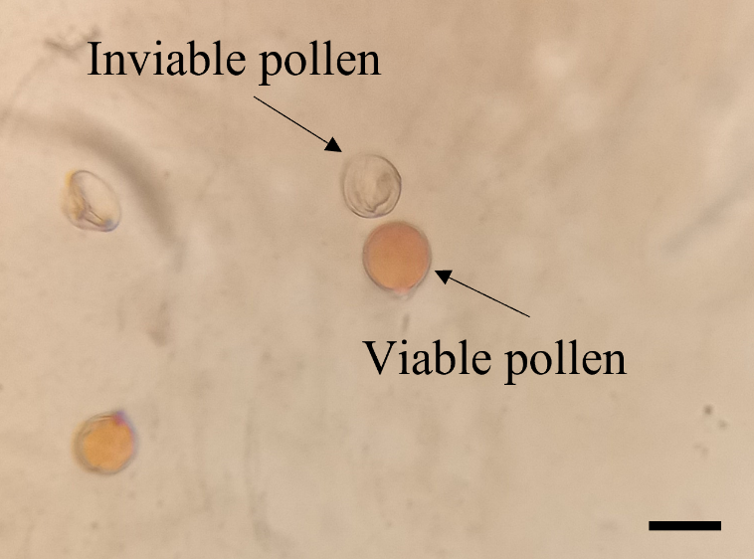
Supplementary Fig. S1. Wild potato Solanum malmeanum (Solanaceae) pollen grains submitted to acetocarmine staining, viable (red coloured) and unviable (transparent, non-coloured). Bar = 20 µm.

Supplementary Fig. S2. Overview of the pollen viability essay of wild potato Solanum malmeanum (Solanaceae) accessions (40× magnification). a) BRA 00167071-0, b) BRA 00167093-4, c) BRA 00183754-1, d) BRA 00183755-8, e) BRA 00183778-0.

Supplementary Fig. S3. Pollen tube growth reaction of self-pollinated diploid Solanum malmeanum (Solanaceae) accessions. a) Pollen tube elongation is inhibited at 2/3 of the style of self-incompatible diploid wild potato S. malmeanum accession BRA 00167071-0 (Genesys code) from Embrapa Potato Genebank, Pelotas, RS, Brazil, using LACMOID staining technique and observation using an optical microscope. Detailed of a) Pollen tubes elongated and reaching the ovary (100× magnification). Bar = 0.5 mm.
Supplementary Fig. S4. Pollen tube growth reaction of self-pollinated diploid Solanum malmeanum (Solanaceae) accessions. a) Pollen tube elongation is inhibited at 2/3 of the style of self-incompatible diploid wild potato S. malmeanum accession BRA 00167093-4 (Genesys code) from Embrapa Potato Genebank, Pelotas, RS, Brazil, using LACMOID staining technique and observation using an optical microscope. Detailed of a) Pollen tubes elongated and reaching the ovary (100× magnification). Bar = 0.5 mm.
Supplementary Fig. S5. Pollen tube growth reaction of self-pollinated diploid Solanum malmeanum (Solanaceae) accessions. a) Pollen tube elongation is inhibited at 2/3 of the style of self-incompatible diploid wild potato S. malmeanum accession BRA 00183754-1 (Genesys code) from Embrapa Potato Genebank, Pelotas, RS, Brazil, using LACMOID staining technique and observation using an optical microscope. Detailed of a) Pollen tubes elongated and reaching the ovary (100× magnification). Bar = 0.5 mm.

Supplementary Fig. S6. Pollen tube growth reaction of self-pollinated diploid Solanum malmeanum (Solanaceae) accessions. a) Pollen tube elongation is inhibited at 1/3 of the style of self-incompatible diploid wild potato S. malmeanum accession BRA 00183778-0 (Genesys code) from Embrapa Potato Genebank, Pelotas, RS, Brazil, using LACMOID staining technique and observation using an optical microscope. Detailed of a) Pollen tubes elongated and reaching the ovary (100× magnification). Bar = 0.5 mm.

Supplementary Fig. S7. Air temperature for the period of implantation of the experiment. Data obtained from the EMBRAPA meteorology center database. Data are presented by Average of Air Temperature (Tave ºC), Maximum Temperature (Tmax ºC), and Minimum Temperature (Tmin ºC) outside the greenhouse.

