Fabrication of Fluorescent PMMA-Carbon Nanodots Optical Films and their Feasibility in Improving Solar Cells Efficiency using Low-Cost Sustainable Materials

Marco C. P. Soares^{1,*,+}, Michele Cacioppo^{2,†,*,+}, Francesco Amato^{2,‡,*,+}, Thiago D. Cabral¹, Marcelo N. P. Carreño³, Inés Pereyra³, Carlos A. S. Ramos³, Manuel Cid³, Gilson S. Goveia⁴, José F. D. Chubaci⁴, Eric Fujiwara¹, Maurizio Prato^{2,5,6}, Julio R. Bartoli^{1,7,*}

¹Laboratory of Photonic Materials and Devices, School of Mechanical Engineering, University of Campinas, Campinas, SP, Brazil
²Carbon Nanotechnology Group, Department of Chemical and Pharmaceutical Sciences, University of Trieste, Trieste, Italy
³Laboratory of Microelectronics, Polytechnic School, University of São Paulo, SP, Brazil (LME/EPUSP)
⁴Institute of Physics, University of São Paulo, SP, Brazil
⁵Center for Cooperative Research in Biomaterials (CIC biomaGUNE), Basque Research and Technology Alliance (BRTA), Paseo de Miramón 182, 20014, Donostia San Sebastián (Spain)
⁶Basque Foundation for Science, Ikerbasque, 48013 Bilbao, Spain
⁷School of Chemical Engineering, University of Campinas, Campinas, SP, Brazil
†Present address: Department of Biological, Chemical and Pharmaceutical Sciences and Technologies (STEBICEF), University of Palermo, Viale delle Scienze Ed. 17, 90128 Palermo, Italy
‡Present Address: Department of Chemistry, University of Rome “La Sapienza”, Rome, Italy
*Corresponding authors: marcosoares.feq@gmail.com (M.C.P.S); michelecacioppo@gmail.com (M.C.); amatofrancesco89@libero.it (F.A.); bartoli@unicamp.br (J.R.B.)
⁺These authors contributed equally to this work.

Supporting Information
Contents
Figure SI 1. Lyophilized α-CDs (5 wt%) dispersed in a mixture comprised of chloroform and methanol (proportion of 2:1 (v/v)) observed under: a. daylight; b. UV light (λ = 365 nm). 2
Figure SI 2. PMMA-NCNDs (5 wt%) solution (before casting) observed under: a. daylight; b. UV light (λ = 365 nm). 2
Figure SI 3. PMMA-NCNDs (5 wt%) films on the Petri dishes after drop casting: a. frontal aspect, under daylight; b. side aspect, under daylight; c. frontal aspect, under UV light (λ = 365 nm); d. side aspect, under UV light (λ = 365 nm). 3
Figure SI 4. a. Silicon solar cell; b. bench for photovoltaic measurements; c. PMMA-NCNDs (0.5 wt%) optical film positioned on the solar cell; d. Measurements of I × V curve and obtention of photovoltaic parameters with Lab Tracer 2.0 software. 4
Figure SI 5. PMMA-α-CDs (5 wt%) solution (before casting) observed under: a. daylight; b. UV light (λ = 365 nm). 4
Figure SI 6. Photoluminescence spectra obtained for PMMA-α-CDs (5 wt%) optical films when reducing the excitation and emission slits from 5 to 2.5 nm. The collected intensities considerably decreased, allowing the observation of the spectra with no saturation. 5
Figure SI 7. Different optical films obtained when observed under: a. daylight; b. UV light (λ = 365 nm). 5
Figure SI 8. Absorbances obtained for the different optical films. 6
Figure SI 9. Transmittances obtained for the different optical films. 7
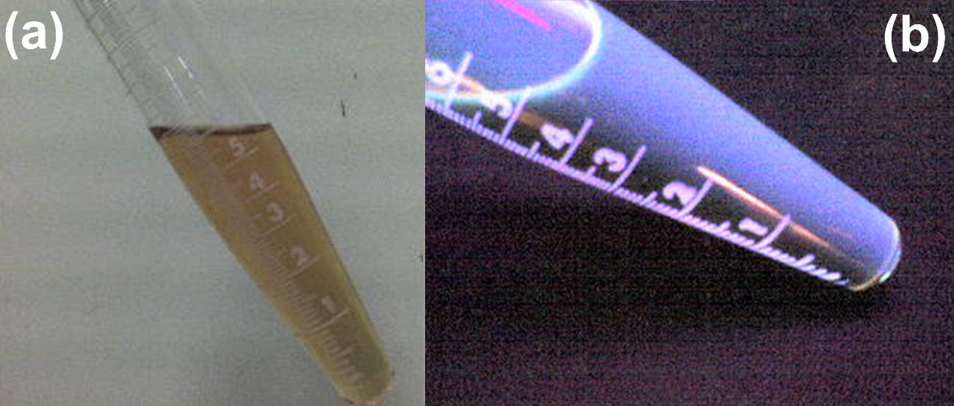
Figure SI 1. Lyophilized α-CDs (5 wt%) dispersed in a mixture comprised of chloroform and methanol (proportion of 2:1 (v/v)) observed under: a. daylight; b. UV light (λ = 365 nm).

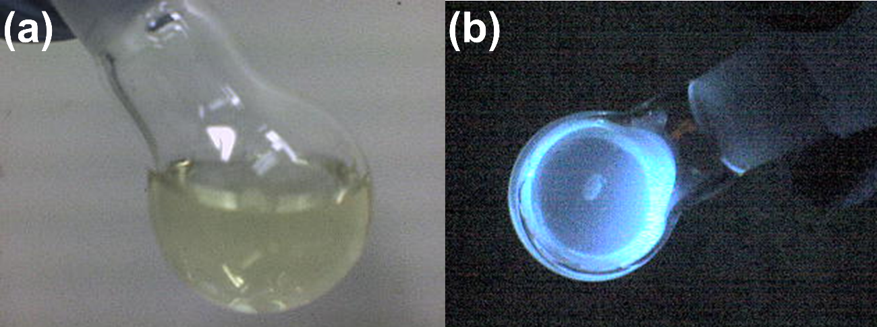
Figure SI 2. PMMA-NCNDs (5 wt%) solution (before casting) observed under: a. daylight; b. UV light (λ = 365 nm).
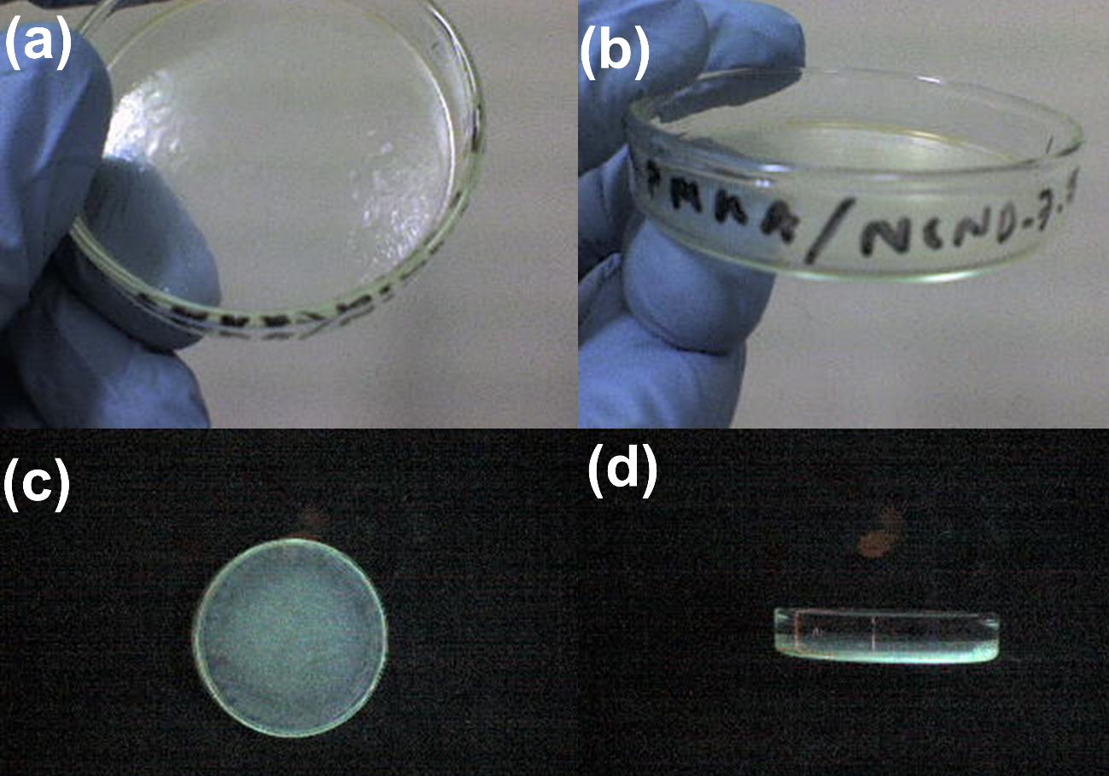
Figure SI 3. PMMA-NCNDs (5 wt%) films on the Petri dishes after drop casting: a. frontal aspect, under daylight; b. side aspect, under daylight; c. frontal aspect, under UV light (λ = 365 nm); d. side aspect, under UV light (λ = 365 nm).

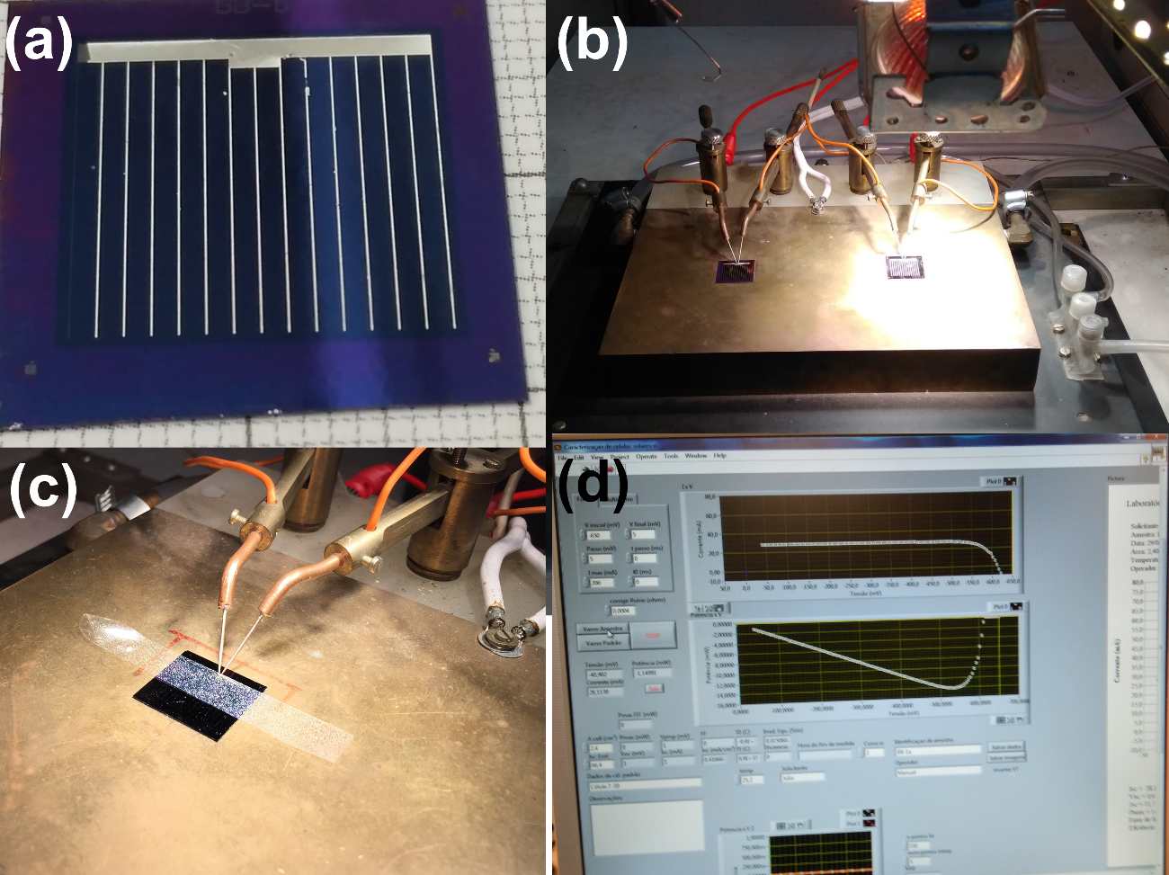
Figure SI 4. a. Silicon solar cell; b. bench for photovoltaic measurements; c. PMMA-NCNDs (0.5 wt%) optical film positioned on the solar cell; d. Measurements of I × V curve and obtention of photovoltaic parameters with Lab Tracer 2.0 software.

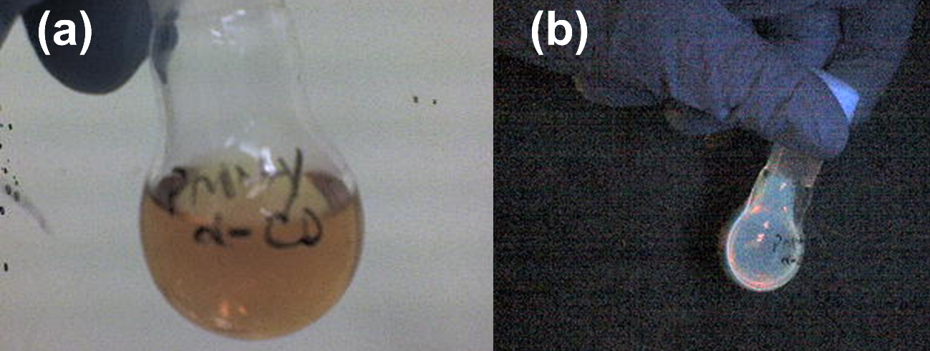
Figure SI 5. PMMA-α-CDs (5 wt%) solution (before casting) observed under: a. daylight; b. UV light (λ = 365 nm).

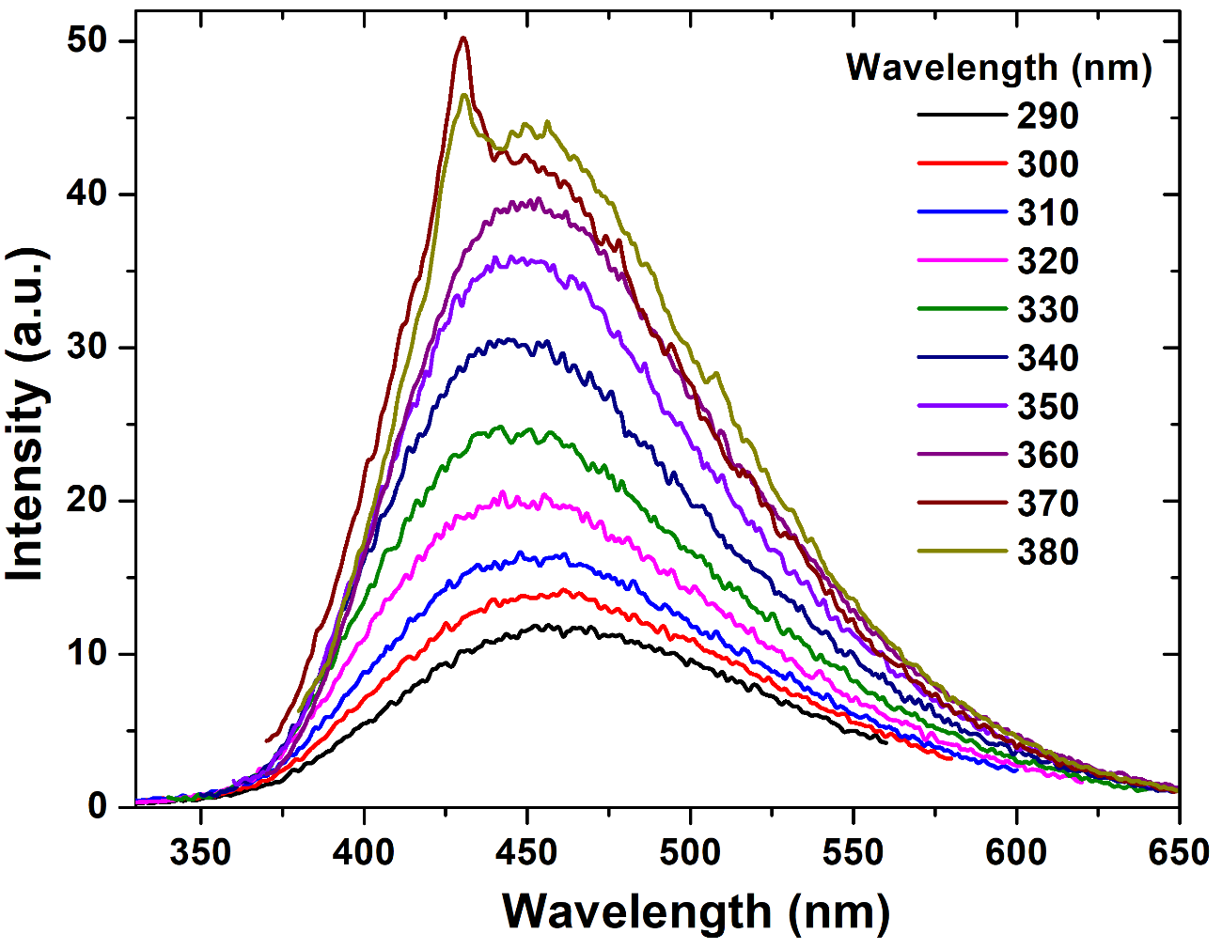
Figure SI 6. Photoluminescence spectra obtained for PMMA-α-CDs (5 wt%) optical films when reducing the excitation and emission slits from 5 to 2.5 nm. The collected intensities considerably decreased, allowing the observation of the spectra with no saturation.

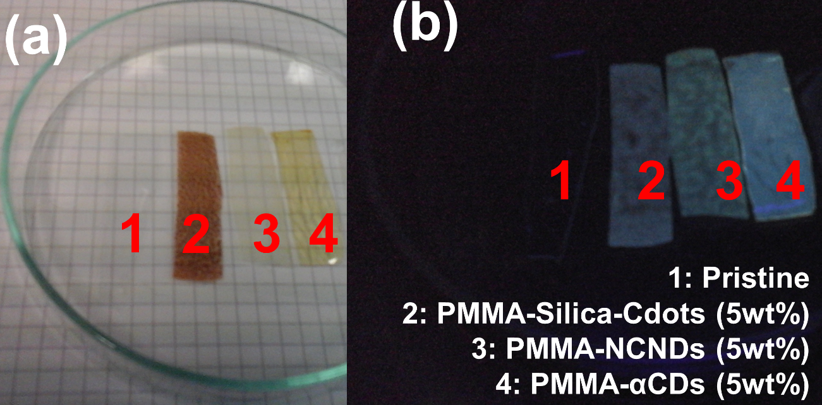
Figure SI 7. Different optical films obtained when observed under: a. daylight; b. UV light (λ = 365 nm).

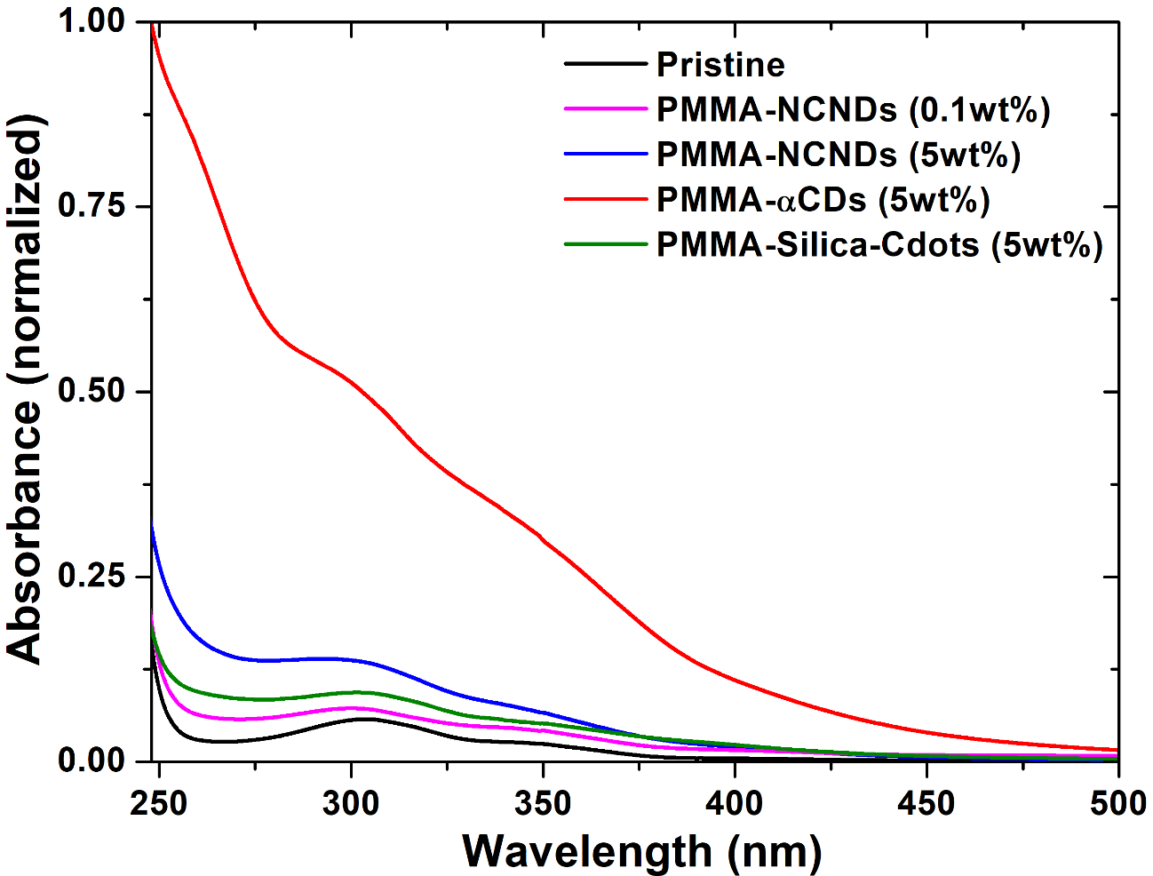
Figure SI 8. Absorbances obtained for the different optical films.

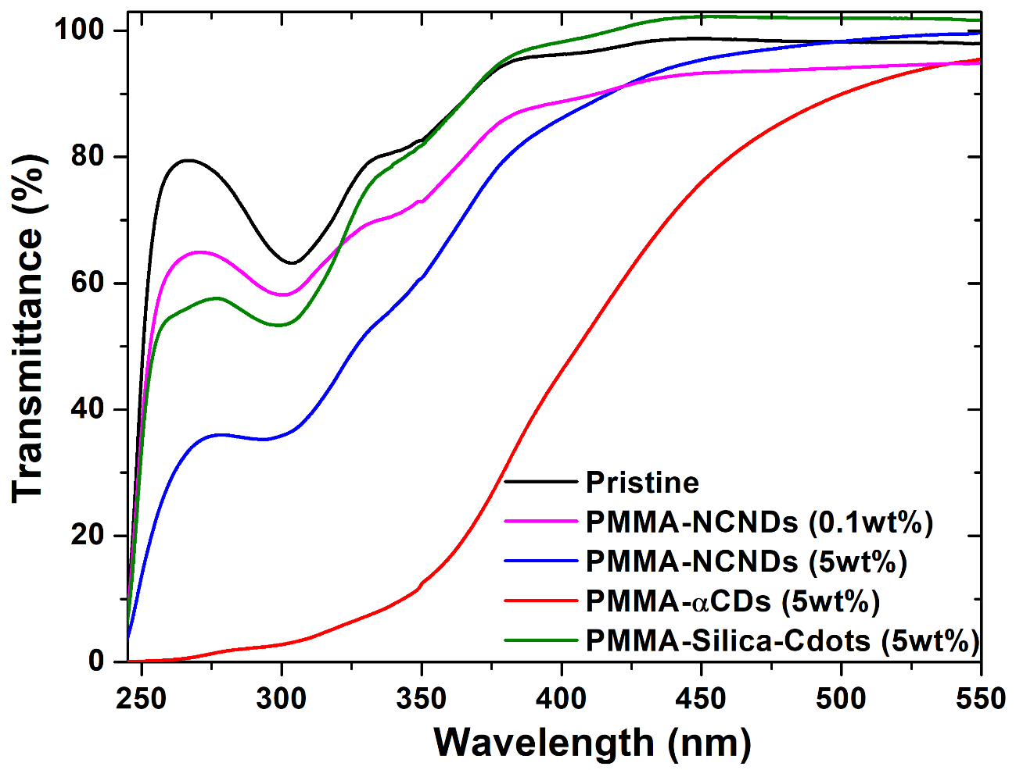
Figure SI 9. Transmittances obtained for the different optical films.

