Supplementary Information

Non-Hermitian broadside coupled split ring resonators with directional sensitivity

Zhenci Sun^{1, 2}, Xiaoguang Zhao^{1, 2,} *, Lingyun Zhang^{1, 2}, Chao Liang³, Bingbai Li^{1, 2}, Wenshuai Lu², Wenqiang Zhang³, Rui You^{4,} *, Jiahao Zhao^{1, 2,} *, and Zheng You^{1, 2, *}

- Department of Precision Instrument, Tsinghua University, Beijing 100084, China
- State Key Laboratory of Precision Testing Technology and Instruments, Tsinghua University, Beijing 100084, China
- College of Engineering, China Agricultural University, Beijing 100083, China
- School of Instrument Science and Opto-Electronic Engineering, Beijing Information Science and Technology University, Beijing 100016, China
* Correspondence:
zhaoxg@mail.tsinghua.edu.cn, Xiaoguang Zhao;
yourui@bistu.edu.cn, Rui You;
falxon@mail.tsinghua.edu.cn, Jiahao Zhao;
yz-dpi@mail.tsinghua.edu.cn, Zheng You.

- The simulated surface current and electric field distribution in the plane of SRR.

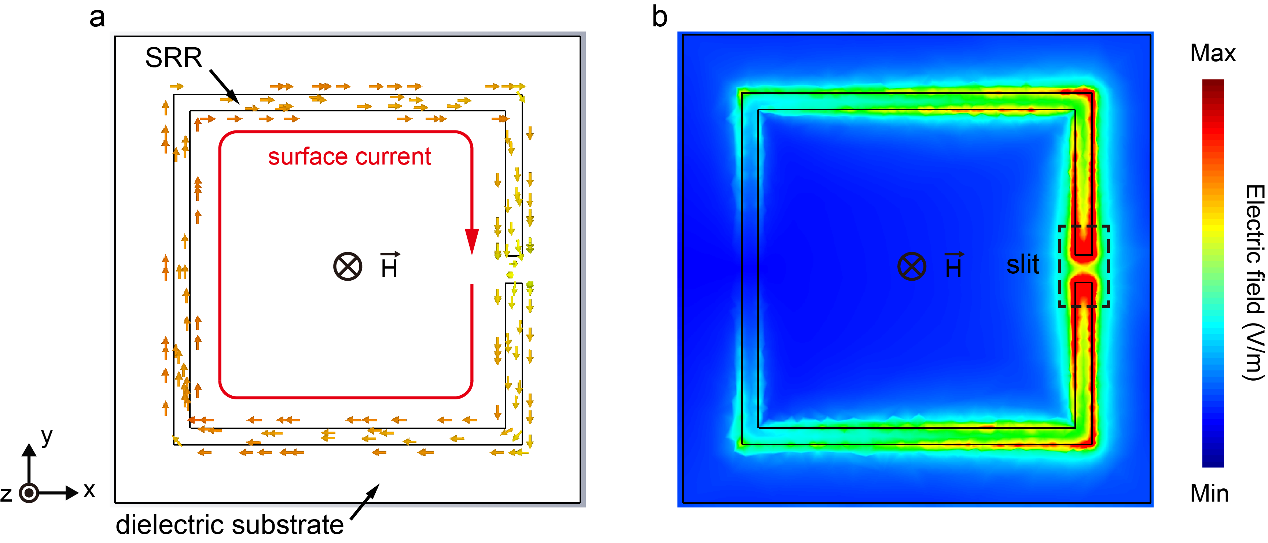

Figure S1. (a) The simulated surface current and (b) electric field distribution in the plane of SRR.

- The geometry for the SRR structures of the BC-SRR.

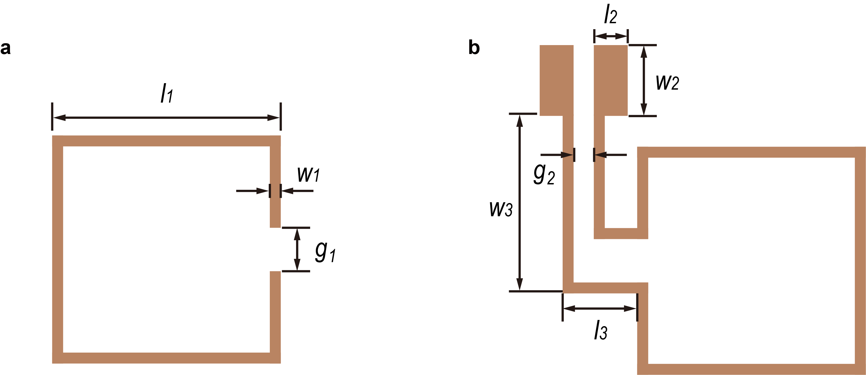

Figure S2. SRR geometry. The geometry for the structures of (a) SRR1 and (b) SRR2 is shown.

Table S1. Design parameters of the optimal SRR.
Symbol | Value
l₁ | 10.5 mm
l₂ | 2 mm
l₃ | 2.3 mm
w₁ | 0.3 mm
w₂ | 4 mm
w₃ | 7.6 mm
g₁ | 2 mm
g₂ | 0.5 mm

- The simulation model to analyze the RF characteristics of the designed BC-SRRs.

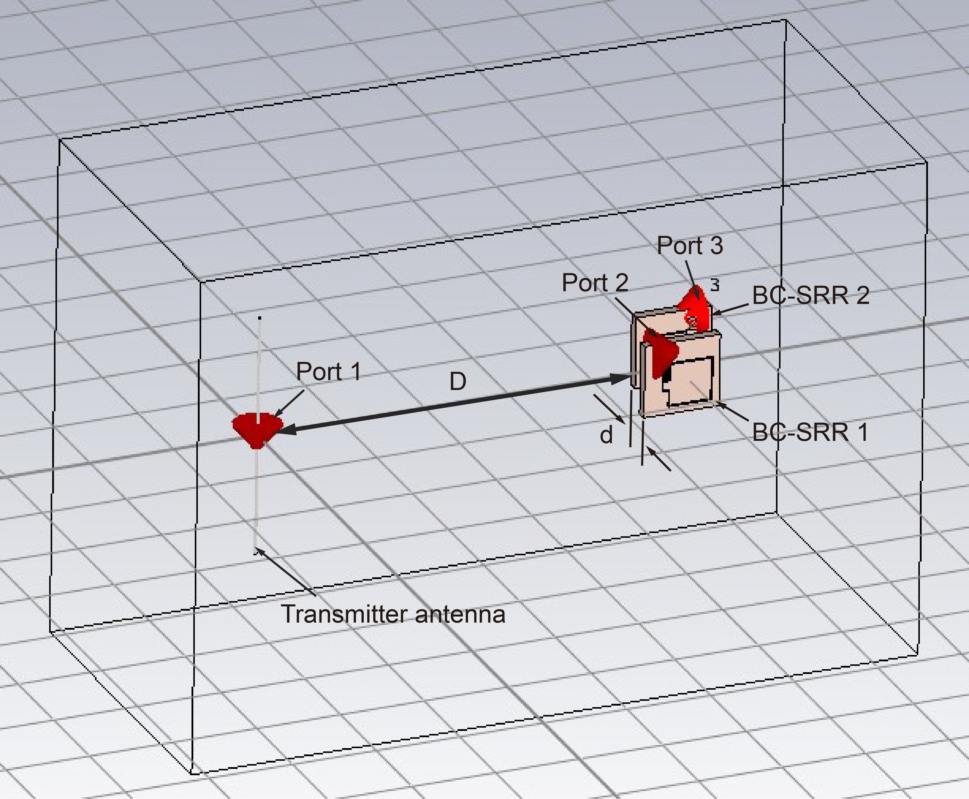

Figure S3. The simulation model to analyze the RF characteristics of the designed BC-SRRs. The BC-SRRs were placed at a distance D = 10 cm from the RF transmitter antenna. The BC-SRR1 and BC-SRR2 were figured with a spacing d and a phase difference of 90°.

In the model, the transmitter antenna is modeled as a single thin perfect electric conducting (PEC) cylinder as a dipole antenna. A gap is formed in the PEC cylinder as port 1 for feeding the excitation. The port 2 and port 3 are placed at the slits of two SRRs for RF energy reception. The material of SRRs and dielectric layer are set as copper and FR4, respectively.

- Simulated and calculated reflection coefficients of the BC-SRR.

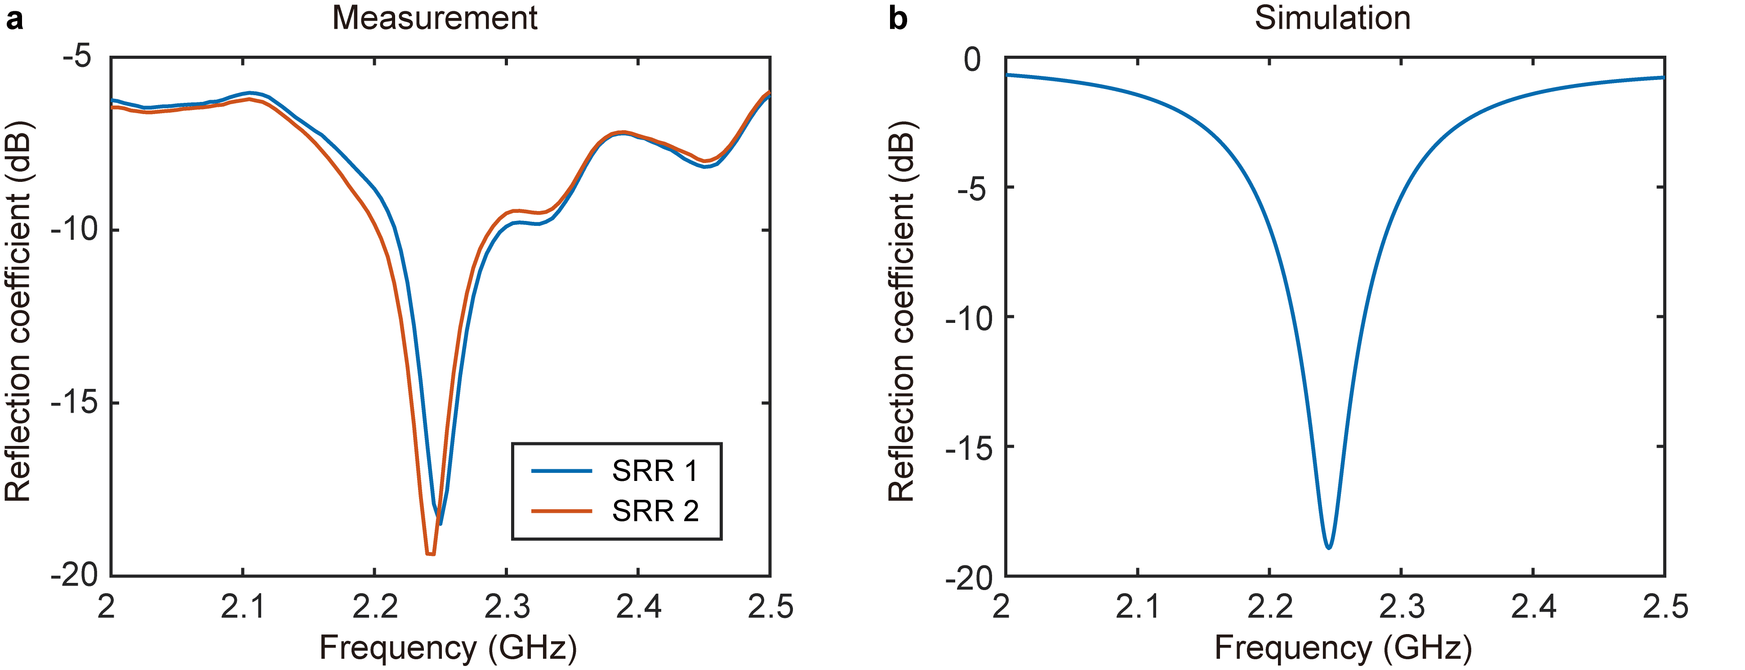

Figure S4. (a) Measured reflection coefficients of the two BC-SRRs. (b) Simulated reflection coefficients of the BC-SRR when the epsilon of dielectric layer is 5. Measured results have shown that the SRR resonated at approximately 2.25 GHz consistent with the simulation. The minimum value of reflection coefficients is around -18.9 dB.

The structural size parameters in the simulation model are the same as those in the actual sample. Note that the two BC-SRRS show slightly different spectra because of manufacturing deviation.

- Simulated and calculated transmission coefficients of the BC-SRR.

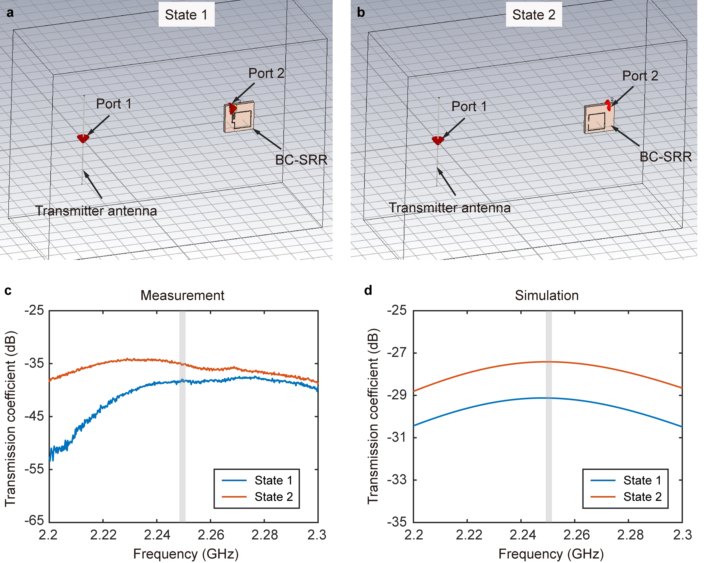

Figure S5. The simulation model to analyze the RF characteristics of the designed BC-SRR. (a) State 1: and (b) State 2. (c) Measured transmission coefficients of the fabricated BC-SRR (State 1 and State 2). (d) Simulated transmission coefficients of the BC-SRR (State 1 and State 2). It can be observed that the measured transmission coefficient (State 2) is higher than that of State 1 at the operating frequency (grey area), which is similar to the simulation results.

- Measured transmission coefficients (S₂₁ and S₃₁) of the BC-SRRs with varied d.

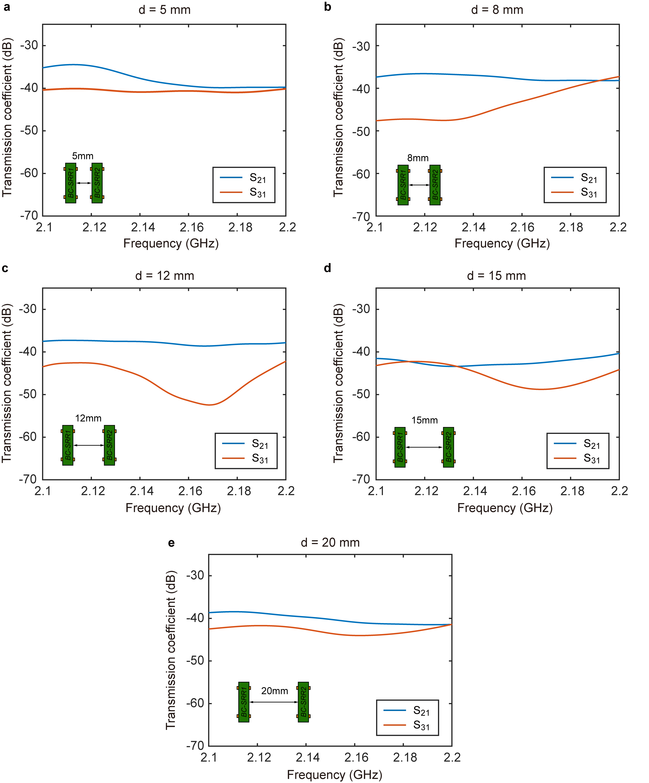
Figure S6. Measured S₂₁ and S₃₁ of the BC-SRRs with different d. (a) 5 mm, (b) 8 mm, (c) 12 mm, (d) 15 mm, and (e) 20 mm.
Since the vector network analyzer has merely two output ports, only one SMA port of the BC-SRRs (port 2/port 3) can be connected to the testing instrument, and the other port (port 3/port 2) was connected to a 50-ohm resistance load. In each measurement, we swapped the connection configuration to obtain both S₂₁ and S₃₁ curves.

