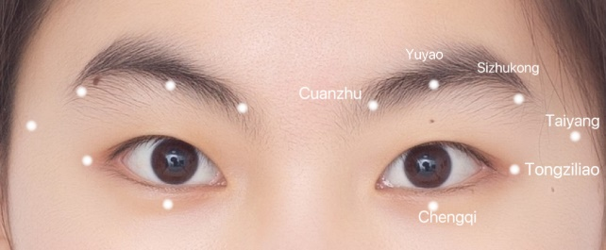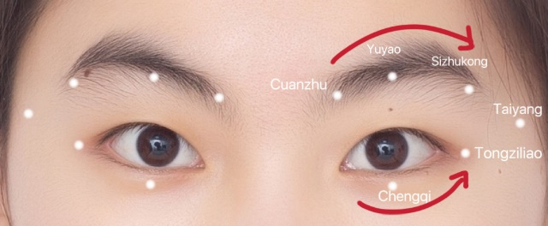
Figure 1 and 2: The positions and order of the acupoints used for eye exercises of acupoints.
The rib surface of the thumb is pressed on the temple, and the rest of the four fingers are fisted, and the inner side of the second section of the left and right index fingers is used to shave the orbit up and down a circle. The upper side begins from the brow and ends at the tip of the brow; Below from the inner corner of the eye to the outer corner of the end, first up and then down, the wheel scraping the next circle.

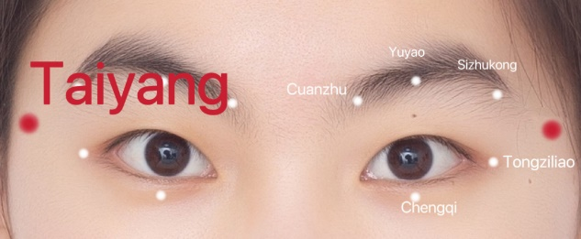
Taiyang (EX-HN5): The middle third of the line between the brow tip and the upper edge of the ear, touch a depression with your finger;

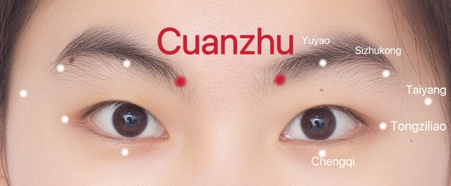
Cuanzhu (BL2): On the face, in the depression of the medial end of the eyebrow, at the supraorbital notch;

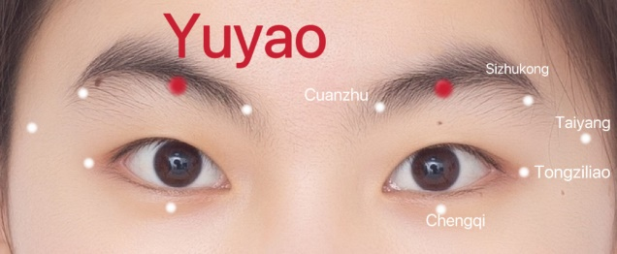
Yuyao (EX-HN4): Right above the pupil, in the middle of the eyebrow;

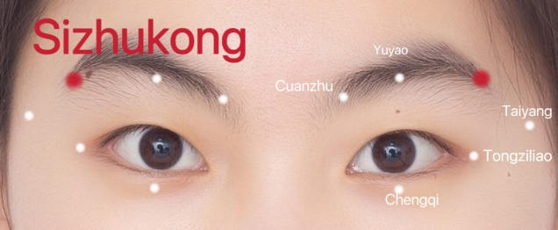
Sizhukong (TE23): In the depression at the end of the brow;

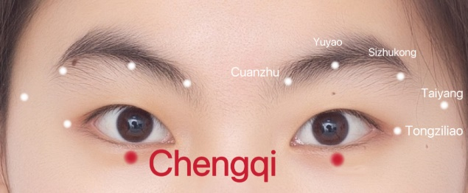
Chengqi (ST1): On the face, directly below the pupil, between the eyelid margin and the inferior orbital margin;

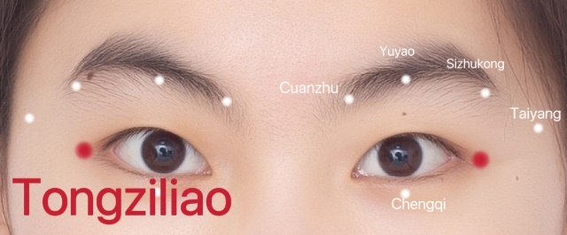
Tongziliao (GB1): A 0.5 cm depression lateral to the canthus.

