Soil-root interactions under conditions of high mechanical resistance facilitated by root mucilage secretion
Plant and Soil
Ehsan Ghezelbashª, Mohammad Hossein Mohammadi^{a,*}, Mahdi Shorafaª
ª Department of Soil Science, Faculty of Agriculture Engineering & Technology, College of Agriculture & Natural Resources, University of Tehran, Daneshkadeh Ave, Karaj 3158777871, Iran
* Corresponding author. E-mail address: mhmohmad@ut.ac.ir
- Supplemental figure S1 showed one of the studied maize brace roots that exuded mucilage due to immerge in water tube for 24 hours.
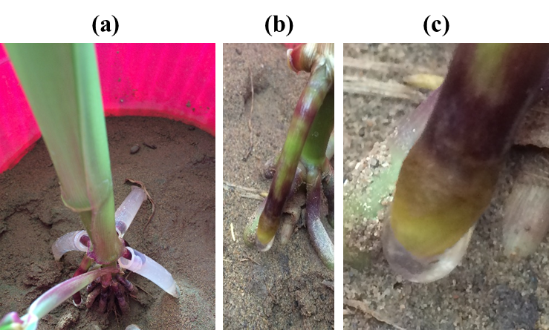
SUPPLEMENTAL FIGURE S1 mucilage extraction from studied maize brace roots
- Mucilage saturation water content shows that maize 704 cultivar contained more water content at saturated form (McCully and Boyer, 1997) in all studied treatments (Supplemental figure S1).
(a)
(b)
SUPPLEMENTAL FIGURE S2 Mucilage saturation water content for maize cultivars under different levels of a) SMR introduced by compaction (SMR1) and b) SMR introduced by cementation (SMR2)

