Physical Understanding of the tropical cyclone intensity and size relations over the North Indian Ocean
Yerni Srinivas Nekkali¹, Krishna K Osuri¹*

¹ Department of Earth and Atmospheric Sciences, NIT Rourkela, Odisha, India

Submitting to the Climate Dynamics
Yerni Srinivas Nekkali (0000-0002-5730-3550)
Krishna Kishore Osuri (0000-0001-9088-9656)

Corresponding Author: Dr. Krishna Kishore Osuri
Assistant Professor,
Department of Earth and Atmospheric Sciences,
NIT Rourkela, Odisha, India
osurikishore@gmail.com

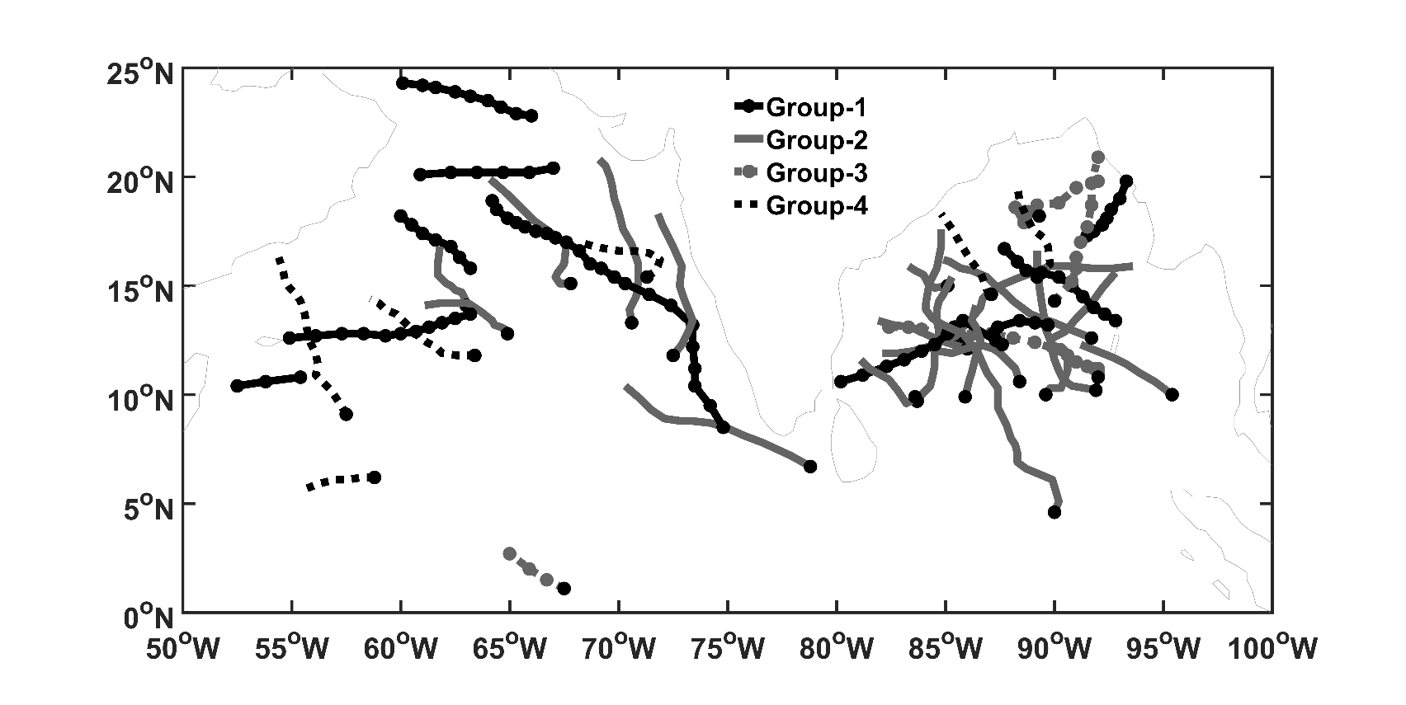
Figure S1: The track distribution related with various groups: Group-1, Group-2, Group-3 and Group-4.
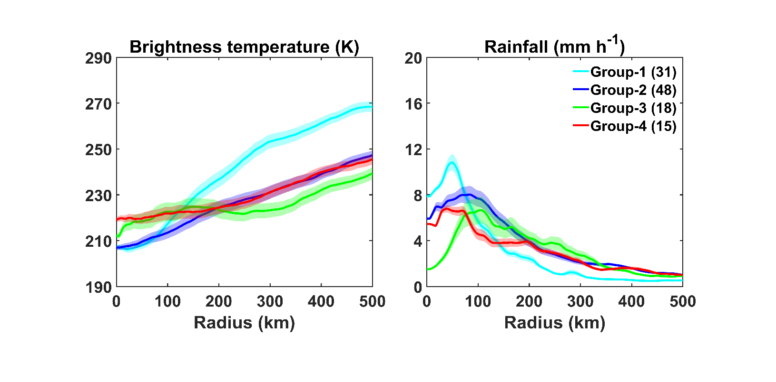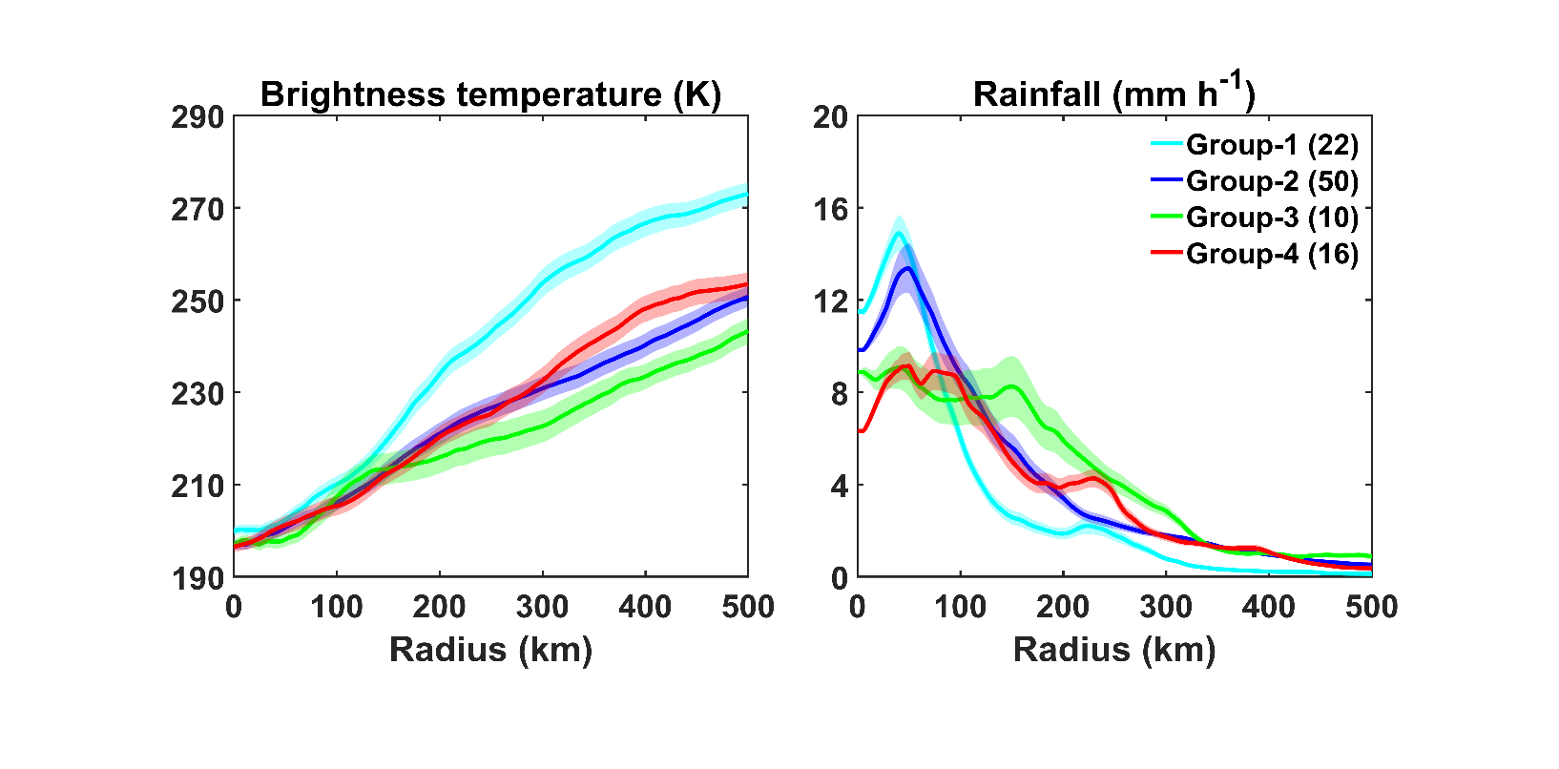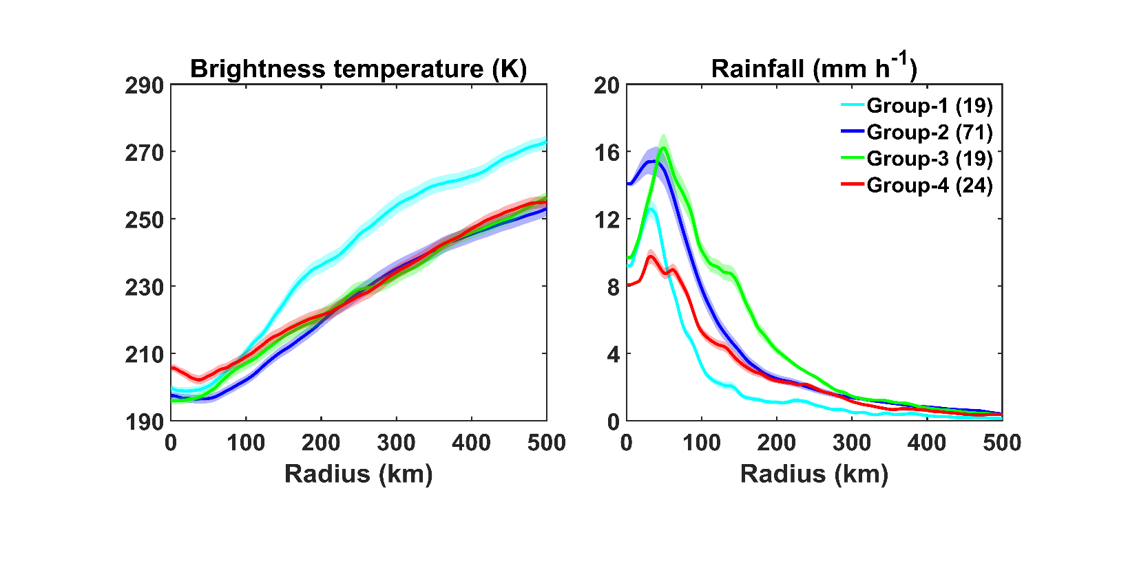
Figure S2: The radial distribution of IR brightness temperature (K) for Group-1, Group-2, Group-3, Group-4 TCs with (a) CS (b) SCS and (c) VSCS intensity stages. (d-f) are the same as (a-c) but for rainfall (mm h⁻¹). The number in parentheses indicates the number of cases. Shading represents the 95% confidence interval.

VSCS SCS CS
(a) (d)

(b) (e)

(c) (f)
Fig S3: Averaged deep Wind shear (m s⁻¹) between atmospheric vertical levels such as 850 and 200 hPa for different groups at CS, SCS and VSCS stage. Bar represents the 95% confidence level.

