Un-supervised classification of ICU patients according to congestion endotypes identifies clinical profiles associated with distinct outcomes.
Pierre-Grégoire Guinot, Dan Longrois, Stefan Andrei, Maxime Nguyen, Belaid Bouhemad

Supplemental Table 1. Proposed Requirements for Cardiovascular Imaging-Related Machine Learning Evaluation (PRIME) checklist
1 Designing the Study Plan
1.1 Describe the need for the application of machine learning to the dataset | Introduction section
1.2 Describe the objectives of the machine learning analysis | Introduction section
1.3 Define the study plan | Machine Learning Approach (Methods) Paragraph 1
1.4 Describe the summary statistics of baseline data | Results section and supplementary table
1.5 Describe the overall steps of the machine learning workflow | Material and method section: statical sub section
2 Data Standardization, Feature Engineering, and Learning
2.1 Describe how the data were processed in order to make it clean, uniform, and consistent | Statistical analysis
2.2 Describe whether variables were normalized and if so, how this was done | Material and method section: statical sub section
2.3 Provide details on the fraction of missing values (if any) and imputation methods | Material and method section: statical sub section
2.4 Describe any feature selection processes applied
2.5 Identify and describe the process to handle outliers if any
2.6 Describe whether class imbalance existed, and which method was applied to deal with it
3 Selection of Machine Learning Models
3.1 Explicitly define the goal of the analysis e.g., regression, classification, clustering
3.2 Identify the proper learning method used (e.g., supervised, reinforcement learning etc.) to address the problem | Machine Learning Approach (Methods) Paragraph 2
3.3 Provide explicit details on the use of simpler, complex, or ensemble models | Machine Learning Approach (Methods) Paragraph 3
3.4 Provide the comparison of complex models against simpler models if possible | Decision tree (Results)
3.5 Define ensemble methods, if used
3.6 Provide details on whether the model is interpretable
4 Model Assessment
4.1 Provide a clear description of data used for training, validation, and testing | Material and method section: statical sub section
4.2 Describe how the model parameters were optimized (e.g., optimization technique, number of model parameters etc.) | Material and method section: statical sub section
5 Model Evaluation
5.1 Provide the metric(s) used to evaluate the performance of the model | Material and method section: statical sub section
5.2 Define the prevalence of disease and the choice of the scoring rule used
5.3 Report any methods used to balance the numbers of subjects in each class
5.4 Discuss the risk associated to misclassification
6 Best Practices for Model Replicability
6.1 Consider sharing code or scripts on a public repository with appropriate copyright protection steps for further development and non-commercial use | Code available on request
6.2 Release a data dictionary with appropriate explanation of the variables | Material and method section
6.3 Document the version of all software and external libraries used | Material and method section: statical sub section
7 Reporting Limitations, Biases and Alternatives
7.1 Identify and report the relevant model assumptions and findings | Results
7.2 If well performing models were tested on a hold-out validation dataset, detail the data of that validation set with the same rigor as that of training dataset (see section 2 above) | NA

Supplemental Table 2. Study cohort’s general characteristics
Variables | Overall cohort  (n = 145)
Age (years), mean (SD) | 64 (15)
Gender, n (%)
- Males | 86 (59%)
Body mass index (kg/m²), mean (SD) | 27.6 (6)
Comorbidities, n (%)
- Chronic obstructive pulmonary disease | 14 (10%)
- High blood pressure | 86 (59%)
- Ischemic heart disease | 49 (34%)
- Chronic systolic heart failure | 21 (15%)
- Valvular heart disease | 37 (26%)
- Peripheral artery disease | 12 (8%)
- Diabetes on oral antidiabetics | 26 (18%)
- Diabetes on insulin | 15 (10%)
- Chronic kidney disease | 15 (10%)
- Stroke | 15 (10%)
Admission SAPS II, median [IQR] | 46 [37;59]
Abbreviations: ICU – intensive care unit; n – number; SAPS II – simplified acute physiology score II; SD – standard deviation.

Supplemental Table 3. Jaccard similarity index mean for HCPC an k means
 | cluster 1 | cluster 2 | cluster 3
HCPC | 0.661 | 0.698 | 0.975
K means clustering | 0.246 | 0.719 | 0.965

Supplemental Table 4. Link between the dimensions and the continuous variables. IVC: inferior vena cava, PLR: passive leg raising, SV: stroke volume.

First Dimension.
Variables | Correlation coefficient | p-value
S/D supra hepatic wave ratio | 0.691 | 6.45e-22
IVC variation's | 0.631 | 1.65e-17
Renal venous impedance | 0.453 | 9.96e-09
Fluid overload | 0.436 | 4.07e-08
SV change following PLR | 0.322 | 7.491e-05
NT pro-BNP | -0.341 | 3.421e-03
Mitral E/e' ratio | -0.511 | 4.65e-11
Central venous pressure | -0.511 | 1.14e-14
Mean IVC diameter | -0.770 | 8.37e-30

Second Dimension
Variables | Correlation coefficient | p-value
Portal vein pulsatility index | 0.719 | 2.24e-24
NT pro-BNP | 0.538 | 2.97e-12
IVC variation's | 0.355 | 1.15e-05
Renal venous impedance | 0.196 | 1.76e-02
SV change following PLR | -0.473 | 1.78e-09

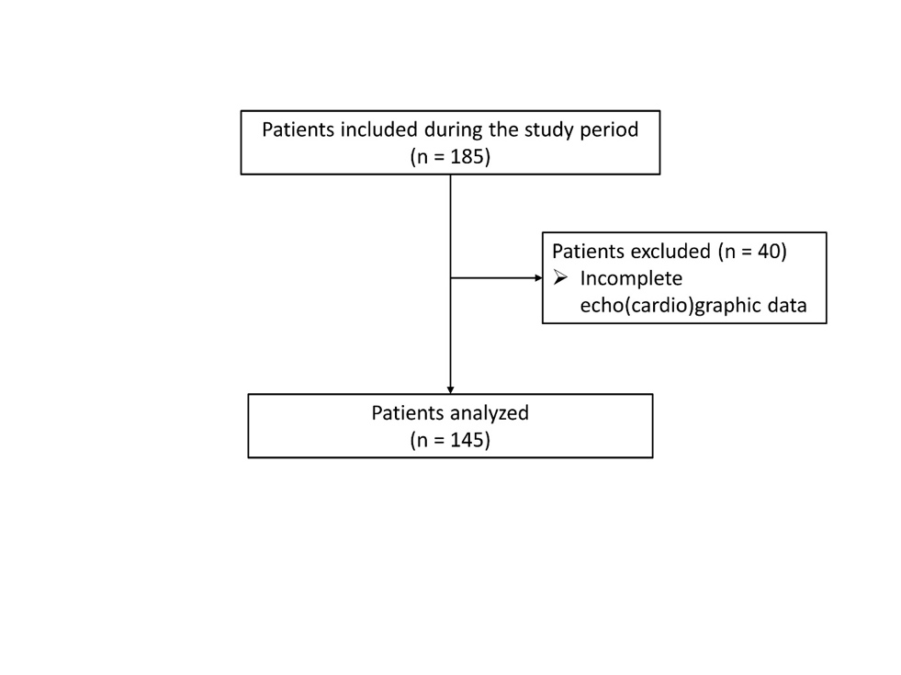
Figure 1. Flow chart diagram of the study

