Supplementary Material
Table.S1 GenBank Accession Numbers used in present study.
Genus | Strain | Genome* | gyrB* | rpoB* | atpD* | infB*
Affinibrenneria salicis.sp. nov. | L3-3HA^{T} | NZ VYKJ00000000 | NZ VYKJ00000000
Brenneria alni | NCPPB 3934^{T} |  | JF311627 | JF311852 | JF311514 | JF311740
Brenneria corticis | gBX10-1-2^{T} (CFCC 11842^{T}) | QDKH00000000 | QDKH00000000
Brenneria goodwinnii | LMG 26270^{T} (FRB 141^{T}) | NZCP014137 | JN544220 | JN544238 | JN544211 | JN544229
Brenneria nigrifluens | LMG 2694^{T} | NZKZ818945 | JF311612 | JF311837 | JF311499 | JF311725
Brenneria populi subsp.populi | D9-5^{T} |  | KJ672083 | KJ672084 | KJ672086 | KJ672085
Brenneria roseae subsp.americana | FRB 223^{T} (LMG 27715^{T}) | NZ QDKJ00000000 | KF308310 | KF308330 | KF308300 | KF308320
Brenneria roseae subsp.roseae | FRB 222^{T} (LMG 27714T) | NZKZ819022 | KF308303 | KF308323 | KF308293 | KF308313
Brenneria rubrifaciens | LMG 2709^{T} (6D370^{T}) | NZCP034035 | JF311617 | JF311842 | JF311504 | JF311730
Brenneria salicis | LMG 2698^{T}（ATCC 15712^{T}) | NZMJMA01000000 | JF311622 | JF311847 | JF311509 | JF311735
Cronobacter sakazakii | ATCC BAA-894^{T} (ATCC 29544^{T}) | NZCP011047 | NZCP011047
Dickeya chrysanthemi | LMG 2804^{T} (NCPPB 402^{T}) | NZCM001974 | JF311636 | JF311861 | JF311523 | JF311749
Dickeya dadantii spp.dierrenbachiae | LMG 25992^{T} (NCPPB 2976^{T}) | NZCM001978 | JF311652 | JF311877 | JF311539 | JF311765
Dickeya dianthicola | LMG 2485^{T} (NCPPB 453^{T}) | NZCM001841 | JF311648 | JF311873 | JF311535 | JF311761
Dickeya fangzhongdai | DSM 101947^{T} | NZCP025003 | NZCP025003
Dickeya paradisiaca | LMG 2542^{T} (NCPPB 2511^{T}) | NZCM001857 | JF311640 | JF311865 | JF311527 | JF311753
Dickeya poaceiphila | NCPPB 569^{T} |  | NZCP042220
Dickeya oryzae | JCM 33020^{T} (ZYY5^{T})
Izhakiella australiensis | D4N98^{T} (LMG 30066^{T}) |  | KY770965 | KY770963 | KY770964 | NZMRUL00000000
Izhakiella capsodis | N6PO6^{T} | NZFOVC01000030 | KM267159 | KM841418 | KM267158 | NZFOVC01000030
Lonsdalea britannica | LMG 26267^{T} | NZLUTN01000001 | JF311666 | JF311891 | JF311553 | JF311779
Lonsdalea iberica | LMG 26264^{T} | NZLUTP01000001 | JF311665 | JF311890 | JF311552 | JF311778
Lonsdalea populi | LMG 27349^{T} (CFCC11748^{T}) | LUTM00000000
Lonsdalea quercina | LMG 2724^{T} (ATCC 29281^{T}) | NZFNQS01000000 | JF311656 | JF311881 | JF311543 | JF311769
Mixta intestinalis | SRCM 103226^{T} | NZCP028271 | NZCP028271
Mixta calida | 1400/07^{T} |  | GQ367480 | GQ367479 | GQ367477 | GQ367476
Mixta tenebrionis | BIT-26^{T} |  | MN089593 | MN089599 | MN089590 | MN089596
Pantoea dispersa | LMG 2603^{T} (CCUG 25232^{T}） | NZVXKA01000001 | FJ617346 | EF988990 | EF988731 | EF988904
Pantoea stewartii spp.stewartii | LMG 2715^{T}（DC283^{T}） | NZCP017581 | EF988831 | EF989003 | EF988744 | EF988917
Pectobacterium betavasculorum | LMG 2466^{T} (NCPPB 2795^{T}) |  | JF311593 | JF311819 | JF311480 | JF311706
Pectobacterium cacticida | LMG 17936^{T} |  | JF311597 | JF311823 | JF311484 | JF311710
Pectobacterium carotovorum | LMG 2404^{T} (DSM 30168^{T}) | NZFQWI01000025 | JF311601 | HM359006† | JF311488 | JF311714
Pectobacterium parvum | Pcc s0421^{T} (LMG 30828^{T}) |  | NZOANP03000001
Pectobacterium wasabiae | LMG 8444^{T} (CFBP 3304^{T}) | NZCP015750 | JF311608 | JF311833 | JF311495 | JF311721
Pectobacterium versatile | 3-2^{T} | NZCP024842
Sodalis praecaptivus | HS^{T} | CP006569 | CP006569

*GenBank accession numbers.
†Sequences used in previous studies.

Table S2. Fatty acid compositions of the novel strains and reference type strains of species.
Strain: 1, Affinibrenneria salicis sp. nov; 2, Lonsdalea quercina LMG 2724^{T}; 3, Brenneria salicis LMG 2698^{T}; 4, Dickeya chrysanthemi LMG 2804^{T}; 5, Pectobacterium carotovorum LMG 2404^{T}.

Fatty acid | 1 | 2 | 3 | 4 | 5
Saturated fatty acids
C_{12:0} | 0.5 | 0.5 | 4.4 | 0.2 | 9.6
C_{14:0} | 9.7 | 10.60 | 5.1 | 6.8 | 1.7
C_{16:0} | 43.5 | 30.2 | 29.8 | 25.9 | 24.5
Unsaturated fatty acids
C_{18:1} ω7c | 2.8 | 9.4 | 14.5 | 15.4 | 13.9
C_{19:0 cyclo} ω8c | 10.7 | - | - | - | -
Cyclopropane fatty acids
C_{17:0} | 18.4 | 9.8 | 9.1 | 1.9 | -
C_{19:0} | - | 1.7 | 0.7 | - | -
C_{14:0} 3OH and/ or C_{16:1} iso I | 7 | 12.7 | 11.5 | 12.5 | 14.8
C_{16:1}ω7c and/ or iso-C_{15:0} 2-OH | 4.5 | 23.1 | 23.6 | 34.3 | 32.6

Table S3. Amino acid identity (AAI) analysis among novel isolate and reference strains of genera Lonsdalea, Brenneria, Dickeya, Pectobacterium, Sodalis
Strain: 1, Affinibrenneria salicis sp. nov; 2, Brenneria salicis LMG 2698^{T}; 3, Dickeya chrysanthemi LMG 2804^{T}; 4, Lonsdalea quercina LMG 2724^{T}; 5, Pectobacterium carotovorum LMG 2404^{T}; 6, Sodalis praecaptivus HS^{T}.
Strains | 1 | 2 | 3 | 4 | 5 | 6
1 | 100 | 71.04 | 68.92 | 69.27 | 70.32 | 64.22
2 | 74.9 | 100 | 74.59 | 73.63 | 81.12 | 68.3
3 | 71.04 | 73.26 | 100 | 73.29 | 74.55 | 66.54
4 | 73.39 | 74.42 | 75.51 | 100 | 73.89 | 67.32
5 | 71.63 | 78.07 | 73.3 | 71.28 | 100 | 66
6 | 65.06 | 65.51 | 64.73 | 64.55 | 65.33 | 100

Fig.S1 Neighbor-joining tree based on 16S rRNA gene sequences of strains of eight genera and the novel species. Bootstrap values after 1000 replicates are expressed as percentages. Cronobacter sakazakii is included as an outgroup; gene sequences were obtained from genome sequencing database (http://www.bacterio.net). Bar, 0.0020 substitutions per site.

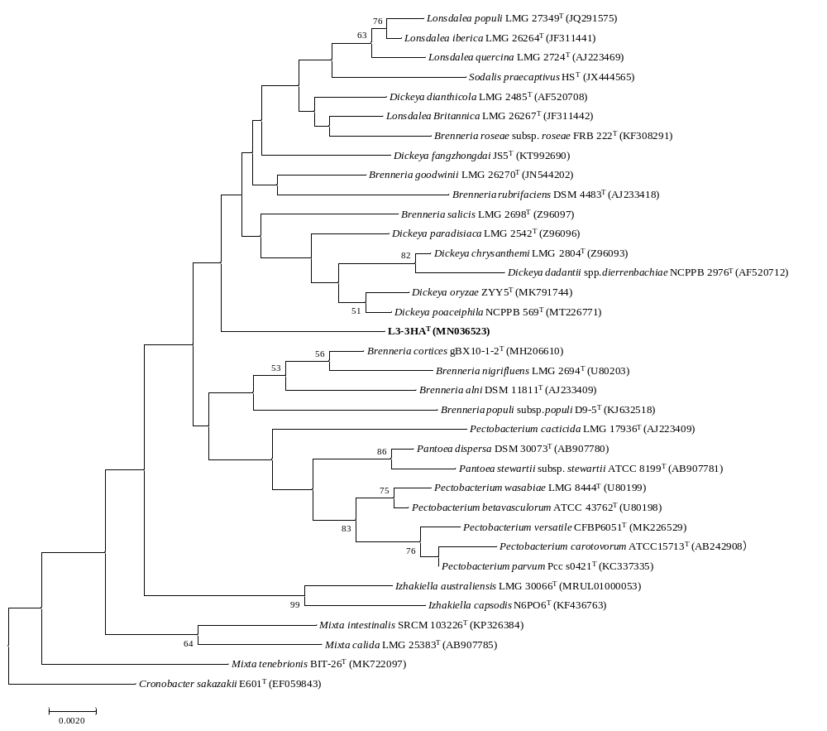

Fig.S2 Neighbor-joining tree based on concatenated partial gyrB, rpoB, atpD, infB gene sequences of the type strains in the genera Lonsdalea, Brenneria, Dickeya, Pectobacterium, Sodalis, Izhakiella, Pantoea and Mixta. Bootstrap values after 1000 replicates are expressed as percentages. Cronobacter sakazakii is included as an outgroup; gene sequences were obtained from genome sequencing database (http://www.ncbi.nlm.nih.gov). Bar, 0.050 substitutions per site.
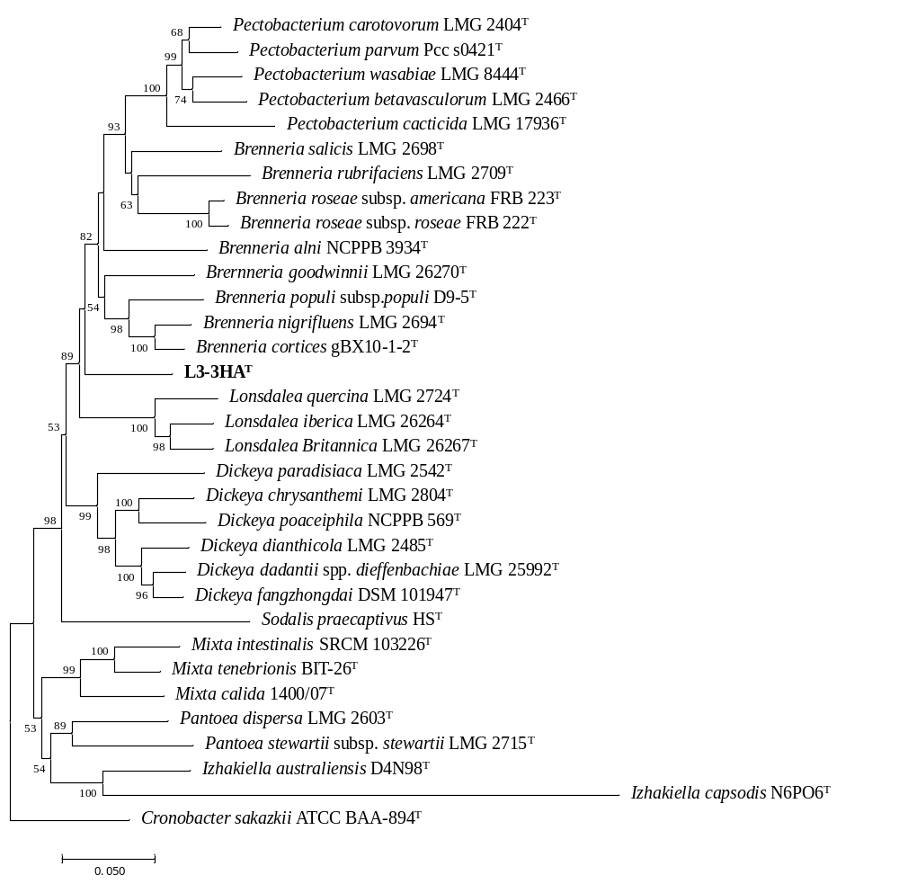

Fig. S3 K-mer of genome sequence of novel strain
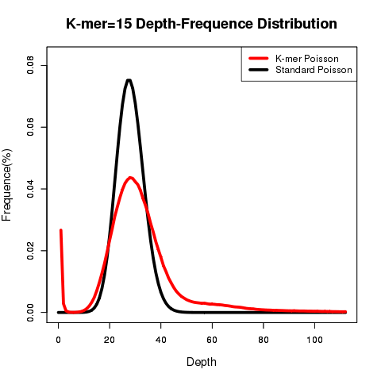
Fig. S4 GC-depth of genome sequence of novel strain
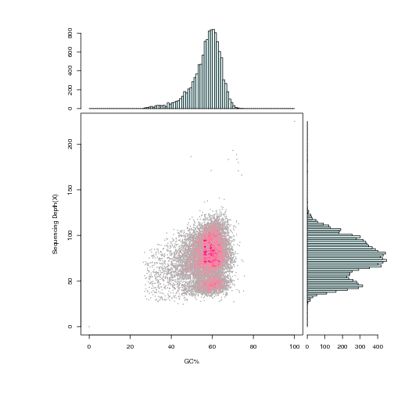
Fig.S5 transmission electron microscopy of Affinibrenneria salicis sp. nov
