Supporting information
Two-step modification of sepiolite (SDS/isep) and its performance for remediation of Pb contaminated water

¹Yiming Gu, ¹*Huixia Feng, ²Bin Wang, ³Liang Zhang, ¹Sijie Liang, ¹Nali Chen, ¹Lin Tan

¹School of Petrochemical Technology, Lanzhou University of Technology, Lanzhou, P.R. China
²School of Materials Science and Engineering, Southwest Jiaotong University, Chengdu, P.R. China
³Department of Machine Intelligence and Systems Engineering Faculty of Systems Engineering, Akita Prefectural University, Akita, Japan

* Corresponding author at: College of Petrochemical Engineering, Lanzhou University of Science and Technology, Lanzhou, 730050, China.
E-mail address: fenghx@lut.edu.cn (H. Feng).

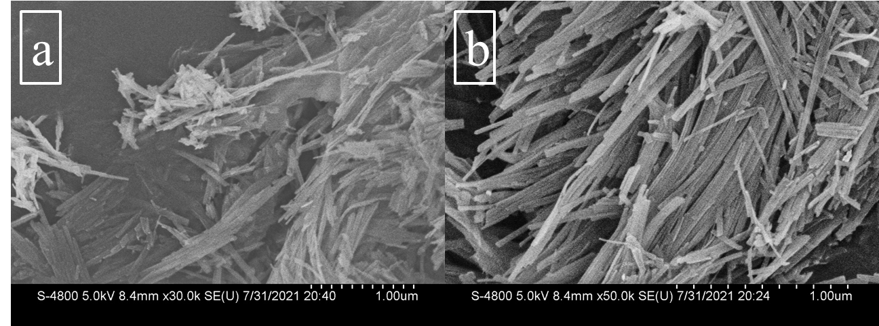
Fig. S1. (a) SEM micrographs of natural sepiolite; (b), SEM micrographs of isep.
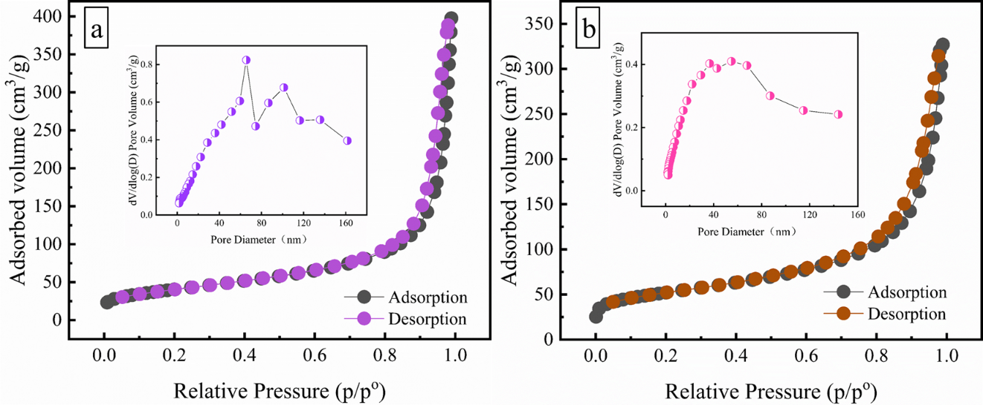
Fig. S2. (a) N₂ adsorption-desorption isotherms and BJH pores of the natural sepiolite.; (b), N₂ adsorption-desorption isotherms and BJH pores of the isep.
Fig. S3. TGA/DTG curve of SDS/isep

Table S1 XRD indexes of natural sepiolite and as@sep adsorbents.
hkl | natural sepiolite |  |  | isep |  |  | SDS/isep
 | 2θ(°) | Height | d(Å) | 2θ(°) | Height | d(Å) | 2θ(°) | Height | d(Å)
(110) | 7.291 | 19438 | 12.114 | 7.341 | 30678 | 11.953 | 7.370 | 14173 | 11.985
(060) | 19.897 | 3557 | 4.459 | 19.703 | 3041 | 4.487 | 19.697 | 2035 | 4.503
(031) | 20.646 | 5498 | 4.298 | 20.626 | 4870 | 4.301 | 20.625 | 3398 | 4.302
(221) | 22.461 | 3548 | 3.955 | 23.767 | 3230 | 3.953 | 23.862 | 1955 | 3.740
(400) | 26.654 | 3978 | 3.342 | 26.731 | 3291 | 3.335 | 26.586 | 1903 | 3.350
(191) | 35.275 | 4541 | 2.542 | 35.012 | 3834 | 2.553 | 35.028 | 2135 | 2.559

Table S2 Sepcific surface area and pore characters of sepiolite and as@sep.
Sample | Sepcific surface | Pore volume | Pore size
natural sepiolite | 143.7 m²/g | 0.61 cm³/g | 17.1 nm
isep | 184.4 m²/g | 0.51 cm³/g | 10.9 nm
SDS/isep | 104.4 m²/g | 0.57 cm³/g | 21.9 nm

Table S3 The cation exchange capacity of three absorbents
Sample | Cation exchange capacity
natural sepiolite | 61.6 cmol/kg
isep | 66.8 cmol/kg
SDS/isep | 68.8 cmol/kg

