Appendix – figures

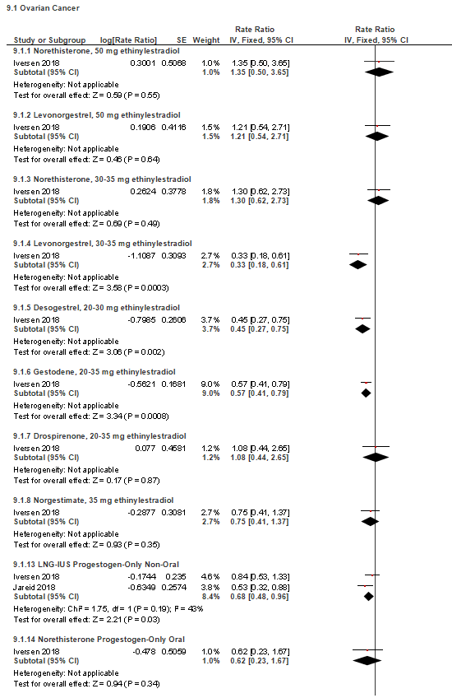
Appendix 3- Figure S1 . Forest Plot on Hormonal Contraceptive Dose Regimens and Ovarian Cancer
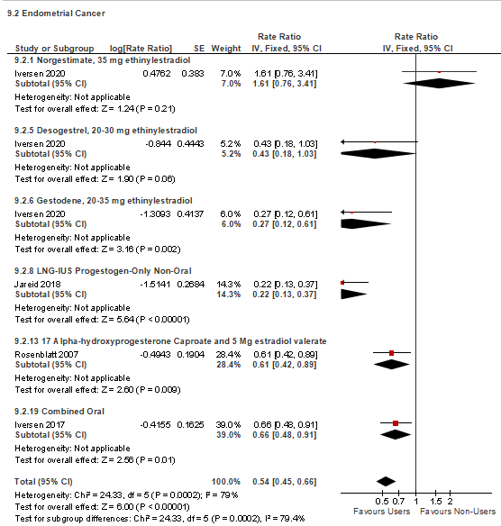
Appendix 3- Figure S2. Forest Plot on Hormonal Contraceptive Dose Regimens and Endometrial Cancer

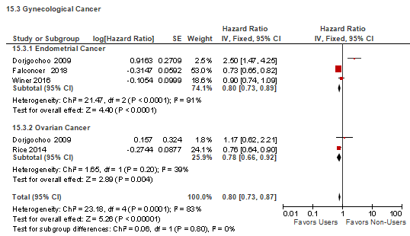
Appendix 3- Figure S3. Forest Plot on Tubal Ligation and Cancer Outcomes

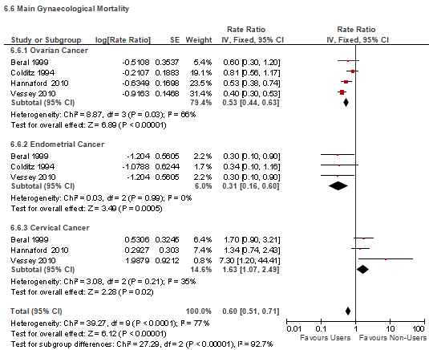
Appendix 3- Figure S4. Forest Plot on Hormonal Contraception and Gynecological Cancer Mortality
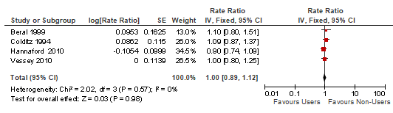
Appendix 3- Figure S5. Forest Plot on Hormonal Contraceptive Use and Breast Cancer Mortality

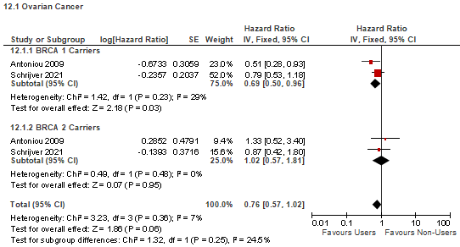
Appendix 3- Figure S6. Forest Plot on Short Term (<5 years) Contraceptive Use and Ovarian Cancer

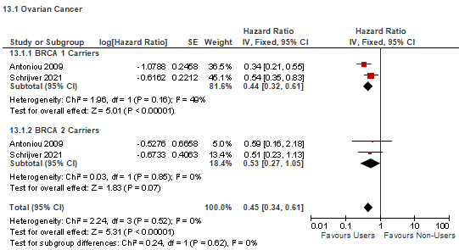
Appendix 3- Figure S7. Forest Plot on Contraceptive Use Between 4-9 years and Ovarian Cancer

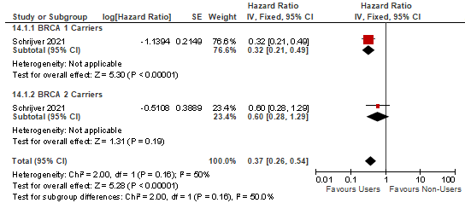
Appendix 3- Figure S8. Forest Plot on Longer Term (> 10 years) Contraceptive Use and Ovarian Cancer

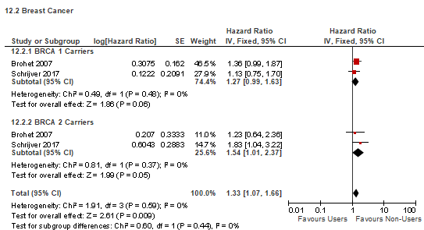
Appendix 3- Figure S9. Forest Plot on Short Term (<5 years) Contraceptive Use and Breast Cancer

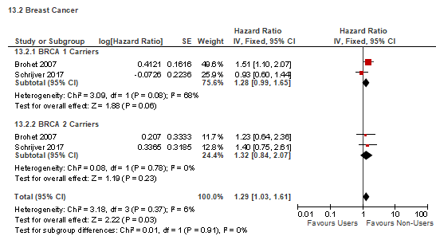
Appendix 3- Figure S10. Forest Plot on Contraceptive Use Between 4-9 years and Breast Cancer

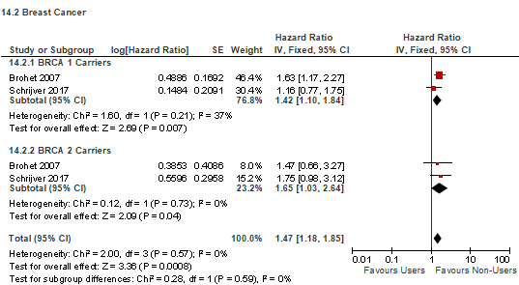
Appendix 3- Figure S11. Forest Plot on Longer Term (> 10 years) Contraceptive Use and Breast Cancer

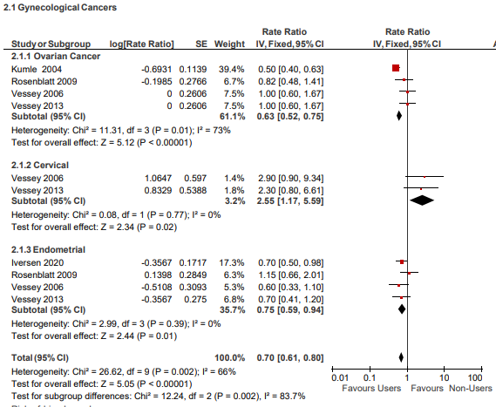
Appendix 3- Figure S12. Forest Plot on Short Term Contraceptive Use and Gynecological Cancer
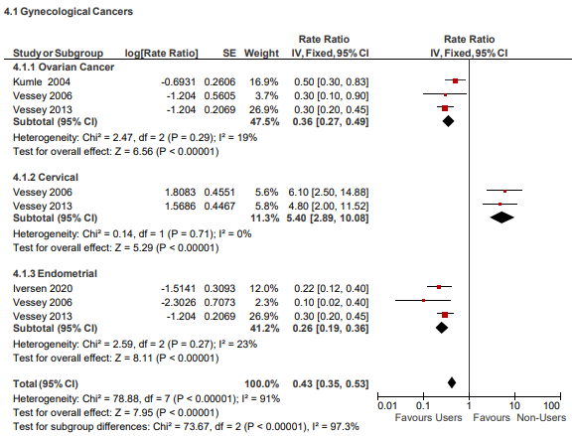

Appendix 3- Figure S13. Forest Plot on Long Term Contraceptive Use and Gynecological Cancer

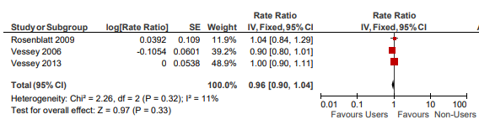
Appendix 3- Figure S14. Forest Plot on Short Term Contraceptive Use and Breast Cancer

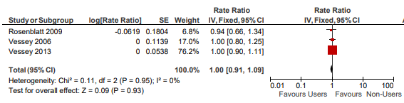
Appendix 3- Figure S15. Forest Plot on Long Term Contraceptive Use and Breast Cancer

