Appendix 1 - A: Summary of U.S. Medical Eligibility Criteria for Contraceptive Use
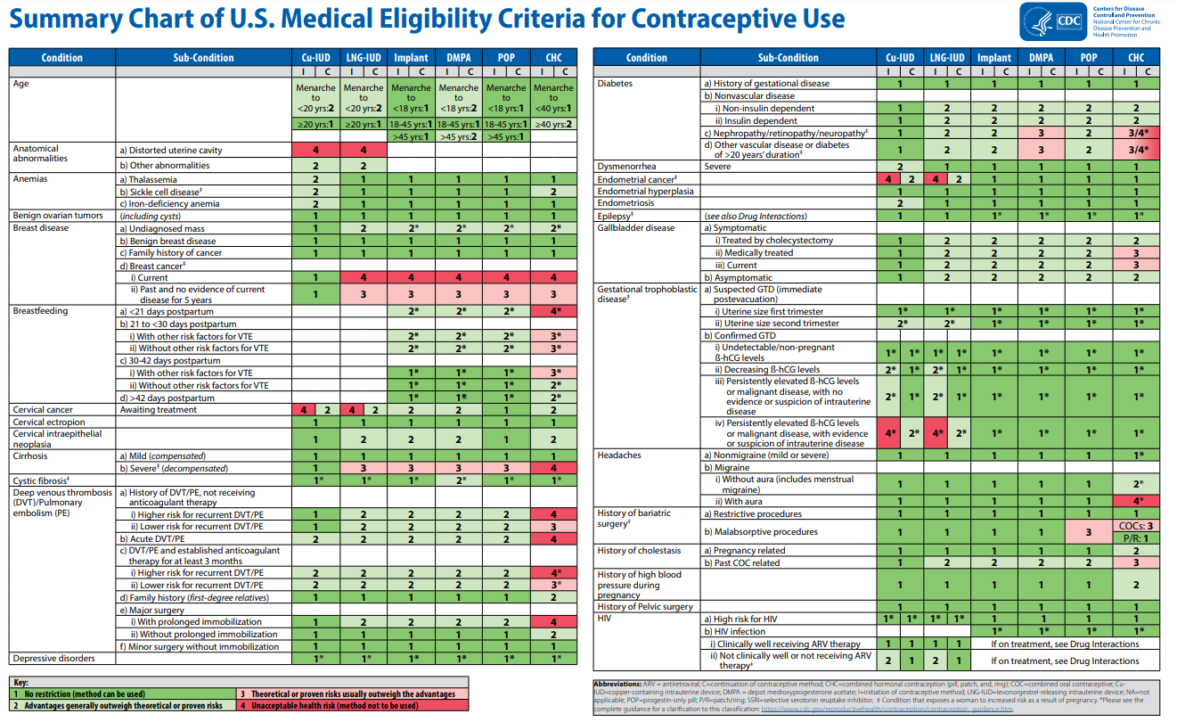
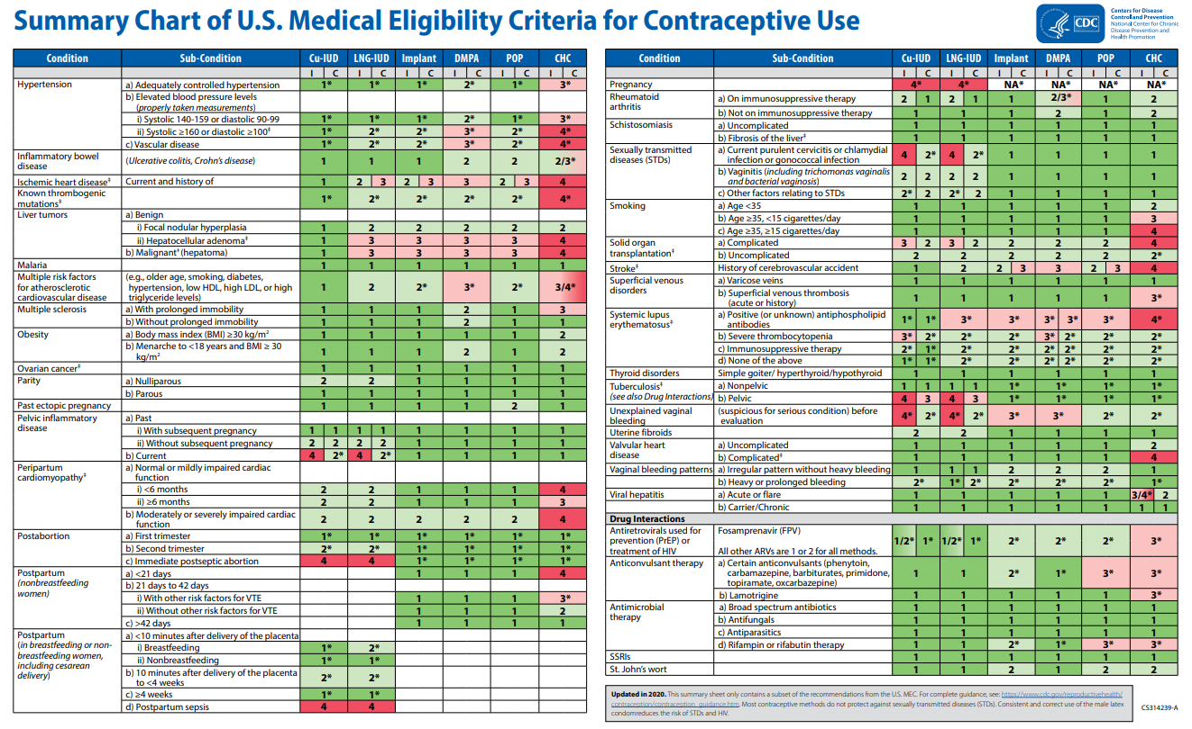

Appendix 1 - B: Data sources
Global databases
Cumulative Index to Nursing and Allied Health Literature (CINAHL)
https://www.ebsco.com/products/research-databases/cinahl-database
OVID Medline
https://www.wolterskluwer.com/en/solutions/ovid/ovid-medline-901
Embase
https://www.embase.com
PsycINFO
https://www.apa.org/pubs/databases/psycinfo
Maternity & Infant Care
https://www.midirs.org/resources/maternity-and-infant-care-mic-database/
Clinical trial.gov
https://clinicaltrials.gov/
Web of science
https://clarivate.com/webofsciencegroup/solutions/web-of-science/
Scopus
https://www.scopus.com
Cochrane Central Register of Controlled Trials (CENTRAL)
https://www.cochranelibrary.com/central
Local databases
Africa (AIM)
http://indexmedicus.afro.who.int/
Latin America and the Caribbean (LILACS)
http://bases.bvs.br/
A network of Health Science Libraries across Asia (HELLIR)
http://www.hellis.org
Virtual Health Sciences Library
http://www.emro.who.int/HIS/VHSL/
IBECS
http://ibecs.isciii.es
Scientific Electronic Library Online (SciELO)
http://www.scielo.br
Pan American Health Library (PAHO)
https://www.paho.org
WHO Library (WHOLIS)
http://dosei.who.int
Western Pacific Region Index Medicus (WPRO)
http://www.wprim.org
Index Medicus for the South‐East Asia Region (IMSEAR)
http://imsear.hellis.org
Indian medical journals (IndMED)
http://indmed.nic.in
Native Health Research Database
http://hscssl.unm.edu/nhd/

Other databases
International Union for the Scientific Study of Population (IUSSP)
http://iussp.org/
Population Association of America (PAA)
https://www.populationassociation.org
International Conference on Family Planning (ICFP)
http://www.fpconference2013.org/
Department for International Development (DFID)
https://www.gov.uk
Canadian funding for international development projects (CIDA)
https://www.international.gc.ca
U.S. Agency for International Development (USAID)
https://www.usaid.gov
University databases for thesis and technical reports
The London School of Hygiene & Tropical Medicine (LSHTM) Database
https://www.lshtm.ac.uk/
Harvard University Database
https://library.harvard.edu
University of California Berkley Database
https://www.lib.berkeley.edu
George Washington University Database
https://library.gwu.edu

Websites of relevant societies and institutions
World Health Organization (WHO)
https://www.who.int
Guttmacher institute
https://www.guttmacher.org
Department for International Development (DFID)
https://www.gov.uk
U.S. Agency for International Development (USAID)
https://www.usaid.gov
Marie Stopes International (MSI)
https://www.msichoices.org/
Population Services International (PSI)
https://www.psi.org
United Nations Population Fund (UNFPA)
https://www.unfpa.org
Population council
https://www.popcouncil.org
Appendix 1 - C: Search strategy
First, we conducted a Medline search. The following medical subject heading (MeSH) search terms and keywords were used, either independently or in combinations:
We also added the following terms for family planning.
"Family Planning Services"[Mesh] OR "Family Planning Policy"[Mesh] OR “planned pregnancy” [TW] OR “planned pregnancies “[TW] OR “one child policy” [TW] OR “one child policies” [TW] OR “pro natalist policy” [TW] OR “pronatalist Policy” [TW] OR “pro natalist policies” [TW] OR “pronatalist Policies” [TW] OR “Antinatalist policy” [TW] OR “Antinatalist policies” [TW] OR"Contraception"[Mesh] OR "fertility inhibition"[TW] OR "fertility control"[TW] OR contraception* [TW] OR contraceptive*[TW] OR Immunocontraception [TW] OR"Contraception Behavior"[Mesh] OR "contraceptive behavior" [TW] OR "contraceptive behaviour" [TW] OR "contraceptive behaviors" [TW] OR "contraceptive behaviours" [TW] OR “contraceptive usage” [TW] OR “contraceptive method switching” [TW] OR “Perinatal Care"[Mesh] OR "postnatal care" OR "postpartum care" OR “perinatal Care” [TW] OR ( postpartum [TW] AND program*[tw]) OR "Birth Intervals"[Mesh] OR "birth interval" [TW] OR "birth intervals" [TW] OR "birth spacing" [TW] OR "pregnancy”, OR “DMPA”, OR “vaginal rings”, OR “modern contraception”.
The family planning terms were then added to the following balloon search themes. We also added terms related to cancers such as
""uterine cervical neoplasms"" [MeSH] OR ""ovarian neoplasms"" [MeSH] OR ""vaginal neoplasms"" [MeSH] OR ""vulvar neoplasms"" [MeSH] OR ""endometrial neoplasms"" [MeSH] OR cervical Cancer OR ovarian Cancer OR vaginal Cancer OR vulvar Cancer OR endometrial Cancer OR uterine Cancer

Second, the Medline search strategy was adjusted to the dictionary of the other databases (A variety of databases were consulted including CINAHL (1981-), OVID Medline (1946-), Embase (1947-), PsycINFO (1800s-), Maternity & Infant Care (1857-), LILACS (1982-), Clinicaltrials.gov (started in 2000 results in 2008), Web of science (1900-), Scopus (2004-), CENTRAL Database (1996-), and 13 local databases) as applicable. We also screened the references of the full-text papers relevant to the review.

Appendix 1 - D: Studies that did not fit under forest plots
RCT
Hogewoning et al., 2003
Hogewoning et al 2003 (Hogewoning et al., 2003) studied condom use and the regression of cervical intraepithelial neoplasia and clearance of HPV in a RCT. This unique study was conducted among 72 female condom users compared with 76 non-condom users. Outcomes were assessed in the condom group (n=64) and in the non-condom group (n=61). The cumulative rates of HPV clearance were 23% vs. 4%, respectively (p = 0.02).
Fiascone et al., 2018
Fiascone and colleagues (2018) studied the impact of depot medroxyprogesterone acetate on tumor glandular cellularity in a double-blind, randomized controlled trial. Injection of 400-mg depot medroxyprogesterone acetate injection (n=38) or 0.9% saline injection (n=38) at the preoperative visit were compared. Patients who received depot medroxyprogesterone acetate injection experienced a larger decrease in tumor glandular cellularity vs placebo groups, (p = 0.002).
Cohort
Ovarian, Endometrial, and Cervical Cancers
Grabrick 2000
A historical cohort study (Grabrick et al., 2000) investigating oral contraceptives and the risk of breast cancer among 6,150 women who have a family history of breast cancer were observed. Significant risks of breast cancer were observed among sisters and daughters of probands who were ever users of OCs (RR 3.3; 95% CI 1.6-6.7). No risk was observed among granddaughters and nieces or among marry-ins.
Graff-Iversen 2006
A cohort study (Graff-Iversen et al., 2006) investigating all-cause mortality and coronary vascular disease (CVD) among 20,282 women through the use of OCPs found that there were no significant difference in all-cause mortality incidence (RR 0.89; 95% CI 0.52-1.87) and CVD (RR 1.44; 95% CI 0.44-4.63) between OC users and non-users.
Gross 1994
The primary objective of this study (Gross & Schlesselman, 1994) was to determine the effect of oral contraceptive use on the cumulative incidence of epithelial ovarian cancer from ages 20-40, 20-50, and 20-55 years among four groups of women: positive family history, negative family history, parous, and nulliparous. Oral contraceptive users were compared to never users of OCs. The study suggests that 5 years of OC use by nulliparous women can reduce their ovarian cancer risk and that 10 years of use by women with a family history of ovarian cancer can reduce their risk to a level below never users of OC’s and those who lack a family history of ovarian cancer.
Heinemann 2002
Within a German cohort study (Heinemann et al., 2002), 10,000 women were observed to understand the association between oral contraceptive use and gynecologic cancer risk. Regardless of duration of OC use, women who used OCs had a lower risk of gynecologic cancers. As the duration (5 years or less, 5-10 years, and greater than 10 years) increased, no clear pattern with reduced risk was observed when compared to never users (RR 0.4, 95% CI 0.2 to 0.7; RR 0.3, 95% CI 0.2 to 0.6; RR 0.6, 95% CI 0.4 to 0.9 respectively). A clear pattern was observed for time since last use (current use, 5 years or less, 6 to 10 years, greater than 10 years) of OCs. As time since last use increased, the risk of gynecologic cancer decreased significantly.

A German cohort study (Heinemann et al., 2002) including 10,000 women ages 18-65 years observed a reduced relative risk of ovarian cancer amongst ever users of oral contraceptives compared to never users (RR 0.2, 95% CI: 0.1 to 0.5).

A German cohort study with 10,000 female participants between the ages of 18 and 65 years found that there is no significant difference in cervical cancer risk between ever and never users of contraceptives (RR 1.2 95% CI 0.5 to 2.8) (Heinemann et al., 2002).

A German cohort study (Heinemann et al., 2002) with 10,000 women reported a reduced relative risk for endometrial cancer among ever users of OCs compared to never users (RR= 0.4, 95% CI: 0.2 to 0.7).

Husing 2016
A multicenter cohort study (Hüsing et al., 2016) including more than 520,000 women across 10 different countries discovered that for every one-year increase of duration of OC-use, there is an average risk reduction of 5% (95% CI 0.93 to 0.96).

Iversen 2007
A cohort study (Iversen et al., 2007) with 5,115 women found no significant difference in all-cause mortality incidence among women who have history of tubal ligation compared to those without (HR 1.05; 95% CI 0.86-1.27). Additionally, no significant difference in the proportion of gynecologic malignancies among women who underwent TL compared to those who have not. Similarly, they found no association in all-cause mortality among ever vs never users of OCs (HR 0.92; 95% CI 0.76-1.13).
Loopik 2020
A population-based retrospective cohort study (Loopik et al., 2020) including 702,037 women aged 29-44 year reported that women who use oral contraceptives were at an increased risk of developing severely abnormal cells found on the surface of the cervix (CIN3+) (RR 2.77, 95% CI 2.65 to 3.00) and cervical cancer (RR 2.06, 95% CI 1.52 to 2.79). Women who did not use any type of contraception have a significantly lower risk of developing CIN3+ and cervical cancer (RR 0.61, 95% CI 0.58 to 0.64, and RR 0.63, 95% CI 0.53 to 0.75, respectively). The same study also found that women who used a copper IUD have a higher risk of developing CIN3+ (RR 1.51, 95% CI 1.32 to 1.74), however, it did not significantly influence the risk of cervical cancer (RR 1.21, 95% CI 0.71 to 2.07).

Michels 2018
A large prospective cohort study (Michels et al., 2018) conducted within the United States included women from 6 states who answered a series of questionnaires to measure duration of OC use, demographic characteristics, and health and lifestyle history focusing on BMI, smoking, and alcohol intake. The risk of ovarian cancer was reduced by 40% among long-term OC users (HR 0.60, 95% CI 0.47 to 0.76). Risk reduction associated with increasing duration of OC is evident across former and current smokers.

Merritt 2015
A large cohort study (Merritt et al., 2015) recruited 518, 408 women from 10 different European Countries to assess the association between OCP use and all-cause mortality. Findings from this study suggest that duration of OC use has no association with all-cause mortality. Even women using OCPs for longer than 15 years had the same chance of all-cause mortality as non-users (HR 1.02; 95% CI 0.91-1.16).

Miracle-McMahill 1997
A cohort study (Miracle-McMahill et al., 1997) including 676,526 aimed to understand the risk of ovarian cancer mortality among women who had a tubal ligation compared to those who did not. Among women who had undergone tubal ligation, researchers observed a 32% lower risk of ovarian cancer mortality compared with women who had never had this procedure (HR = 0.68; 95% CI 0.45 to 1.03). Years since tubal ligation had protective effects for women who had the procedure over 10 years ago, however, shorter durations had no significant reduction in risk of ovarian cancer mortality.

Shafrir 2017
A cohort study (Shafrir et al., 2017) conducted from 1989 to 2013 with 116,429 female nurses from the United States looked at the association between OCP use and ovarian cancer. There was no significant difference in time to ovarian cancer cases among OCP users who have used it from 1 to 15 or more years compared to never users. A increased time to ovarian cancer was observed among OCP users who have used the contraception for less than 6 months compared to never users (HR 1.82; 95% CI 1.13-2.93).

Sponholtz 2018
The association of OC use and endometrial cancer was observed among 47,555 Black women within a cohort study conducted in the United States (Sponholtz et al., 2018). Authors noted that the findings from this study are generally consistent with the results from studies conducted with White women. There was no significant difference in cancer risk among ever users of OCs compared to never users (IRR= 0.63; 95% CI 0.63 to 1.18). A protective effect was observed for OC durations longer than 10 years (IRR = 0.45; 0.27 to 0.74).

Syrjanen 2006
A cross-sectional and cohort study (Syrjanen et al., 2006) with 3,187 women from six different outpatient clinics located in three New Independent States of the former Soviet Union investigated the predictors of human papillomavirus (HPV) infections, with OC use being one of the main predictors. In univariate analysis, no significant differences in the odds of HPV development was observed among users and non-users of any contraception methods (OR 1.05; 95% CI 0.89-1.23), including oral contraception (OR 1.09; 95% CI 0.87-1.37). No significant differences in the proportion of HPV negative and positive tests were observed among OC users, other contraception users, and non-users (Chi-Square Test, P=0.440).
Tsilidis 2011
A European prospective study (Tsilidis et al., 2011) with 370,000 women recruited from 1992 – 2000 from 10 European Countries and 23 centers was investigating the hazards of OC use on ovarian cancer risk. Model adjusting for age, smoking, BMI, age at menarche and other factors found no association between OC use and ovarian cancer (HR 0.86; 95% CI 0.73-1.00). No significant protective effect was observed among OC users except for those who have used it for more than 10 years (HR 0.55; 95% CI 0.41-0.75).
Westreich 2014
A cervical cancer cohort study (Westreich et al., 2014) conducted in South Africa including HIV-infected women aged 18 to 65 to investigate the association between HC use and cervical cancer incidence and cervical cancer progression. No statistically significant effect of individual HC methods (NET-EN, DMPA, and COC) were observed in the incidence or progression of cervical cancer cases.
Case-Control Studies
Robbins 2009
This population-based, multicenter study conducted in eight areas of the United States (Robbins et al., 2009) aimed to examine the prognostic influence of reproductive factors on survival after ovarian cancer diagnosis. They followed 410 women longitudinally, ages 20-54 years, who participated in the 1980 to 1982 Cancer and Steroid Hormone study as incident ovarian cancer cases. During follow-up at 9.2 years, 212 women died. Age at menarche and number of lifetime ovulatory cycles relative to age predicted ovarian cancer survival. Risk of death was higher among women with the highest number of lifetime ovulatory cycles (LOC) compared to those with fewer LOC (HR, 1.67, 95% CI 1.20-2.33). Women whose age at menarche was <12 years had increased risk of death compared to those whose menses began at 14 years or older (HR 1.51, 95% CI, 1.02, 2.24). Ultimately, high lifetime ovulatory cycles and younger age of menarche were associated with decreased survival after ovarian cancer. In unadjusted survival analysis among women with ovarian cancer, poorer chances of survival at 5 years, 10 years, and 15 years were observed among women who never used oral contraceptives, compared with women who ever used oral contraceptives (P=0.0012). In multivariate analysis, the use of OCs was not significantly associated with survival from any cause of death (HR 0.87; 95% CI 0.65-1.17).
Rosenblatt 1996
This multinational hospital-based case-control study (Rosenblatt & Thomas, 1996) aims to evaluate the association between tubal ligation and hysterectomy and epithelial ovarian cancer. Data was collected between 1979 and 1988. 393 cases were compared to 2563 controls. A nonsignificant reduction in risk was associated with tubal ligation (OR 0.72, 95% CI 0.26-1.27) and hysterectomy (OR 0.58, 95% CI 0.26-1.27). The possible protective effect of tubal ligation was greatest for women of parity less than four and for only clear cell tumors (OR, 0.32, 95% CI 0.006-2.5) and endometrioid tumors (OR, 0.20; 95%R CI 0.046-1.46). This study did not produce results with statistical significance and the authors suggested that other studies be conducted that include standardized histological review to investigate the relationship between specific types of ovarian carcinomas to hysterectomy and tubal ligation.

Appendix: Acronyms
CI | Confidence interval
GRADE | Grades of Recommendation, Assessment, Development, and Evaluation
HC | Hormonal contraceptive
IUD | Intrauterine device
LNG-IUS | Levonorgestrel intrauterine system
MD | Mean differences
OC | Oral contraceptive
OCP | Oral contraceptive pill
OR | Odds ratios
PICO | Population, intervention, comparison, outcome
PECO | Population, exposure, comparison, outcome
RCT | Randomized controlled trial
RR | Risk ratios
SMD | Standardized mean differences
WHO | World Health Organization
CI |  | Confidence interval
GRADE |  | Grades of Recommendation, Assessment, Development, and Evaluation
HC |  | Hormonal contraceptive
IUD |  | Intrauterine device
LNG-IUS |  | Levonorgestrel intrauterine system
MD |  | Mean differences
OC |  | Oral contraceptive
OCP |  | Oral contraceptive pill
OR |  | Odds ratios
PICO |  | Population, intervention, comparison, outcome
PECO |  | Population, exposure, comparison, outcome
RCT |  | Randomized controlled trial
RR |  | Risk ratios
SMD |  | Standardized mean differences
WHO |  | World Health Organization

