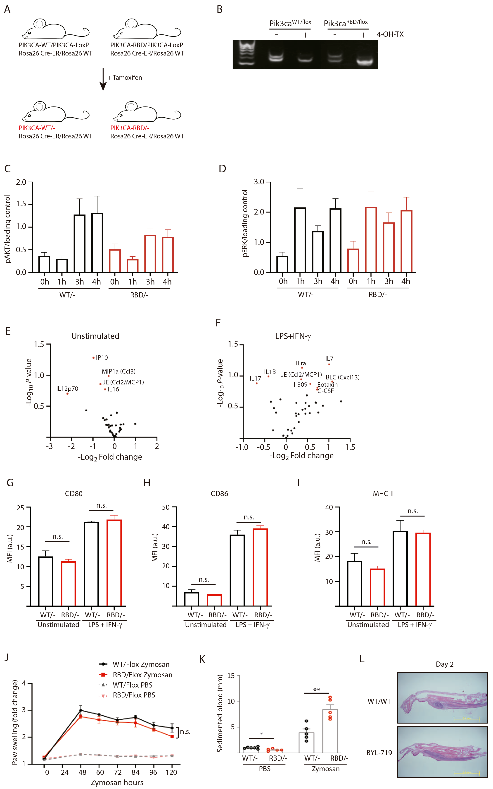

Supplementary Figure S1. Pik3ca^{RBD/-} mice have more extended inflamed tissue after zymosan injection. (A) Schematic representation of the mouse model used in which the interaction of p110α with RAS was disrupted by the introduction of two-point mutations, T208D and K227A, into the endogenous Pik3ca gene (Pik3ca^{RBD}). Wild-type (Pik3ca^{WT}) and Pik3ca^{RBD} mice were bred with mice containing a floxed Pik3ca allele and a mouse carrying a conditional Cre recombinase (Cre-ERT2) allele targeted to the ubiquitously expressed Rosa26 locus; (B) Representative PCR showing efficiency of floxed allele removal after treatment with 4-hydroxytamoxifen for 48 hours; (C) Graph quantifying p-AKT signal from 3 independent WB and normalized against its loading control; (D) Graph quantifying p-ERK signal from 3 independent WB and normalized against its loading control; (E) Volcano plots corresponding to identified cytokines differentially expressed in unstimulated BMDMs; (F) Volcano plots corresponding to identified cytokines differentially expressed in LPS + IFN-γ BMDMs; (G) (H) (I) Pik3caRBD/- and Pik3caRBD/- BMDMs were stimulated with LPS+IFN- and expression of (G) CD80; (H) CD86; and (I) MHCII were analysed by flow cytometry (Pik3caRBD/- n = 5; Pik3caWT/- n = 3). Error bars indicate mean ± SEM. Significance using Mann-Whitney test: n.s. no-significant.; (J) Pik3ca^{WT/Flox} and Pik3ca^{RBD/Flox} mice were injected with zymosan or PBS in the back-hind paws and inflammation was measured and plotted over time, Pik3ca^{WT/Flox} n = 5; Pik3ca^{RBD/Flox} PBS n = 5; Pik3ca^{WT/Flox} Zymosan n = 5; Pik3ca^{RBD/Flox} Zymosan n = 5; Error bars indicate mean ± SEM. Significance using 2-way ANOVA test: n.s. non-significant (K) Blood from the same mice was obtained by cardiac puncture prior culling and blood sedimentation was measured. The clear layer formed at the top was used for data quantification. Black dots represent data from Pik3ca^{WT/−} mice and red dots represent data from Pik3ca^{RBD/-} mice. Each dot represents an individual mouse. Each dot represents an individual mouse. Error bars indicate mean ± SEM. Significance using Student’s t test: * p < 0.05; **p < 0.01. Pik3ca^{WT/−} PBS n = 6; Pik3ca^{RBD/-} PBS n = 5; Pik3ca^{WT/−} Zymosan n = 4; Pik3ca^{RBD/-} Zymosan n = 4; (L) Representative images showing zymosan-induced inflammatory area in Pik3ca^{WT/WT} mice and Pik3ca^{WT/WT} mice treated with BYL-719.

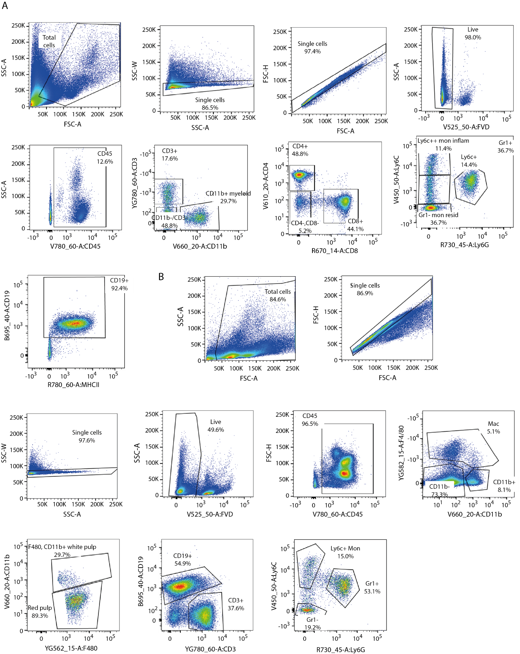

Supplementary Figure S2. Gating Strategy for Immune Population Analysis in Blood and Spleen. (A) Graphs showing gating strategy used to analyze immune populations in peripheral blood from Pik3ca^{WT/-} and Pik3ca^{RBD/-} mice. (B) Graphs showing gating strategy used to analyze immune populations in spleens from Pik3ca^{WT/-} and Pik3ca^{RBD/-} mice.

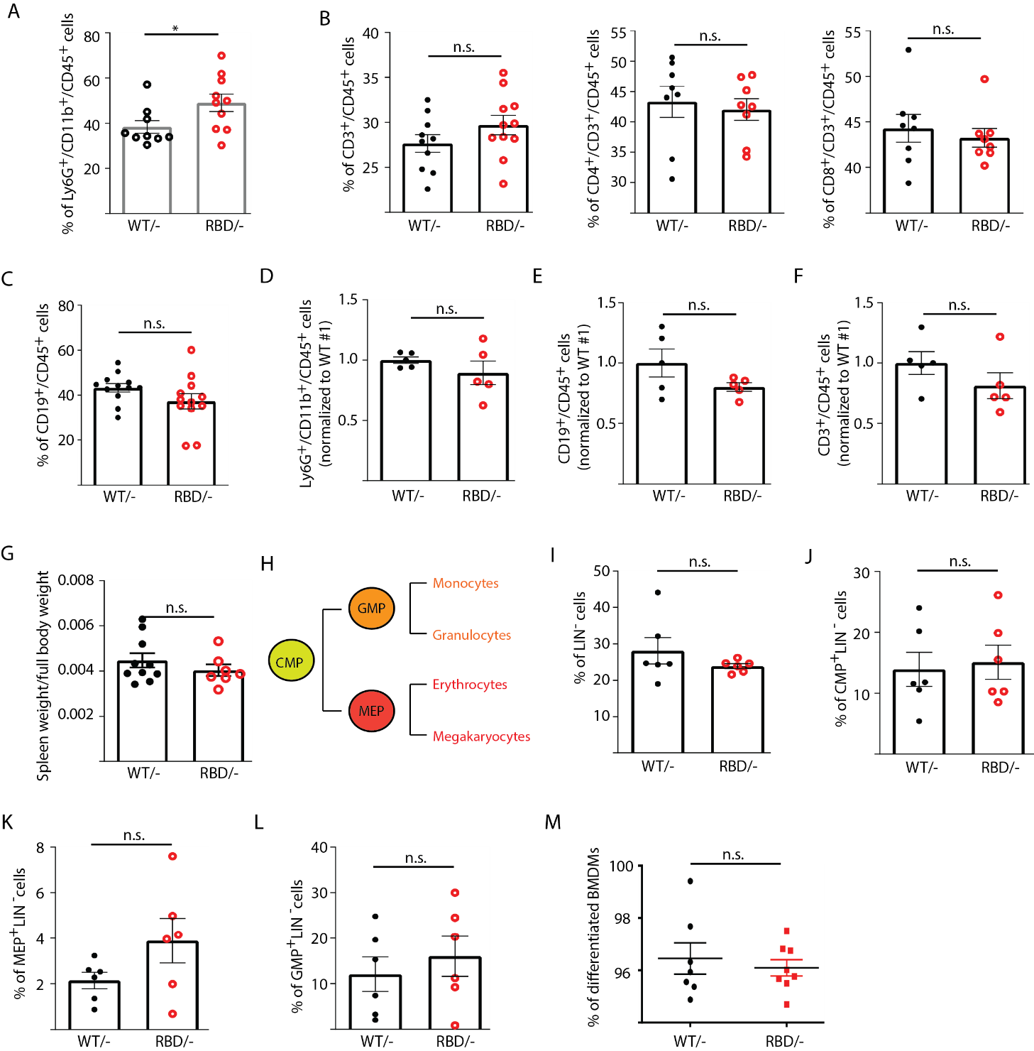
Supplementary Figure S3. Disruption of RAS-p110α interaction does not affect the number of B-cells or T-cells in blood or spleen. Twelve-week-old mice were treated with tamoxifen and after four weeks, flow cytometry analysis was performed to determine abundancy of different immune populations. (A) Granulocytes in circulating blood; (B) CD3, CD4+ and CD8+ T-cells in circulating blood; (C) B-cells in circulating blood; (D) Granulocytes in spleen; (E) B-cells in spleen; (F) T-cells in spleen; (G) Spleen weight compared to full body; (H) Schematic representation of myeloid precursors differentiation (CMP-common myeloid progenitor; GMP-Granulocyte-monocyte progenitor; MEP-Megakaryocyte-erythroid progenitor); (I) Graph showing percentage of bone marrow cells progenitor cells (have not acquire any lineage marker, Lin⁻); (J) Graph showing percentage of CMP cells within progenitor cells; (K) Graph showing percentage of MEP cells within progenitor cells; (L) Graph showing percentage of GMP cells within progenitor cells; (M) Graph depicting % of differentiated macrophages obtained in culture from bone marrow precursors in the presence of m-CSF. Black dots represent data from Pik3ca^{WT/−} mice and red dots represent data from Pik3ca^{RBD/-} mice. Each dot represents an individual mouse. Error bars indicate mean ± SEM. Significance using Student’s t test: n.s. non-significant.

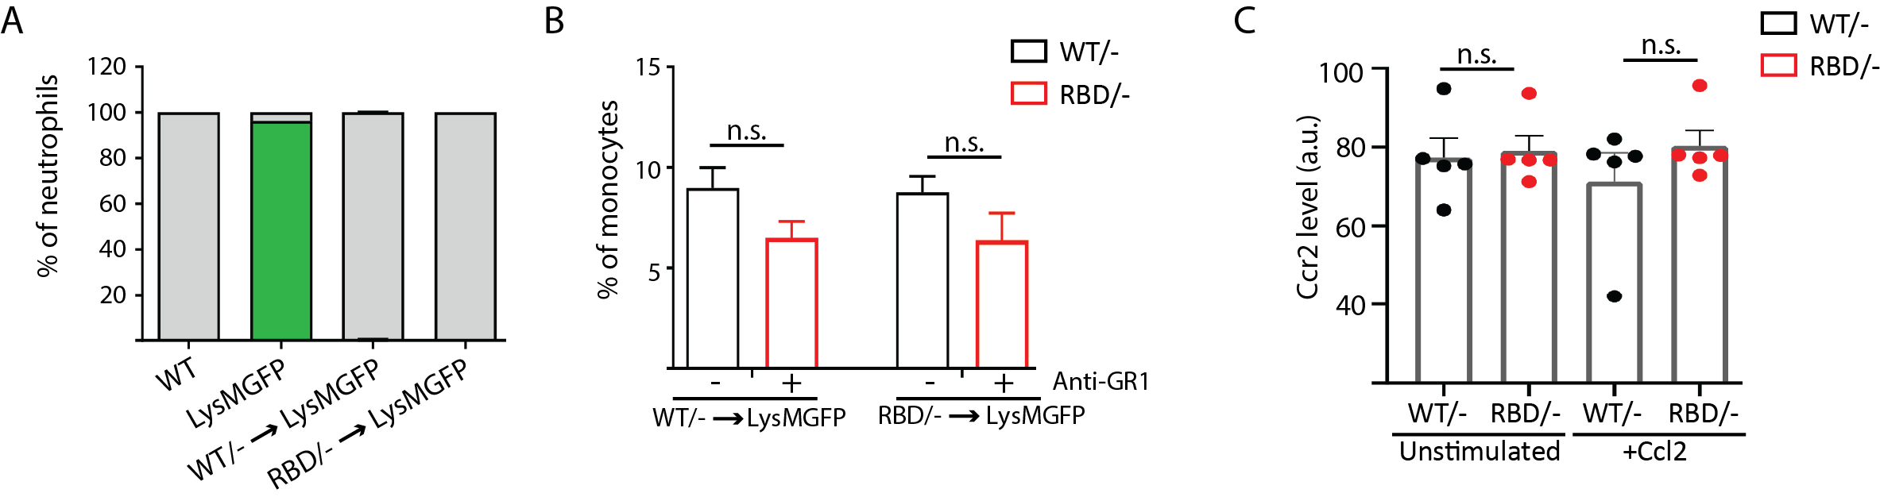

Supplementary Figure S4. Pik3ca^{RBD/-} monocytes do not extravasate through the endothelium. (A) Graph showing levels of neutrophil reconstitution in chimera’s bone marrow. Blood from chimera mice was collected and GFP in granulocytes was analysed by flow cytometry to determine engraftment percentage. (B) Graph quantifying the number of monocytes in the blood of chimera mice treated with anti-GR1 (25μg/mouse/day) for 3 days. (C) Graph showing levels of expression of CCR2 in Pik3ca^{WT/-} and Pik3ca^{RBD/-} BMDMs detected by flow cytometry. Error bars indicate mean ± SEM. Significance using Mann-Whitney test: n.s. no-significant

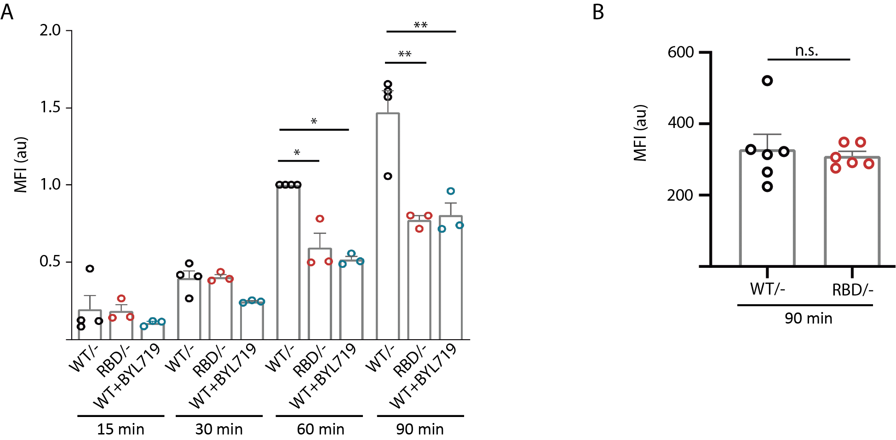

Supplementary Figure S5. Disruption of RAS-p110α interaction has a differential role in phagocytosis. (A) Graph representing the ability of Pik3ca^{RBD/-} and Pik3ca^{RBD/-} BMDMs to phagocyte sepharose beads. Data from 3 independent experiments are presented; (B) Graph representing the ability of Pik3ca^{RBD/-} and Pik3ca^{RBD/-} BMDMs to phagocyte Borrelia burgdorferi. Data from 6 independent mice are presented. Error bars indicate mean ± SEM. Significance using Mann-Whitney test: * p < 0.05; **p < 0.01; n.s. no-significant

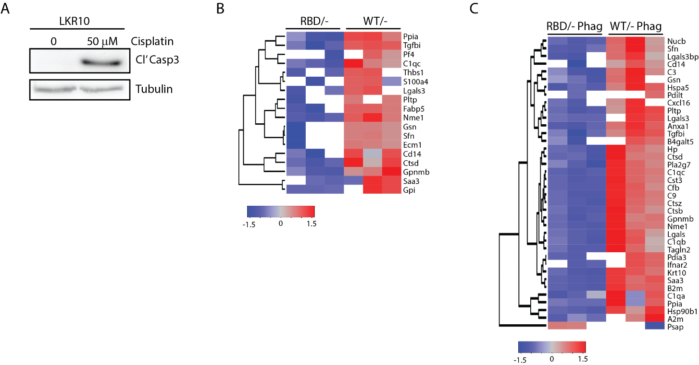
Supplementary Figure S6. Disruption of RAS-p110α interaction alters the secretome of BMDMs. (A) WB showing induction of apoptosis in LKR10 cell line treated with cisplatin for 16 hours; (B) Dendrogram showing hierarchical clustering of peptides found in the secretome analysis of Pik3ca^{RBD/-} and Pik3ca^{RBD/-} BMDMs in steady state conditions; (C) Dendrogram showing hierarchical clustering of peptides found in the secretome analysis of Pik3ca^{RBD/-} and Pik3ca^{RBD/-} BMDMs phagocytosing apoptotic cells.

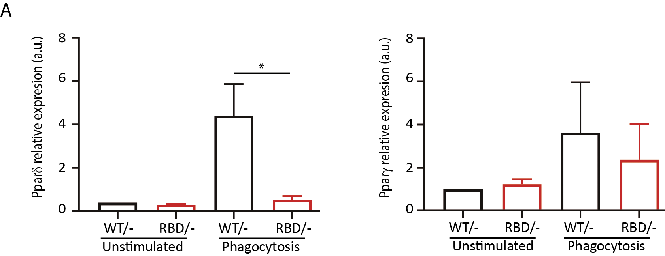
Supplementary Figure S7. Disruption of RAS-p110α interaction impacts expression of inflammation resolution mediators. Pik3ca^{RBD/-} and Pik3ca^{RBD/-} BMDMs were set up to phagocyte apoptotic cells and expression of (A) Pparδ and (B) Pparγ was measured by qPCR.

