ANNEX I: Study variables
These variables were obtained through the designed and approved (by the institutional ethical committee, see Methods part also) Survey (RedCAP).
- Sociodemographic and clinical profile:
• Age
• Gender: female, male, non-binary, other
• Relationship status: male partner, female partner, non-binary partner, no partner, other
• Country of birth:
• Religion: Islam, Hindu, Buddhist, Christian, Jewish, others.
• Paid work: yes/no
• TPAL: births, preterm births, abortions, living children
• Baby’s birth weight: in grams
• Weeks of gestation at birth: weeks
• Maternity leave: Yes/no, expected duration in weeks
• Partner leave to care for the baby: yes/no expected duration in weeks
• Maternal pathology: insulin-induced diabetes, type II diabetes, hypertension, digestive disease, immunological disease, endocrine disease, mental illness, breast surgery, others
• Neonatal pathology: low birth weight baby, premature, jaundice/high bilirubin, newborn hospitalization

- Newborn variables:
• Type of feeding in hospital: EBF, MF, FF.
• Type of feeding at 1 month of the child’s life: EBF, MF, FF.
• In the case of MF or FF, indicate how much infant formula you feed your baby daily, in ml:
• Number of bottles or syringes of infant formula you give your baby daily: from 1 to more than 8 a day.
• How many ml does each bottle or syringe have: 10-150 ml
• How much water is used to prepare the infant formula: ml/day

- Breastfeeding accessories:
• Do you use a breast pump: Yes/No
• Do you use milk storage containers: Yes/No
• Total number of milk storage containers you own:
• Do you use bags to store milk: Yes/No
• How many bags do you use each week:
• Do you use nipple shields: Yes/No
• Do you use a nursing supplementer: Yes/No
• How many cans of infant formula do you use weekly: yes/no and number per week (based on a 800 gr can)
• Number of containers/bottles you have at home
• Do you have bottles: Yes/No and number
• Do you use brushes to clean the bottles: Yes/No
• Do you use a bottle warmer: Yes/No
• Do you use a bottle sterilizer: Yes/No
• Do you use pediatric nasogastric tubes: Yes/No
• Reusable nursing pads: Yes/No
• Disposable nursing pads: Yes/no and how many disposable nursing pads do you use per week.

- Mother's nutrition variables:
a.- Eating habits
• What type of diet do you follow: No special diet, vegetarian, vegan, gluten-free, food allergies, therapeutic diet (diabetes, high blood pressure, dyslipidemia, etc.)
• Do you take any vitamin supplements: Yes/no
• Where do you usually buy food: Supermarket, take away, small business (neighborhood, market), local product (km 0) usually, local product (Km 0) less than 50%, local product (km 0) more than 50%
• How do you usually go shopping? Car: 0-5 km, Car: 6-10 km, Car: > 11 km, walking, public transport
• Type of energy in your kitchen: Butane gas, natural gas, electricity, biomass (wood)
• Members of the family who usually cook: Mother, partner, both, others
• How much of the food do you end up throwing away? From < 5%, 6-10%, 11-24%, > 25%

b.- Register of the mother's daily diet (24h)
• Diet. “24-hour food register. 24hR”: The three main meals and snacks (before breakfast, mid-morning, afternoon, and before bed)
• Type of food: Portions, packaging, type of cooking, characteristics of the product (fresh, frozen), origin of the product, condiments and drink
• Packaging: Glass, Tetra Brik, plastic, paper, no packaging
• Characteristics of the food: Fresh, frozen, pre-cooked, canned, preserved in glass
• Cooking methods: Raw, boiled, steamed, fried, baked, or griddle
• Sauces and condiments: Mayonnaise, ketchup, tomato, mustard, soy, oil, vinegar, butter
• Beverages: Water, carbonated soft drinks (Coca-Cola, lemonade, etc.), packaged juices, alcoholic beverages, vegetable milk or animal milk
• Food origin: Local, Catalonia, Europe/Mediterranean, unknown, other
• Food measurement: Small (100 gr), medium (200 gr), large (300 gr); fruit: ½ piece small portion, 1 piece (medium portion), 2 large pieces (See the Food Atlas in Annex IV.)

ANNEX II: The Nutrition Atlas
This Nutrition Atlas was developed by the GREEN MOTHER project research team (adapted from the Catalan Government’s nutrition guide "Small changes to eat better") and will be used in the study:
VEGETABLES:
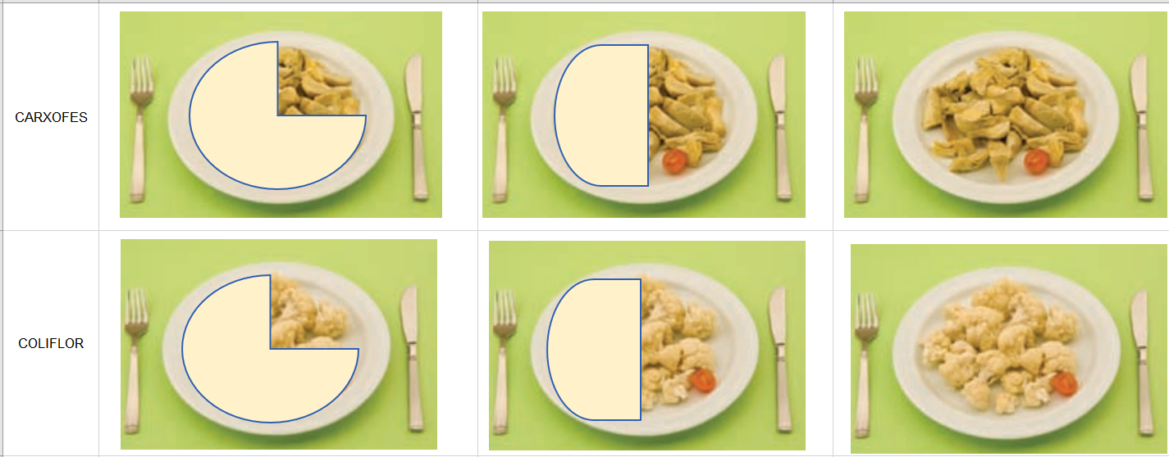
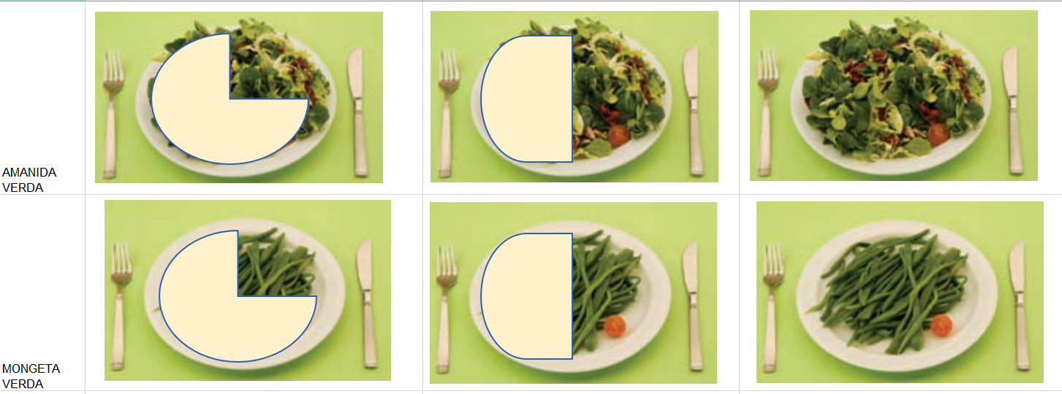
CEREALS, LEGUMES & PASTA:
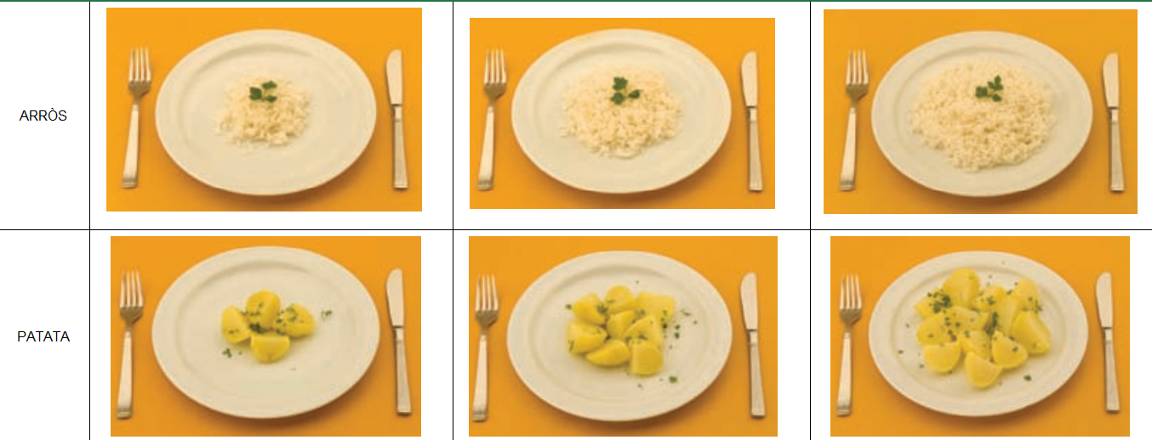
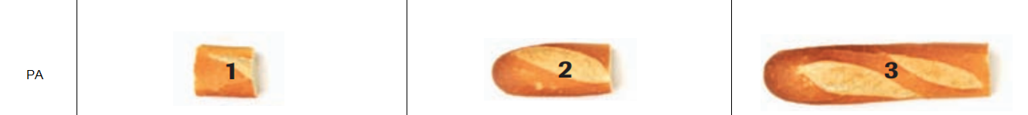
MEAT & FISH:
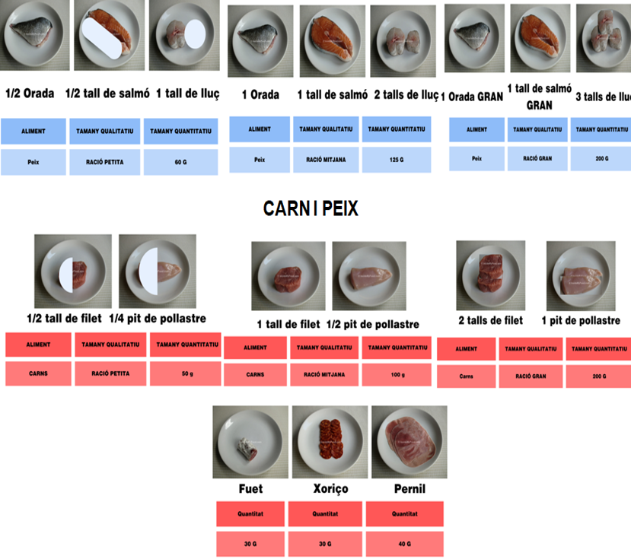
FRUITS:
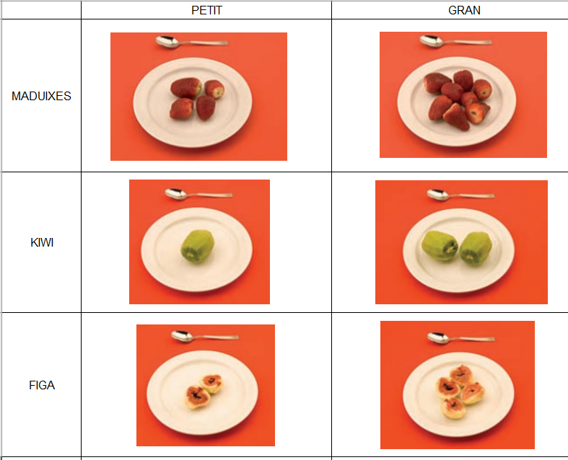

https://salutpublica.gencat.cat/ca/ambits/promocio_salut/alimentacio_saludable/Publicacions/Alimentacio-saludable-per-a-tothom/Petits-canvis-per-menjar-millor/
It is given in Catalonian language since as it is used in the study

