Supporting Information

1. AFM acquisition of the electroswelling-induced oscillations

During the acquisition of the electroswelling spectra, fast adjustments of the z-scanner height are avoided as the AC oscillation frequencies are kept above the bandwidth of the z-scanner feedback-loop control. When operating in contact mode, the AFM feedback-loop acts to counteract variations in the vertical deflection signal, consequently acquiring the topography of the sample. By changing the z-servo gain parameter, we can modify the bandwidth of the feedback-loop. Figure S1a shows the vertical deflection and the z-height signals measured during the acquisition of an electroswelling spectrum (NSC36 probe, force set point 10 nN). The gain is set to 0.1. From normalized data, we observe that the feedback loop starts to effectively follow the sample oscillation only below a certain frequency f_{c}. Consequently, the deflection signal is suppressed, and the height signal increases. The position of f_{c} can be tuned by modifying the gain parameter (Figure S1b and S1c). Setting the z servo gain to 0.01 in our system (Figure S1c) allows for a stable acquisition of the vertical deflection induced by electroswelling in the frequency range of our experiment.

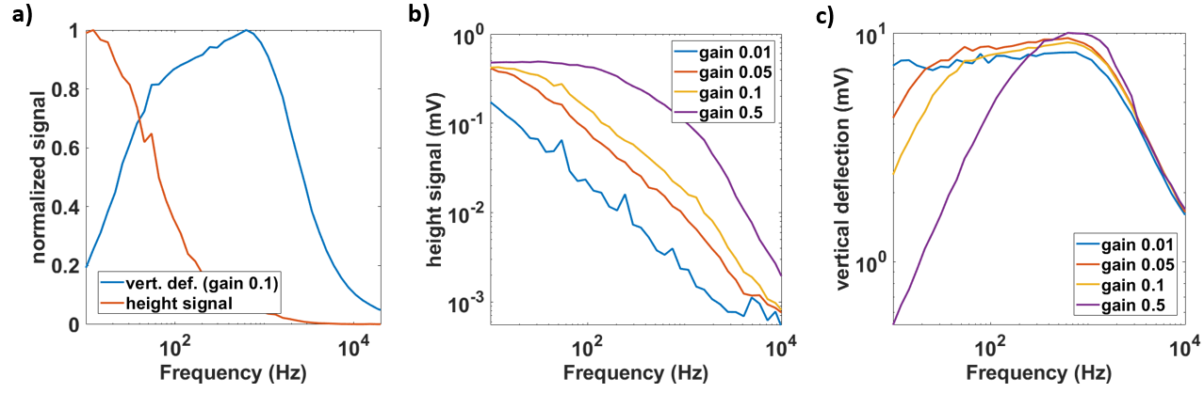
Figure S1: Adjustment of the AFM z-servo gain parameter to maximize the acquisition of the electroswelling-induced oscillations on the surface of the sample. a) Normalized z-height and vertical deflection signals as a function of the frequency of V_{in}. The gain is set to 0.1. b) Height and vertical deflection (c) signals measured varying the z-servo gain.

2. Measurement of the cantilever sensitivity and calculation of the swelling amplitude

We measured the cantilever sensitivity s_{c} of NSC36 probes in liquid through force-distance spectroscopies on the rigid glass substrate of the samples (Figure S2a). The probe was lifted to the vertical coordinate z₀ = 0.1 μm from the contact position, then gradually approached to the sample surface (scan speed 0.3 μm/s) down to z₁ = -0.2 μm and finally retracted again to z₀. s_{c} was extracted from the slope of the linear cantilever deflection signal measured in contact regime (Figure S2b). During electroswelling measurements, the force set point for contact mode operation was set to 10 nN to have a significative interaction between the probe and the sample. After applying the V_{in} signal, we calculated the swelling amplitude as |S| = |D|/s_{c} , where |D| is the amplitude of the vertical deflection of the AFM cantilever caused by the sample oscillation.

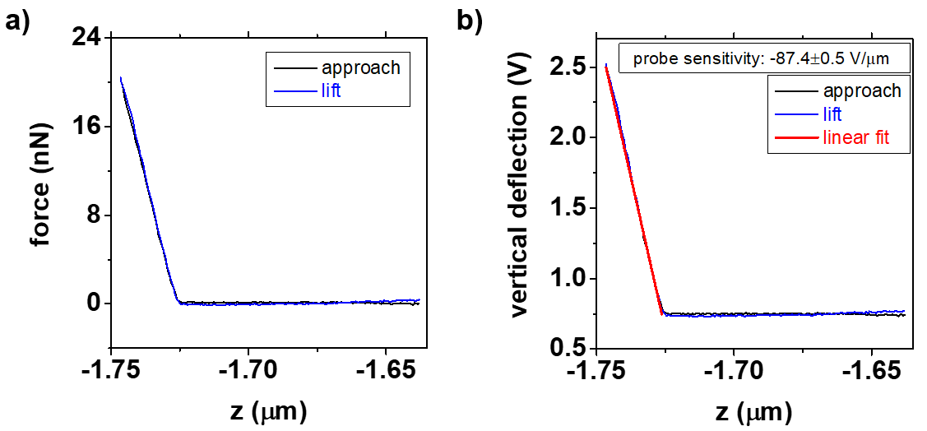
Figure S2: a) Measurement of NSC36 cantilever sensitivity through force-distance spectroscopy on the glass substrates of the sample. b) Determination of the cantilever sensitivity.

3. Derivation of the charge phasor

In an AC circuit, we can define the charge phasor as the time integral of the current phasor:

$$\overline{Q}=\int{\overline{I}dt} (S3.1)$$
$$\overline{Q}= \int{|I|e^{j(ωt+ϕ_{I})}dt} =\frac{|I|e^{j(ωt+ϕ_{I})}}{jω}=\frac{\overline{I}}{jω} (S3.2)$$
thereby, we obtain
$$\overline{Q}\left(t\right)=\frac{\left|I\right|}{ω}e^{j(ωt+ϕ_{I}-\frac{π}{2})}=\left|Q\right|e^{j(ωt+ϕ_{Q})} (S3.3)$$
with
$$\left|Q\right|=\frac{\left|I\right|}{ω}; ϕ_{Q}=ϕ_{I}-\frac{π}{2} (S3.4)$$

4. Frequency dependence model of the swelling phasor

The PEDOT:PSS/electrolyte interface can be modeled with an equivalent RC series circuit, composed by the ionic resistance of the electrolyte R and the capacitance C of the electric double layer in the polymeric layer. The input voltage phasor $\overline{V_{in}}(t)={|V}_{in}|e^{jωt}$and the current phasor $I\left(t\right)=|I|e^{j(ωt+ϕ_{I})}$ are related through the electrochemical impedance transfer function:
$$Z \text{=} \frac{1}{jωC}+R (S3.1)$$
Using the impedance, we can express the charge phasor as a function of the input voltage phasor:
$$\overline{Q}\left(t\right)=\int{\overline{I}dt}=\int{\frac{{|V}_{in}|}{\frac{1}{jωC}+R}e^{jωs}ds} (S3.2)$$
we obtain
$$\overline{Q}\left(t\right)=\frac{C{|V}_{in}|}{\sqrt{1+{\left(ωRC\right)}^{2}}}e^{j\left[ωt+atan⁡(-ωRC)\right]} (S3.3)$$
with amplitude and phase
$$\left|\overline{Q}\right|=\frac{C{|V}_{in}|}{\sqrt{1+{\left(ωRC\right)}^{2}}}; ϕ_{Q}=atan\left(-ωRC\right) (S3.4)$$
We can finally relate charge and swelling phasors through the actuation function:
$$A=\frac{\overline{S}}{\overline{Q}} (S3.5)$$
The experimental spectroscopy data shows that A has a constant value $A\left(ω\right)=a$ over the experimental frequency range. Accordingly, we can write the mathematical expressions for the swelling amplitude and phase:
$$\left|\overline{S}\right|=\frac{aC{|V}_{in}|}{\sqrt{1+{\left(ωRC\right)}^{2}}}; ϕ_{S}=atan\left(-ωRC\right) (S3.4)$$
obtaining a good agreement with experimental results in Figure 2d.

5. Water diffusion and osmosis in electroactuation of conductive polymers

Electroswelling spectroscopy measurements highlight how osmosis plays a minor role in the electroactuation mechanism. Using D_{w} ≈ 10⁻¹² m²/s as the water diffusion coefficient in PEDOT:PSS³ and assuming the complete hydration of the polymeric layer on the vertical axis, we can estimate the diffusion time as $t_{d}=\frac{t^{2}}{4D_{w}}$, where t is the thickness of the PEDOT:PSS film. Results obtained for our experiment are reported in Table S4. These clearly illustrate that water diffusion is a relatively “slow” process with respect to electroswelling. Assuming osmosis as responsible for the latter implies a substantial discrepancy between the charge injected in the material and its volume change for frequencies higher than f_{d} =1/t_{d}, which is not observed in the experiments (Figure 3b and 3c). Moreover, no significative increases in the actuation width are measured when f < f_{d}. The actuation timescale is not limited by the diffusive transport of water at the polymer/electrolyte interface caused by an increase of the osmotic pressure, but by the transport of hydrated cations.

thickness (nm) | t_{d} (s) | f_{d} (Hz)
102 | 0.002601 | 384.4675125
243 | 0.01476225 | 67.74035123
605 | 0.09150625 | 10.92821529
1570 | 0.616225 | 1.622783886

Table S4: Estimation of the timescale (t_{d}) and characteristic frequency (f_{d}) of water diffusion in PEDOT:PSS

6. Calculation of the ion hydration radius
If we assume that each injected ion is responsible for the electronic doping/de-doping of the material, we can express the swelling amplitude as a function of the number of ions as
$$S \text{=} aN_{ion}e (S5.1)$$
where a is the actuation coefficient (expressed in nm/nC), N_{ion} the total number of ions, and e the elementary charge. Spectroscopy data combined with the imaging experiment demonstrate that the charge uptake in the polymeric matrix is uniformly distributed within the film volume. Thereby, the volume change V_{s} induced by ionic injection is $V_{s}\text{=} A_{el}S=N_{ion}(aA_{el}e)$, where A_{el} is the electrode area. This identifies the volume of a single ion as
$$v_{ion} \text{=} aA_{el}e (S5.2)$$
and its radius will be
$$r_{ion}={\left(\frac{3v_{ion}}{4π}\right)}^{1/3}={\left(\frac{3{aA}_{el}e}{4π}\right)}^{1/3} (S5.3)$$

