Supplementary Figure legends

Supplementary Figure 1. Mendelian Randomization analysis between circulating adiponectin levels of multiple-ethnicity individuals and prostate caner of European. (A) Scatter plot; (B) Forest plot; (C) leave-one-out plot; (D)funnel plot.

Supplementary Figure 2. Mendelian Randomization analysis between circulating adiponectin levels of multiple-ethnicity individuals and prostate caner of East Asian. (A) Scatter plot; (B) Forest plot; (C) leave-one-out plot; (D)funnel plot.

Supplementary Figure 3. Mendelian Randomization analysis between circulating adiponectin levels of European individuals and prostate caner of European. (A) Scatter plot; (B) Forest plot; (C) leave-one-out plot; (D)funnel plot.

Supplementary Figure 4. Mendelian Randomization analysis between circulating adiponectin levels of East Asian individuals and prostate caner of East Asian. (A) Scatter plot; (B) Forest plot; (C) leave-one-out plot; (D)funnel plot.

Supplementary Table 1. The characteristics of SNPs selected from multiple-ethnicity individuals

SNP | Chr | Gene | Position | EA | OA | EAF | Beta | SE | P | R² | F-statistics
rs2791552 | 1 | LYPLAL1 | 219652033 | C | A | 0.676 | -0.052 | 0.007 | 1.75E-14 | 0.00118 | 77.698
rs2943641 | 2 | IRS1 | 227093745 | C | T | 0.646 | -0.058 | 0.006 | 1.76E-21 | 0.00154 | 100.962
rs2276853 | 3 | KIF9 | 47282303 | A | G | 0.594 | -0.033 | 0.006 | 3.35E-08 | 0.00053 | 34.432
rs13303 | 3 | STAB1 | 52558008 | C | T | 0.569 | 0.058 | 0.006 | 2.69E-21 | 0.00165 | 108.283
rs17366568 | 3 | ADIPOQ | 186570453 | A | G | 0.118 | -0.226 | 0.009 | 1.43E-145 | 0.01063 | 704.055
rs13133548 | 4 | FAM13A | 89740128 | A | G | 0.489 | -0.039 | 0.006 | 5.91E-12 | 0.00076 | 49.841
rs4311394 | 5 | ARL15 | 53300662 | G | A | 0.257 | 0.258 | 0.007 | 1.68E-10 | 0.02542 | 1708.998
rs10282707 | 7 | SNX13 | 17911038 | T | C | 0.383 | -0.040 | 0.006 | 1.96E-10 | 0.00076 | 49.582
rs3735080 | 7 | GIMAP7 | 150217309 | T | C | 0.245 | -0.049 | 0.007 | 7.70E-13 | 0.00089 | 58.249
rs10861661 | 12 | RIC8B | 107174646 | C | A | 0.229 | -0.040 | 0.007 | 1.75E-09 | 0.00056 | 37.038
rs7134375 | 12 | PDE3A | 20473758 | A | C | 0.410 | 0.053 | 0.006 | 3.69E-20 | 0.00136 | 89.161
rs11057353 | 12 | DNAH10 | 124265687 | C | T | 0.645 | 0.054 | 0.006 | 2.74E-19 | 0.00134 | 87.610
rs2925979 | 16 | CMIP | 81534790 | C | T | 0.693 | 0.080 | 0.006 | 1.38E-37 | 0.00272 | 178.909
rs4805885 | 19 | PEPD | 33906123 | C | T | 0.603 | 0.063 | 0.006 | 2.85E-25 | 0.00190 | 124.742

Chr = chromosome; EA = effect allele; OA = other allele; EAF = frequency of effect allele; SE = standard error.

Supplementary Table 2. The characteristics of SNPs selected from European individuals

SNP | Chr | Gene | Position | EA | OA | EAF | Beta | SE | P | R² | F-statistics
rs1108842 | 3 | GNL3 | 52720080 | C | A | 0.50 | 0.03 | 0.004 | 3.66E-11 | 0.000450 | 13.211
rs6810075 | 3 | ADIPOQ | 186548565 | T | C | 0.60 | 0.06 | 0.005 | 3.60E-41 | 0.001728 | 50.796
rs998584 | 6 | VEGFA | 43757896 | C | A | 0.50 | 0.03 | 0.005 | 5.84E-08 | 0.000450 | 13.211
rs2980879 | 8 | TRIB1 | 126481475 | T | A | 0.70 | 0.03 | 0.005 | 1.08E-08 | 0.000378 | 11.097
rs7955516 | 12 | PDE3A | 20498036 | C | A | 0.40 | 0.03 | 0.005 | 2.43E-08 | 0.000432 | 12.683
rs601339 | 12 | GPR109A | 123174743 | G | A | 0.20 | 0.04 | 0.006 | 3.87E-11 | 0.000512 | 15.032
rs7133378 | 12 | DNAH10 | 124409502 | G | A | 0.70 | -0.03 | 0.005 | 1.29E-09 | 0.000378 | 11.097
rs2925979 | 16 | CMIP | 81534790 | T | C | 0.30 | -0.04 | 0.005 | 1.87E-18 | 0.000672 | 19.733
rs12922394 | 16 | CDH13 | 82672327 | T | C | 0.10 | -0.10 | 0.011 | 3.16E-18 | 0.001800 | 52.916
rs731839 | 19 | PEPD | 33899065 | G | A | 0.35 | -0.04 | 0.005 | 2.20E-13 | 0.000728 | 21.379

Chr = chromosome; EA = effect allele; OA = other allele; EAF = frequency of effect allele; SE = standard error.

Supplementary Table 3. The characteristics of SNPs selected from East Asian individuals

SNP | Chr | Gene | Position | EA | OA | EAF | Beta | SE | P | R² | F-statistics
rs12714975 | 3 | KCNH8 | 19085374 | C | G | 0.047 | 0.16 | 0.04 | 7.60E-06 | 0.002293 | 27.866
rs10937273 | 3 | ADIPOQ | 186549695 | A | G | 0.404 | 0.12 | 0.01 | 1.80E-22 | 0.006935 | 84.655
rs12211360 | 6 | HIVEP2 | 143119832 | A | G | 0.966 | -0.21 | 0.04 | 2.80E-07 | 0.002897 | 35.220
rs3943077 | 10 | WDR11-FGFR2 | 122945086 | A | G | 0.567 | 0.09 | 0.01 | 1.80E-13 | 0.003977 | 48.409
rs11168618 | 12 | OR8S1-LALBA | 48933233 | T | C | 0.137 | -0.08 | 0.02 | 1.10E-06 | 0.001513 | 18.374
rs1187415 | 12 | ZNF664 | 124491529 | C | G | 0.920 | -0.11 | 0.02 | 2.30E-07 | 0.001781 | 21.631
rs10847980 | 12 | GPR109A | 123387922 | T | G | 0.771 | -0.06 | 0.01 | 7.40E-06 | 0.001271 | 15.431
rs4783244 | 16 | CDH13 | 82662268 | T | G | 0.360 | -0.33 | 0.01 | 6.80E-165 | 0.050181 | 640.486
rs2925979 | 16 | CMIP | 81534790 | T | C | 0.411 | -0.08 | 0.01 | 2.10E-10 | 0.003099 | 37.681
rs889140 | 19 | PEPD | 33889000 | A | G | 0.450 | 0.08 | 0.01 | 3.60E-12 | 0.003168 | 38.528
rs6518702 | 22 | GAL3ST1 | 30948752 | T | C | 0.249 | -0.06 | 0.01 | 5.20E-06 | 0.001346 | 16.344

Chr = chromosome; EA = effect allele; OA = other allele; EAF = frequency of effect allele; SE = standard error.

Supplementary Figure 1

A B
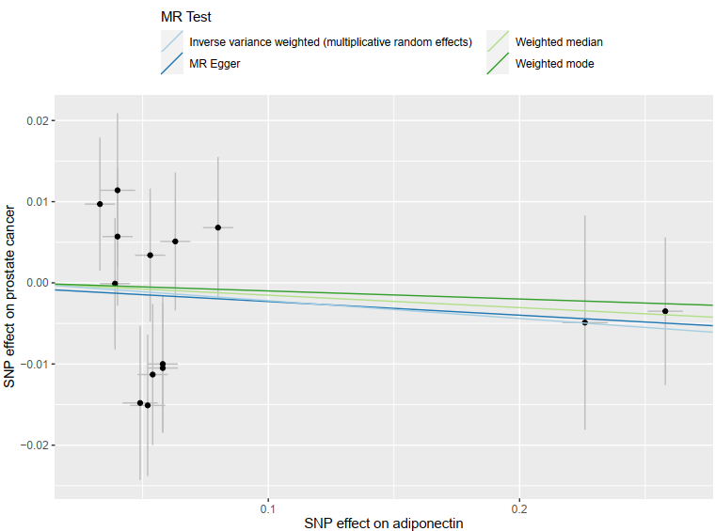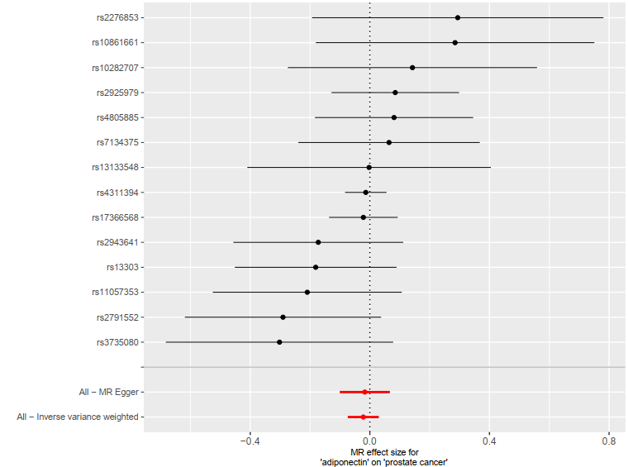
C D
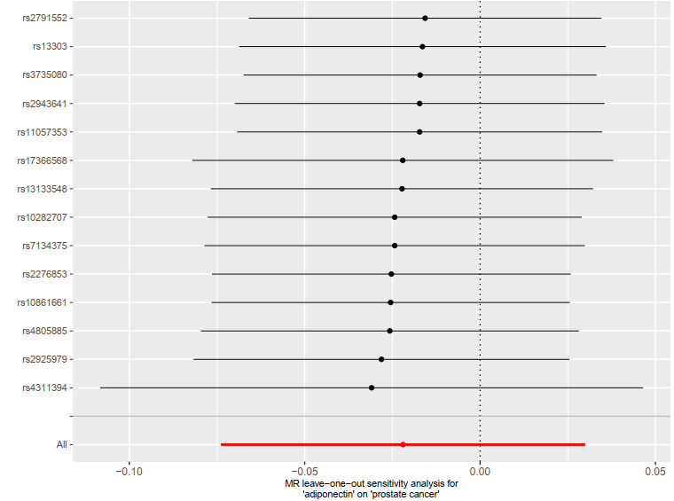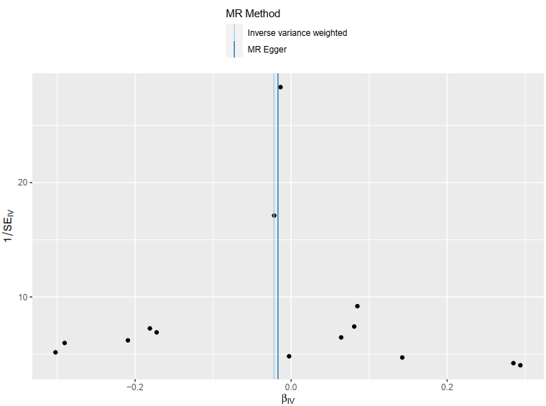

Supplementary Figure 1. Mendelian Randomization analysis between circulating adiponectin levels of multiple-ethnicity individuals and prostate caner of European. (A) Scatter plot showed a potential protective effect; (B) Forest plot showed the effect of every SNP; (C) leave-one-out plot showed the effect after excluding one SNP; (D)funnel plot showed the distribution of each SNP.

Supplementary Figure 2

A B
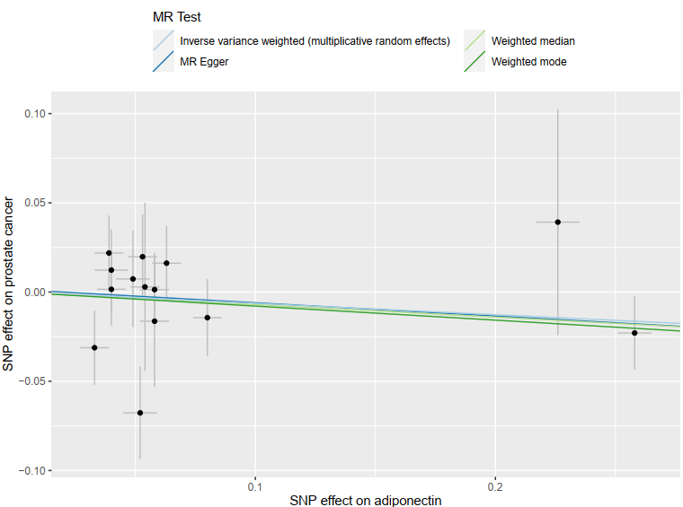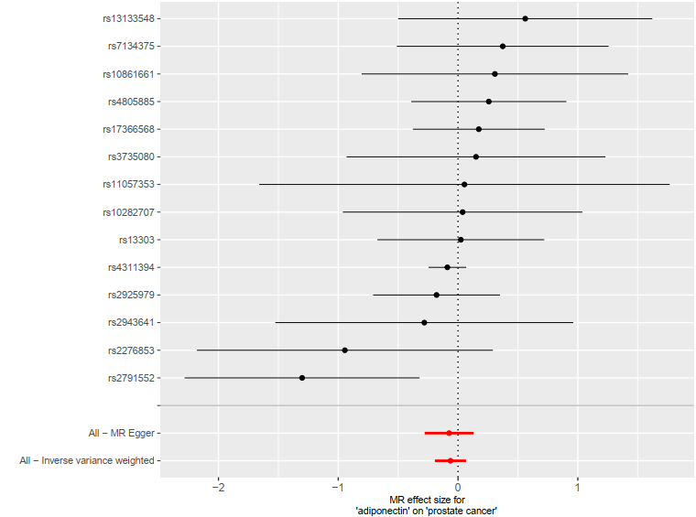
C D
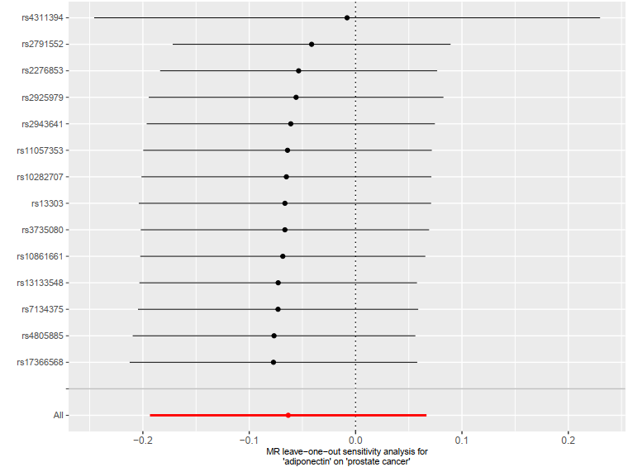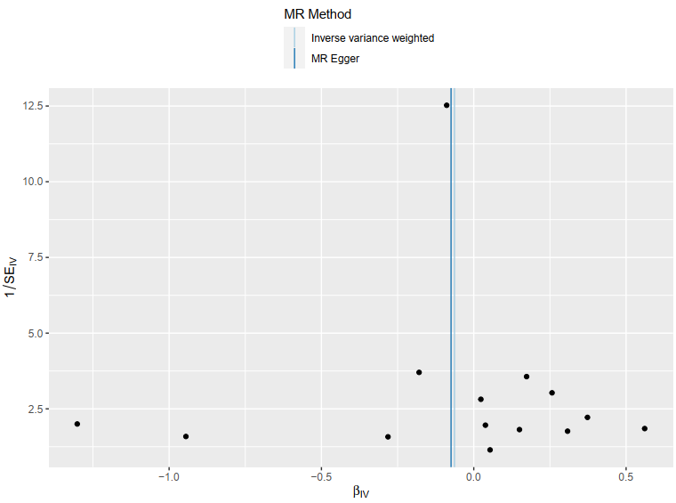

Supplementary Figure 2. Mendelian Randomization analysis between circulating adiponectin levels of multiple-ethnicity individuals and prostate caner of East Asian. (A) Scatter plot showed a potential protective effect; (B) Forest plot showed the effect of every SNP; (C) leave-one-out plot showed the effect after excluding one SNP; (D)funnel plot showed the distribution of each SNP.

Supplementary Figure 3

A B
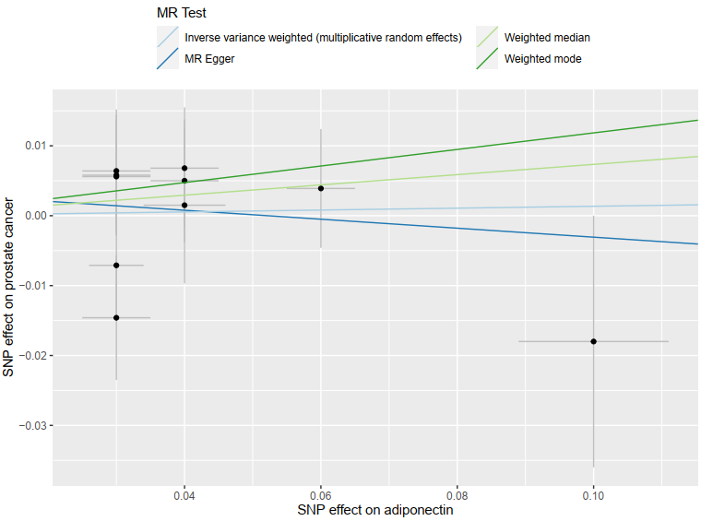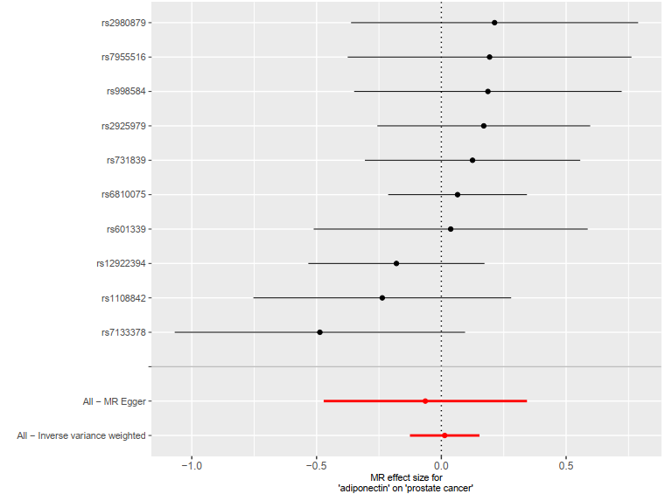
C D
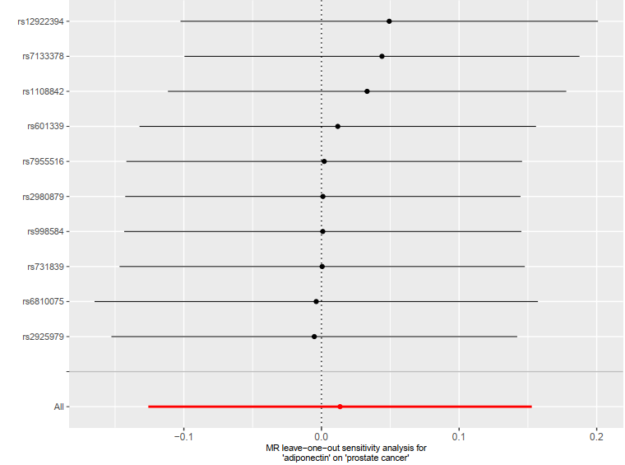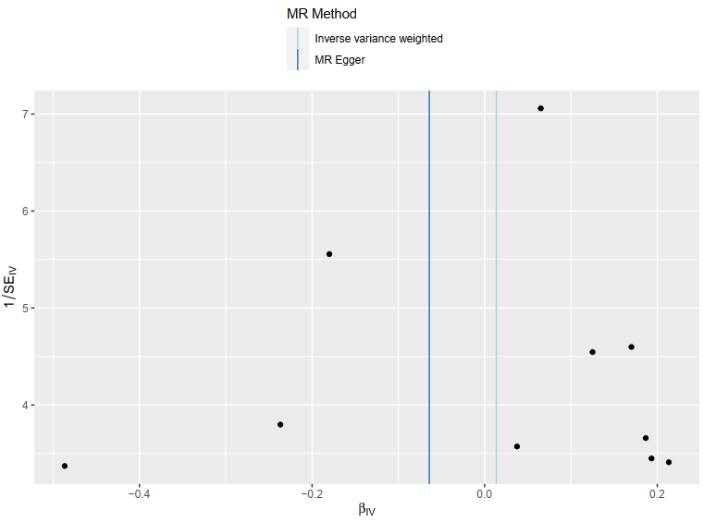

Supplementary Figure 3. Mendelian Randomization analysis between circulating adiponectin levels of European individuals and prostate caner of European. (A) Scatter plot showed a potential protective effect; (B) Forest plot showed the effect of every SNP; (C) leave-one-out plot showed the effect after excluding one SNP; (D)funnel plot showed the distribution of each SNP.

Supplementary Figure 4

A B
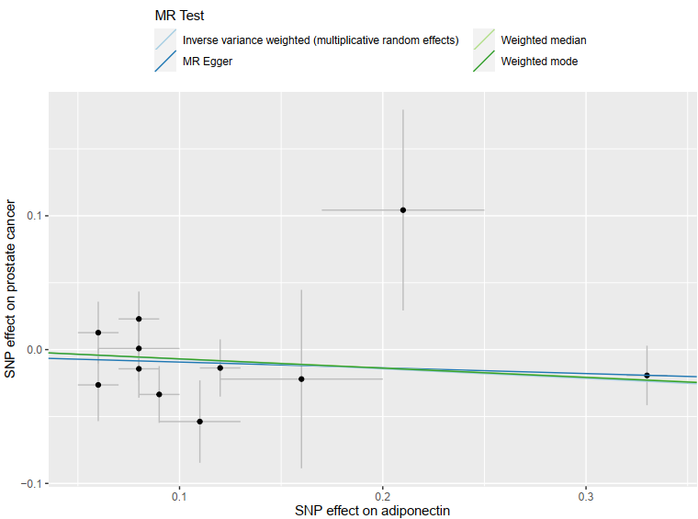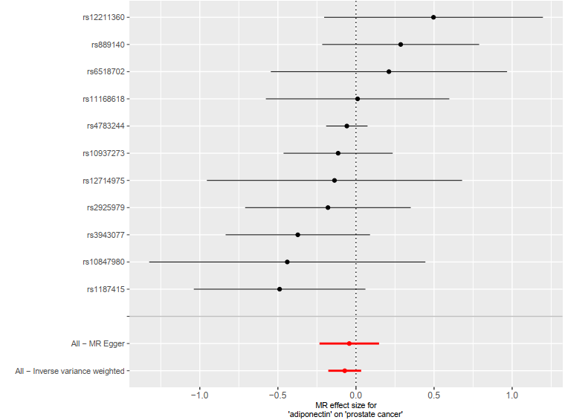
C D
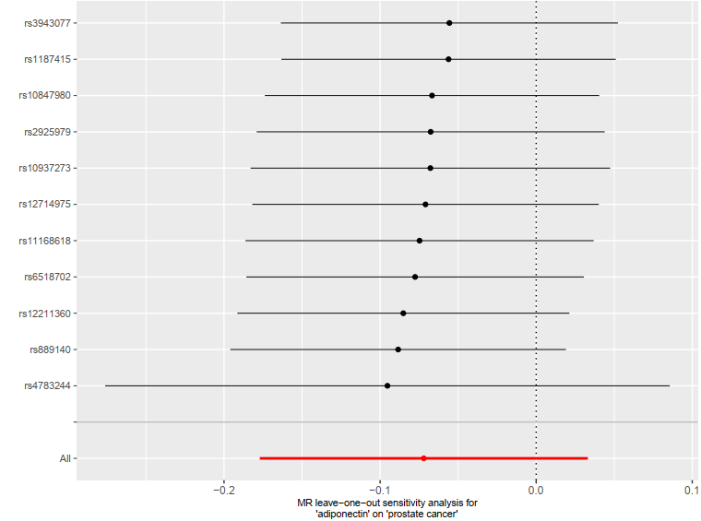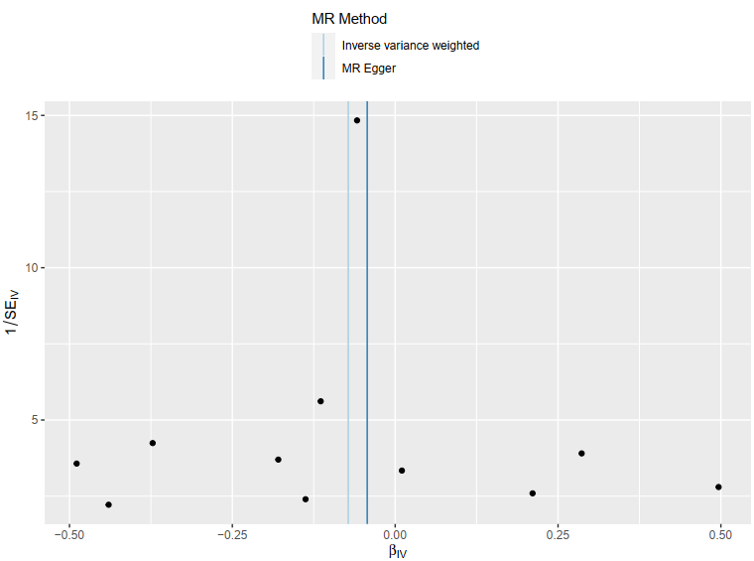

Supplementary Figure 4. Mendelian Randomization analysis between circulating adiponectin levels of East Asian individuals and prostate caner of East Asian. (A) Scatter plot showed a potential protective effect; (B) Forest plot showed the effect of every SNP; (C) leave-one-out plot showed the effect after excluding one SNP; (D)funnel plot showed the distribution of each SNP.

