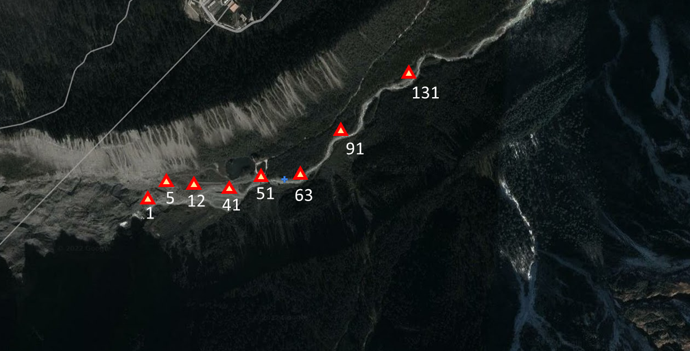
Figure S1. The Geographic location of sampling sites in Hailuogou glacier foreland. which represent eight different ages of glacier retreat: 1 (S1), 5 (S2), 12 (S3), 41 (S4), 51 (S5), 63 (S6), 91 (S7) and 131 (S8) years, respectively

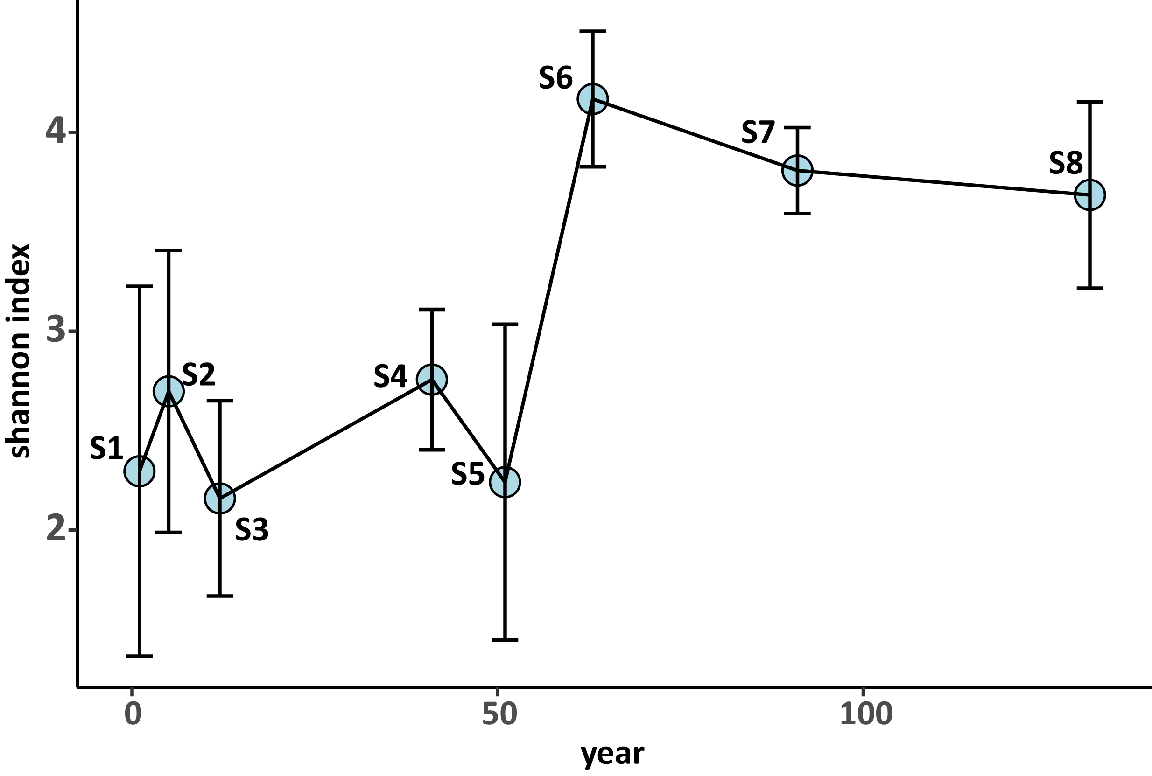
Figure S2. The Shannon index of huge phage communities. The error bar indicated the standard deviation.

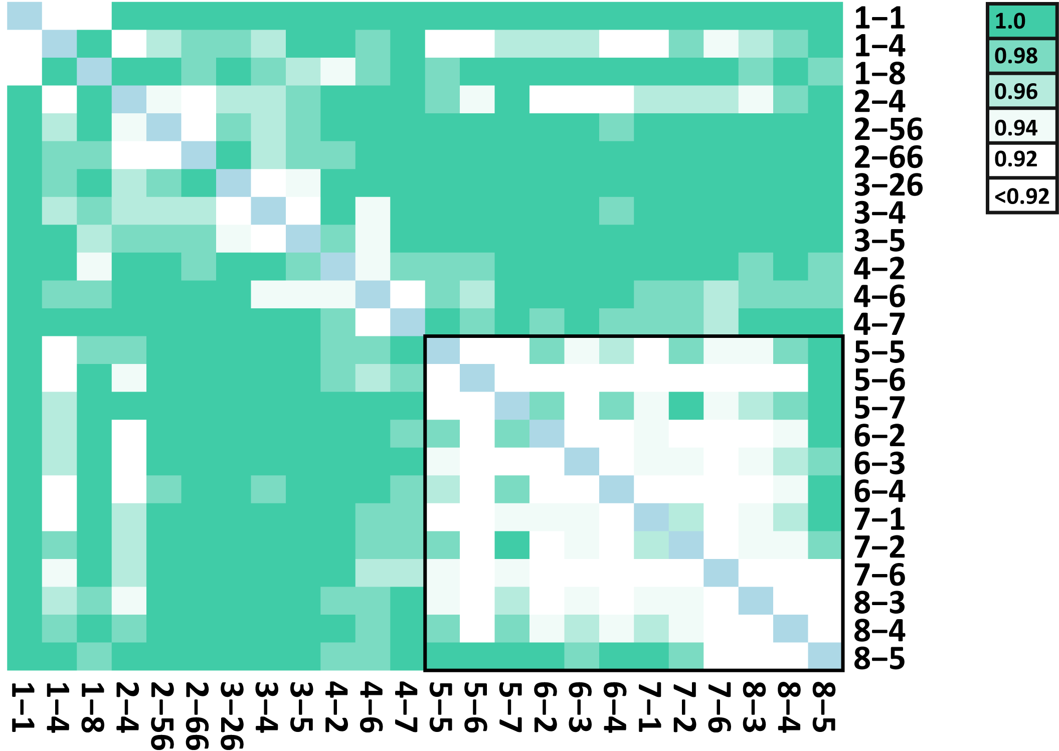
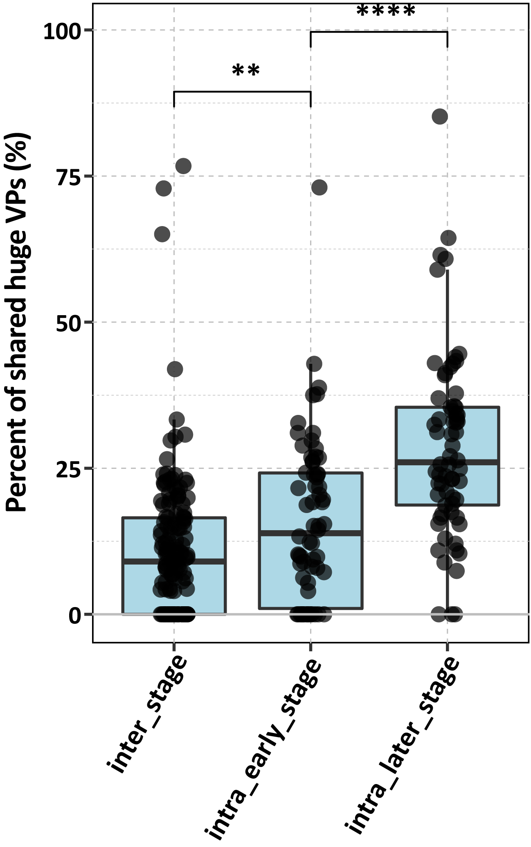
a
b
Figure S3. (a) The heatmap indicated the Bray-Curtis distance of huge viral community between different viromes. (b) The boxplot indicated the percent of shared huge VPs between different groups.

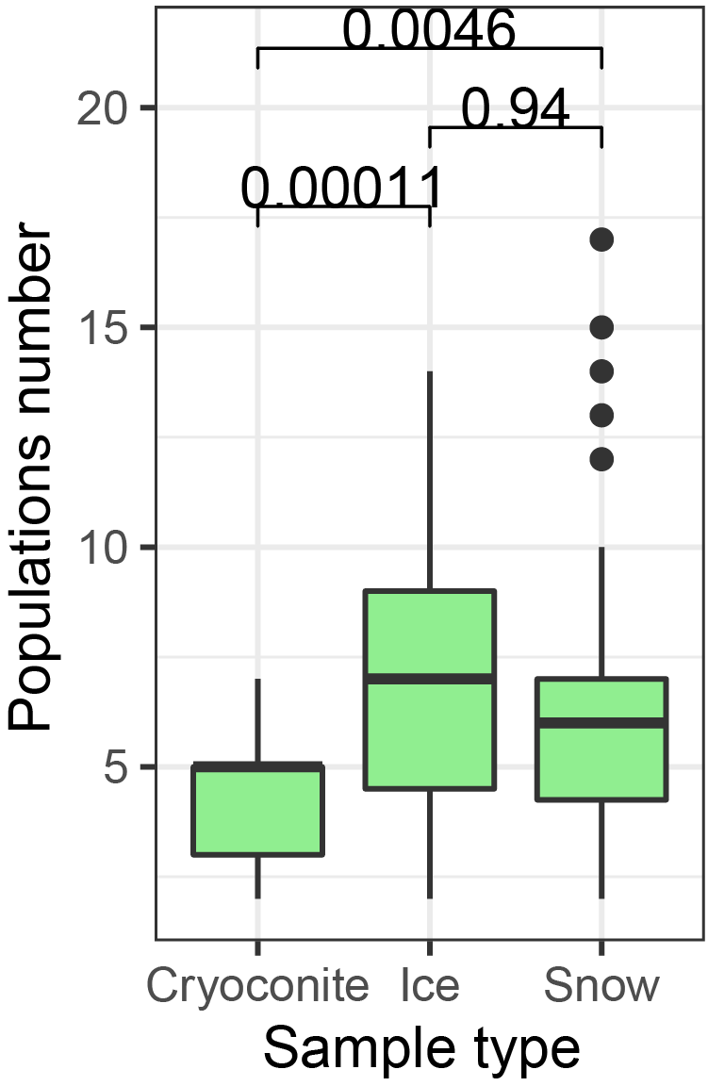
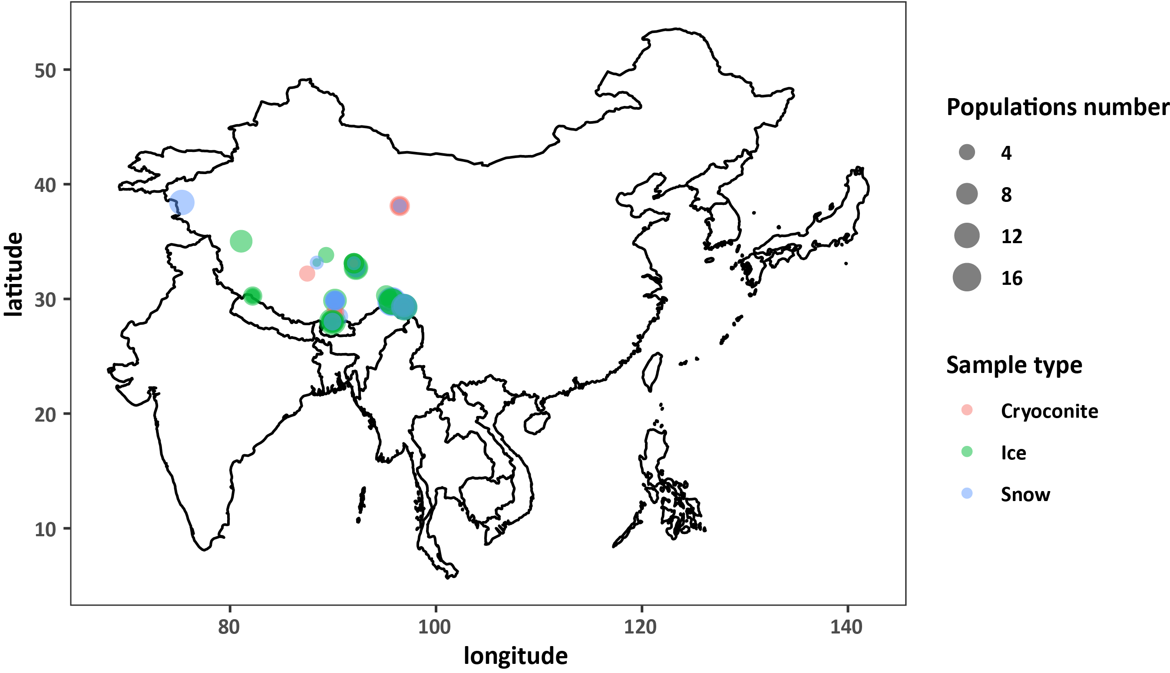
Figure S4 (a) The biogeography of huge phages in Tibetan glaciers. (b) The boxplot showed the detected number of huge phages in glaciers metagenomes with different sample types. Inset values display the p value of the Wilcox.test. The statistical test used was two-tailed.
a
b

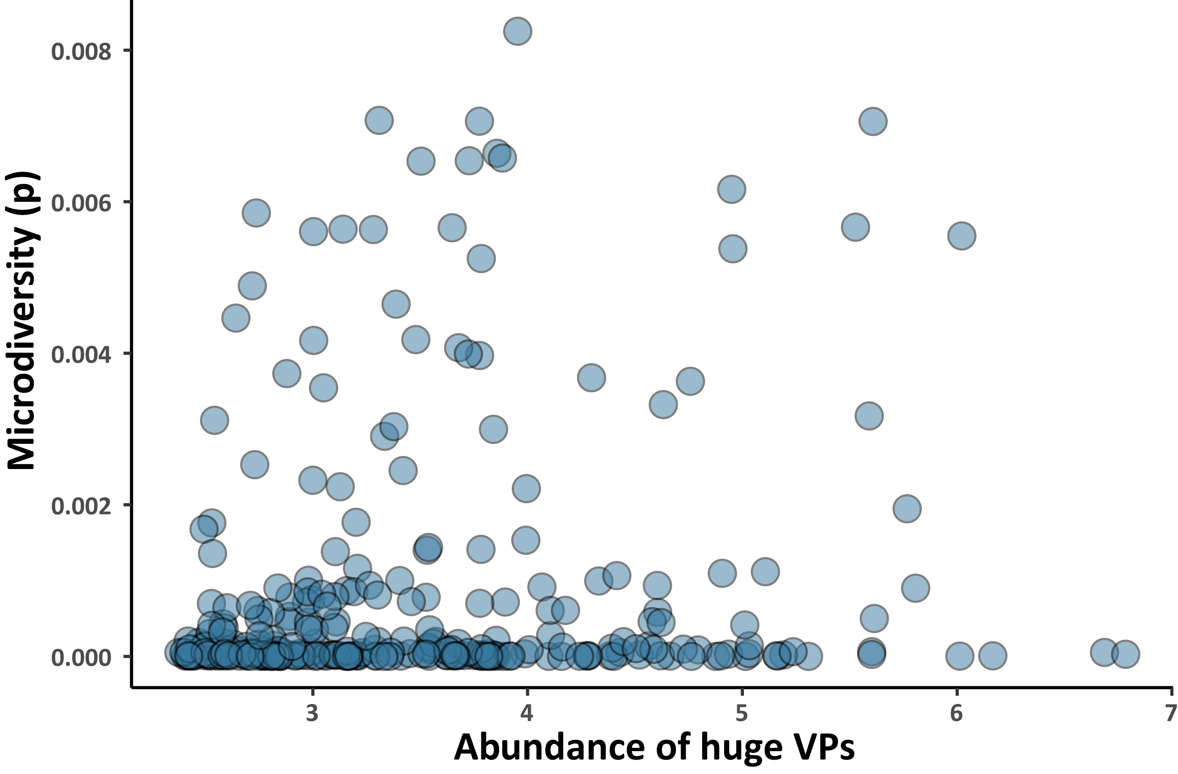
Figure S5 The scatterplot indicated the relationship between the microdiveristy and the abundance of huge VPs.

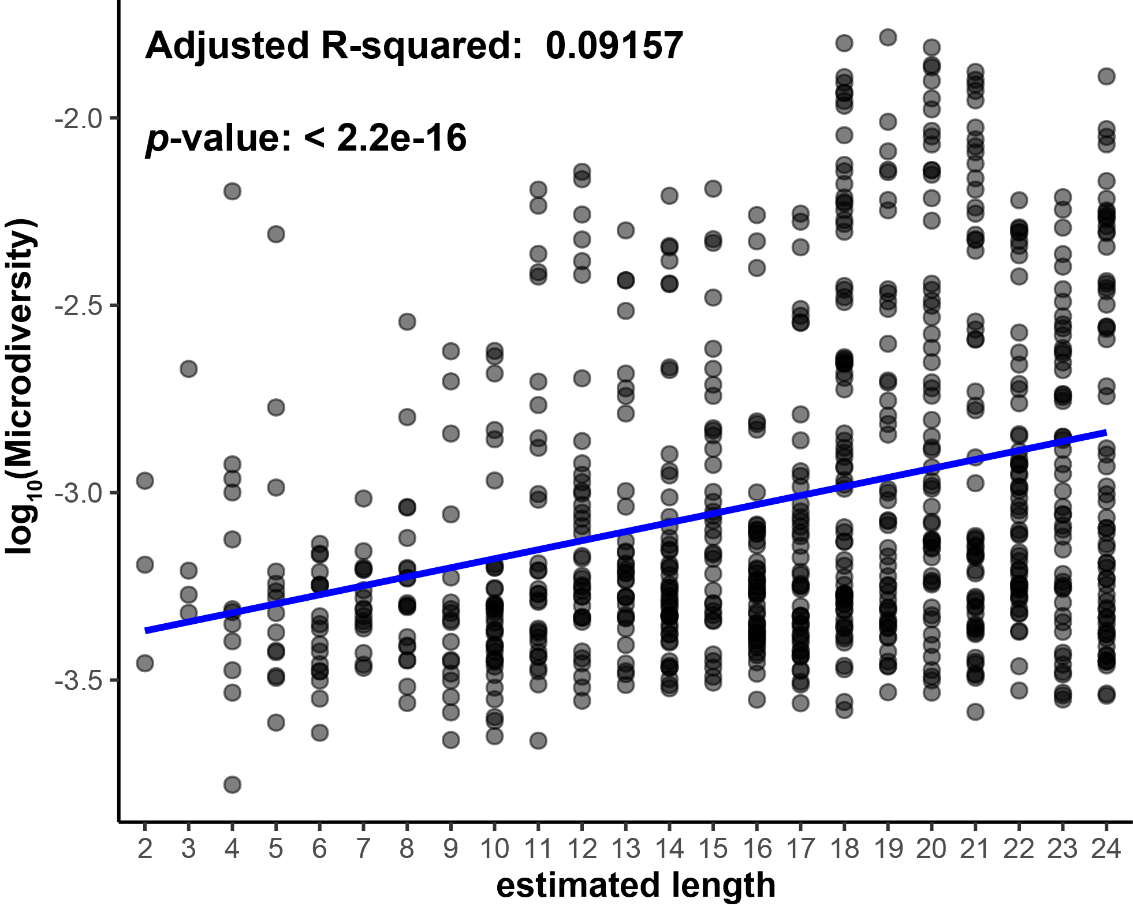
Figure S6 The scatterplot indicated the relationship between microdiversity and site distribution of huge VPs. The microdiversity of huge VPs were calculated using package inStrain. Inset values display the adjusted R² and p value of F-statistic. The statistical test used was two-tailed.

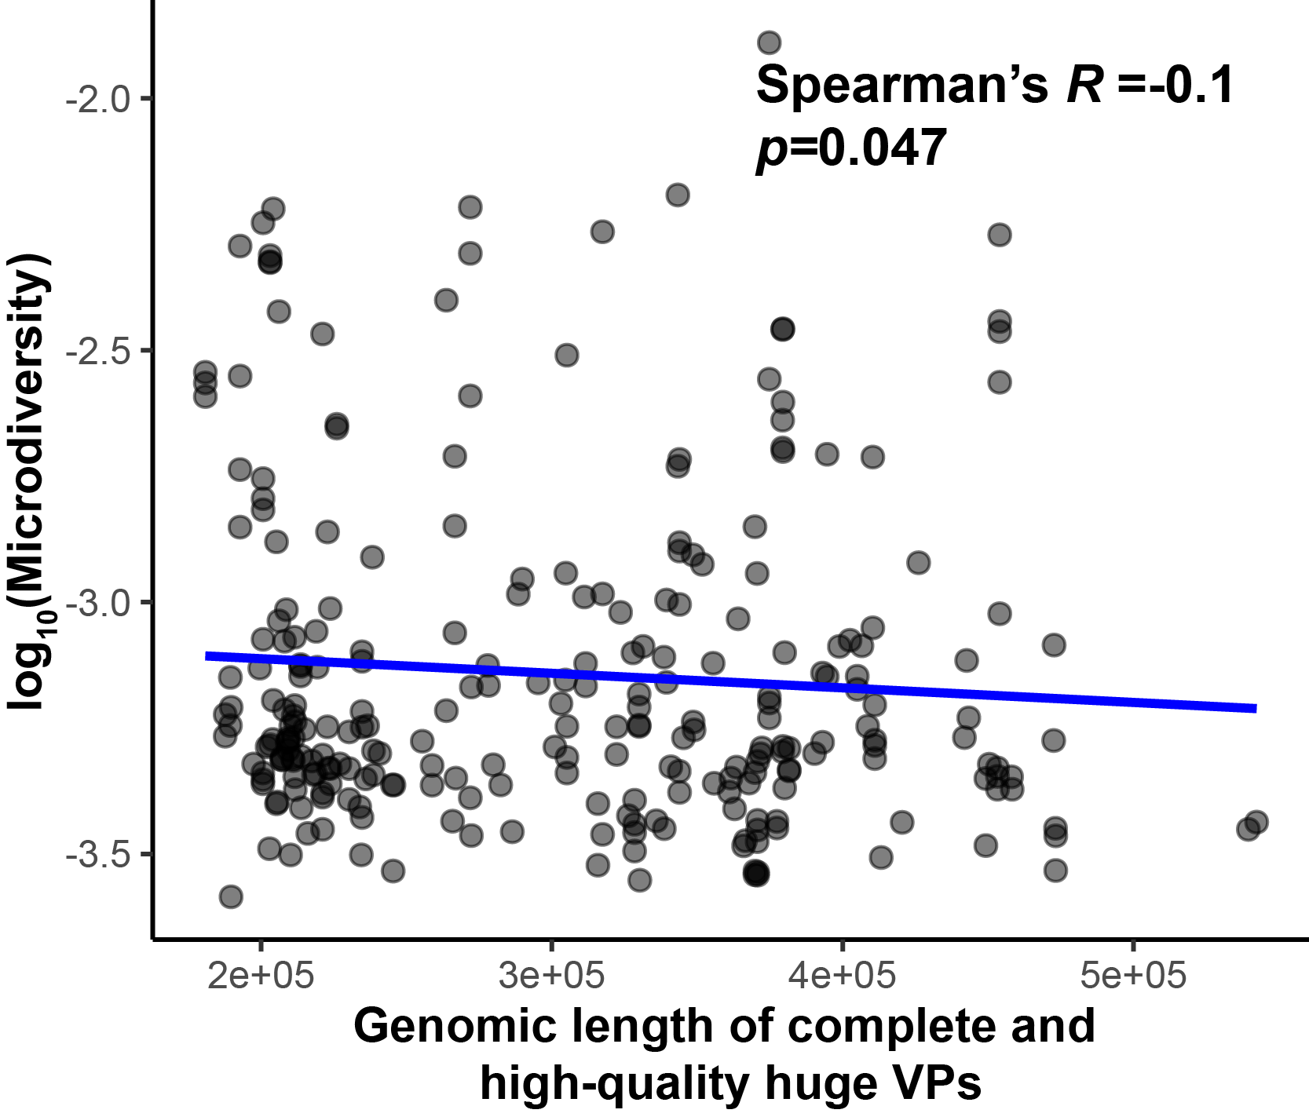
Figure S7 The scatterplot indicated the linear relationship between microdiversity and genome size of complete and high-quality huge VPs. Inset values display the R² and p value of Spearman test. The statistical test used was two-tailed.

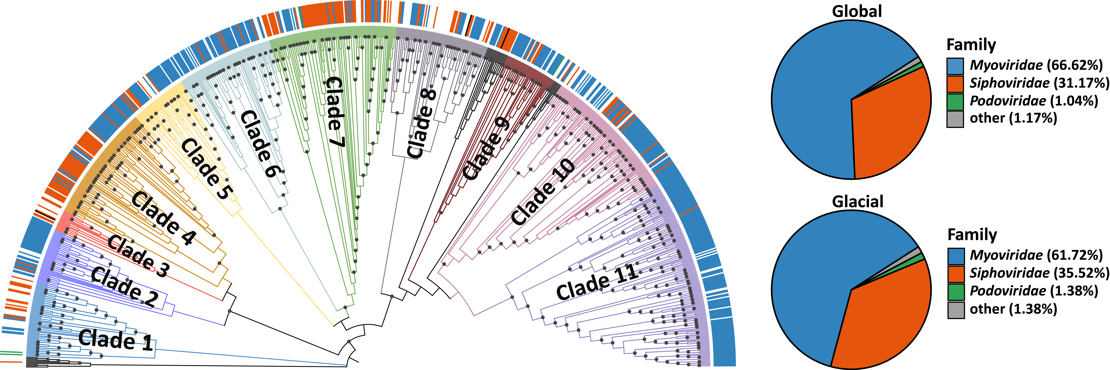
Figure S8. The left panel showed the distribution of families assigned by RaFAH-taxon in the phylogenomic tree. The right panel showed the proportions of the taxa of global and local huge phages at family-level, respectively.

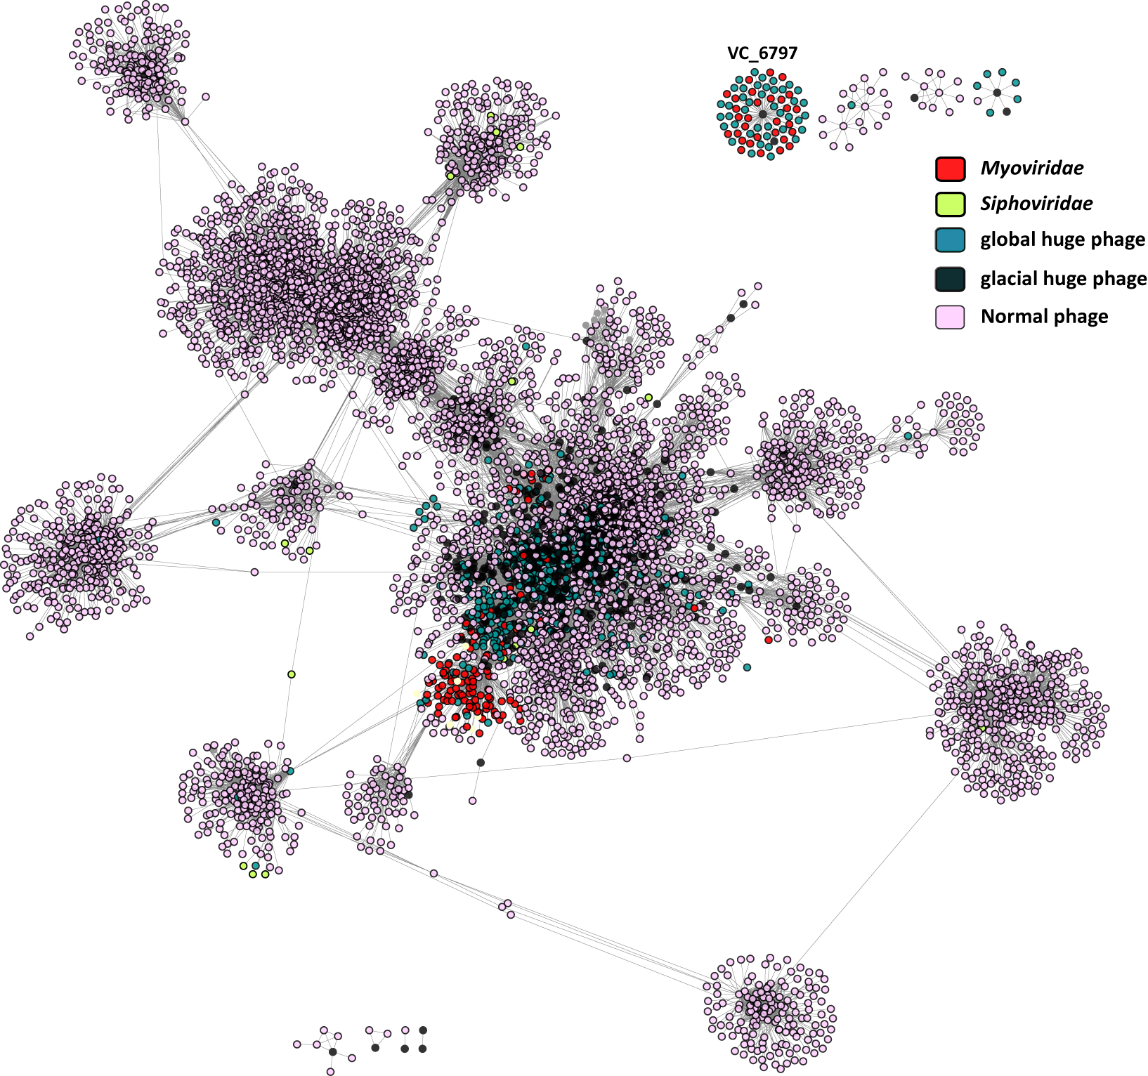
Figure S9. A gene-shared network between huge phages and reference genomes (Ref-201). The figure was visualized by software Cytoscape v3.7.2.

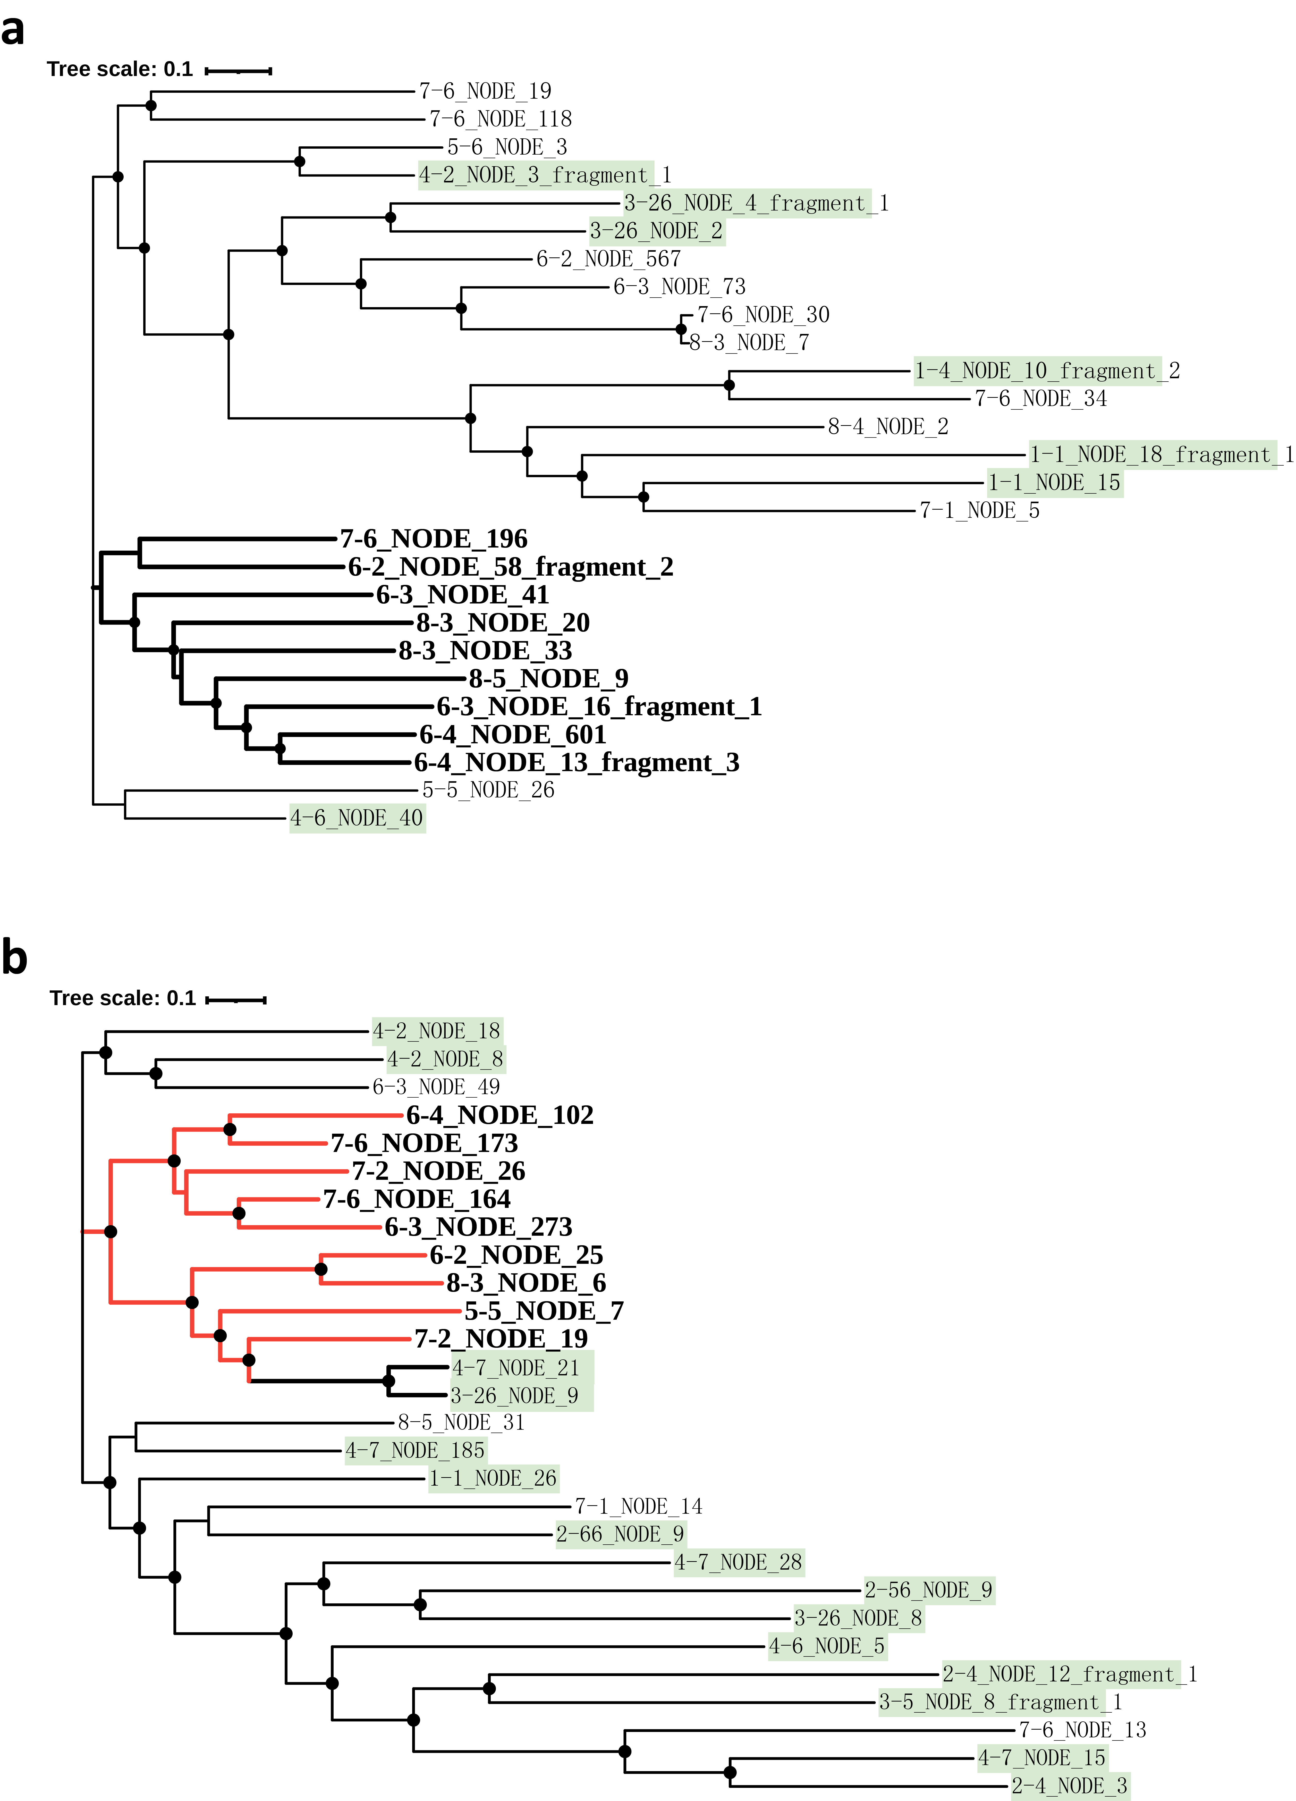
Figure S10 (a) The Maximum-likelihood phylogenomic tree was constructed by concatenated core-genome of huge phages within VC320 clustered by vConTACT2, it included 27 leaves, The filled circles on tree branches represent the bootstrap value are 100. (b) The Maximum-likelihood phylogenomic tree was constructed by concatenated core-genome of huge phages within VC322 clustered by vConTACT2, it included 28 leaves, The filled circles on tree branches represent the bootstrap value are 100. The leaves in the two trees filled by color green represented the huge phage from the early stage of glacial retreat, and others represented them recovered from later stage.

