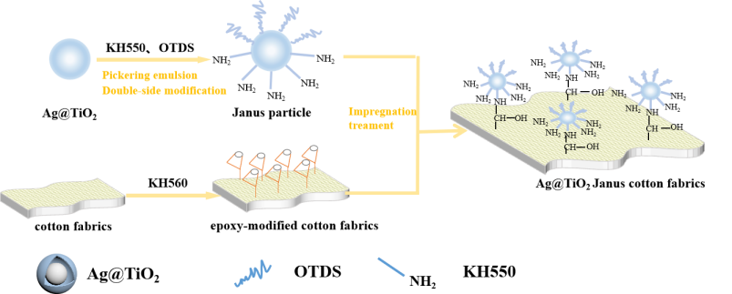
Fig.1. Schematic illustration of the synthesis of Ag@TiO₂ Janus particles and finishing cotton fabrics with Ag@TiO₂ Janus particles
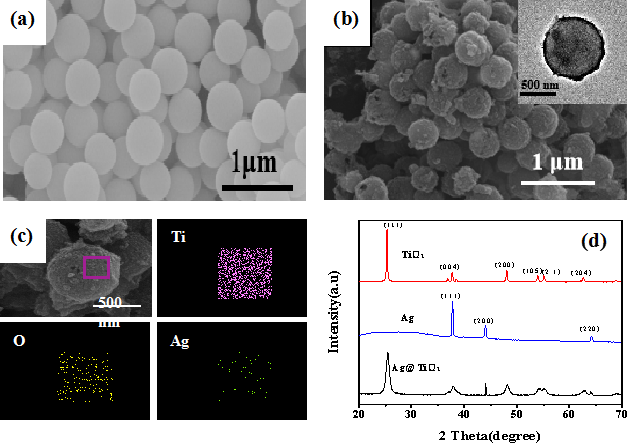
Fig.2 SEM images of (a) Ag/C templates and (b) Ag@TiO₂ microspheres. EDS spectrum of (c) Ag@TiO₂ microspheres. XRD curves of (d) nano Ag, nano TiO₂ and nano Ag@TiO₂ microspheres
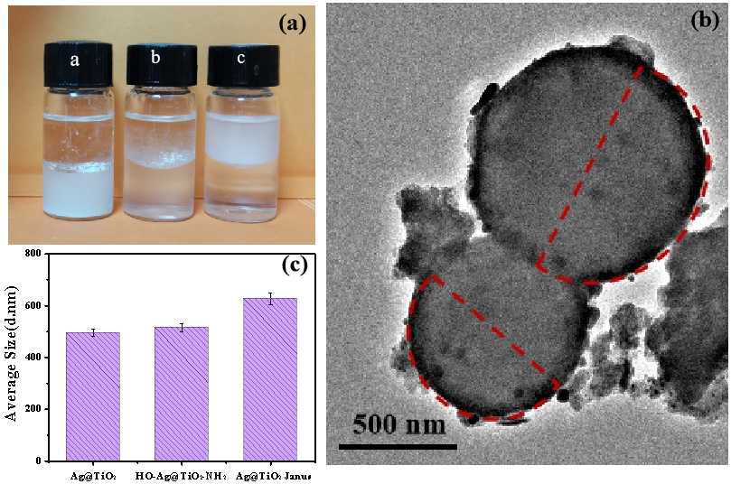
Fig.3(a) dispersion state of HO-Ag@TiO₂-NH₂((a)), Ag@TiO₂ Janus((b)) and C₁₈-Ag@TiO₂((c)) at the interface between methyl methacrylate and deionized water , (b) TEM photos of Ag@TiO₂ Janus nanoparticles labeled with silver and (c) Average particles size graph of unmodified Ag@TiO₂, HO-Ag@TiO₂-NH₂ and Ag@TiO₂ Janus nanoparticles
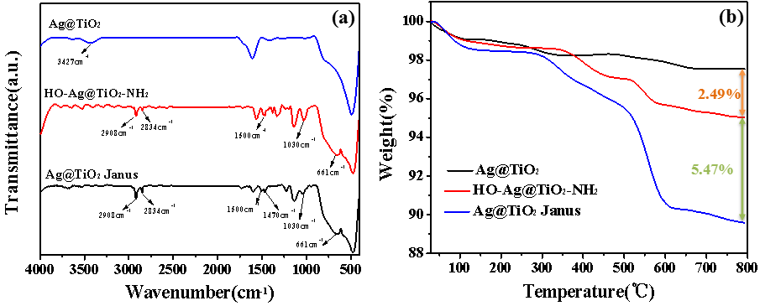
Fig.4 (a) FT-IR spectra and (b) TG curves of Ag@TiO₂, HO-Ag@TiO₂-NH₂ and Ag@TiO₂ Janus particles
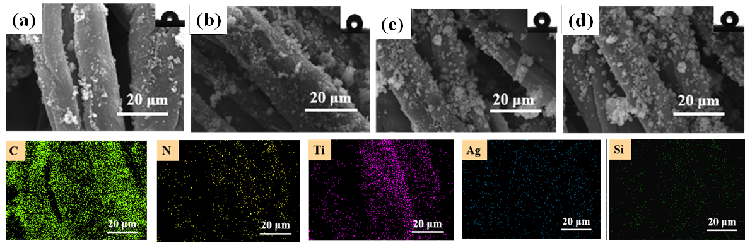
Fig.5 SEM photos of epoxy modified fabrics with different concentrations of Ag@TiO₂ Janus nanoparticles ((a): 1.5%, (b): 2.0%, (c): 2.5% and (d): 3.0%) and EDS spectrum of fabric treated with 2.5% Ag@TiO₂ Janus nanoparticles
Fig.6 FT-IR spectra of E-cotton fabrics and Ag@TiO₂ Janus/E-cotton fabrics
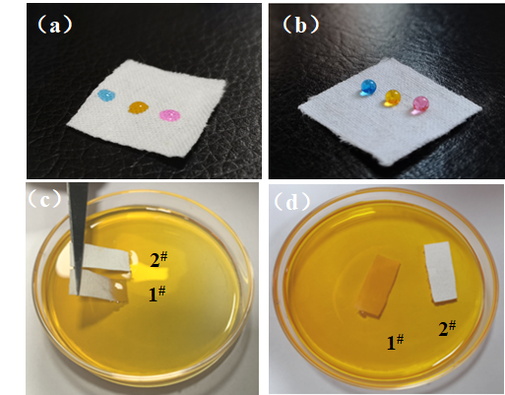
Fig. 7 Placement of dyed water droplets on raw cotton fabrics (a) and Ag@TiO₂ Janus/E-cotton fabrics (b) Placement of fabrics in dyeing aqueous solution before and after modification (c, d)
Fig.8 Changes of contact angles of Ag @ TiO₂ Janus/e-cotton fabrics and C₁₈-Ag@TiO₂/E-cotton fabric with (a) high temperature washing, (b) wear cycle, (c)pH value and (d) different organic solvent treatments
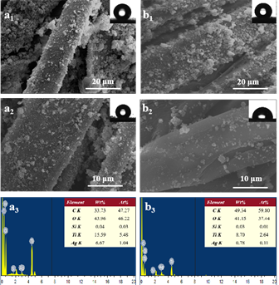
Fig.9 SEM photos of Ag @ TiO₂ Janus/e-cotton fabrics (a₁-a₃) and C₁₈-Ag @ TiO₂/e-cotton fabrics (b₁-b₃) before and after ultrasonic treatment (a₁, b₁- before water washing; a₂, b₂- after water washing) and EDS spectra after water washing
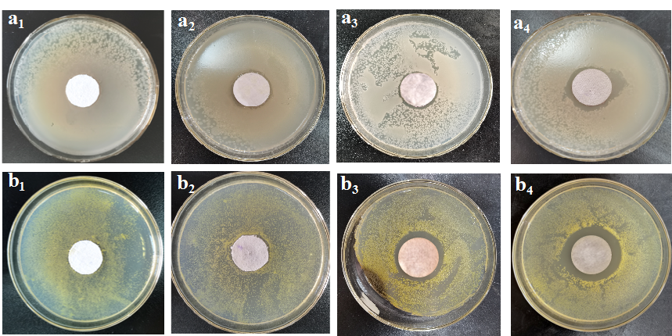
Fig. 10 The photograph of antibacterial effect of raw cotton fabric (a₁, b₁), TiO₂/ E-cotton fabric (a₂, b₂), Ag@TiO₂/ E-cotton fabric (a₃,b₃) and Ag@TiO₂ Janus/ E-cotton fabric (a₄,b₄) against E.coli (a) and S.aureus (b).

Fig.11 antibacterial rate of Ag @ TiO₂ Janus/e-cotton fabrics after ultrasonic water washing treatment
Fig.12 UV protection performance of the E-cotton fabrics and Ag@TiO₂ Janus/E-cotton fabrics
Fig.13 Physical and mechanical strength (a), softness (b), whiteness (c) and air permeability (d) of the cotton fabrics before and after modification

