Supplementary Information

Dual Catalysis of Gold Nanoclusters: Photocatalytic Cross-Dehydrogenative Coupling
by Cooperation of Superatomic Core and Molecularly Modified Staples

Katsuhiro Isozaki,* Kenta Iseri, Ryohei Saito, Kyosuke Ueda, and Masaharu Nakamura*

International Research Center for Elements Science, Institute for Chemical Research, Kyoto University, Gokasyo, Uji, Kyoto 611-0011, Japan, and Department of Energy and Hydrocarbon Chemistry, Graduate School of Engineering, Kyoto University, Nishikyoku, Kyoto 615-8510, Japan.

E-mail: kisozaki@scl.kyoto-u.ac.jp, masaharu@scl.kyoto-u.ac.jp

Contents
Experimental Section····························································································································S2
Table S1–S5. Screening of reaction conditions·······································································S15–S17
Table S6. Stoichiometric reaction between DOP1-AuNC and 2a w/wo presence of 1a·················S17
Table S7. Radical trapping experiments··················································································S18
Scheme S1. Reaction in larger scale························································································S18
Figure S1. Time-course profile of reaction between L/D-1j and 2a. ······································S19
Figure S2. Association experiment of 1a with DOP1-SAc in CDCl₃. ····································S20
Figure S3. ¹H NMR chemical shift of 1a in the presence of DOP1-AuNC in CDCl₃. ·············S20
Figure S4. Association experiment of 2a with DOP1-SAc in CDCl₃. ····································S21
Figure S5. ¹H NMR chemical shift of 2a in the presence of DOP1-AuNC in CDCl₃. ·············S21
Figure S6. ESI-MS spectrum of MixL-AuNC.·········································································S22
Figure S7. UV–Vis absorption spectra of MixL-AuNC and DOP1-AuNC in CHCl₃.······················S22
Figure S8. Photosensitized oxidation of DPBF with DOP1-AuNC and MixL-AuNC.····················S23
Figure S9. Kohn-Sham orbital of [Au₂₅(SMe)₁₈]⁻, [Au₂₅(SMe)₁₇(C≡CPh)^{apex}]⁻, and [Au₂₅(SMe)₁₇(C≡CPh)^{core}]⁻ near the HOMO and LUMO levels.···································S25
Table S8. Absorption Property and Relative Energy of AuNCs in Excited States·····················S26
Figure S10. DFT-calculated UV-Vis absorption spectra of AuNCs.················································S26
Table S9. Averaged Bond Lengths of AuNCs in Ground and Excited States··································S27
Table S10. Averaged Bond Lengths in Reaction Intermediates·····················································S27
Figure S11. Molecular structure of calculated intermediates in apex-substituted pathway.·················S28
Figure S12. Molecular structure of calculated intermediates in core-substituted pathway.·················S29
¹H and ¹³C NMR spectra······································································································S30
Experimental Section
General. All reactions dealing with air- or moisture-sensitive compounds were carried out in a dry reaction vessel under a positive pressure of argon. The air- and moisture-sensitive liquids and solutions were transferred via syringes or a PTFE cannula. Analytical TLC was performed on glass plates coated with 0.25 mm 230–400 mesh silica gel containing a fluorescent indicator (Merck, #1.05715.0009). The TLC plates were visualized by exposure to UV light (254 nm), iodine vapor, and by immersion in a ninhydrin solution, followed by heating on a hot plate. Organic solutions were concentrated by rotary evaporation at ca. 30–400 mmHg. Flash column chromatography was performed on Merck silica gel 60 (spherical, neutral, 140–325 mesh).
Instruments. Proton nuclear magnetic resonance (¹H NMR) and carbon nuclear magnetic resonance (¹³C NMR) spectra were recorded on JEOL ECS-400NR (392 MHz) spectrometer. Proton chemical shift values are reported in parts per million (ppm, δ scale) downfield from tetramethylsilane and are referenced to the tetramethylsilane (δ 0.00). ¹³C NMR spectra were recorded at 98.5 MHz: carbon chemical shift values are reported in parts per million (ppm, δ scale) downfield from tetramethylsilane and are referenced to the carbon resonance of CDCl₃ (δ 77.16). Data are presented as: chemical shift, multiplicity (s = singlet, d = doublet, t = triplet, q = quartet, quint = quintet, sext = sextet, sept = septet, m = multiplet and/or multiplet resonances, br = broad), coupling constant in hertz (Hz), signal area integration in natural numbers, and assignment (italic). The high precision isotope peak intensities ratios were determined by Fourier transformation-ion cyclotron resonance-mass spectrometry (FT-ICR-MS) coupled with electron spray ionization (ESI) technique using a SolariX FT-ICR-MS spectrometer (Bruker Daltonics GmbH). UV−Vis absorption spectra were recorded on a Shimadzu UV-2700 spectrometer. Photochemical reactions were carried out using Asahi Spectra MAX-303 Xe light sources. The photo-irradiation power was measured by HIOKI optical power meter 3664. Flash column chromatography was performed using Biotage SP-1 and Yamazen YFLC-AI-580.
Materials. Materials were purchased from Wako, Tokyo Chemical Industry Co., Ltd., Nakalai tesque, Inc., and other commercial suppliers, and were used without further purification, unless otherwise noted. Ethanol (EtOH), sodium borohydride (NaBH₄), 2,2,6,6-tetramethylpiperidine 1-oxyl (TEMPO), N,N,N’,N’-tetramethylethylenediamine (TMEDA), copper(I) bromide, toluene, potassium carbonate (K₂CO₃), and tetrahydrofuran (THF) were purchased from Wako. Methanol (MeOH), 1,4-hydroquinone (HQ), distilled water (H₂O), L-proline, butyraldehyde, and triethylamine (NEt₃) were purchased from Nacalai tesque. Tetrachloroauric(III) acid tetrahydrate (HAuCl₄·4H₂O) was purchased from TANAKA KIKINNZOKU KOGYO K. K. Methanol anhydrous (MeOH), 4-ethynyltoluene (2d), methyl 4-ethynylbenzoate (2f), and 1-butylpyrrolidine (1a) were purchased from Sigma-Aldrich. 4-Ethynylanisole (2a), 2-phenylethyl mercaptan (PhCH₂CH₂SH), tetraoctylammonium bromide (TOAB), and 1,2,3,4-tetrahydroisoquinoline were purchased from TCI. Chloroform (CHCl₃) and ethyl acetate (EtOAc) were purchased from Kishida Chemical Co., Ltd. Chloroform-d was purchased from Cambridge Isotope Laboratories, Inc. DOP1-SH, DOP1-SAc, and DOP2-AuNC were synthesized according to the previously reported method. PET-AuNC, and chloro(dimethylsulfide)gold (I) (Me₂SAuCl) were synthesized according to the literature method.

Synthesis of propargylamine products.
Propargylamine products were synthesized by four types of synthetic procedures. Procedure A: Cu-catalyzed three component coupling for pyrrolidine derivatives, procedure B: Cu-catalyzed A³-coupling with amine, aldehyde, and alkyne, procedure C: DOP1-AuNC-photocatalyzed cross-dehydrogenative coupling of amine and alkyne, procedure D: Ru-catalyzed alkynylation of amines.

Procedure A: Synthesis of regioisomers of propargylamine products from pyrrolidine substrates.
Regioisomers of propargylamine products were synthesized at once by Saidel’s decarboxylative three-component coupling reaction. To CuBr (21.5 mg, 0.150 mmol), a solution of TMEDA (45 μl, 0.30 mmol) in toluene (2.0 ml) was added, then the mixture solution was stirred under argon for 10 min. The mixture solution consisted of blue solution and green solid. To the mixture solution L-proline (173 mg, 1.50 mmol) and alkyne (1.50 mmol) were added, and stirred for further 1 h. Then, the mixture solution was heated to 120 °C, and the solution of aldehyde (1.0 mmol) in toluene (161 μl) was added dropwise for 18 h. The resulting mixture solution was diluted with EtOAc and filtrated by short pad of silica gel. The yellow filtrate was concentrated. The residue was purified by silica gel flash column chromatography and preparative thin-layer chromatography, where major fractions of the corresponding products were isolated as the regioisomer products.

Procedure B: Synthesis of propargylamine products by A³ coupling.
A regioisomer of 3ha, 3-(4-methoxyphenyl)-N,N-dimethyl-1-phenylprop-2-yn-1-amine (3ha’) was synthesized by Cu-catalyzed three-component coupling reaction of amine, aldehyde, and alkyne. To CuBr (43,6 mg, 0.300 mmol), a solution of TMEDA (90 μl, 0.60 mmol) in toluene (4.0 ml) was added, then the mixture solution was stirred under argon for 10 min. The mixture solution consisted of blue solution and green solid. To the mixture solution dimethylamine (135 mg, 3.00 mmol) and 4-ethynylanisole (3.00 mmol) were added, and stirred for further 1 h. Then, the mixture solution was heated to 120 °C, and the solution of benzaldehyde (2.0 mmol) in toluene (298 μl) was added dropwise for 18 h. The resulting mixture solution was diluted with EtOAc and filtrated by short pad of silica gel. The yellow filtrate was concentrated. The residue was purified by silica gel flash column chromatography, where major fractions of the corresponding products were isolated as the regioisomer product.

Procedure C: Photocatalytic cross-dehydrogenative coupling of tertiary amine and terminal alkyne.
A Schlenk-head NMR tube was loaded with amines (0.12 mmol), alkynes (60 μmol), and AuNCs (0.6 μmol), purged with O₂ (1 atm), and filled with CDCl₃ (600 µL). The NMR tube was subjected to bottom irradiation using an Asahi Spectra MAX-303 xenon light source. The photo-irradiation power, ranging from 3.5 to 3.7 mW/cm², was measured by a HIOKI 3664 optical power meter. The reaction progress was monitored via ¹H NMR spectroscopy using a JEOL ECS-400NR instrument. After the reaction stopped, the solvent was evaporated and the residue was subjected to flash silica gel column chromatography, where major fraction was collected to afford the propargylamine product.

Procedure D: Ru-catalyzed alkynylation of amine
1-Butyl-2-(phenylethynyl)pyrrolidine (3ae) was synthesized by Ru-catalyzed alkynylation of amine according to the reported method. To Shvo catalyst (1-hydroxytetraphenylcyclopentadienyl-(tetraphenyl-2,4-cyclopentadiene-)-μ-hydrotetracarbonyldiruthenium(II), 21.8 mg, 1.0 mol %), 1-butylpyrrolidine (3.0 ml, 19.3 mmol) was added, then phenylacetylene (204 mg, 2.0 mmol) was added via syringe. The mixture solution was heated to 120 °C under argon atmosphere for 24 h. The resulting mixture solution was evaporated and the residue was purified by silica gel flash column chromatography twice, where major fractions of the corresponding products were isolated as the regioisomer products.

1-Butyl-2-((4-methoxyphenyl)ethynyl)pyrrolidine (3aa)
This compound was synthesized by procedure A using 4-ethynylanisole and butyraldehyde. Yield: 12%; ¹H NMR (391.8 MHz, CDCl₃): δ 7.36 (d, J = 9.0 Hz, 2H, -Ar-H), 6.81 (d, J = 8.5 Hz, 2H, -Ar-H), 3.78 (s, 3H, -OCH₃), 3.55 (t, J = 6.2 Hz, 1H, -NCH(alkynyl)CH₂-), 2.88 (qd, J = 8.4, 3.1 Hz, 2H, C₃H₇CH₂N-, BuNCH₂CH₂-), 2.52–2.46 (m, 1H, BuNCH₂-), 2.42–2.36 (m, 1H, C₃H₇CH₂N-), 2.22–2.13 (m, 1H, -CH₂CH₂CH-), 2.05–1.88 (m, 2H, -CH₂CH₂CH(alkynyl)-, -CH₂CH₂CH(alkynyl)-), 1.86–1.78 (m, 1H, -CH₂CH₂CH(alkynyl)-), 1.60–1.52 (m, 2H, -CH₂CH₂C₂H₅), 1.42–1.33 (m, 2H, -CH₂CH₂CH₃), 0.93 (t, J = 7.4 Hz, 3H, -CH₂CH₃); ¹³C NMR (98.5 MHz, CDCl₃): δ 159.5, 133.2, 115.7, 114.0, 87.3, 84.4, 55.4, 53.6, 52.2, 32.0, 30.1, 22.2, 21.1, 14.2.

1-(1-(4-Methoxyphenyl)hex-1-yn-3-yl)pyrrolidine (3aa’).
This compound was synthesized together with 3aa by procedure A using 4-ethynylanisole and butyraldehyde. Yield: 17%; ¹H NMR (391.8 MHz, CDCl₃): δ 7.36 (dt, J = 9.3, 2.5 Hz, 2H, -Ar-H), 6.82 (dt, J = 9.3, 2.5 Hz, 2H, -Ar-H), 3.80 (s, 3H, -ArOCH3), 3.69 (t, J = 7.4 Hz, 1H, -NCH(alkynyl)CH₂-), 2.79–2.70 (m, 4H, -NCH₂CH₂-), 1.84–1.43 (m, 8H, -NCH₂CH₂-, -CH₂CH₂CH₃), 0.97 (t, J = 7.4 Hz, 3H, -CH₂CH₃); ¹³C NMR (CDCl3, 98.5 MHz): δ 159.4, 133.2, 115.7, 113.9, 86.5, 85.2, 55.4, 55.0, 49.8, 37.3, 23.6, 20.1, 14.0.

2-((4-Methoxyphenyl)ethynyl)-1-metylpyrrolidine (3ba)
This compound was synthesized by procedure C using 4-ethynylanisole and 1-methylpyrrolidine. Yield: 2%; ¹H NMR (391.8 MHz, CDCl₃): δ 7.36 (d, J = 9.0 Hz, 2H, -Ar-H), 6.82 (d, J = 8.5 Hz, -Ar-H), 3.80 (s, 3H, -OCH₃), 3.29 (t, J = 7.2 Hz, 1H, -NCH(alkynyl)CH₂-), 2.94 (td, J = 8.8, 3.9 Hz, 1H, -NCH₂CH₂-), 2.48 (s, 3H, CH₃N-) 2.39 (dd, J = 15.9, 8.8 Hz, 1H, -NCH₂CH₂-), 2.22–2.15 (m, 1H, -CH(alkynyl)CH₂CH₂-), 2.05–1.92 (m, 2H, -CH(alkynyl)CH₂CH₂-, -CH₂CH₂CH₂-), 1.83–1.78 (m, 1H, -CH₂CH₂CH₂-).
This compound was assigned based on the reported spectral data.

1-((4-Methoxyphenyl)ethynyl)-2-methyl-1,2,3,4-tetrahydroisoquinoline (3ca)
This compound was assigned based on the reported spectral data.

1-((4-Methoxyphenyl)ethynyl)-2-phenyl-1,2,3,4-tetrahydroisoquinoline (3da)
This compound was assigned based on the reported spectral data.

1-(1-(4-Methoxyphenyl)prop-1-yn-3-yl)piperidine (3ea)
This compound was assigned based on the reported spectral data.

1-(1-(4-Methoxyphenyl)prop-1-yn-3-yl)morpholine (3fa)
This compound was synthesized by procedure C using N-methylmorpholine and 4-ethynylaniasole. Yield: 61%; ¹H NMR (391.8 MHz, CDCl₃): δ 7.37 (d, J = 9.0 Hz, 2H, -Ar-H), 6.83 (d, J = 9.0 Hz, 2H, Ar-H), 3.81 (s, 3H, -OCH₃), 3.77 (t, J = 4.7 Hz, 4H, -OCH₂CH₂-), 3.49 (s, 2H, -NCH₂C≡C-), 2.64 (t, J = 4.5 Hz, 4H, -NCH₂CH₂-).
This compound was assigned based on the reported data.

N,N-Diethyl-4-(4-methoxyphenyl)but-3-yn-2-amine (3ga)
This compound was assigned based on the reported spectral data.

N-Benzyl-3-(4-methoxyphenyl)-N-methylprop-2-yn-1-amine (3ha)
This compound was assigned based on the reported spectral data.

N,N-Dimethyl-3-(4-methoxyphenyl)-1-phenylprop-2-yn-1-amine (3ha’)
This compound was synthesized by procedure B using dimethylamine, benzaldehyde, and 4-ethynylanisole. Yield: 6%; ¹H NMR (391.8 MHz, CDCl₃): δ 7.60 (d, J = 7.6 Hz, 2H, -Ph-ºH), 7.46 (d, J = 8.5 Hz, 2H, -Ar-H), 7.36 (t, J = 7.4 Hz, 2H, -Ph-^{m}H), 7.29 (t, J = 7.2 Hz, 1H, -Ph-^{p}H), 6.86 (d, J = 8.5 Hz, 2H, -Ar-H), 4.81 (s, 1H, -NCH(alkynyl)Ph), 3.82 (s, 3H, -OCH₃), 2.32 (s, 6H, -N(CH₃)₂); ¹³C NMR (98.5 MHz, CDCl₃): δ 159.6, 139.0, 133.3, 128.6, 128.3, 127.7, 115.5, 114.1, 88.3, 83.3, 62.4, 55.5, 41.8.

Methyl N-(3-(4-methoxyphenyl)prop-2-yn-1-yl)-N-methyl-L-phenylalaninate (3ia)
This compound was synthesized by procedure C using N,N-dimethyl-L-phenylalanine methyl ester and 4-ethynylanisole. Yield: 48%; ¹H NMR (391.8 MHz, CDCl₃): δ 7.37 (d, J = 9.0 Hz, 2H, -Ar-H), 7.29–7.25 (m, 2H, -Ph-H), 7.22–7.20 (m, 3H, -Ph-H), 6.83 (d, J = 9.0 Hz, 2H, -Ar-H), 3.81 (s, 3H, -OCH₃), 3.77–3.63 (m, 3H, -C≡CCH₂N-, -NCH(CH₂Ph)(CO-)-), 3.57 (s, 3H, -OCH₃), 3.07 (d, J = 8.1 Hz, 2H, -CHCH₂Ph) 2.52 (s, 3H, -NCH₃); ¹³C NMR (98.5 MHz, CDCl₃): δ 172.4, 159.6, 138.0, 133.2, 129.3, 128.5, 126.6, 115.3, 114.0, 85.2, 83.3, 67.7, 55.4, 51.5, 44.9, 38.7, 36.3.

Methyl N-(3-(4-methoxyphenyl)prop-2-yn-1-yl)-N-methylglycyl-L-phenylalaninate (L-3ja)
This compound was synthesized by procedure C using methyl N,N-dimethylglycyl-L-phenylalaninate and 4-ethynylanisole. Yield: 57%; ¹H NMR (391.8 MHz, CDCl₃): δ 7.53 (d, J = 8.2 Hz, 1H, -CONHCH-), 7.35 (d, J = 8.7 Hz, 2H, -Ar-H), 7.30–7.21 (m, 3H, -Ph-H), 7.14 (d, J = 6.4 Hz, 2H, -Ar-H), 6.83 (d, J = 8.7 Hz, 2H, -Ph-H), 4.93–4.88 (m, 1H, -NHCH(CH₂Ph)CO-) 3.81 (s, 3H, -OCH₃), 3.73 (s, 3H, -OCH₃), 3.49–3.39 (m, 2H, -C≡CCH₂N-), 3.23–3.05 (m, 4H, -N(CH₃)CH₂CO-, -CHCH₂Ph) 2.32 (s, 3H, -NCH₃); ¹³C NMR (98.5 MHz, CDCl₃): δ 172.1, 170.4, 159.6, 136.1, 133.2, 129.3, 128.7, 127.2, 115.0, 114.0, 85.5, 82.2, 59.5, 55.4, 52.6, 52.4, 47.2, 42.6, 38.0.

Methyl N-(3-(4-methoxyphenyl)prop-2-yn-1-yl)-N-methylglycyl-D-phenylalaninate (D-3ja)
This compound was synthesized as similar to L-3ja using N,N-dimethylglycyl-D-phenylalaninate as the starting material. The product was assigned by the spectral accordance with L-3ja.

1-Butyl-2-(2-methoxyphenylethynyl)pyrrolidine (3ac)
This compound was synthesized by procedure A using L-proline, butyraldehyde, and 2-ethynylanisole. Yield: 21%; ¹H NMR (391.8 MHz, CDCl₃): δ 7.39 (dd, J = 7.6, 1.8 Hz, 1H, -Ar-⁶H), 7.27–7.23 (m, 1H, -Ar-⁴H), 6.90–6.84 (m, 2H, -Ar-^{3,5}H), 3.85 (s, 3H, -OCH₃), 3.66 (dd, J = 7.2, 4.9 Hz, 1H, -NCH(alkynyl)CH₂-), 2.93–2.83 (m, 2H, C₃H₇CH₂N-, BuNCH₂CH₂-), 2.53 (td, J = 8.9, 6.0 Hz, 1H, BuNCH₂-), 2.48–2.41 (m, 1H C₃H₇CH₂N-), 2.21–2.13 (m, 1H, -CH₂CH₂CH-), 2.13–2.08 (m, 2H, -CH₂CH₂CH(alkynyl)-, -CH₂CH₂CH(alkynyl)-), 1.86–1.79 (m, 1H, -CH₂CH₂CH(alkynyl)-), 1.60–1.52 (m, 2H, -CH₂CH₂C₂H₅), 1.43–1.33 (m, 2H, -CH₂CH₂CH₃), 0.94 (t, J = 7.2 Hz, 3H, -CH₂CH₃); ¹³C NMR (98.5 MHz, CDCl₃): δ 160.1, 133.7, 129.3, 120.4, 112.8, 110.7, 93.1, 80.7, 55.8, 55.4, 53.3, 52.0, 31.9, 31.0, 22.2, 21.0, 14.2.

1-(1-(2-Methoxyphenyl)hex-1-yn-3-yl)pyrrolidine (3ac’).
This compound was synthesized by procedure A using L-proline, butyraldehyde, and 2-ethynylanisole. Yield: 19%; ¹H NMR (391.8 MHz, CDCl₃): δ 7.38 (dd, J = 7.4, 1.6 Hz, 1H, -Ar-⁶H), 7.25 (ddd, J = 8.6, 6.8, 1.5 Hz, 1H, -Ar-⁴H), 6.87 (qd, J = 7.9, 7.0 Hz, 2H, -Ar-^{3,5}H), 3.85 (s, 3H, -OCH₃), 3.78 (t, J = 7.4 Hz, 1H, -NCH(alkynyl)CH₂-), 2.83–2.70 (m, 4H, -NCH₂CH₂-), 1.82–1.49 (m, 8H, -NCH₂CH₂-, -CH₂CH₂CH₃), 0.97 (t, J = 7.2 Hz, 3H, -CH₂CH₃); ¹³C NMR (98.5 MHz, CDCl₃): δ 160.2, 133.6, 129.3, 120.4, 112.9, 110.8, 92.6, 81.5, 55.9, 55.2, 49.7, 37.4, 23.7, 20.1, 14.1.

1-Butyl-2-(4-methylphenylethynyl)pyrrolidine (3ad)
This compound was synthesized by procedure A using L-proline, butyraldehyde, and p-tolyl acetylene. Yield: 24%; ¹H NMR (391.8 MHz, CDCl₃): δ 7.31 (d, J = 6.3 Hz, 2H, -Ar-H), 7.09 (d, J = 8.1 Hz, 2H, -Ar-H), 3.54 (dd, J = 7.6, 5.4 Hz, 1H, -NCH(alkynyl)CH₂-), 2.91–2.84 (m, 2H, C₃H₇CH₂N-, BuNCH₂CH₂-), 2.47 (td, J = 8.8, 6.3 Hz, 1H, BuNCH₂-), 2.41–2.33 (m, 4H, C₃H₇CH₂N-, -C₆H₄CH₃), 2.21–2.12 (m, 1H, -CH₂CH₂CH-), 2.05–1.77 (m, 2H, -CH₂CH₂CH(alkynyl)-, -CH₂CH₂CH(alkynyl)-), 1.86–1.78 (m, 1H, -CH₂CH₂CH(alkynyl)-), 1.60–1.52 (m, 2H, -CH₂CH₂C₂H₅), 1.42–1.33 (m, 2H, -CH₂CH₂CH₃), 0.93 (t, J = 7.4 Hz, 3H, -CH₂CH₃); ¹³C NMR (98.5 MHz, CDCl₃): δ 137.9, 131.7, 129.0, 120.5, 88.3, 84.5, 55.3, 53.5, 52.1, 31.9, 31.0, 22.2, 21.5, 21.0, 14.2.

1-(1-(4-Methylphenyl)hex-1-yn-3-yl)pyrrolidine (3ad’)
This compound was synthesized by procedure A using L-proline, butyraldehyde, and p-tolyl acetylene. Yield: 39%; ¹H NMR (391.8 MHz, CDCl₃): δ 7.31 (d, J = 8.1 Hz, 2H, -Ar-H), 7.09 (d, J = 7.6 Hz, 2H, -Ar-H), 3.68 (t, J = 7.2 Hz, 1H, -NCH(alkynyl)CH₂-), 2.79–2.65 (m, 4H, -NCH₂CH₂-), 2.33 (s, 3H, -C₆H₄CH₃), 1.81–1.46 (m, 8H, -NCH₂CH₂-, -CH₂CH₂CH₃), 0.97 (t, J = 7.4 Hz, 3H, -CH₂CH₃); ¹³C NMR (98.5 MHz, CDCl₃): δ 137.9, 131.7, 129.1, 120.5, 87.6, 85.4, 55.0, 49.8, 37.4, 23.6, 21.5, 20.1, 14.1.

1-Butyl-2-(phenylethynyl)pyrrolidine (3ae)
This compound was synthesized by procedure D using 1-butylpyrrolidine and phenylacetylene. Yield: 4%. ¹H NMR (391.8 MHz, CDCl₃): δ 7.43–7.41 (m, 2H, -Ar-H), 7.30–7.27 (m, 3H, -Ar-H), 3.58 (dd, J = 7.4, 5.2 Hz, 1H, -NCH(alkynyl)CH₂-), 2.88 (qd, J = 8.3, 3.0 Hz, 2H, C₃H₇CH₂N-, BuNCH₂CH₂-), 2.54–2.49 (m, 1H, BuNCH₂-) 2.44–2.37 (m, 1H, C₃H₇CH₂N-), 2.18–2.16 (m, 1H, -CH₂CH₂CH-), 2.05–1.84 (m, 3H, -CH₂CH₂CH(alkynyl)-, -CH₂CH₂CH(alkynyl)-), 1.59–1.52 (m, 2H, -CH₂CH₂C₂H₅), 1.41–1.33 (m, 2H, -CH₂CH₂CH₃), 0.94 (t, J = 7.4 Hz, 3H, -CH₂CH₃); ¹³C NMR (98.5 MHz, CDCl₃): δ 131.8, 128.3, 127.9, 123.5, 88.9, 84.5, 77.4, 77.1, 76.8, 55.2, 53.5, 52.1, 31.8, 30.9, 22.2, 21.0.

Methyl 4-((1-butylpyrrolidin-2-yl)ethynyl)benzoate (3af)
This compound was synthesized by modified procedure A using L-proline, butyraldehyde, and 4-ethynylanisole. To CuBr (287 mg, 2.00 mmol), a solution of TMEDA (596 μl, 4.00 mmol) in toluene (5.0 ml) was added, then the mixture solution was stirred under argon atmosphere for 10 min. The mixture solution consisted of blue solution and green solid. To the mixture solution L-proline (230 mg, 2.00 mmol), methyl 4-ethynylbenzoate (2.00 mmol), and butyraldehyde (180 μl, 2.00 mmol) were added. Then, the mixture solution was heated to 120 °C and stirred for 18 h. The resulting mixture solution was diluted with EtOAc and filtrated by short pad of silica gel. The yellow filtrate was concentrated. The residue was purified by silica gel flash column chromatography, where major fractions of the corresponding products were isolated as the regioisomer products. Yield: 1%. ¹H NMR (391.8 MHz, CDCl₃): δ 7.96 (d, J = 8.7 Hz, 2H, -Ar-H), 7.47 (d, J = 8.7 Hz, 2H, -Ar-H), 3.91 (s, 3H, -COOCH₃), 3.58 (dd, J = 7.4, 5.4 Hz, 1H, -NCH(alkynyl)CH₂-), 2.91–2.83 (m, 2H, C₃H₇CH₂N-, BuNCH₂CH₂-), 2.50 (td, J = 8.7, 6.3 Hz, 1H, BuNCH₂-), 2.43–2.37 (m, 1H, C₃H₇CH₂N-), 2.23–2.14 (m, 1H, -CH₂CH₂CH-), 2.08–1.79 (m, 3H, -CH₂CH₂CH-, BuNCH₂CH₂CH₂-), 1.59–1.50 (m, 2H, -CH₂CH₂C₂H₅), 1.43–1.36 (m, 2H, -CH₂CH₃), 0.96 (t, J = 7.5 Hz, 3H, -CH₂CH₃); ¹³C NMR (98.5 MHz, CDCl₃):δ 166.7, 131.7, 129.5, 129.2, 128.3, 92.5, 83.8, 55.3, 53.5, 52.3, 52.1, 31.8, 31.0, 30.9, 22.2, 21.0, 14.2.

Methyl 4-(3-(pyrrolidin-1-yl)hex-1-yn-1-yl)benzoate (3af’)
This compound was synthesized by the same procedure of 3af. Yield: 1%. ¹H NMR (391.8 MHz, CDCl₃):δ 7.95 (d, J = 8.7 Hz, 2H, -Ar-H), 7.46 (d, J = 7.8 Hz, 2H, -Ar-H), 3.90 (s, 3H, -COOCH₃), 3.71 (t, J = 7.4 Hz, 1H, -NCH(alkynyl)CH₂-), 2.76–2.66 (m, 4H, -NCH₂CH₂-), 1.80–1.42 (m, 8H, -NCH₂CH₂-, -CH₂CH₂CH₃), 0.96 (t, J = 7.5 Hz, 3H, -CH₂CH₃); ¹³C NMR (98.5 MHz, CDCl₃):δ 166.7, 131.7, 129.5, 129.2, 128.3, 91.9, 84.8, 54.9, 52.3, 49.9, 37.1, 23.6, 20.0, 14.0.

1-Butyl-2-(4-fluorophenylethynyl)pyrrolidine (3ag)
This compound was synthesized by procedure A using 1-ethynyl-4-fluorobenzene and butyraldehyde. Yield: 31%; ¹H NMR (391.8 MHz, CDCl₃): δ 7.42–7.37 (m, 2H, -Ar-H), 6.98 (tt, J = 8.9, 2.3 Hz, 2H, -Ar-H), 3.52 (dd, J = 7.4, 5.6 Hz, 1H, -NCH(alkynyl)CH₂-), 2.91–2.83 (m, 2H, C₃H₇CH₂N-, BuNCH₂CH₂-), 2.46 (td, J = 8.9, 6.1 Hz, 1H, BuNCH₂-) 2.40–2.34 (m, 1H, C₃H₇CH₂N-), 2.21–2.12 (m, 1H, -CH₂CH₂CH-), 2.04–1.78 (m, 3H, -CH₂CH₂CH(alkynyl)-, -CH₂CH₂CH(alkynyl)-), 1.59–1.51 (m, 2H, -CH₂CH₂C₂H₅), 1.43–1.33 (m, 2H, -CH₂CH₂CH₃), 0.94 (t, J = 7.2 Hz, 3H, -CH₂CH₃); ¹³C NMR (98.5 MHz, CDCl₃): δ 163.6 (s), 161.1 (s), 133.6 (d, J_{C–F} = 8.5 Hz), 119.6 (d, J_{C–F} = 3.8 Hz), 115.5 (d, J_{C–F} = 21.6 Hz), 88.9 (s), 83.3 (s), 55.3 (s), 53.6 (s), 52.2 (s), 31.9 (s), 31.0 (s), 22.3 (s), 21.0 (s), 14.2 (s).

1-(1-(4-Fluorophenyl)hex-1-yn-3-yl)pyrrolidine (3ag’).
This compound was synthesized by procedure A using 1-ethynyl-4-fluorobenzene and butyraldehyde. Yield: 30%; ¹H NMR (391.8 MHz, CDCl₃): δ 7.42–7.37 (m, 2H, -Ar-H), 7.01–6.96 (m, 2H, -Ar-H), 3.68 (t, J = 7.4 Hz, 1H, -NCH(alkynyl)CH₂-), 2.77–2.67 (m, 4H, -NCH₂CH₂-), 1.82–1.44 (m, 8H, -NCH₂CH₂-, -CH₂CH₂CH₃), 0.97 (t, J = 7.4 Hz, 3H, -CH₂CH₃); ¹³C NMR (98.5 MHz, CDCl₃): δ 163.6 (s), 161.1 (s), 133.7 (d, J_{C-F} = 8.5 Hz), 119.7 (d, J_{C-F} = 2.8 Hz), 115.6 (d, J_{C-F} = 21.6 Hz), 88.1 (s), 84.3 (s), 77.2 (t), 54.9 (s), 49.9 (s), 37.3 (s), 23.6 (s), 20.1 (s), 14.1 (s).

1-Butyl-2-(4-chlorophenylethynyl)pyrrolidine (3ah)
This compound was synthesized by procedure A using 1-chloro-4-ethynylbenzene and butyraldehyde. Yield: 8%; ¹H NMR (391.8 MHz, CDCl₃): δ 7.34 (dt, J = 8.8, 2.0 Hz, 2H, -Ar-H), 7.27–7.25 (m, 2H, -Ar-H), 3.52 (dd, J = 7.6, 5.4 Hz, 1H, -NCH(alkynyl)CH₂-), 2.89–2.82 (m, 2H, C₃H₇CH₂N-, BuNCH₂CH₂-), 2.50–2.34 (m, 2H, C₃H₇CH₂N-, BuNCH₂CH₂-), 2.21–2.12 (m, 1H, -CH₂CH₂CH-), 2.02–1.83 (m, 3H, -CH₂CH₂CH(alkynyl)-, -CH₂CH₂CH(alkynyl)-), 1.56–1.51 (m, 2H, -CH₂CH₂C₂H₅), 1.40–1.34 (m, 2H, -CH₂CH₂CH₃), 0.93 (t, J = 7.4 Hz, 3H, -CH₂CH₃); ¹³C NMR (98.5 MHz, CDCl₃): δ 133.8, 132.9, 128.5, 121.9, 90.2, 83.2, 55.2, 53.5, 52.1, 31.7, 30.9, 22.2, 20.9, 14.1.

1-Butyl-2-(2-pyridylethynyl)pyrrolidine (3ai)
This compound was synthesized by procedure A using 2-ethynylpyridine and butyraldehyde. Yield: 9% ¹H NMR (391.8 MHz, CDCl₃): δ 8.57–8.55 (m, -C(alkynyl)NCHCH-), 7.62 (td, J = 7.9, 1.9 Hz, 1H, -C(alkynyl)NCHCH-), 7.42–7.40 (m, 1H, -C(alkynyl)CHCH-), 7.20 (ddd, J = 7.6, 4.9, 0.9 Hz, 1H, -C(alkynyl)CHCH-), 3.67 (dd, J = 7.4, 5.2 Hz, 1H, -NCH(alkynyl)CH₂-), 2.91–2.83 (m, 2H, C₃H₇CH₂N-, BuNCH₂CH₂-), 2.59–2.42 (m, 2H, C₃H₇CH₂N-, BuNCH₂CH₂-), 2.24–2.17 (m, 1H, -CH₂CH₂CH-), 2.10–1.92 (m, 2H, -CH₂CH₂CH(alkynyl)-, -CH₂CH₂CH(alkynyl)-), 1.89–1.79 (m, 1H, -CH₂CH₂CH(alkynyl)-), 1.57–1.51 (m, 2H, -CH₂CH₂C₂H₅), 1.40–1.35 (m, 2H, -CH₂CH₂CH₃), 0.93 (t, J = 7.2 Hz, 3H, -CH₂CH₃); ¹³C NMR (98.5 MHz, CDCl₃): δ 133.9, 133.0, 128.6, 122.1, 90.2, 83.3, 55.3, 53.6, 52.2, 31.9, 31.0, 22.3, 21.0, 14.2.

1-Butyl-2-(2-thiophenyl)ethynylpyrrolidine (3aj)
This compound was synthesized by procedure A using butyraldehyde and 2-ethynylthiophene. Yield: 26%; ¹H NMR (391.8 MHz, CDCl₃): δ 7.20 (dd, J = 5.2, 1.1 Hz, 1H, -Ar-⁵H), 7.16 (dd, J = 3.6, 0.9 Hz, 1H, -Ar-³H), 6.94 (dd, J = 4.9, 3.6 Hz, 1H, -Ar-⁴H), 3.58 (dd, J = 7.4, 5.2 Hz, 1H, -NCH(alkynyl)CH₂-), 2.89–2.81 (m, 2H, C₃H₇CH₂N-, BuNCH₂CH₂-), 2.50 (td, J = 8.9, 6.0 Hz, 1H, BuNCH₂-), 2.42–2.35 (m, 1H, C₃H₇CH₂N-), 2.22–2.10 (m, 1H, -CH₂CH₂CH-), 2.05–1.87 (m, 2H, -CH₂CH₂CH(alkynyl)-, -CH₂CH₂CH(alkynyl)-), 1.87–1.76 (m, 1H, -CH₂CH₂CH(alkynyl)-), 1.58–1.50 (m, 2H, -CH₂CH₂C₂H₅), 1.40–1.34 (m, 2H, -CH₂CH₂CH₃), 0.94 (t, J = 7.2 Hz, -CH₂CH₃); ¹³C NMR (98.5 MHz, CDCl₃): δ 131.7, 126.9, 126.6, 123.6, 93.1, 77.6, 55.5, 53.5, 52.1, 31.8, 31.0, 22.3, 21.0, 14.2.

1-(1-(2-Thiophenyl)hex-1-yn-3-yl)pyrrolidine (3aj’)
This compound was synthesized together with 3aj by procedure A using butyraldehyde and 2-ethynylthiophene. Yield: 10%; ¹H NMR (391.8 MHz, CDCl₃): δ 7.21 (dd, J = 5.2, 1.1 Hz, 1H, -Ar-⁵H), 7.17 (dd, J = 3.8, 1.1 Hz, 1H, -Ar-³H), 6.96 (dd, J = 4.9, 3.6 Hz, 1H, -Ar-⁴H), 3.78 (dd, J = 9.2, 5.6 Hz, 1H, -CH₂CH(alkynyl)N-), 2.86–2.66 (m, 4H, BuN(CH₂-)CH₂-), 1.88–1.78 (m, 4H, -CH₂CH₂CH₂-), 1.78–1.67 (m, 2H, -CH₂CH₂CH-), 1.67–1.54 (m, 1H, -CH₂CH₂CH₃), 1.54–1.40 (m, 1H, -CH₂CH₂CH₃), 0.96 (t, J = 7.4 Hz, 3H, -CH₂CH₃) ; ¹³C NMR (98.5 MHz, CDCl₃): δ 131.8, 127.0, 126.6, 123.4, 92.0, 78.8, 55.3, 49.9, 36.9, 23.7, 20.1, 14.0.

1-Butyl-2-(Oct-1-yn-1-yl)pyrrolidine (3ak)
This compound was synthesized by procedure A using 1-octyne and butyraldehyde. Yield: 9%. ¹H NMR (391.8 MHz, CDCl₃): δ 3.28 (dd, J = 7.1, 5.3 Hz, 1H, -NCH(alkynyl)CH₂-), 2.85–2.78 (m, 2H, C₃H₇CH₂N-, BuNCH₂CH₂-), 2.42–2.04 (m, 5H, C₃H₇CH₂N-, BuNCH₂CH₂-, -(alkynyl)CH₂CH₂-, -CH₂CH₂CH(alkynyl)-), 1.89–1.76 (m, 3H, -CH₂CH₂CH(alkynyl)-, -CH₂CH₂CH(alkynyl)-), 1.55–1.26 (m, 12H, -CH₂CH₂CH₂CH₂CH₃, -NCH₂CH₂CH₂CH₃), 0.95–0.88 (m, 6H, -(alkynyl)C₅H₁₀CH₃, NC₃H₆CH₃); ¹³C NMR (98.5 MHz, CDCl₃): δ 84.6, 79.2, 54.9, 53.4, 51.9, 32.0, 31.4, 30.8, 28.9, 28.5, 22.6, 22.0, 21.0, 18.8, 14.1.

4-(Pyrrolidin-1-yl)-5-dodecyne (3ak’)
This compound was synthesized by procedure A using 1-octyne and butyraldehyde. Yield: 7%. ¹H NMR (391.8 MHz, CDCl₃): δ 3.52–3.48 (m, 1H, -NCH(alkynyl)CH₂-), 2.74–2.65 (m, 4H, -NCH₂CH₂₋), 2.24–2.17 (m, 2H, -(alkynyl)CH₂CH₂-), 1.82–1.75 (m, 4H, -NCH₂CH₂-), 1.68–1.26 (m, 12H, -CH₂CH₂CH₂CH₂CH₃, -NCH₂CH₂CH₂CH₃), 0.95–0.87 (m, 6H, -(alkynyl)C₅H₁₀CH₃, NC₃H₆CH₃); ¹³C NMR (98.5 MHz, CDCl₃): δ 85.7, 77.8, 54.6, 49.5, 37.2, 31.4, 29.1, 28.6, 23.6, 22.7, 20.0, 18.7, 14.1, 14.0.

1-Butyl-2-(trimethylsilylethynyl)pyrrolidine (3al)
This compound was synthesized by procedure D using trimethylsilylacetylene and 1-butylpyrrolidine. Yield: 5%. ¹H NMR (391.8 MHz, CDCl₃): δ 3.32 (dd, J = 7.4, 5.2 Hz, 1H, -NCH(alkynyl)CH₂-), 2.84–2.77 (m, 2H, C₃H₇CH₂N-, BuNCH₂CH₂-), 2.43–2.37 (m, 1H, BuNCH₂-), 2.33–2.26 (m, 1H, C₃H₇CH₂N-), 2.11–2.04 (m, 1H, -CH₂CH₂CH-), 1.95–1.84 (m, 2H, -CH₂CH₂CH(alkynyl)-, -CH₂CH₂CH(alkynyl)-), 1.79–1.74 (m, 1H, -CH₂CH₂CH(alkynyl)-), 1.55–1.47 (m, 2H, -CH₂CH₂C₂H₅), 1.41–1.31 (m, 2H, -CH₂CH₂CH₃), 0.93 (t, J = 7.2 Hz, 3H -CH₂CH₃), 0.16 (s, 9H, -Si(CH₃)₃); ¹³C NMR (98.5 MHz, CDCl₃): δ 105.9, 88.5, 55.4, 53.4, 52.1, 31.8, 30.9, 22.7-22.9, 22.2, 21.0, 14.1, 0.2.

Table S1. Screening of molar ratio of substrates

Table S2. Screening of catalyst loading and concentration

Table S3. Screening of solvents

Table S4. Screening of base additives

Table S5. Screening of light source

Table S6. Stoichiometric reaction between DOP1-AuNC and 2a w/wo presence of 1a

Table S7. Radical trapping experiments

Scheme S1. Reaction in larger scale

Figure S1. Time-course profile of photocatalytic cross-dehydrogenative coupling between L/D-1j and 2a.

Figure S2. ¹H NMR chemical shift of α-protons of 1a (5.0 mM) in the presence of and variable concentration (200, 100, 50, 25, 12.5, 6.25, and 3.12 mM) of DOP1-SAc in CDCl₃.
Figure S3. ¹H NMR chemical shift of α-protons of 1a (5.0 mM) in the presence of DOP1-AuNC (1.00 mM) in CDCl₃.
Figure S4. ¹H NMR chemical shift of alkyne terminal proton of 2a (5.0 mM) in the presence of and variable concentration (200, 100, 50, 25, 12.5, 6.25, and 3.12 mM) of DOP1-SAc in CDCl₃.

Figure S5. ¹H NMR chemical shift of alkyne terminal proton of 2a (5.0 mM) in the presence of DOP1-AuNC (1.00 mM) in CDCl₃.

Figure S6. ESI-MS spectrum of MixL-AuNC.

Figure S7. UV–Vis absorption spectra of MixL-AuNC (red line) and DOP1-AuNC (black line) in CHCl₃.

Figure S8. (a) Time-course UV-Vis absorption spectra of DPBF with 1.0 mol % of MixL-AuNC in CHCl₃ (10 mM) under oxygen atmosphere irradiated by 680 nm light. (b) Time-course profile of photosensitized oxidation of DPBF with DOP1-AuNC (black circle) and MixL-AuNC (red diamond).

Theoretical calculation
Geometry optimization of organic molecules and AuNCs were studied through DFT calculations using the B3LYP functional with Grimme’s D3BJ dispersion correction. Basis sets used were LanL2dz for Au and 6-31G(d) for S, O, N, C, and H atoms. Singlet spin states were assumed for ground states geometries of AuNCs. Structural optimization was carried out followed by frequency calculations to confirm that the optimized structures had no imaginary frequencies, indicating that they were located at the local/global minima of the potential energy surfaces. The relative energies between reaction intermediates were shown with vibrational zero-point energy corrections. The molecular geometries for the transition states were first estimated by Reaction Plus software package, based on the nudge d elastic band (NEB) method, and were subsequently re-optimized using Gaussian 16. All other calculations were conducted using the Gaussian 16 program.

Figure S9. Kohn-Sham orbital of [Au₂₅(SMe)₁₈]⁻, [Au₂₅(SMe)₁₇(C≡CPh)^{apex}]⁻, and [Au₂₅(SMe)₁₇(C≡CPh)^{core}]⁻ near the HOMO and LUMO levels. Orbitals are depicted at the 0.02e level.

Table S8. Absorption property and relative energy of alkynyl-exchanged AuNCs in excited states
(a)
(b)
(c)
Figure S10. DFT-calculated UV-Vis absorption spectra of (a) [Au₂₅(SMe)₁₈]⁻, (b) [Au₂₅(SMe)₁₇(C≡CPh)^{apex}]⁻, and (c) [Au₂₅(SMe)₁₇(C≡CPh)^{core}]⁻.

Table S9. Averaged bond lengths of alkynyl-exchanged AuNCs in ground and excited states

Table S10. Averaged bond lengths of d_{core–shell} and d_{shell–shell} in reaction intermediates

Figure S11. Molecular structure of calculated intermediates in apex-substituted pathway.
Figure S12. Molecular structure of calculated intermediates in core-substituted pathway.

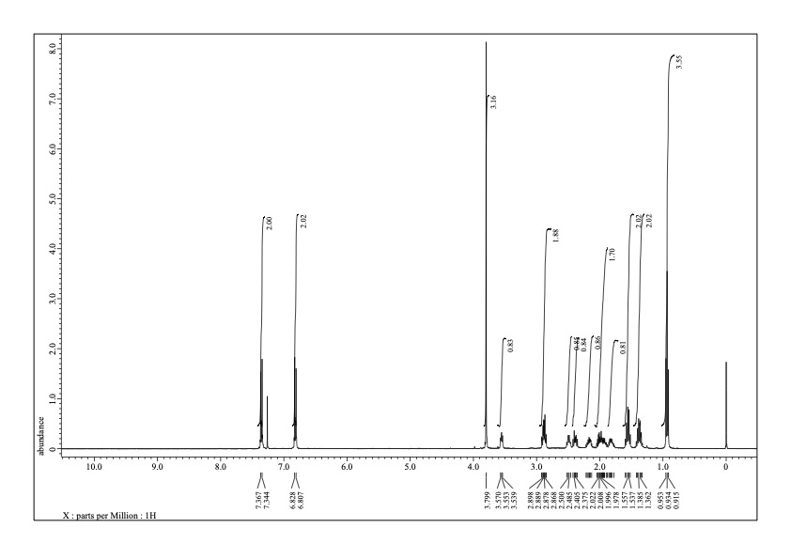
¹H NMR spectrum (392 MHz, CDCl₃) of 3aa.
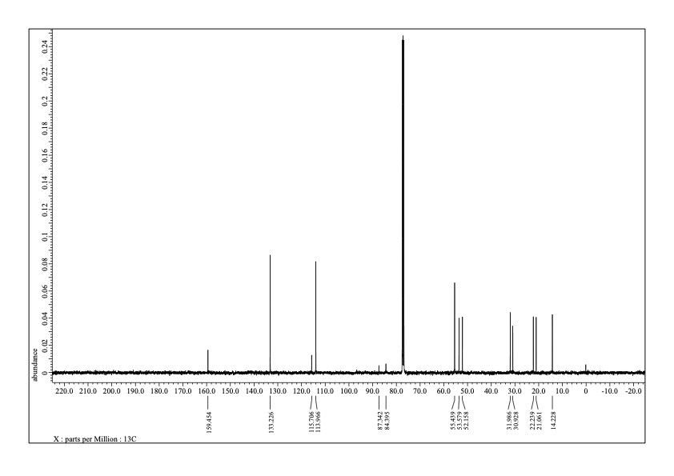
¹³C NMR spectrum (98.5 MHz, CDCl₃) of 3aa.
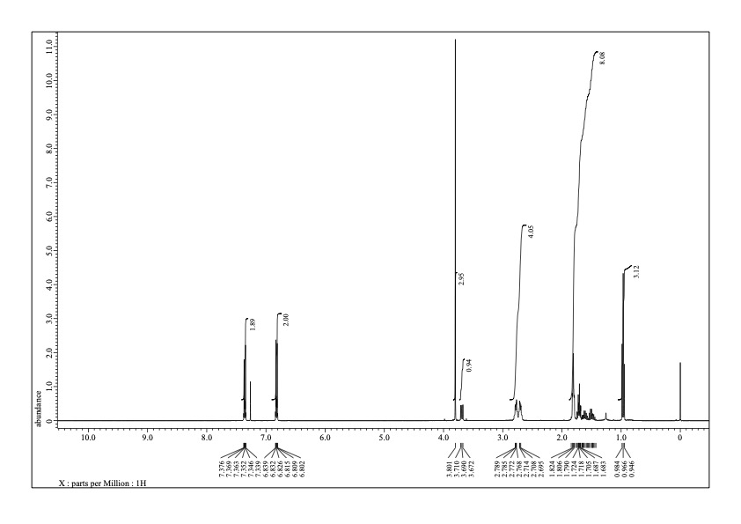
¹H NMR spectrum (392 MHz, CDCl₃) of 3aa'.
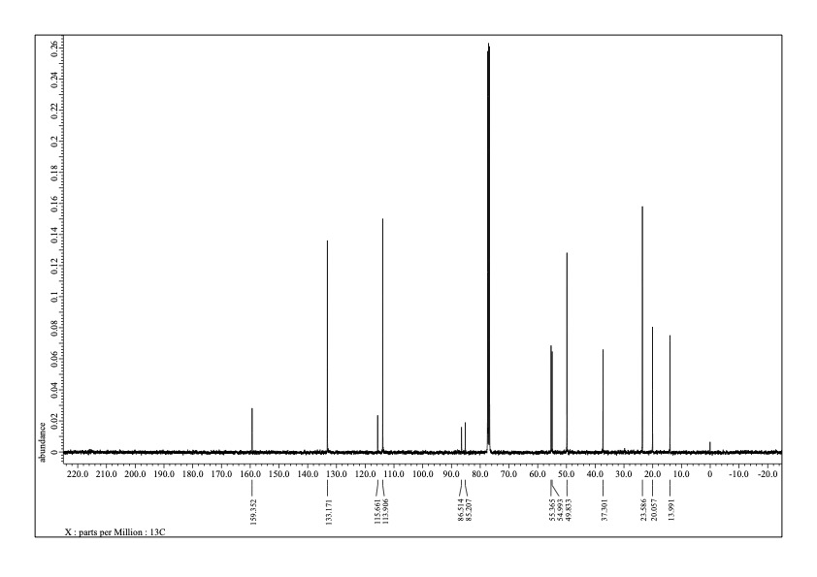
¹³C NMR spectrum (98.5 MHz, CDCl₃) of 3aa’.

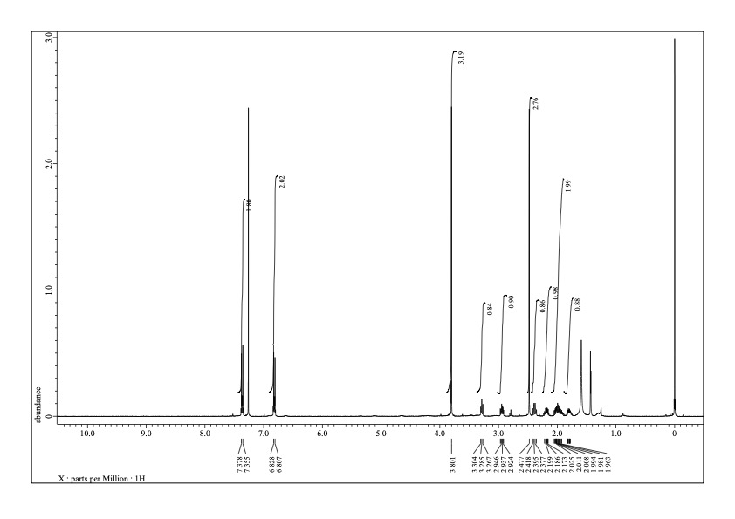
¹H NMR spectrum (392 MHz, CDCl₃) of 3ba.

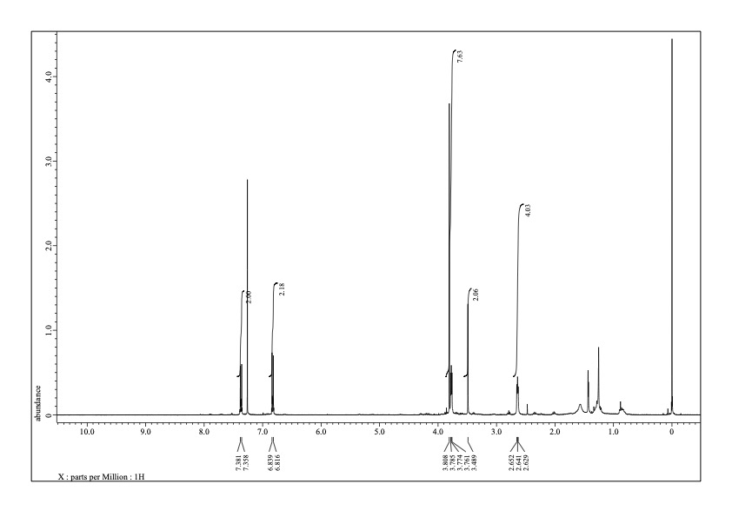
¹H NMR spectrum (392 MHz, CDCl₃) of 3fa.

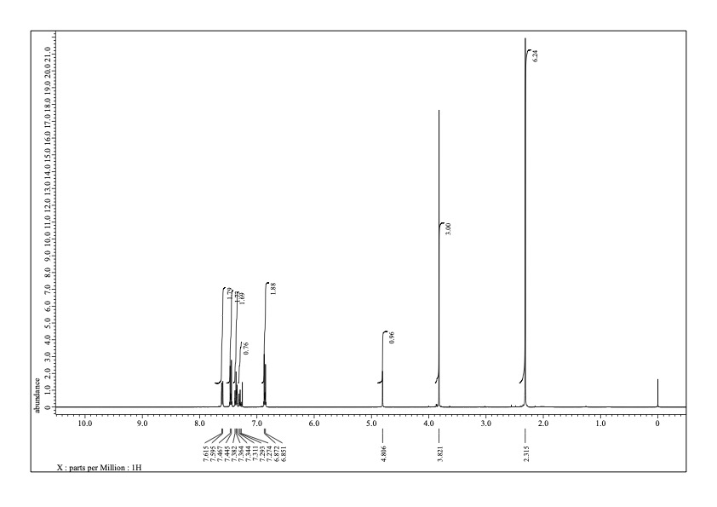
¹H NMR spectrum (392 MHz, CDCl₃) of 3ha’.

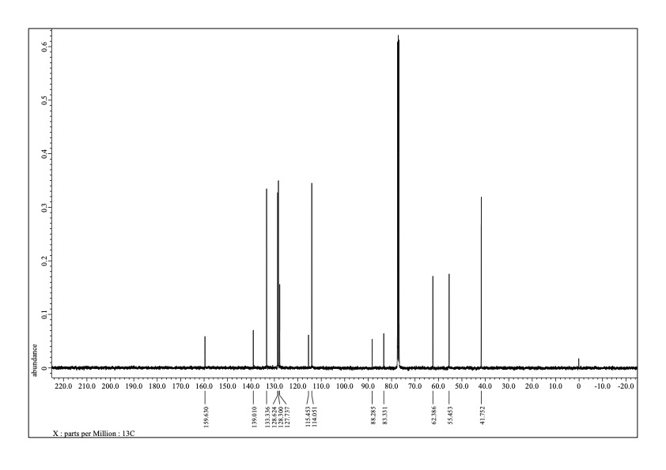
¹³C NMR spectrum (98.5 MHz, CDCl₃) of 3ha’.

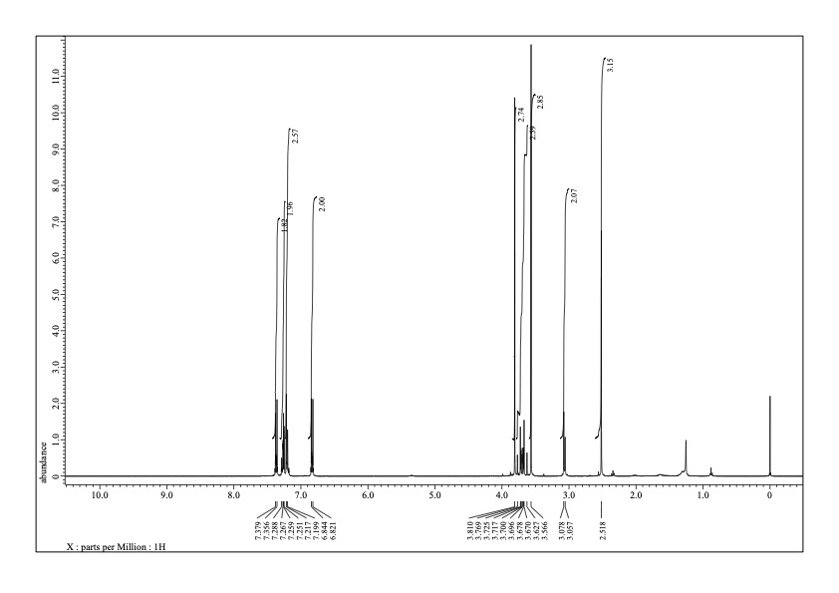
¹H NMR spectrum (392 MHz, CDCl₃) of 3ia.

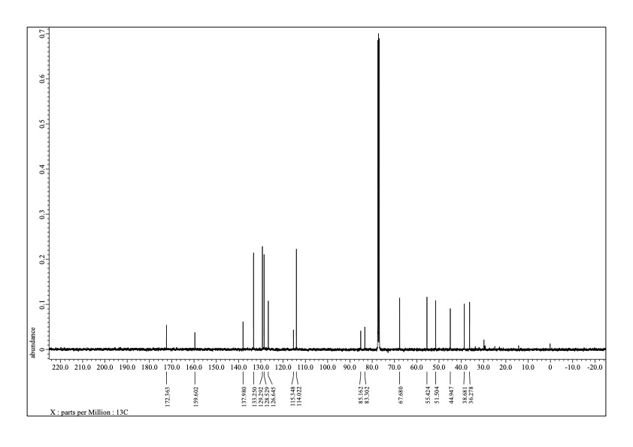
¹³C NMR spectrum (98.5 MHz, CDCl₃) of 3ia.

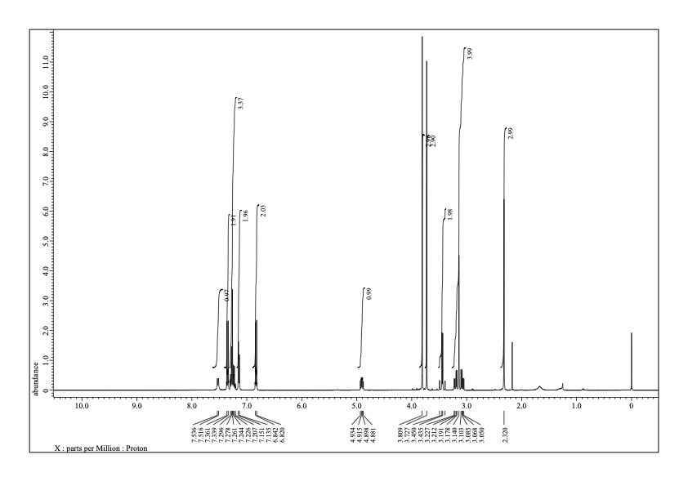
¹H NMR spectrum (392 MHz, CDCl₃) of L-3ja.

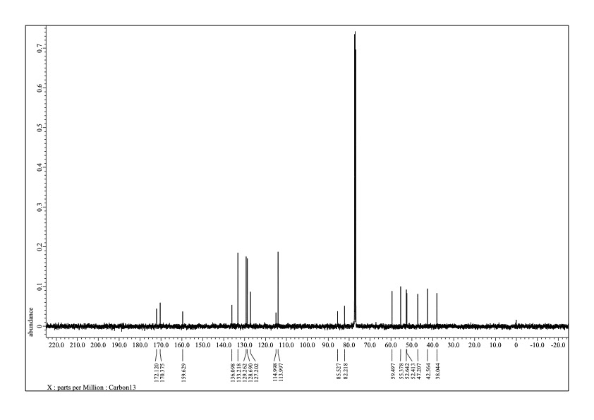
¹³C NMR spectrum (98.5 MHz, CDCl₃) of L-3ja.

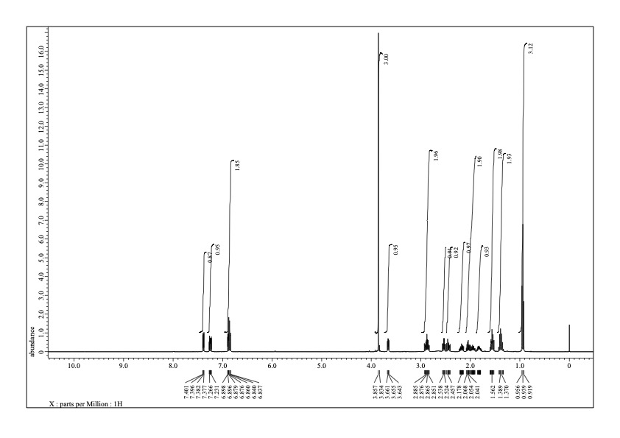
¹H NMR spectrum (392 MHz, CDCl₃) of 3ac.

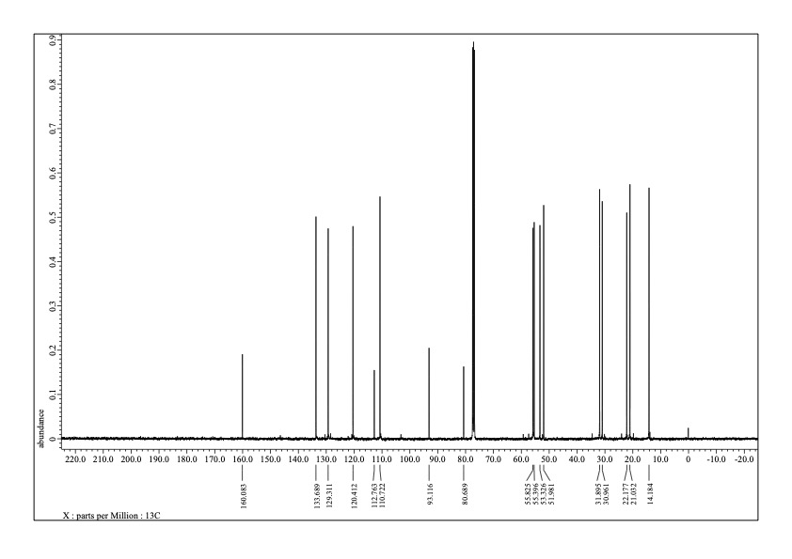
¹³C NMR spectrum (98.5 MHz, CDCl₃) of 3ac.
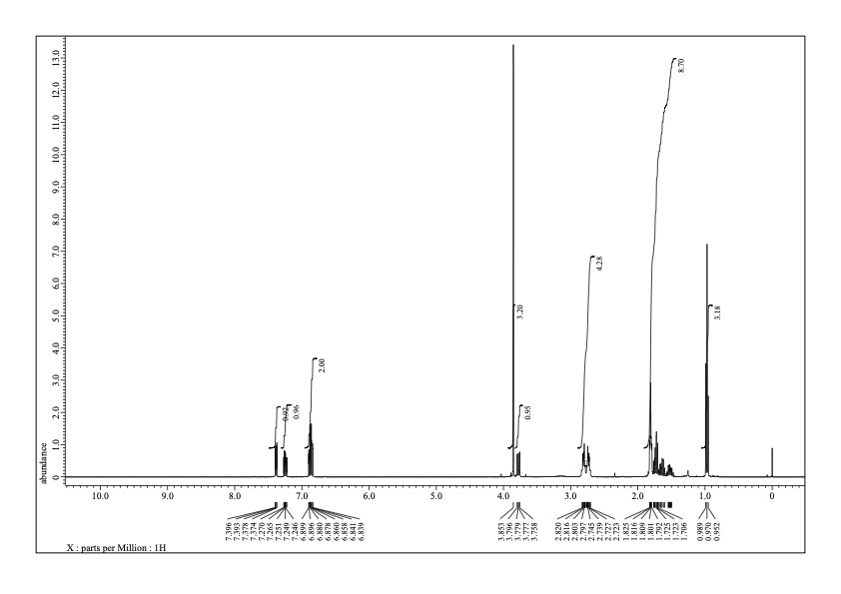
¹H NMR spectrum (392 MHz, CDCl₃) of 3ac’.

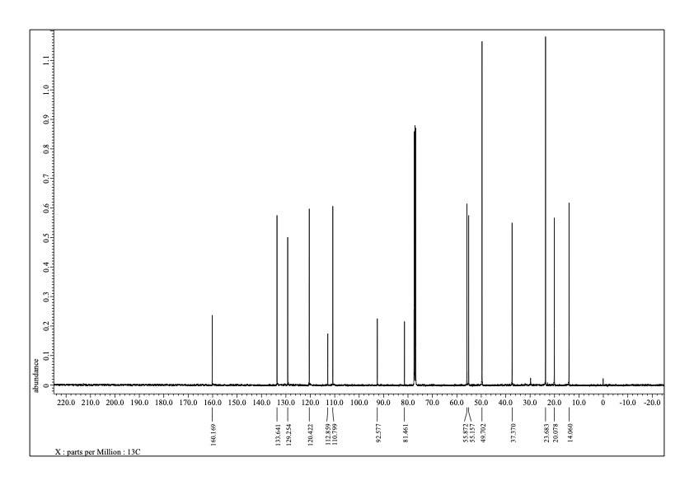
¹³C NMR spectrum (98.5 MHz, CDCl₃) of 3ac’.

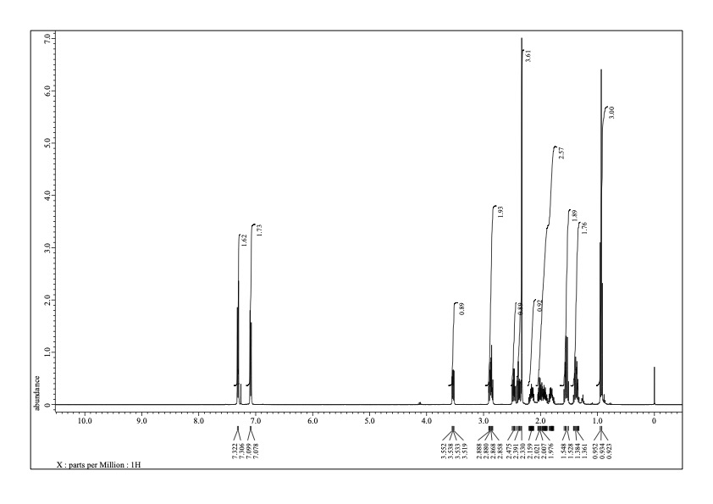
¹H NMR spectrum (392 MHz, CDCl₃) of 3ad.

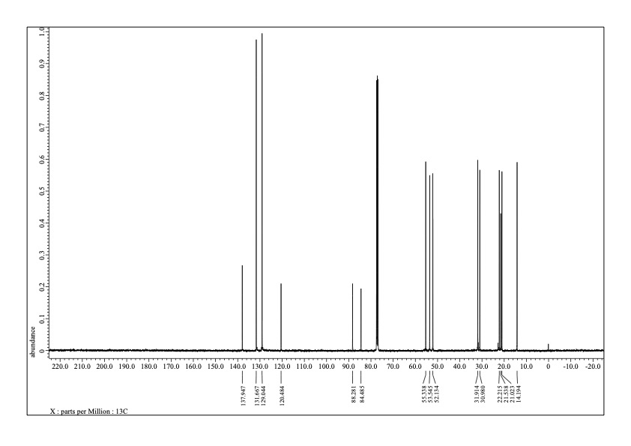
¹³C NMR spectrum (98.5 MHz, CDCl₃) of 3ad.

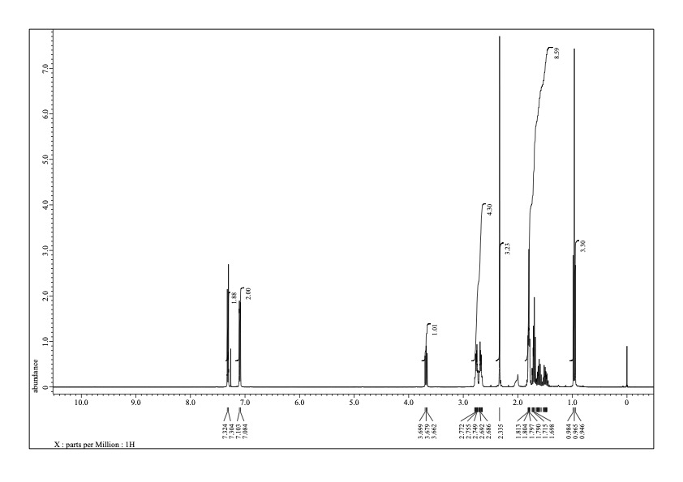
¹H NMR spectrum (392 MHz, CDCl₃) of 3ad’.
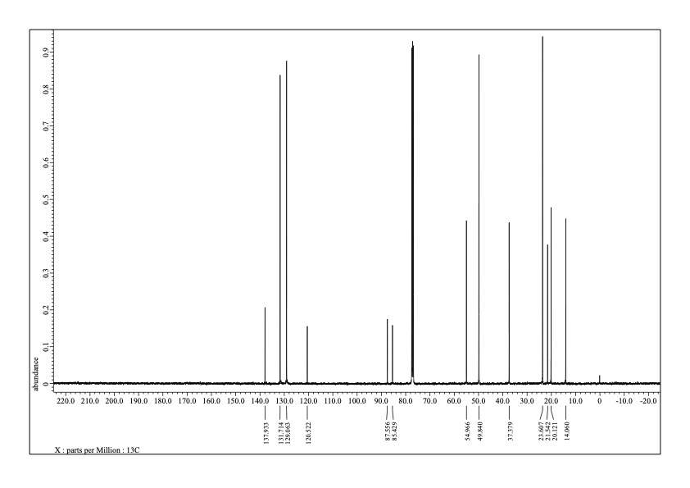
¹³C NMR spectrum (98.5 MHz, CDCl₃) of 3ad’.
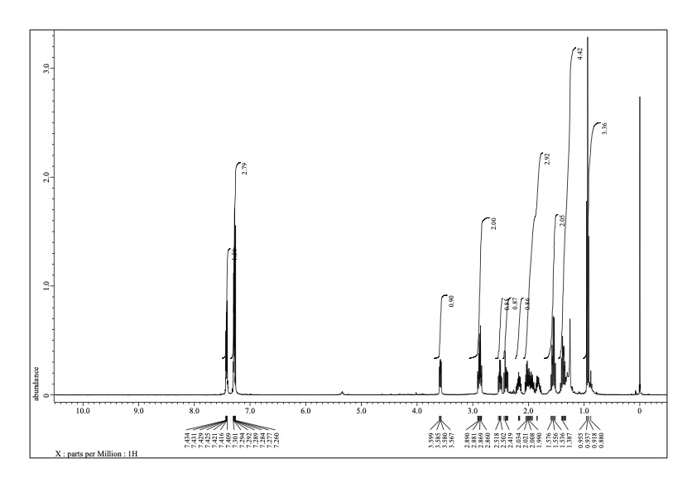
¹H NMR spectrum (392 MHz, CDCl₃) of 3ae.
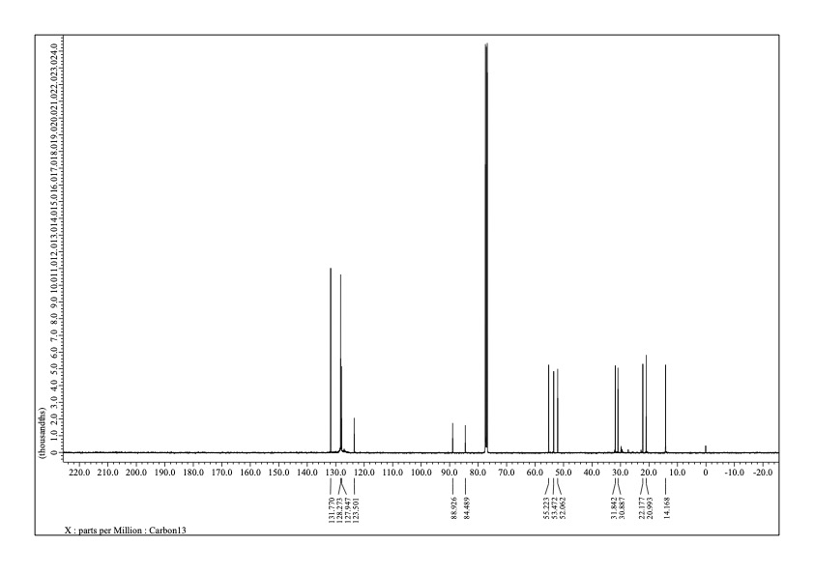
¹³C NMR spectrum (98.5 MHz, CDCl₃) of 3ae.
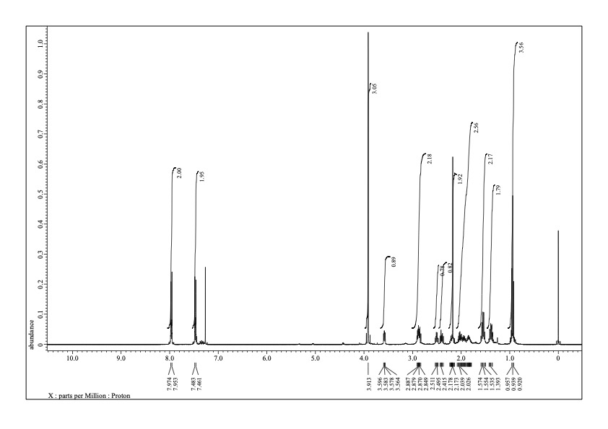
¹H NMR spectrum (392 MHz, CDCl₃) of 3af.
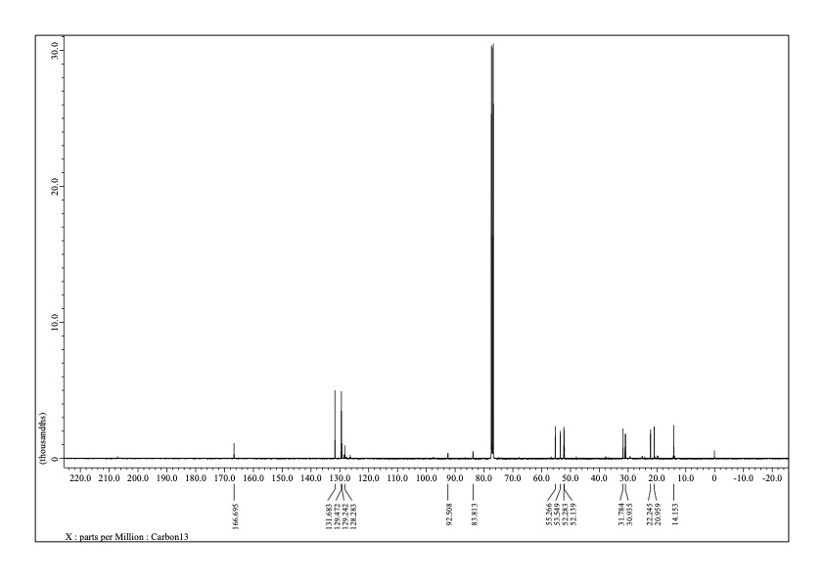
¹³C NMR spectrum (98.5 MHz, CDCl₃) of 3af.
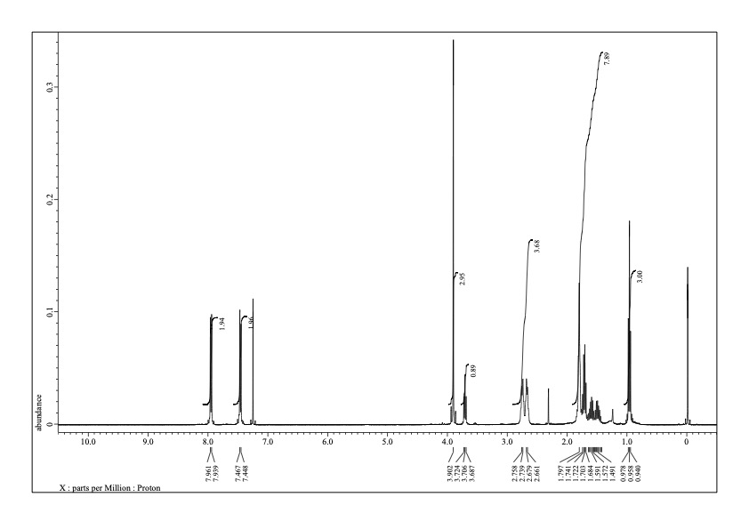
¹H NMR spectrum (392 MHz, CDCl₃) of 3af’.
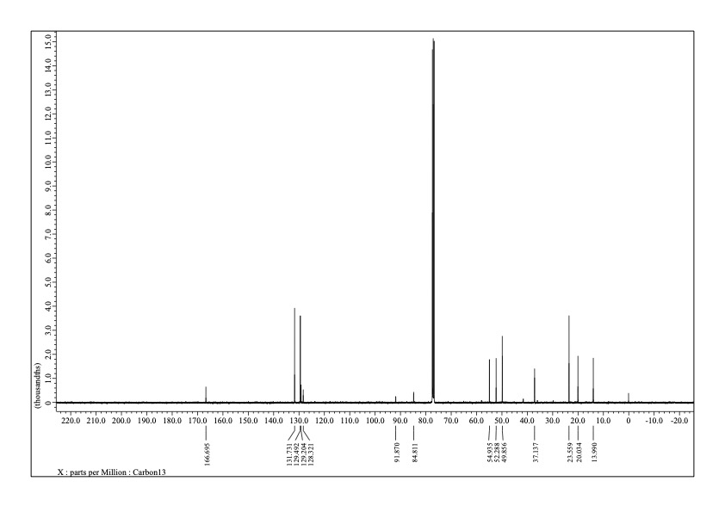
¹³C NMR spectrum (98.5 MHz, CDCl₃) of 3af’.
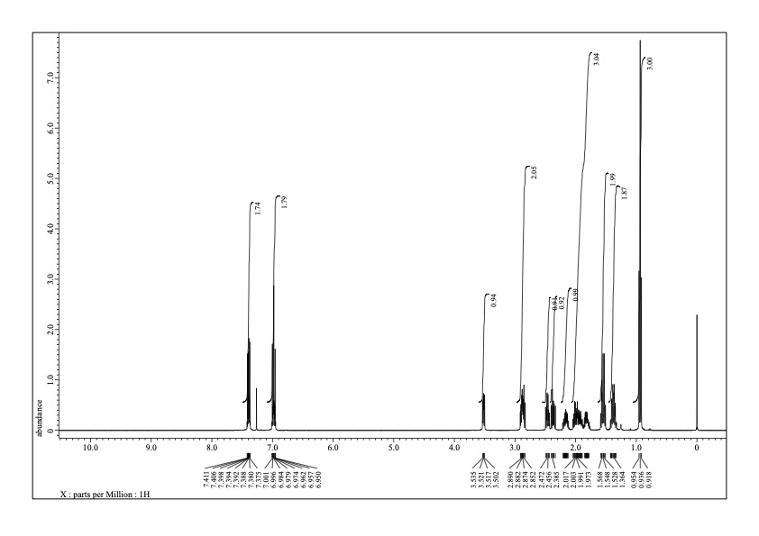
¹H NMR spectrum (392 MHz, CDCl₃) of 3ag.
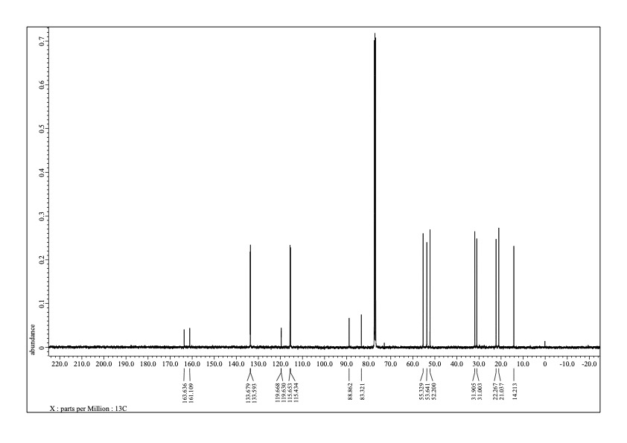
¹³C NMR spectrum (98.5 MHz, CDCl₃) of 3ag.
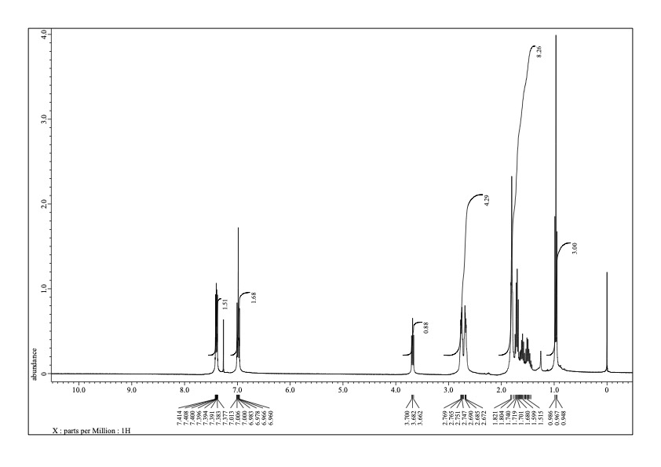
¹H NMR spectrum (392 MHz, CDCl₃) of 3ag’.
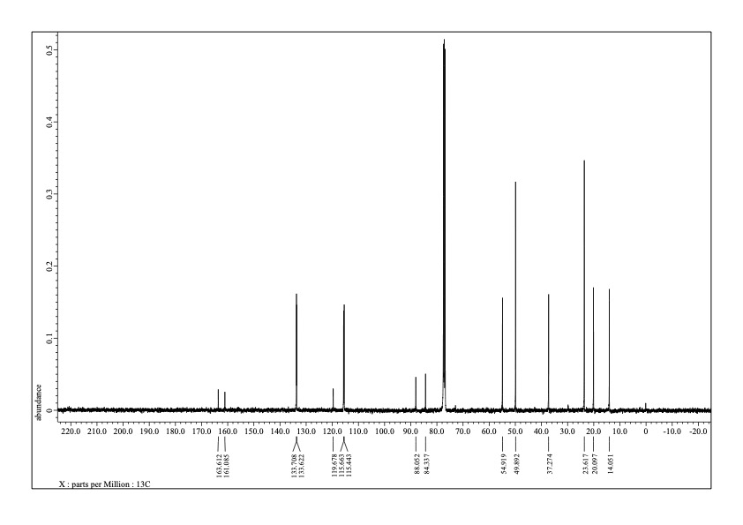
¹³C NMR spectrum (98.5 MHz, CDCl₃) of 3ag’.
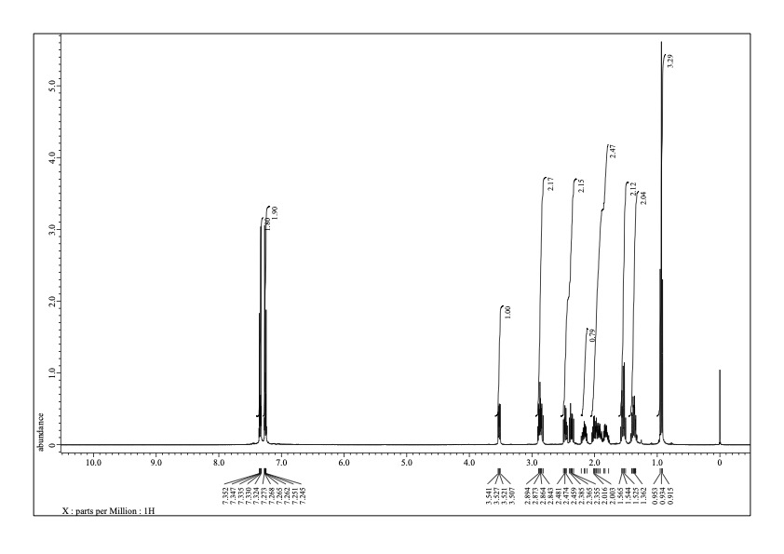
¹H NMR spectrum (392 MHz, CDCl₃) of 3ah.
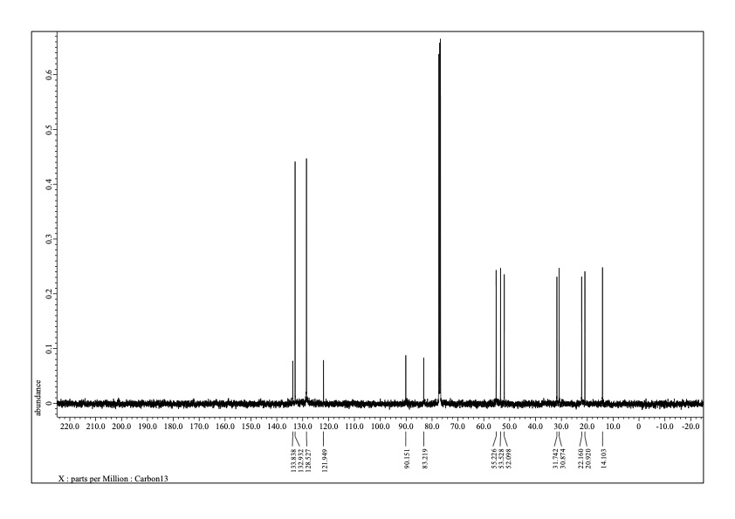
¹³C NMR spectrum (98.5 MHz, CDCl₃) of 3ah.
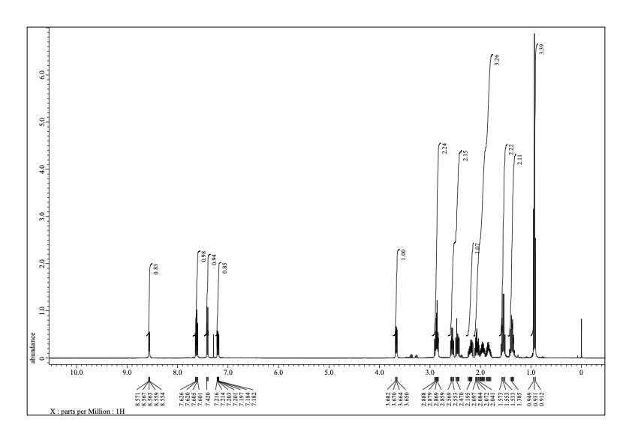
¹H NMR spectrum (392 MHz, CDCl₃) of 3ai.
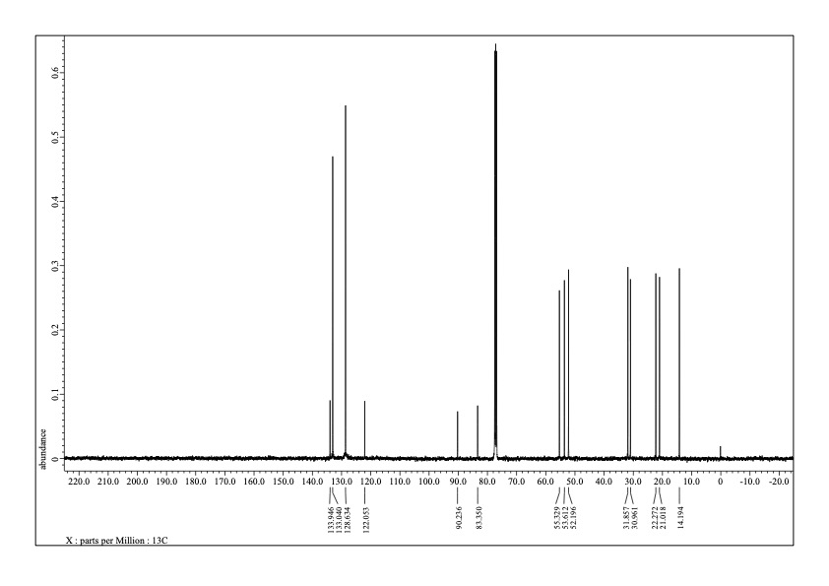
¹³C NMR spectrum (98.5 MHz, CDCl₃) of 3ai.
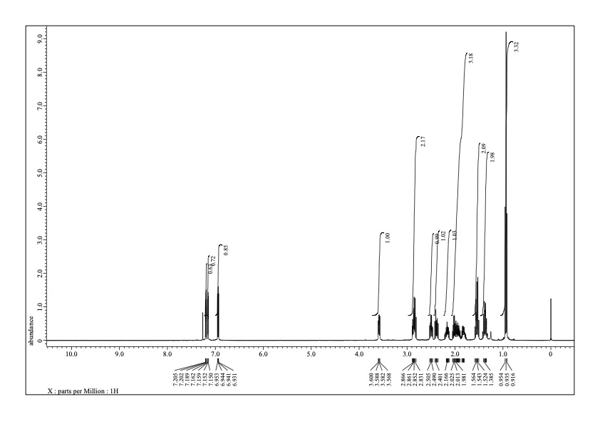
¹H NMR spectrum (392 MHz, CDCl₃) of 3aj.
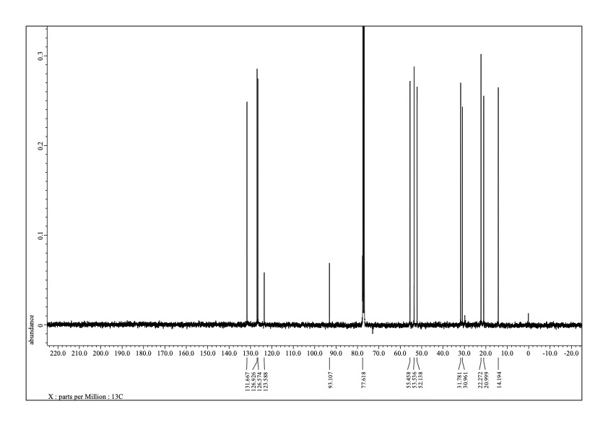
¹³C NMR spectrum (98.5 MHz, CDCl₃) of 3aj.
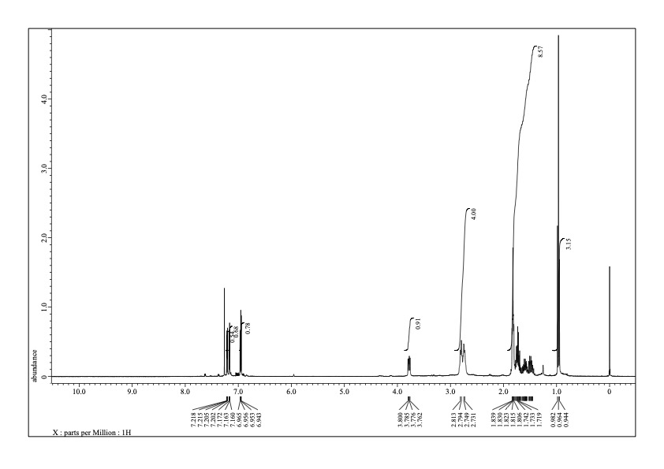
¹H NMR spectrum (392 MHz, CDCl₃) of 3aj’.
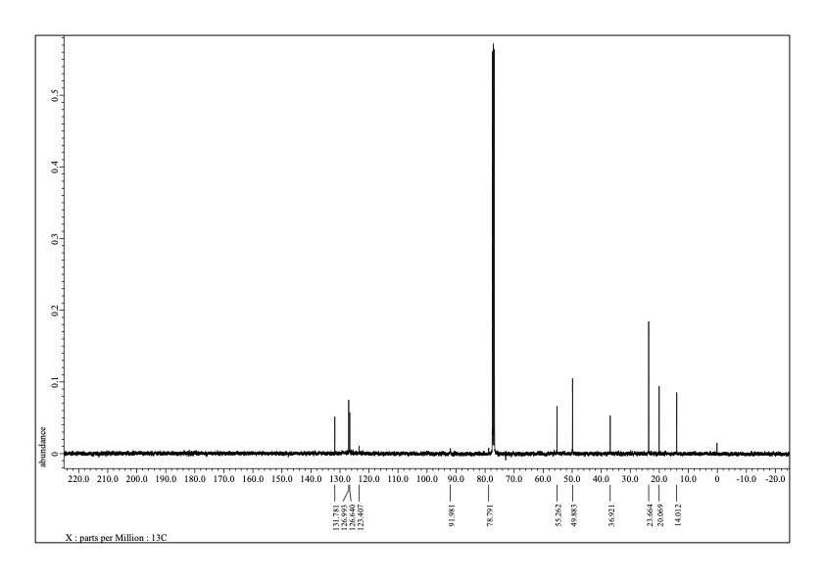
¹³C NMR spectrum (98.5 MHz, CDCl₃) of 3aj’.
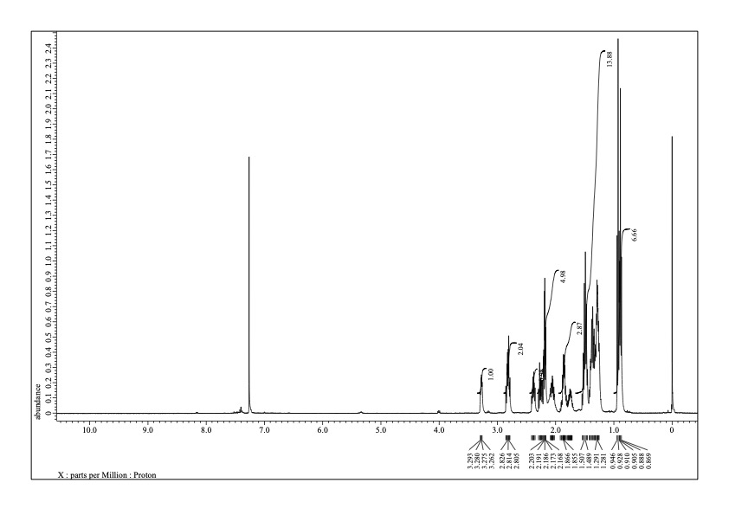
¹H NMR spectrum (392 MHz, CDCl₃) of 3ak.
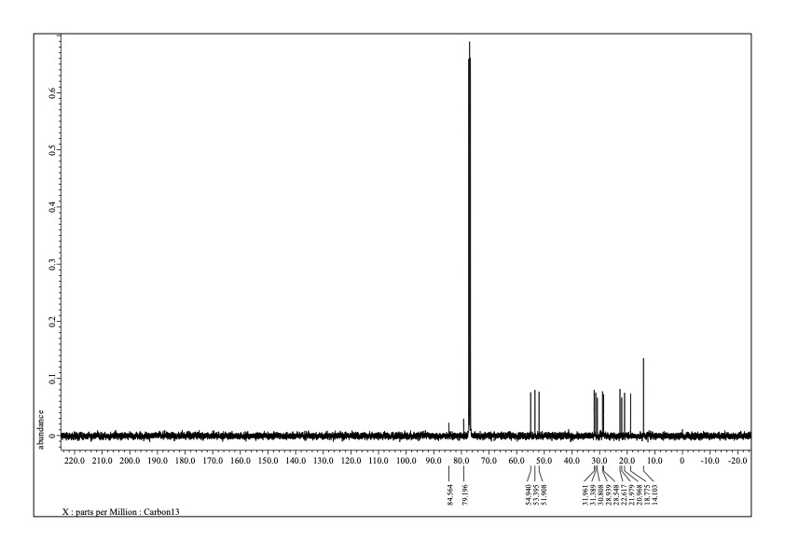
¹³C NMR spectrum (98.5 MHz, CDCl₃) of 3ak.
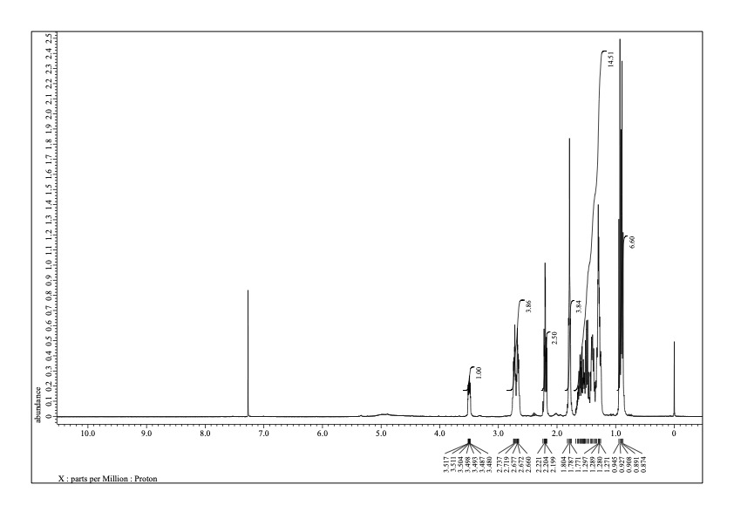
¹H NMR spectrum (392 MHz, CDCl₃) of 3ak’.
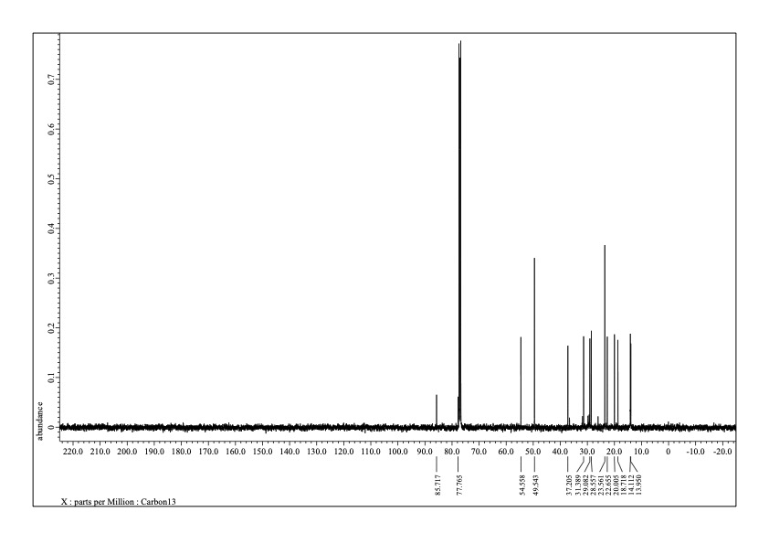
¹³C NMR spectrum (98.5 MHz, CDCl₃) of 3ak’.
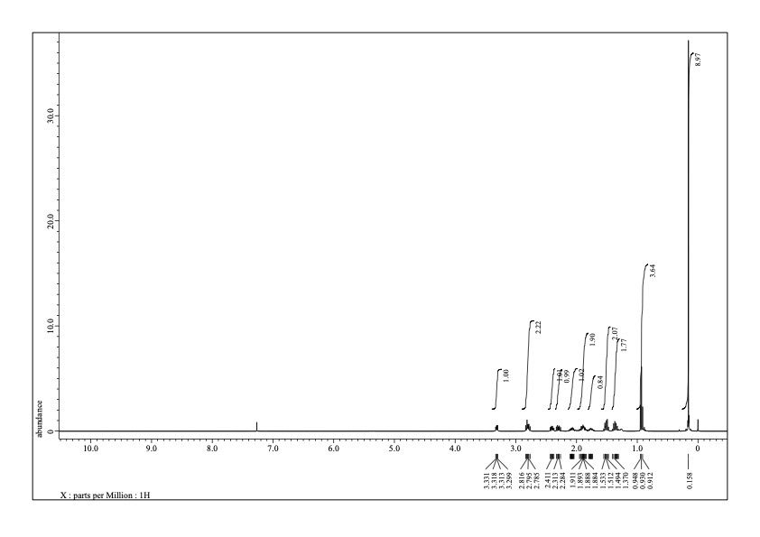
¹H NMR spectrum (392 MHz, CDCl₃) of 3al.
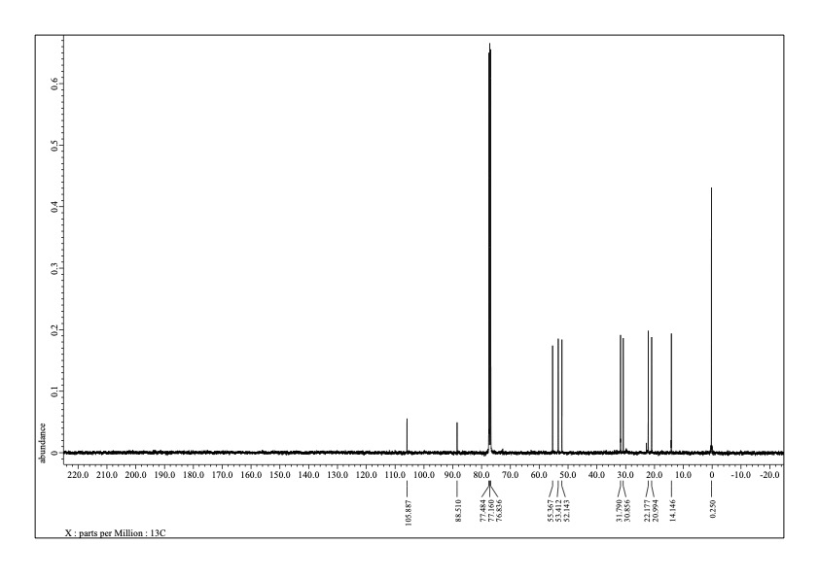
¹³C NMR spectrum (98.5 MHz, CDCl₃) of 3al.

Isozaki, K.; Ueno, R.; Ishibashi, K.; Nakano, G.; Yin, H.; Iseri, K.; Sakamoto, M.; Takaya, H.; Teranishi, T.; Nakamura, M. ACS Catal. 2021, 11, 13180–13187.
Qian, H.; Liu, C.; Jin, R. Sci. China Chem. 2012, 55, 2359–2365.
Hooper, T. N.; Butts, C. P.; Green, M.; Haddow, M. F.; McGrady, J. E.; Russell, C. A. Chem. Eur. J. 2009, 15, 12196–12200.
Zhang, C.; Saidel, D. J. Am. Chem. Soc. 2010, 132, 1798–1799.
Jovel, I.; Prateeptongkum, S.; Jackstell, R.; Vogl, N.; Weckbecker, C.; Beller, M. Chem. Commun. 2010, 46, 1956–1958.
Chatterjee, P.; Wang, H.; Manzano, J. S.; Kanbur, U.; Sadow, A. D.; Slowing, I. I. Catal. Sci. Technol. 2022, 12, 1922–1933.
Odachowski, M.; Greaney, M. F.; Turner, N. J. ACS Catal. 2018, 8, 10032–10035.
Li, Z.; MacLeod, P. D.; Li, C.-J. Tetrahedron Asymm. 2006, 17, 590–597.
Gao, J.; Song, Q.-W.; He, L.-N.; Yang, Z.-Z.; Dou, X.-Y. Chem. Commun. 2012, 48, 2024–2026.
Park, K.; Heo, Y.; Lee, S. Org. Lett. 2013, 15, 3322–3325.
Ma, L.; Shi, X.; Li, X.; Shi, D. Org. Chem. Front. 2018, 5, 3515–3519.
Niu, M.; Yin, Z.; Fu, H.; Jiang, Y.; Zhao, Y. J. Org. Chem. 2008, 73, 3961–3963.
Grimme, S.; Ehrlich, S.; Goerigk, L. Effect of the Damping Function in Dispersion Corrected Density Functional Theory, J. Comput. Chem. 2011, 32, 1456–1465.
Software to optimize reaction paths along the user’s expected ones, HPC Systems Inc., http://www.hpc.co.jp/chem/react1.html
Jónsson, H.; Mills, G.; Jacobsen, K. W.; Nudged Elastic Band Method for Finding Minimum Energy Paths of Transitions, in Classical and Quantum Dynamics in Condensed Phase Simulations, Ed. Berne, B. J.; Ciccotti, G. and Coker, D. F. 385 (World Scientific, 1998); Henkelman, G. and Jónsson, H. Improved tangent estimate in the nudged elastic band method for finding minimum energy paths and saddle points, J. Chem. Phys. 2000, 113, 9978.
Gaussian 16, Revision C.01, Frisch, M. J.; Trucks, G. W.; Schlegel, H. B.; Scuseria, G. E.; Robb, M. A.; Cheeseman, J. R.; Scalmani, G.; Barone, V.; Petersson, G. A.; Nakatsuji, H.; Li, X.; Caricato, M.; Marenich, A. V.; Bloino, J.; Janesko, B. G.; Gomperts, R.; Mennucci, B.; Hratchian, H. P.; Ortiz, J. V.; Izmaylov, A. F.; Sonnenberg, J. L.; Williams-Young, D.; Ding, F.; Lipparini, F.; Egidi, F.; Goings, J.; Peng, B.; Petrone, A.; Henderson, T.; Ranasinghe, D.; Zakrzewski, V. G.; Gao, J.; Rega, N.; Zheng, G.; Liang, W.; Hada, M.; Ehara, M.; Toyota, K.; Fukuda, R.; Hasegawa, J.; Ishida, M.; Nakajima, T.; Honda, Y.; Kitao, O.; Nakai, H.; Vreven, T.; Throssell, K.; Montgomery, J. A., Jr.; Peralta, J. E.; Ogliaro, F.; Bearpark, M. J.; Heyd, J. J.; Brothers, E. N.; Kudin, K. N.; Staroverov, V. N.; Keith, T. A.; Kobayashi, R.; Normand, J.; Raghavachari, K.; Rendell, A. P.; Burant, J. C.; Iyengar, S. S.; Tomasi, J.; Cossi, M.; Millam, J. M.; Klene, M.; Adamo, C.; Cammi, R.; Ochterski, J. W.; Martin, R. L.; Morokuma, K.; Farkas, O.; Foresman, J. B.; Fox, D. J. Gaussian, Inc., Wallingford CT, 2016.

