Supporting information
Cell-surface photochemistry mediated calcium overload for synergistic tumor therapy
Jun Wang, ^{1,#} Wei Wang, ^{1,#} Qingmei Shen⁴, Lan Lan^{5,} Cuiping Guan⁵, Xinchang Xu, ^{1,*} Weishuo Li, ^{3,*} and Yongzhong Du ^{2,*}

¹ Department of Pharmacy, Affiliated Hangzhou Dermatology Hospital, Zhejiang University School of Medicine, Hangzhou, 310009, China
² Institute of Pharmaceutics, College of Pharmaceutical Sciences, Zhejiang University, 866 Yu-Hang-Tang Road, Hangzhou, 310058, China
³ Center for Molecular Metabolism, School of Environmental and Biological Engineering, Nanjing University of Science and Technology, 200 Xiao Ling Wei Street, Nanjing, 210094, China
⁴ School of Basic Medical Sciences, Zhejiang Chinese Medical University, Hangzhou, 310053, China
⁵ Department of Dermatology, Affiliated Hangzhou Dermatology Hospital, Zhejiang University School of Medicine, Hangzhou, 310009, China

# These authors contributed equally to this work.

Corresponding Authors:
Yongzhong Du, E-mail: duyongzhong@zju.edu.cn, Phone: +86-571-88208435
Xinchang Xu, E-mail: zxyyadr@163.com
Weishuo Li, E-mail: liweishuo@njust.edu.cn

Contents
Experiment
Scheme S1. Illustration of the synthesize procedure of AH(CA)@UCNP-PpIX.
Fig. S1. Characteristic of UCNP and amino-modified UCNP.
Fig. S2. A representative TEM image and size distribution of PpIX modified UCNP.
Fig. S3. Synthetic and ¹H-NMR spectrum of polyHM.
Fig. S4. Synthetic and ¹H-NMR spectrum of polyHM(CA). The green square frame marked the specific proton peaks of polyHM(CA).
Fig. S5. A representative TEM photograph and size distribution of polyHM(CA)@UCNP-PpIX.
Fig. S6. Cell viabilities of Raji cells after irradiation with 980 nm NIR laser (2 W/cm²) under different irradiation time.
Fig. S7. CD20 expression levels of various cancer cell lines.
Fig. S8. Flow cytometry analysis of Raji cells incubated with AH(CA)@UCNP-PpIX at different concentrations and time points, respectively.
Fig. S9. Semi-quantitative results of Raji cells exposed to AH(CA)@UCNP-PpIX for different time points was calculated based on Fig. 2E using Image J.
Fig. S10. The mean fluorescence intensity of DCF was quantitatively calculated by Image J based on Fig. 2F.
Fig. S11. Intracellular ROS generation in Raji cells was measured via confocal microscopy after treatment with AH(CA)@UCNP-PpIX for various time periods.
Fig. S12. SEM images of Raji cells without crosslinking of AH(CA)@UCNP-PpIX at cell surface.
Fig. S13. Quantitatively analysis of relative protein expression of Bcl-2, Bcl-xL, Bax, Bak and Caspase-3 in Raji cells after various treatments based on Fig. 3G.
Fig. S14. Quantitatively analysis of relative Cyt c protein expression in Raji cells after various treatments based on Fig. 3H and I.
Fig. S15. Mean fluorescence intensity of Ki67, Tunel and Caspase-3 was quantitatively analysed based on Fig. 5H.
Fig. S16. Microscopic images of H&E stained major organs (heart, liver, spleen, lung and kidney) of mice with various treatments via intravenous injection at the end of observation. Scale bar, 50 μm.

Materials and methods
Materials and animals
Rare earth chlorides (YCl₃·6H₂O, YbCl₃·6H₂O, TmCl₃·6H₂O), NH₄F and NaOH were obtained from Macklin Biochemical Co., Ltd (Shanghai, China). 1-octadecene, oleic acid and 2-aminoethyl dihydrogenphosphate (AEP) were purchased from Sigma-Aldrich Co., Ltd (St. Louis, MO, USA). 1-ethyl-3-(3-dimethylaminopropyl)carbodiimide (EDC), N-hydroxysuccinimide (NHS) and protoporphyrin IX (PpIX) were provided by Aladdin Co., Ltd (Shanghai, China). N,N’-dicyclohexylcarbodimide (DCC), 4-dimethylaminopyridine (DMAP), 2-hydroxyethyl methacrylate (HM), 2-cyano-2-propyl benzodithioate and 4.4’-azobis(4-cyanovaleric acid) (ACVA) were acquired from Sigma-Aldrich Co., Ltd (St. Louis, MO, USA). Ethanol absolute, cyclohexane, methanol, cinnamic acid and dimethyl sulfoxide (DMSO) were obtained from Aladdin Co., Ltd (Shanghai, China).The Mal-PEG₃-Mal was synthesized by ToYang Bio Tech. Inc (Shanghai, China). Dulbecco's Modified Eagle Medium (DMEM) and Roswell Park Memorial Institute-1640 (RPMI-1640) was provided by Sigma-Aldrich Co., Ltd (St. Louis, MO, USA). Cell counting kit-8 (CCK8), 3-(4,5-dimethyl-2-thiazolyl)-2,5-diphenyl-2H-tetrazolium bromide (MTT), Annexin V-FITC/PI apoptosis detection kit, Fluo-4 AM and mitochondrial membrane potential assay kit (JC-1) were purchased from Beyotime Biotech Co., Ltd (Shanghai, China). The anti-CD20 aptamer (sequence: 5’-CTCCTCTGAC TGTAACCACG CCGTATGTCC GAAATACGGA GAACAGCACT CATATGCAAG CCATACGCGG AGGTGCACGC GCATAGGTAG TCCAGAAGCC-3’) was provided by Sangon Biotech Co., Ltd (Shanghai, China). Primary antibodies including anti-CD20, anti-Bcl-2, anti-Bcl-xL, anti-Bak, anti-Bax, anti-cleaved caspase-3 were all obtained from Abcam Co., Ltd (Cambridge, UK).
Balb/c nude mice aged 6-8 weeks (18-20 g) were purchased from Slack Laboratory Animal Co., Ltd (Shanghai, China). All animal experiments were performed in accordance with the National Institutes of Health Guide for the Care and Use of Laboratory Animals with the approval of the Scientific Investigation Board of Zhejiang University.
Preparation and characterization of UCNP-PpIX
In a proper route of NaYF₄:Yb³⁺,Tm³⁺ upconversion nanoparticles (UCNP) preparation, 0.795 mmol YCl₃·6H₂O, 0.2 mmol YbCl₃·6H₂O and 0.005 mmol TmCl₃·6H₂O were weighted into a 50 mL flask. Subsequently, 6 mL of oleic acid (OA) and 15 mL of octadecene were added, and the reaction system was heated to 160 °C for 40 min to form a homogeneous solution. When the solution cooled down to room temperature, the mixture of NaOH (2.5 mmol) and NH₄F (4 mmol) in 10 mL of methanol was added and the reaction system was kept at 50 °C for 30 min with magnetic stirring. After that, methanol was evaporated and the mixture solution was heated to 300 °C for 1.5 h under argon protection. Finally, the mixture solution was washed with ethanol for at least three times, and UCNP was collected via centrifugation (4500 rpm, 5min) and stored in cyclohexane.
Then the amino-functionalized UCNP was further fabricated via ligand exchange. Briefly, 200 mg of 2-aminoethyl dihydrogenphosphate (AEP) was dispersed in 10 mL of a mixture of deionized water and ethanol with a volume ration of 3:2, and 5 mL of cyclohexane solution of OA-functioned UCNP was dropped into the system and stirred vigorously for 48 h at room temperature. Afterward, the UCNP could transfer from top cyclohexane to bottom water layer and be collected via centrifugation (4500 rpm, 5min) for further use.
In order to covalently conjugated protoporphyrin IX (PpIX) to UCNP, 5 mL of DMSO solution containing 5 mg of PpIX, 8.28 mg of 1-ethyl-3-(3-dimethylaminopropyl)carbodiimide (EDC), and 6.14 mg of N-hydroxysuccinimide (NHS) was stirred at 60 °C for 1 h, and then 5 mL of amino-functionalized UCNP (2 mg/mL) was added into the solution and stirred vigorously for another 48 h. Afterwards, UCNP-PpIX conjugates were centrifuged and washed with water to remove any unreacted PpIX. The amount of photosensitizer attached to UCNP was calculated from the PpIX absorption spectrum.
Synthesizes and characterization of polyHM(CA)
Our previously developed method was used to synthesize polyHM(CA) [1]. In a typical procedure, 0.423 g of 2-cyano-2-propyl benzodithioate, 0.01074 g of 4,4'-azobis(4-cyanovaleric acid), 0.95 mL of 2-hydroxyethyl methacrylate (HM) and 2.56 mL of dioxane were added into a 25 mL three-necked flask. Subsequently, argon was pumped for 1 h to remove the oxygen from the system. After that, the flask was immersed into an oil bath which had been preheated to 80 °C. The reaction system was then polymerized for 8 h under argon protection and rapidly cooled to room temperature in liquid nitrogen. Finally, the mixture solution was precipitated in 10-fold excess volume ether. The obtained precipitate was then washed thrice with ether and dried in a vacuum oven at 50 °C for 24 h, namely polyHM. Next, the cinnamic acid (CA) was introduced onto polyHM via esterification reaction. Briefly, 17.63 mg of CA, 122.89 mg of DCC and 7.28 mg of DMAP (CA: DCC: DMAP=1: 5: 0.5, mol: mol) were dissolved in 5 mL of anhydrous DMSO and stirrer at 50 °C for 1.0 h. Afterwards, 2 mL of anhydrous DMSO containing 50.82 mg of polyHM was added to the solution and stirred at 60 °C for another 48 h. The obtained solution was then dialysis against deionized water with a dialysis membrane (MWCO: 3.5 kDa) for 48 h, followed by lyophilization and the polyHM(CA) was obtained. The ¹H-NMR spectra of the polyHM and polyHM(CA) were acquired via an NMR spectrometer (AC-80, BrukerBioSpin, Germany).
Preparation and characterization of polyHM(CA)@UCNP-PpIX.
The remaining amino groups of UCNP-PpIX was used to react with the carboxyl groups of polyHM(CA) to obtain the polyHM(CA)@UCNP-PpIX. In a typical procedure, 50 mg of polyHM(CA) was weighted into a 25 mL three-necked flask and dissolved in 5 mL of anhydrous DMSO. Subsequently, 24.3 mg of EDC and 17.9 mg of NHS was added and the reaction system was stirrer at 50 °C for 1.0 h. After that, 10 mg of UCNP-PpIX dispersed in 5 mL of DMSO was dropped into the system and the mixed solution was stirred at 60 °C for another 48 h. The product was then centrifuged (14000 rpm, 15 min) to acquire the precipitate. Finally, the precipitate was washed with deionized water for three times and dried at 50 °C to obtain the polyHM(CA)@UCNP-PpIX. The size distribution and morphology of polyHM(CA)@UCNP-PpIX was observed via dynamic light scattering (DLS) and transmission electron microscope (TEM), respectively.
Synthesize and characterization of AH(CA)@UCNP-PpIX
Briefly, 20 mg of polyHM(CA)@UCNP-PpIX was charged in a 10 mL three-neck flask and dispersed in 3 mL of distilled THF. Thereafter, 200 μL of cyclohexylamine was added and the reaction system was stirred for 48 h with the protection of argon at room temperature. After that, the mixture solution was centrifuged (14000 rpm, 15 min) to acquire the precipitate. Then the precipitate was washed thrice with n-hexane and dried to obtained the thiol-derivatized polyHM(CA)@UCNP-PpIX. Next, 2 mL of Tris-EDTA (TE) buffer contained 0.02 μmol of thiol-modified aptamer was dropped into 1 mL of TE buffer which contained 0.1 μmol of Mal-PEG₃-Mal. And the reaction system was stirred at 37 °C for 12 h, followed by dialysis against deionized water for 48 h to remove any unreacted regents (MWCO: 3.5 kDa). Finally, the acquired maleamide-functionalized aptamer solution was mixed with thiol-derivatized polyHM(CA)@UCNP-PpIX (2 mg/mL) and stirred for another 24 at room temperature to obtain AH(CA)@UCNP-PpIX.
To prove the successful modification of aptamer to thiol-derivatized polyHM(CA)@UCNP-PpIX, agrose gel electrophoresis was carried out. In a typical experiment, polyHM(CA)@UCNP-PpIX was first labeled by FITC. Briefly, 200 μg of FITC was dissolved in 1 mL of ethanol and then added dropwise into the 5 mL of deionized water which contained polyHM(CA)@UCNP-PpIX (1mg/mL). After that, the mixture solution was stirred for 24 h at room temperature and the obtained solution was then centrifuged (14000 rpm, 15 min) to acquire the precipitate, which was FITC-labeled polyHM(CA)@UCNP-PpIX. Thereafter, the obtained FITC-tagged polyHM(CA)@UCNP-PpIX was reacted with malemide-functionalized aptamer to give FITC-labeled AH(CA)@UCNP-PpIX. Finally, polyHM(CA)@UCNP-PpIX, AH(CA)@UCNP-PpIX, and the mixture of aptamer and polyHM(CA)@UCNP-PpIX was subjected to 1% agrose gel. The obtained gel was visualized via Gel Imager (Gel Logic 200, Kodak, USA).
Photo-crosslinking of AH(CA)@UCNP-PpIX in vitro
Briefly, the nanoparticles of AH(CA)@UCNP-PpIX or polyHM(CA)@UCNP-PpIX dispersed in deionized water (800 μg/mL) were irradiated by a 980 nm NIR laser (2 W/cm²) for different times (0, 5, 10, 20 and 30 min). Afterwards, the particle sizes of the nanoparticles were measured via DLS, and the morphology of polyHM(CA)@UCNP-PpIX irradiated for 30 min was observed via TEM.
Detection of ROS generation in vitro
The generation of extracellular ROS was measured with DPBF probes. In a typical process, DPBF was dissolved in ethanol and diluted to 10 mM, which was then mixed with 2 mL of AH(CA)@UCNP-PpIX aqueous dispersion (0.5 mg/mL). Afterwards, the mixture was irradiated by a 980 nm NIR laser (2 W/cm²) for various time periods (0, 5, 10, 20 and 30 min) in the dark. The generation of ROS was demonstrated via the characteristic absorption decrease of the DPBF at 410 nm using a UV-vis absorption spectrum.
AH(CA)@UCNP-PpIX binding onto the cell surface
Cell lines and culture
Raji and Jurkat cells in RPMI-1640 medium supplemented with 10% (v/v) FBS and penicillin/streptomycin (100 U/mL of each) were incubated in the cell incubator (37 °C and 5% CO₂). For HUVEC, HEK293 and NIH3T3 cell lines, the condition of culture was almost the same, expect DMEM instead of RPMI-1640 medium was used.

Expression levels of CD20 protein in tumor cell lines
Western blot was employed to measure the CD20 expression levels in Raji, Jurkat, CT26, A549, Bel and 4T1 cell lines. In a typical experiment, Raji cells were suspended in serum-free medium and seeded in 6-well plate at a density of 5×10⁵ cells per well and allowed to cultivate overnight. Afterwards, cells were harvested and lysed by cell lysis buffer. The obtained proteins were then subjected to SDS-PAGE and immunoblotted with anti-CD20 antibody, according to the manufactory’s protocol. The β-actin was used as the reference. Afterwards, the blots were washed and incubated with horseradish peroxidase-labeled goat anti-rabbit IgG for 2 h at room temperature, followed by imaging (Chemiluminescence imager, Bio-Rad, USA).
Cellular uptake
Firstly, the flow cytometry was used to examined the binding efficiency of AH(CA)@UCNP-PpIX onto Raji cells. In a typical experiment, Raji cells were seeded in a 1.5 mL sterile tubes at a density of 1×10⁵ cells per tube for 24 h, and then exposed to various concentration of AH(CA)@UCNP-PpIX (0, 20, 50, 100, 200, 400, 600 μg/mL). After 2 h co-incubation at 37 °C, the cells were harvested and washed thrice with cold PBS. Then the mean fluorescence intensity of PpIX (excitation at 400 nm and emission at 632 nm) was measured via flow cytometry (Cytomic FC 500MCL, Beckman, USA). Jurkat cells were served as the negative control.
Furthermore, the confocal microscopy was employed to observe the distribution of AH(CA)@UCNP-PpIX. Briefly, Raji cells were seeded in 1.5 mL sterile tubes with a volume of 100 μL, and the density of the cells was set at 1×10⁶/mL. Afterwards, AH(CA)@UCNP-PpIX was added into the tubes at the final concentration of 600 μg/mL and co-incubated for various time periods (2, 4, 6 and 8 h). The cells were then collected, washed thrice with cold PBS and fixed. Finally, the obtained cells were observed using confocal laser scanning microscopy (Leica, TCS SP8, Germany).
CD20 receptors clustering induced by AH(CA)@UCNP-PpIX
TEM was employed to observe the CD20 receptors clustering on Raji cell-surface after photo-crosslinking.of AH(CA)@UCNP-PpIX. Briefly, Raji cells were seeded in a 12-well plate at a density of 1×10⁵ cells per well and cultured for 24 h. After that, the cells were incubated with FITC-labeled anti-CD20 antibody (400 nM) and AH(CA)@UCNP-PpIX (600 μg/mL) for another 6 h. Afterwards, the cells were irradiated with a 980 nm NIR laser (2 W/cm², 5 min break after 10 min of irradiation) for 30 min. Finally, the cells were washed and stained for the observing via confocal laser scanning microscopy. The cells without NIR irradiation was used as a control group.
Intracellular ROS detection
In order to detect ROS in cells, Raji cells were cultured into 12-well plate and incubated overnight. After that, AH(CA)@UCNP-PpIX (600 μg/mL) was incubated with cells for 6 h and then irradiated with NIR laser (2 W/cm², 5 min break after 10 min of irradiation) for different time periods (0, 5, 10, 20 and 30 min). Finally, DCFH-DA solution (20 μM) was added to culture medium for additional 20 min. The fluorescence intensity of DCF in cells was detected via flow cytometry, as well as examined by confocal microscopy.
Cytotoxicity and apoptosis
The biocompatibility of AH(CA)@UCNP-PpIX without NIR irradiation was investigated by MTT assay. Briefly, HUVEC, HEK293 and NIH3T3 cells were suspended in serum-free medium and seeded into a 96-well plate with a density of 1×10⁴ cells per well for 24 h, and then the cell culture medium was refreshed with 200 μL of medium containing AH(CA)@UCNP-PpIX at various concentrations ranging from 0 to 1000 μg/mL. The cells were incubated for another 48 h. After that, 20 μL of MTT were added and incubated for another 4 h at 37 °C. Subsequently, the medium was replaced with 100 μL of DMSO. Finally, the absorbance of the solution in each well was measured by microplate reader at the wavelength of 570 nm.
Subsequently, the antitumor effects of AH(CA)@UCNP-PpIX performed with or without NIR irradiation were determined by CCK8 assay and live/dead staining. For the analysis of cell viability via CCK8 method, Raji cells were seeded in a 96-well plate at a density of 5×10³ cells per well and allowed to cultivate overnight. Afterwards, the cells were treated with AH(CA)@UCNP, AH@UCNP-PpIX or AH(CA)@UCNP-PpIX at various concentration (at a final concentration from 0 to 1000 μg/mL) for 6 h. The NIR treated groups was then irradiated with a 980 nm NIR laser (2 W/cm², 5 break after 10 min of irradiation) for 30 min, followed by incubation at 37 °C for another 24 h. Cell viability was measured via CCK8 test kit, following the manufacture’s instruction. For live/dead staining, Raji cells were inoculated into a 24-well plate at a density of 1×10⁴ cells per well, incubated with the above mentioned three kinds of preparations for 6 h. Afterwards, the cells were irradiated with a 980 nm NIR laser at 2 W/cm² for 30 min. Next, the cells were incubated with calcein AM (4 μM) and PI (4 μM) for 30 min. Finally, the labeled cells were observed using a confocal microscopy.
Cell apoptosis induced by AH(CA)@UCNP-PpIX with or without NIR irradiation were evaluated by flow cytometry. In a typical procedure, Raji cells were seeded in a 12-well plate with the cell density of 1×10⁵ cells per well and allowed to cultivate overnight. After that, cells were exposed to AH(CA)@UCNP, AH@UCNP-PpIX or AH(CA)@UCNP-PpIX at the final concentration of 600 μg/mL for 6 h and then treated with or without NIR irradiation as describe above. After a 24 h incubation, cells were harvested and stained via the Annexin V-FITC/PI apoptosis detection kit according to the manufacturer’s instructions, followed by flow cytometer analysis.
Morphology observation of Raji cells after treatment with AH(CA)@UCNP-PpIX
Briefly, Raji cells were seeded in a 6-well plate at a density of 5×10⁵ cells per well and allowed to cultivate overnight. Thereafter, cells were treated with AH(CA)@UCNP, AH@UCNP-PpIX or AH(CA)@UCNP-PpIX at the final concentration of 600 μg/mL for 6 h and applied with or without NIR irradiation. The cells were then incubated at 37 °C for another 24 h. Finally, the cells were washed and collected for scanning electron microscopy (SEM) observation.
Calcium influx investigation
In a typical experiment, 5×10⁵ Raji cells were seeded in a 6-well plate and allowed to cultivate overnight. Then the cells were exposed to AH(CA)@UCNP, AH@UCNP-PpIX or AH(CA)@UCNP-PpIX at the final concentration of 600 μg/mL. After co-incubation for 6 h, the cells were irradiate with or without NIR laser for 30 min. Subsequently, Fluo-4 AM (5×10⁻⁶ M), which is an intracellular calcium indicator was added and allowed to culture for another 30 min at 37 °C. Finally, the cells were washed and stained for the observation via a confocal microscopy.
Mitochondrial membrane potential study
The mitochondria membrane potential (△ψm) were measured with mitochondria membrane potential assay kit, which is named JC-1 probe. Briefly, Raji cells were seeded at a density of 1×10⁵ cells per well in 12-well plate and allowed to incubate overnight. After that, AH(CA)@UCNP, AH@UCNP-PpIX or AH(CA)@UCNP-PpIX ( at the final concentration of 600 μg/mL) was added and co-cultivate for another 6 h. Then, the cells were irradiated with a 980 nm NIR laser at 2 W/cm² for 30 min. Next, the cells were washed with PBS and processed with JC-1 probe according to the product description. Finally, the cells were observed by fluorescence microscopy or analyzed via flow cytometry.
Apoptotic proteins detection
For western blot, Raji cells were suspended in serum-free medium and seeded in 6-well plate at a density of 5×10⁵ cells per well and allowed to cultivate overnight. The cells were exposed to AH(CA)@UCNP, AH@UCNP-PpIX or AH(CA)@UCNP-PpIX (at the final concentration of 600 μg/mL) for 6 h. Afterwards, the cells were treated with or without 980 nm NIR irradiation for 30 min. Then cells were lysed and subjected to SDS-PAGE, immunoblotted with anti-apoptosis antibodies (Bal-2 and Bcl-xL) or pro-apoptosis antibodies (Bax, Bak and Cleaved caspase-3) according to the manufactory’s protocol. The β-actin was used as the reference.
Finally, the proteins were visualized via Chemiluminescence imager (ChemiDoc XRS+, Bio-Rad, USA).
Cytochrome c release measurement
Western blot was employed to determine the cytochrome c expression levels changes in mitochondria and cytoplasm of Raji cells. In a typical experiment, Raji cells were inoculated into a 6-well plate with a cell density of 5×10⁵ per cell. After that, AH(CA)@UCNP, AH@UCNP-PpIX or AH(CA)@UCNP-PpIX at a final concentration of 600 μg/mL was added and co-incubation for 6 h. The cells were then applied to 980 nm NIR irradiation for 30 min. The cells were harvested and cytochrome c from mitochondria and cytochrome c was extracted according to the manufactory’s instruction. Next, the obtained protein samples were immunoblotted with the antibodies with the antibodies of cytochrome c, following the protocol mentioned above. Finally, the proteins were washed and imaged by Chemiluminescence imager.
Biodistribution of AH(CA)@UCNP-PpIX in Raji tumor bearing mice
The xenografted tumor models were first established by subcutaneous injection of Raji cells (2×10⁷) dispersed in serum-free RPMI-1640 medium into the right flanks of Balb/c nude mice. Treatment began when the tumor volume reached about 300 mm³. Two hundred microliters of free PpIX, polyHM(CA)@UCNP-PpIX or AH(CA)@UCNP-PpIX were injected into the mice via the tail vain and at 2, 6, 12, 24, 48 and 72 h after injection, the treated mice were anesthetized and the fluorescence images were acquired by Maestro in vivo imaging system. At 72 h post-i.v. injection, the mice were sacrificed to harvested the main tissues (heart, liver, spleen, lung, kidney and tumor). Fluorescence imaged were obtained, and the fluorescence intensity of the tissues was measured ex vivo using an in vivo imaging system. In addition, the tumor tissues were sliced and stained for the observation of fluorescence via confocal microscopy.
In vivo antitumor study
In total, 2×10⁷ of Raji cells were subcutaneous injected into the right flanks of Balb/c nude mice. When the tumor volume reached about 100 mm³, the mice were randomly sorted into six groups (6 mice per group) to respectively receive one of the following treatments once every other day: Saline, NIR, AH(CA)@UCNP-PpIX, AH(CA)@UCNP+NIR, AH@UCNP-PpIX+NIR and AH(CA)@UCNP-PpIX+NIR. 50 mg/kg of the test agents per dose was used in the treatment and at 24 h post-i.v. injection, the 980 nm NIR laser was applied locally for 30 min (2 W/cm², 5 min break after 10 min of irradiation). The body weight and tumor volume were monitored every 2 days and the survival time was also recorded. The tumor volume was calculated using the formula: a²×b/2, in which a and b represent the smallest and largest diameters of the corresponding tumor, respectively. At the end of monitoring on day 31, the mice were sacrificed and main tissues (heart, liver, spleen, lung, kidney and tumor) were harvested and fixed in 4% paraformaldehyde, embedded in paraffin, cut into 5 μm slices, and stained with H&E, then examined under a light microscope. The apoptosis of tumor tissues also be studied via immunofluorescence of Ki67, Tunel and Caspase-3 staining.
Biosafety investigation in vivo
On day 31 after treatment, possible adverse effects of test agents were assessed via detect the counts of WBC and PLT, as well as the levels of CRE, BUN, AST and ALT. The above indexes were measured by using an automated Beckman Analyzer (Beckman Instruments GmbH, Munich, Germany). All samples were measured in triplicate.
Statistical analysis
Statistical calculations were performed using Prism 8 software (GraphPad). Data were expressed as the mean and SD. Differences were statistically evaluated by unpaired two-tailed T test. The differences were considered to be statistically significant for a p value of < 0.05.

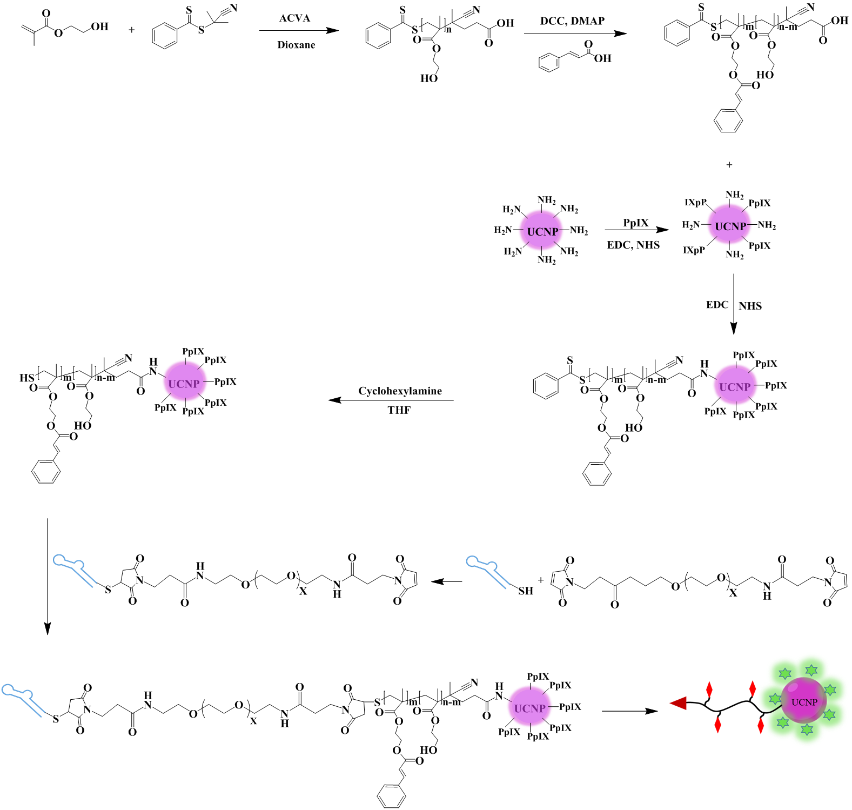
Scheme S1. Illustration of the synthesize procedure of AH(CA)@UCNP-PpIX.
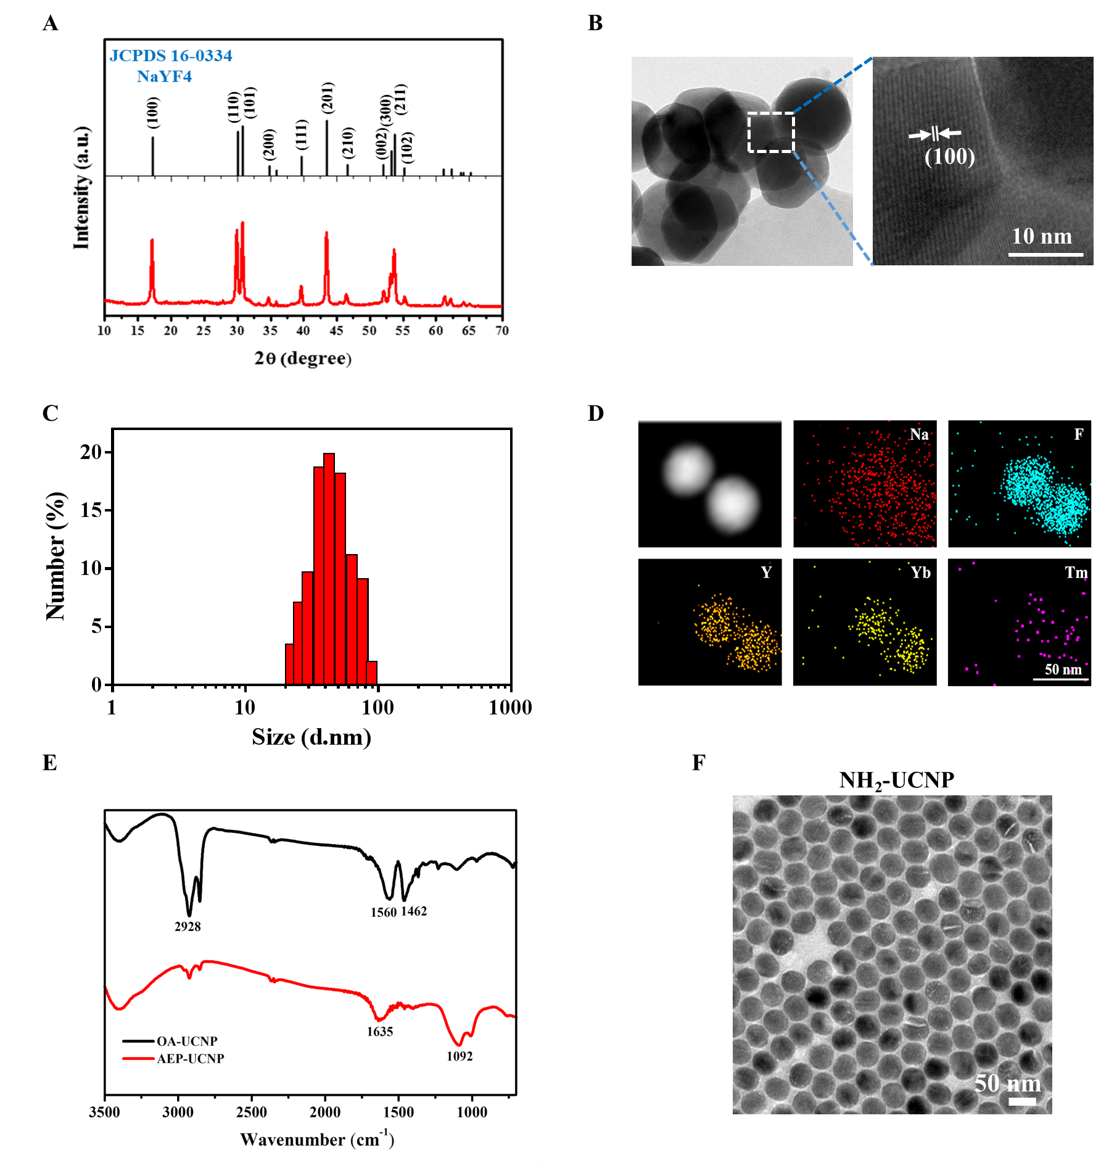
Fig. S1. Characteristic of UCNP and PpIX-modified UCNP. (A) X-ray diffraction pattern of UCNP. (B) High resolution transmission electron microscopy (HR-TEM) image of UCNP. (C) Size distribution of UCNP. (D) An energy dispersion spectrum (EDS)-TEM photograph of UCNP. (E) Fourier transform infrared spectroscopy (FTIR) absorption of OA-stabilized UCNP (black curve) and amino-functionalized UCNP (red curve). (F) A representative TEM photograph of amino-functionalized UCNP.
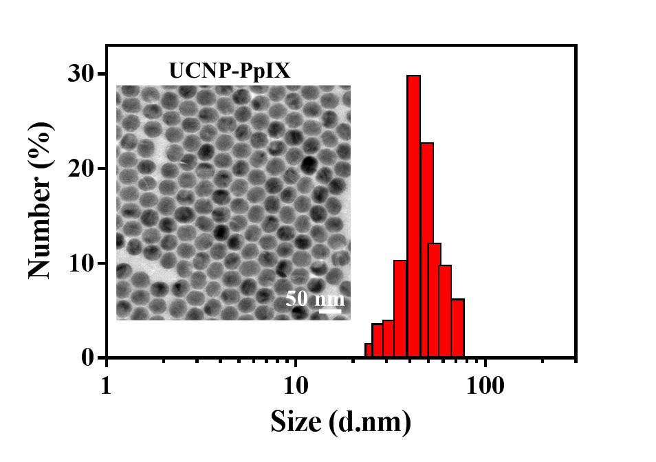
Fig. S2. A representative TEM image and size distribution of PpIX modified UCNP.
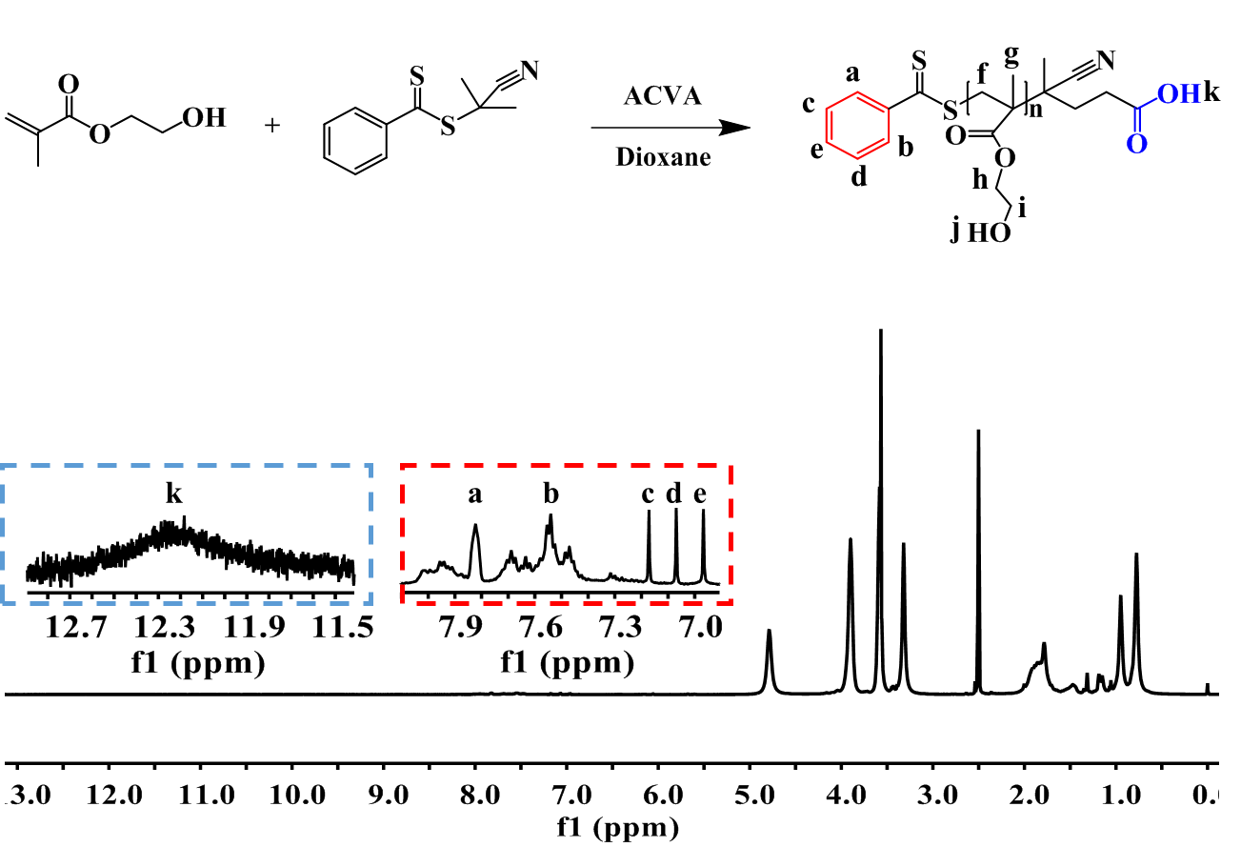
Fig. S3. Synthetic and ¹H-NMR spectrum of polyHM. The square frame marked the specific proton peaks of polyHM.

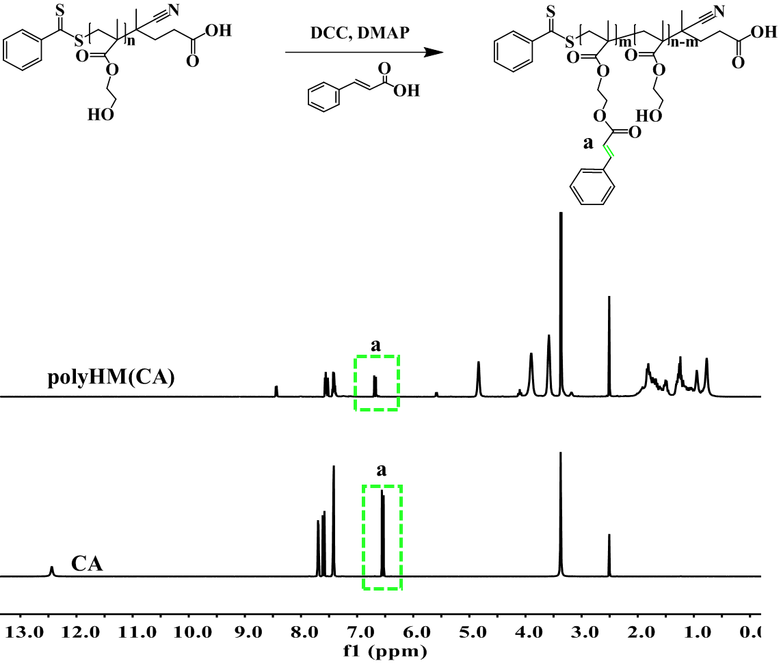
Fig. S4. Synthetic and ¹H-NMR spectrum of polyHM(CA). The green square frame marked the specific proton peaks of polyHM(CA).

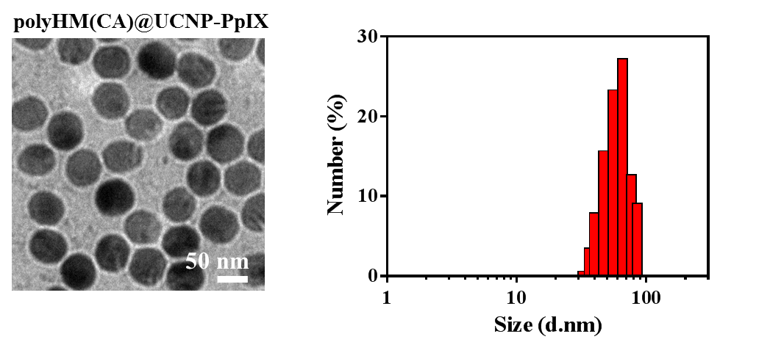
Fig. S5. A representative TEM photograph and size distribution of polyHM(CA)@UCNP-PpIX.

Fig. S6. Cell viabilities of Raji cells after irradiation with 980 nm NIR laser (2 W/cm², 5 min break after 10 min of irradiation) under different irradiation time.

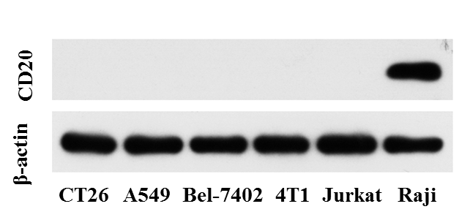
Fig. S7. CD20 expression levels of various cancer cell lines.

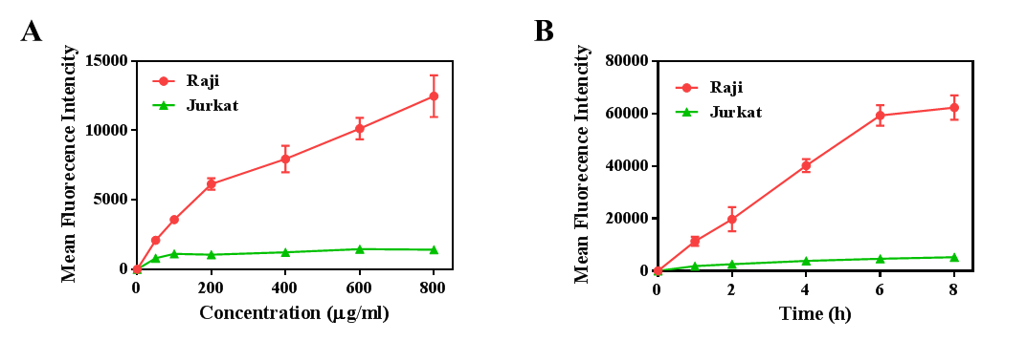
Fig. S8. Flow cytometry analysis of Raji cells incubated with AH(CA)@UCNP-PpIX at different concentrations (A) and time points (B).

Fig. S9. Semi-quantitative results of Raji cells exposed to AH(CA)@UCNP-PpIX for different times was calculated based on Fig. 2E using Image J.

Fig. S10. The mean fluorescence intensity of DCF was quantitatively calculated by Image J based on Fig. 2F.

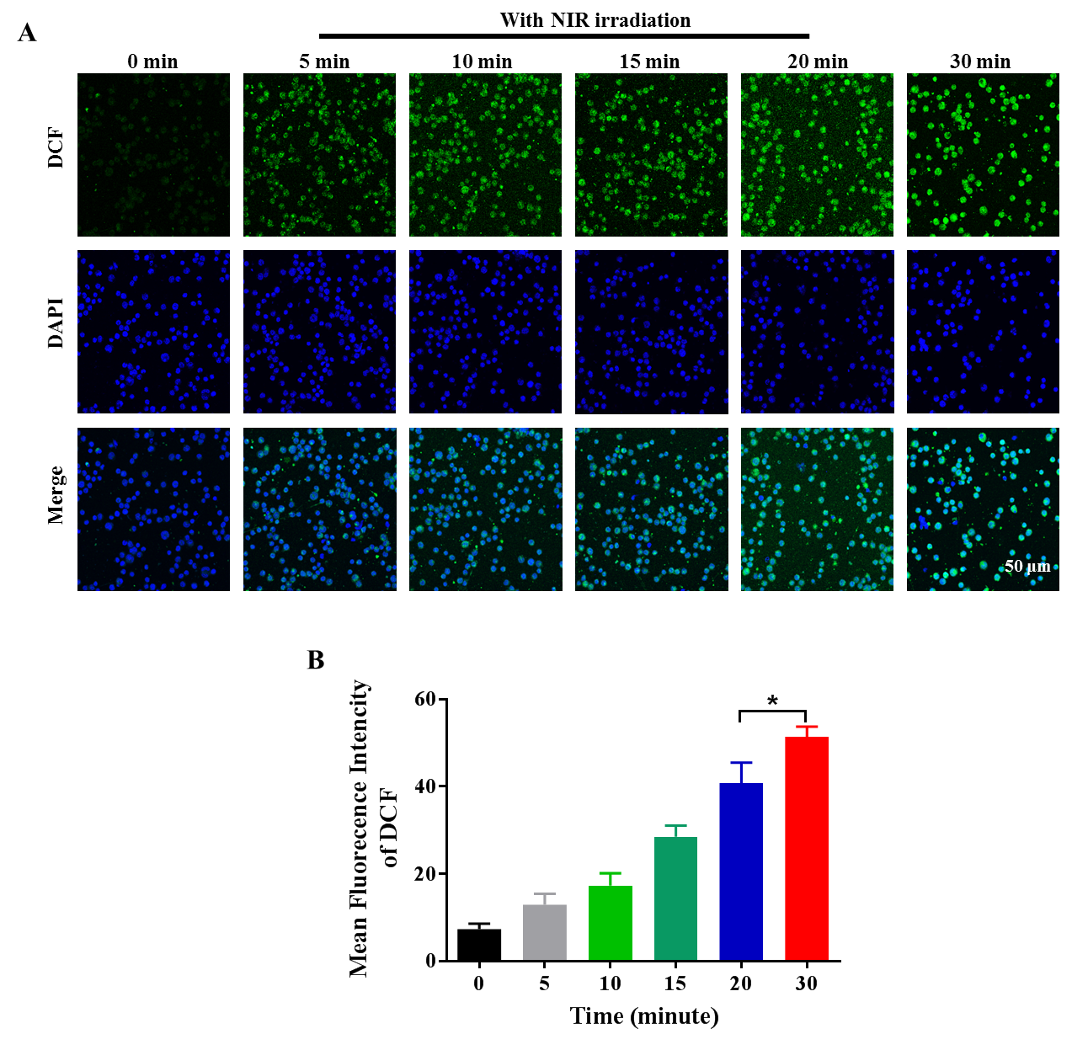
Fig. S11. Intracellular ROS generation in Raji cells was measured via confocal microscopy after treatment with AH(CA)@UCNP-PpIX for various time periods.

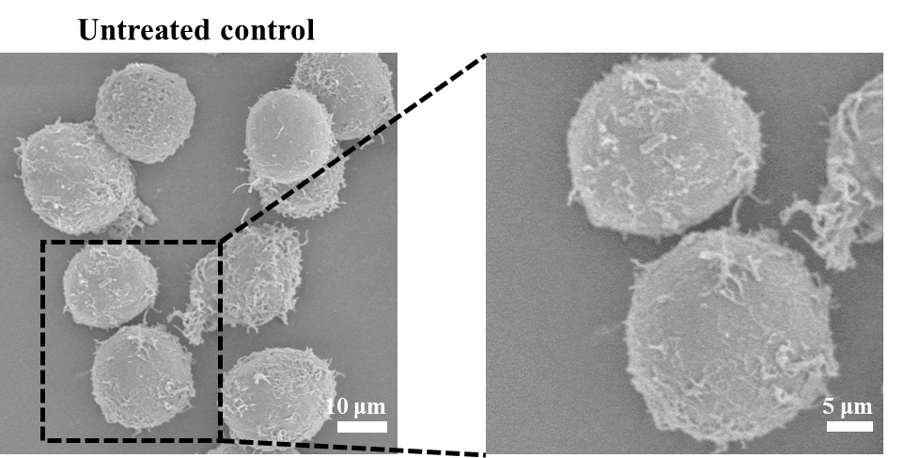
Fig. S12. SEM images of Raji cells without crosslinking of AH(CA)@UCNP-PpIX at cell surface.

Fig. S13. Quantitatively analysis of relative protein expression of Bcl-2, Bcl-xL, Bax, Bak and Caspase-3 in Raji cells after various treatments based on Fig. 3G.

Fig. S14. Quantitatively analysis of relative Cyt c protein expression in Raji cells after various treatments based on Fig. 3H and I.

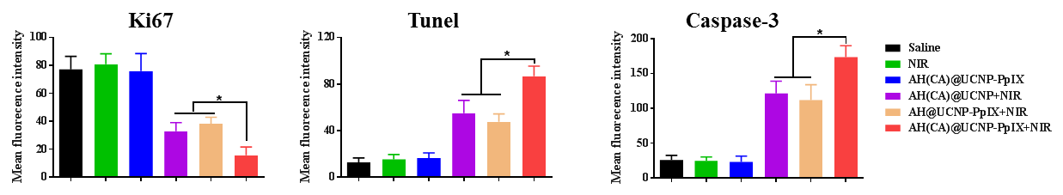
Fig. S15. Mean fluorescence intensity of Ki67, Tunel and Caspase-3 was quantitatively analysed based on Fig. 5H.

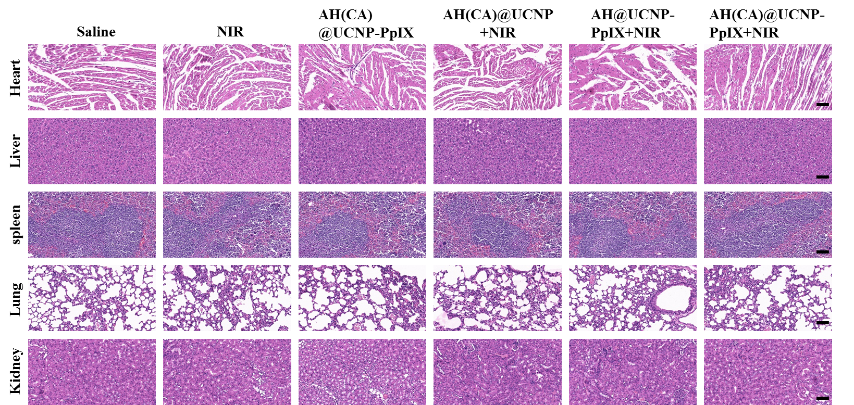
Fig. S16. Microscopic images of H&E stained major organs (heart, liver, spleen, lung and kidney) of mice with various treatments via intravenous injection at the end of observation. Scale bar, 50 μm.

