Exogenous systemin peptide treatment in olive alters Bactrocera oleae (Diptera, Tephritidae) oviposition preference
Luiza Sánchez^{1,2}, Ana E. Cunha^{1,2}, Nuno Rodrigues^{1,2}, José Alberto Pereira^{1,2}, Paula Baptista^{1,2,*}
¹Centro de Investigação de Montanha (CIMO), Instituto Politécnico de Bragança, Campus de Santa Apolónia, 5300-253 Bragança, Portugal
²Laboratório para a Sustentabilidade e Tecnologia em Regiões de Montanha, Instituto Politécnico de Bragança, Campus de Santa Apolónia, 5300-253 Bragança, Portugal

* Corresponding author. Tel.: + 351 273 303 332; Fax + 351 273 325 405.
E-mail address: pbaptista@ipb.pt

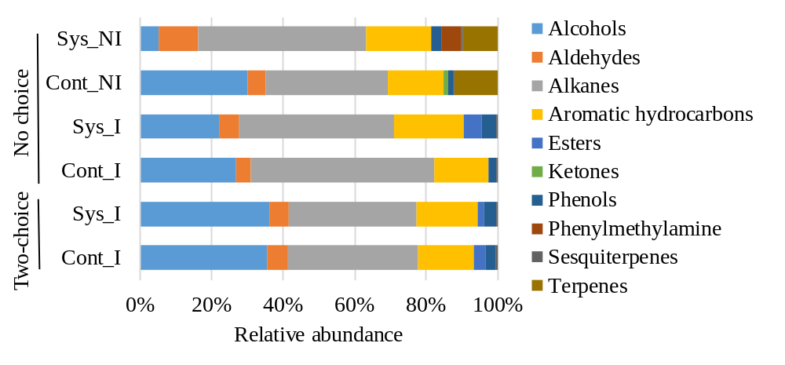
Fig. S1 Relative abundance (expressed in chromatographic area) of volatile organic compounds per chemical classes identified in olives infested (I) and non-infested (NI) by Bactrocera oleae from systemin-treated (Sys) and not-treated (Cont) olive branches assessed in the no-choice and two-choice assays.

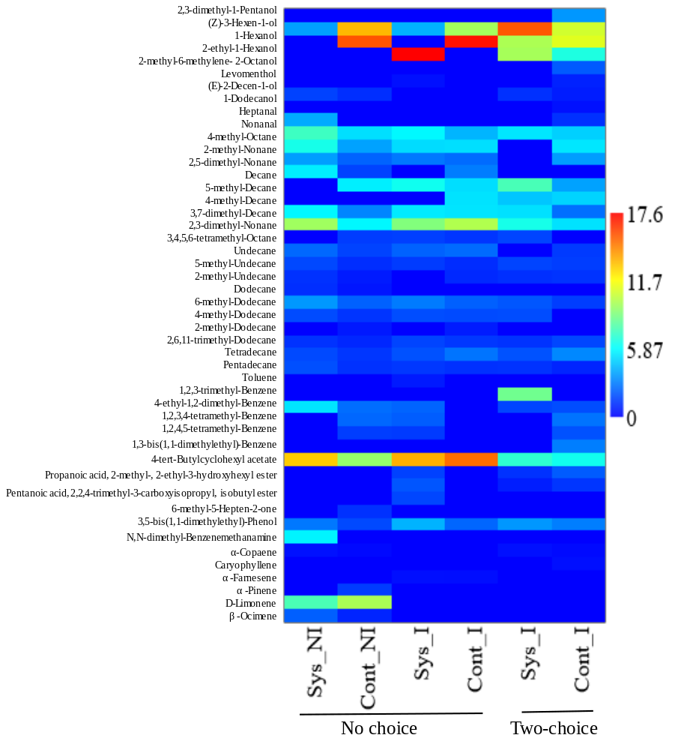
Fig. S2 Heatmap visualization of volatile compounds identified in olives infested (I) and non-infested (NI) by Bactrocera oleae from systemin-treated (Sys) and not-treated (Cont) olive branches assessed in the no-choice and two-choices assays. The color intensity (blue to red) refers to compound abundance in each sample. This figure was performed on PAST v4.12b software.

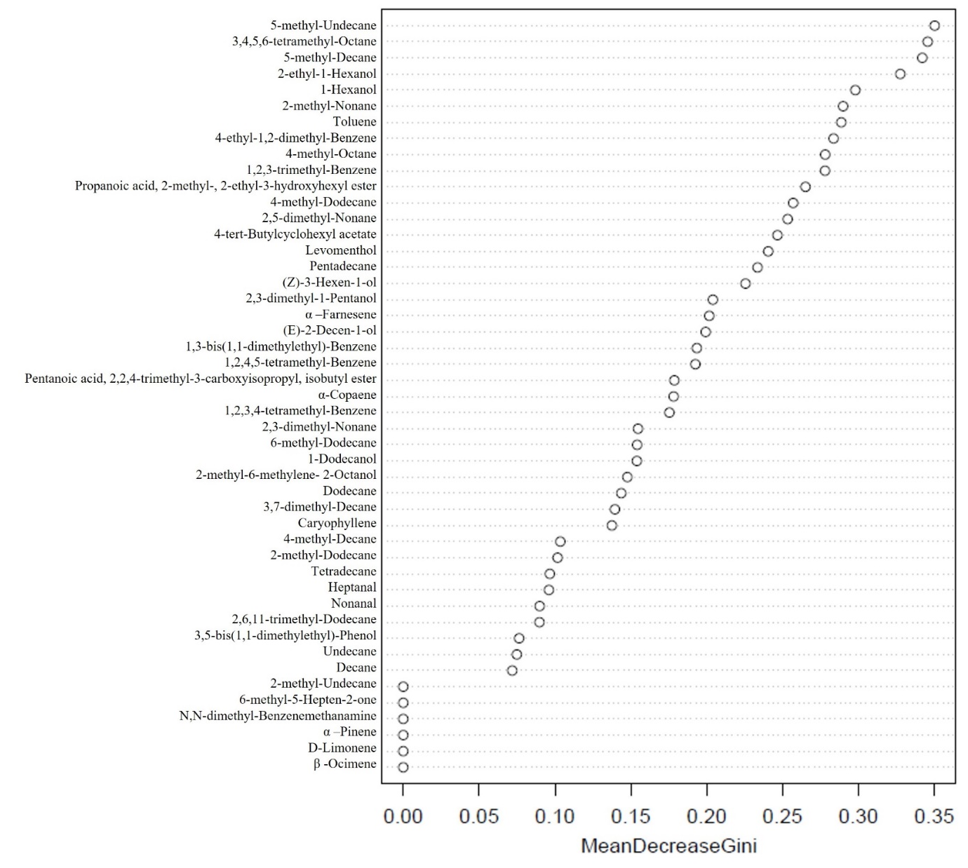
Fig. S3 Ranking of the volatile organic compounds (VOCs) emitted by infested olives that had the most important contribution in the discrimination of the treatments systemin-treated and not-treated olive branches assessed in the no-choice and two-choices experiments. Gini coefficient value is a measure for variables importance on treatments (systemin-treated and not-treated). The most important VOCs lie between 0.23 and 0.35.

Table S1. Volatile compounds detected in this study: retention time (RT). Kovat’s retention indices (RI), and selected ions used as m/z identifiers (QI).
RT  (min) | RI calª | RI Llit^{b} | Compounds | QI m/z
 |  |  | Alcohols
7.85 | 848 | 832 | 2,3-dimethyl-1-Pentanol | 43/56/41
10.39 | 908 | 873 | (Z)-3-Hexen-1-ol | 41/67/82
11.09 | 918 | 881 | 1-Hexanol | 43/56/69
21.22 | 1075 | 1048 | 2-ethyl-1-Hexanol | 41/57/70
24.21 | 1111 | 1074 | 2-methyl-6-methylene- 2-Octanol | 43/59/79
31.33 | 1212 | 1180.78 | Levomenthol | 71/81/95
33.69 | 1251 | 1251 | (E)-2-Decen-1-ol | 41/57/68
51.36 | 1521 | 1488 | 1-Dodecanol
 |  |  | Aldehydes
12.83 | 953 | 909 | Heptanal
26.45 | 1149 | 1130 | Nonanal
 |  |  | Alkanes
10.82 | 914 | 881 | 4-methyl-Octane | 43/85/71
16.82 | 1008 | 978.3 | 2-methyl-Nonane | 43/57/41
17.66 | 1017 | 986 | 2,5-dimethyl-Nonane | 57/43/85
19.23 | 1048 | 1015 | Decane
20.23 | 1061 | 1057 | 5-methyl-Decane | 57/43/85
20.79 | 1070 | 1061 | 4-methyl-Decane | 43/71/57
23.26 | 1100 | 1086 | 3,7-dimethyl-Decane | 43/57/71
23.46 | 1103 | 1064 | 2,3-dimethyl-Nonane | 57/43/71
23.64 | 1105 | 1086 | 3,4,5,6-tetramethyl-Octane | 57/43/71
26.25 | 1146 | 1115 | Undecane
26.81 | 1154 | 1154 | 5-methyl-Undecane | 43/57/71
30.79 | 1205 | 1166 | 2-methyl-Undecane | 43/57/71
33.35 | 1247 | 1214 | Dodecane
34.33 | 1260 | 1253 | 6-methyl-Dodecane | 57/43/71
34.88 | 1268 | 1259 | 4-methyl-Dodecane | 43/71/57
37.78 | 1308 | 1288 | 2-methyl-Dodecane | 43/71/57
38.90 | 1322 | 1320 | 2,6,11-trimethyl-Dodecane | 57/71/43
46.74 | 1441 | 1413 | Tetradecane
52.72 | 1541 | 1512 | Pentadecane
 |  |  | Aromatic hydrocarbons
6.70 | 832 | 788 | Toluene | 65/91/92
18.65 | 1028 | 1020.6 | 1,2,3-trimethyl-Benzene
24.59 | 1116 | 1104 | 4-ethyl-1,2-dimethyl-Benzene
27.21 | 1159 | 1150.4 | 1,2,3,4-tetramethyl-Benzene
27.52 | 1163 | 1147 | 1,2,4,5-tetramethyl-Benzene
37.06 | 1298 | 1249 | 1,3-bis(1,1-dimethylethyl)-Benzene
 |  |  | Esters
39.75 | 1332 | 1322 | 4-tert-Butylcyclohexyl acetate
44.94 | 1416 | 1415 | Propanoic acid, 2-methyl-, 2-ethyl-3-hydroxyhexyl ester | 89/71/56
58.68 | 1644 | 1605 | Pentanoic acid, 2,2,4-trimethyl-3-carboxyisopropyl, isobutyl ester | 71/43/28
 |  |  | Ketones
18.29 | 1024 | 987 | 6-methyl-5-Hepten-2-one
 |  |  | Phenols
53.73 | 1566 | 1555 | 3,5-bis(1,1-dimethylethyl)-Phenol | 191/57/206
 |  |  | Phenylmethylamine
21.86 | 1083 | 1042 | N,N-dimethyl-Benzenemethanamine | 91/0/0
 |  |  | Sesquiterpenes
45.23 | 1420 | 1407 | α-Copaene | 105/119/93
48.01 | 1470 | 1467 | Caryophyllene
53.47 | 1561 | 1533 | α -Farnesene | 41/93/69
 |  |  | Terpenes
14.83 | 982 | 953 | α -Pinene
21.14 | 1074 | 1044 | D-Limonene
22.58 | 1092 | 1054 | β -Ocimene
aRIcalc: retention indices calculated from C8 to C20 n-linear alkanes with TRB-5MS capillary column.
bRIlit: retention indices reported in the literature for TRB-5MS capillary column or equivalent. Identification method: Compounds were identified by comparing the MS fragmentation pattern with those of STD and mass spectra database performed using NIST Standard Reference Database 69, PubChem Compound Summary and ChemSpider database. Considering fit and retrofit values >80 %.

