Appendix Ⅰ
Table Description of glass bangle fragment samples from archaeological site of Northern Qatar
Sample No. | Site | Image | Area | Other codes | Bangle Type | Description and comments
1 | Al Ruwaida | 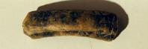 | Area B | DOA.RWA.2013 | Dark Monochrome | Wide and heavy, slightly corroded
2 | Al Ruwaida | 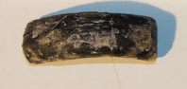 | Area B | DOA.RWA.2014 | Dark Monochrome | Wide and heavy, slightly corroded.
3 | Al Ruwaida | 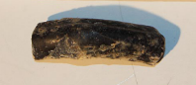 | Area B | DOA.RWA.2013 | Dark Monochrome | Slightly corroded.
4 | Al Ruwaida | 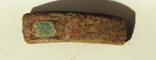 | Area B | DOA.RWA.2013 | Red opaque with Polychrome inlay | Corroded red opaque glass and corroded inlay of uncertain colour
5 | Al Ruwaida | 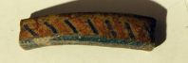 | Area B | DOA.RWA.2013 | Marvered band with thin diagonal stripes | Slightly corroded. Body colour in pale green. Marvered band with regular black, yellow, orange stripes
6 | Al Rubaiqa | 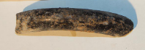 | Area A |  | Dark Monochrome | Moderately wide and heavy, slightly corroded.
7 | Al Rubaiqa | 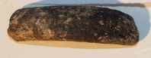 | Area A | DGB001-04 | Dark Monochrome | Wide and heavy, slightly corroded.
8 | Al Rubaiqa | 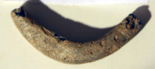 | Area A | DGB001-03 | Dark Monochrome | Moderately wide and heavy, corroded.
9 | Al Rubaiqa | 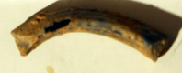 | Area B |  | Dark Monochrome | Moderately wide and heavy, corroded.
10 | Al Rubaiqa | 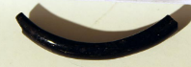 | Area A |  | Dark Monochrome | Fine. Well preserved and shiny.
11 | Al Huwaila | 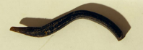 |  |  | Dark Monochrome | Fine. S-shaped waster (?). Slightly corroded.
12 | Al Huwaila | 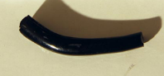 |  |  | Dark Monochrome | Fine. Well preserved and shiny.
13 | Al Huwaila | 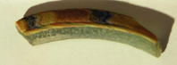 |  |  | Marvered band with irregular pattern | Pale green glass, black yellow and red marvered band. Also thin striped trails either side of band? Slightly corroded
14 | Al Huwaila | 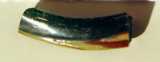 |  |  | Diagonal stripes in trail or thin band | Pale green translucent glass, yellow and red tapering trail. Well preserved and shiny.
15 | Al Huwaila | 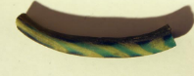 |  |  | Diagonal stripes in trail or thin band | Yellowish brown glass, yellow and green tapering. Slightly corroded
16 | Al Huwaila | 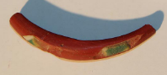 |  |  | Polychrome inlay | Red opaque glass with white, green and yellow opaque inlay, partly fallen out. Not corroded.
17 | Al Yousefiya | 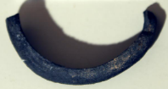 |  |  | Dark Monochrome | Moderately wide and heavy, slightly corroded.
18 | Al Yousefiya | 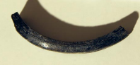 |  |  | Dark Monochrome | Fine, slightly corroded.
19 | Al Yousefiya | 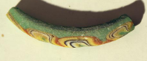 |  |  | Marvered band with irregular pattern | Pale green glass, black, thin marvered band with irregular pattern in yellow and orange opaque. Slightly corroded
20 | Al Yousefiya | 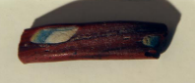 |  |  | Polychrome inlay | Red opaque glass with blue, white opaque, and yellow opaque inlay. Slightly corroded.
21 | Al Zubarah | 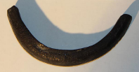 |  | T2011-54-5 | Dark Monochrome | Wide and heavy, slightly corroded.
22 | Al Zubarah | 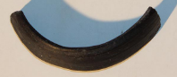 |  | T2011-57-3 | Dark Monochrome | Wide and heavy, well preserved.
23 | Al Zubarah | 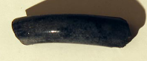 |  | T2011-57-3 | Dark Monochrome | Moderately wide and heavy, well preserved and shiny.
24 | Al Zubarah | 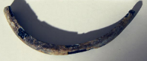 |  | DOA ZU-2003-486 | Dark Monochrome | Fine. Corroded.
25 | Al Zubarah | 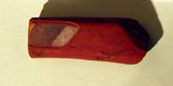 |  | T2011-54-5 | Polychrome inlay | Red opaque glass with white, blue? and yellow opaque inlay, truncated. Not corroded.
26 | Freiha | 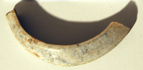 |  | DOA FRH-2002-313 | Dark Monochrome | Wide and heavy, corroded.
27 | Freiha | 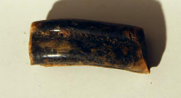 |  | DOA FRH-2002-335 | Dark Monochrome | Wide and heavy, slightly corroded.
28 | Freiha | 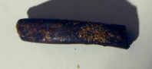 |  | DOA FRH-2002-337 | Dark Monochrome | Moderately wide, corroded.
29 | Freiha | 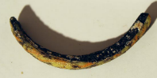 |  | DOA FRH-2002-335 | Marvered band with irregular pattern | Yellow and orange trail on dark body. Corroded.
30 | Freiha | 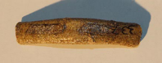 |  | DOA FRH-2002-347 | Polychrome inlay | Red opaque glass (corroded to yellowish on surface) with long dark inlaid panels. Seriously corroded.
31 | Fuwairit | 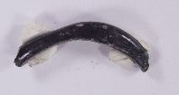 | Tr. 3 | F.645 | Dark Monochrome | Misshapen, well preserved, shiny
32 | Fuwairit | 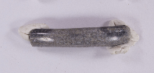 | Tr.3 | F.645 | Dark Monochrome | plano-convex shape
33 | Fuwairit | 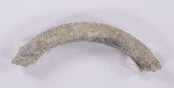 | Tr.1 | F.212 | Dark Monochrome | Plano-convex shape
34 | Fuwairit | 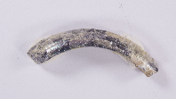 | Tr.1 | F.194 | Dark Monochrome | Plano-convex shape
35 | Fuwairit | 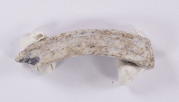 | Tr.1 | F.294 | Dark Monochrome | Trefoil shape
36 | Fuwairit | 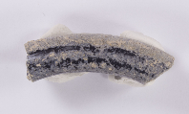 | Tr.1 | F.383 | Dark Monochrome | Light grey outer with a Plano-convex shape
37 | Fuwairit | 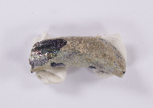 | Tr.1 | F.139 | Dark Monochrome | Trefoil shape
38 | Fuwairit | 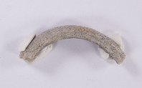 | Tr.1 | F.376 | Dark Monochrome | Plano-convex shape
39 | Fuwairit | 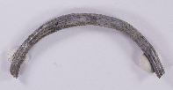 | Tr.7 | F.3297 | Dark Monochrome | Plano conves shape with possible twisted decoration
40 | Fuwairit | 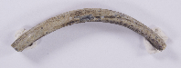 | Tr.7 | F.3237 | Dark Monochrome | Plano-convex shape, possibly twisted decoration
41 | Fuwairit | 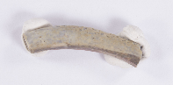 | Tr.7 | F.3241 | Dark Monochrome | Plano convex shape
42 | Fuwairit | 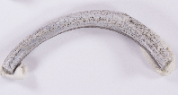 | Tr.7 | F.3217 | Dark Monochrome | Plano-convex shape
43 | Fuwairit | 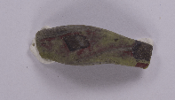 | Tr.7 | F.3331 | Polychrome inlay | Red opaque, flattened rectangular shape
44 | Fuwairit | 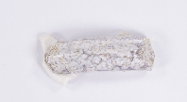 | Tr.1 | F.2027 | Dark Monochrome | Plano-convex/trefoil shape
45 | Fuwairit | 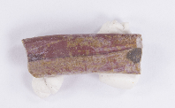 | Tr.1 | F.2027 | Polychrome inlay | Flattened rectangular shape
46 | Fuwairit | 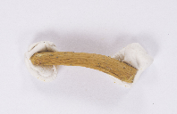 | Tr.1 | F.2146 | Dark Monochrome | Flattened rectangular shape
47 | Fuwairit | 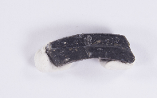 | Tr.6 | F.2520 | Dark Monochrome | Trefoil shape
48 | Fuwairit | 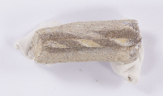 | Tr.1 | F.2021 | Diagonal stripes in trail or thin band | Green, triangular shape
49 | Fuwairit | 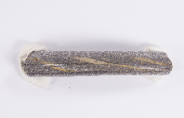 | Tr.1 | F.2134 | Diagonal stripes in trail or thin band | Dark body with yellow opaque stripes. Triangular shape
50 | Fuwairit | 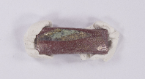 | Tr.1 | F.2077 | Polychrome inlay | Red opaque body with yellow inlay. Almost flattened rectangular shape
51 | Fuwairit | 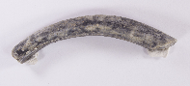 | Tr.7 | F.3265 | Dark Monochrome | Plano-convex shape
52 | Fuwairit | 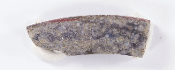 | Tr.7 | F.3309 | Diagonal stripes in trail or thin band | Dark body with thin red and white opaque stripes on band. Moderately corroded.
53 | Fuwairit | 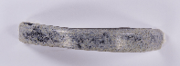 | Tr.7 | F.3033 | Dark Monochrome | Rectangular/ plano-convex shape. When refitted the pieces form almost a full bangle
54 | Fuwairit | 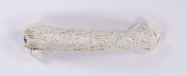 | Tr.1 | F.2072 | Dark Monochrome | Plano-convex shape. Corroded surface
55 | Fuwairit | 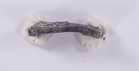 | Tr.7 | F.3222 | Dark Monochrome | Flattened rectangular shape
56 | Fuwairit | 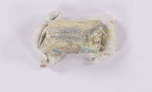 | Tr.5 | F.1205 | Turquoise Monochrome | Plano-convex shape
57 | Fuwairit | 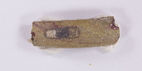 | Tr.1 | F.2036 | Polychrome inlay | Red opaque. Almost flattened rectangular shape
58 | Fuwairit | 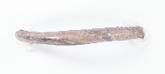 | Tr.7 | F.3309 | Marvered band with irregular pattern | Dark body with red and yellow bands. Plano-convex uneven shape.

