Supplemental Material
Supplemental Table 1. Definitions for exposure and covariate codes used for defining medical conditions, comorbidities, drug treatments and procedures for atrial fibrillation 1
Supplemental Table 2. Definitions of study outcomes. 4
Supplemental Table 3. Subgroup analysis for gender, age, hypertension stratification 5
Supplemental Table 4. Sensitivity analysis using a different time window of 120 days 6
Supplemental Table 5. E-values for MACE and all-cause mortality. 7

Supplemental Figure 1. Illustration of study design 8

Supplemental Table 1. Definitions for exposure and covariate codes used for defining medical conditions, comorbidities, drug treatments and procedures for atrial fibrillation
Medical conditions | ICD-10 Code
Atrial fibrillation | I48
Treatment Exposures | ATC code
Antiarrhythmic agent class I and III (rhythm control) | C01B
Antiarrhythmic agent class II (rate control) | C07AB, C07AA05
Antiarrhythmic agent class IV (rate control) | A10BG, A10BD03, A10BD05, A10BD04
Antiarrhythmic agent class V (rate control) | C01AA05, C01EB10
Procedure Exposure
Catheter ablation (rhythm control) | Manually extracted from medical order
Covariates
Medication Use | ATC Code
Platelet inhibitor | B01AC;
Anticoagulant | B01AA, B01AE07, B01AF, B01AX05;
Lipid lowering drug | ATC: C10;
Insulins | A10A
ACEis/ARBs | C09A,C09B,C09C,C09D
Non-potassium sparing diuretics | C03A, C03B, C03X
Potassium-sparing diuretics | C03D
Other hypertensives treatments | C02, C07, C08C, C08D, C08E, C08G
Comorbidity | ICD-10 Code
Heart failure | I11.0, I50, I97.1
Hypertension | I10, I11, I12, I13, I15
Diabetes mellitus | E10, E11, E12, E13, E14
Ischemic stroke | I63, I64
Other cerebrovascular disease | I65-I69, G45.4,G46
Chronic heart disease | I21, I22, I25.2, H34.0, I60-I69, I05-I08, I27
Chronic kidney disease | E12, E42, I120, I13.1, I13.2, N18, N19
Chronic obstructive pulmonary disease | J40-J47
Ongoing cancer | C00-C97 diagnosed within 3 years prior to the index date

Supplemental Table 2. Definitions of study outcomes.
Outcome | Definitions | ICD codes
MACE
Ischemic stroke | Any admission diagnosis of ischemic stroke | ICD-10: I63, I64
Hospitalized heart failure | Any admission diagnosis of heart failure | ICD-10: I11.0, I50, I97.1
Acute myocardial  infarction | Any admission diagnosis of myocardial infarction | ICD-10: I21, I22, I23
Cardiovascular death | Defined from death record, we filtered all possible death records manually | ICD-10: G45-G46, H341, I
MACE: major adverse cardiovascular events.

 | MACE |  | HF |  | Stroke
Subgroups | Adjusted HR | P value | Adjusted HR | P value | Adjusted HR | P value
Male | 0.89[0.65, 1.21] | 0.21 | 0.78[0.54, 1.15] | 0.46 | 0.88[0.56, 1.39] | 0.51
Female | 0.66[0.47, 0.94] |  | 0.63[0.41, 0.97] |  | 0.69[0.40,1.21]
<65 years old | 0.58[0.34, 1.02] | 0.28 | 0.38[0.17, 0.85] | 0.05 | 1.03[0.47,2.26] | 0.33
>=65 years old | 0.86[0.66, 1.11] |  | 0.84[0.61, 1.13] |  | 0.76[0.51,1.15]
With hypertension | 0.74[0.56, 0.98] | 0.71 | 0.57[0.40, 0.82] | 0.06 | 0.95[0.65,1.40] | 0.016
Without hypertension | 0.81[0.54, 1.23] |  | 1.03[0.64, 1.65] |  | 0.33[0.15,0.71]
Supplemental Table 3. Subgroup analysis for gender, age, hypertension stratification.
HR: Hazard ratio, HF: heart failure, MACE: major adverse cardiovascular events. P value in this table stands for treatment-factor interaction.
Supplemental Table 4. Sensitivity analysis using a different time window of 120 days
Outcome | Group | No. | Follow-up  (year) | Event | Person-year | Incidence rate (per 1000 person-year) | Crude HR unadjusted | HR adjusted
MACE | Rate | 4886 | 3.4[1.6-5.9] | 444 | 20289 | 22[20-23] | 1 | 1
MACE | Rhythm | 2275 | 2.9[1.5-4.7] | 115 | 7969 | 14[12-17] | 0.66[0.54, 0.82]*** | 0.79[0.63, 0.98]*
HF | Rate | 4886 | 3.6[1.7-6.0] | 298 | 20699 | 14[12-16] | 1 | 1
HF | Rhythm | 2275 | 2.9[1.5-4.7] | 71 | 8053 | 9[7-11] | 0.61[0.47, 0.79]*** | 0.71[0.53, 0.94]*
Stroke | Rate | 4886 | 3.7[1.7-6.1] | 201 | 21058 | 9[8-11] | 1 | 1
Stroke | Rhythm | 2275 | 2.9[1.5-4.8] | 52 | 8135 | 6[5-8] | 0.66[0.49, 0.90]** | 0.83[0.59, 1.17]
Cardiovascular death | Rate | 4886 | 3.8[1.8-6.3] | 19 | 21627 | 9[5-13] | 1 | 1
Cardiovascular death | Rhythm | 2275 | 3.0[1.6-4.9] | 3 | 8261 | 4[1-9] | 0.41[0.12, 1.40] | 0.44[0.13, 1.54]
All-cause mortality | Rate | 4886 | 3.7[1.8-6.2] | 84 | 21221 | 4[3-5] | 1 | 1
All-cause mortality | Rhythm | 2275 | 2.9[1.5-4.8] | 17 | 8165 | 2[1-3] | 0.51[0.30, 0.86]* | 0.64[0.36, 1.12]
HR: hazard ratio, HF: heart failure, MACE: major adverse cardiovascular events.

Supplemental Table 5. E-values for MACE and all-cause mortality.
 | ERC vs usual care
MACE
Adjusted HR (95% CI) | 0.75[0.61, 0.94]
E value (confidence limit) | 1.98 (1.31)
All-cause mortality
Adjusted HR (95% CI) | 0.61[0.35, 1.07]
E value (confidence limit) | 2.44 (1)
MACE: major adverse cardiovascular events,

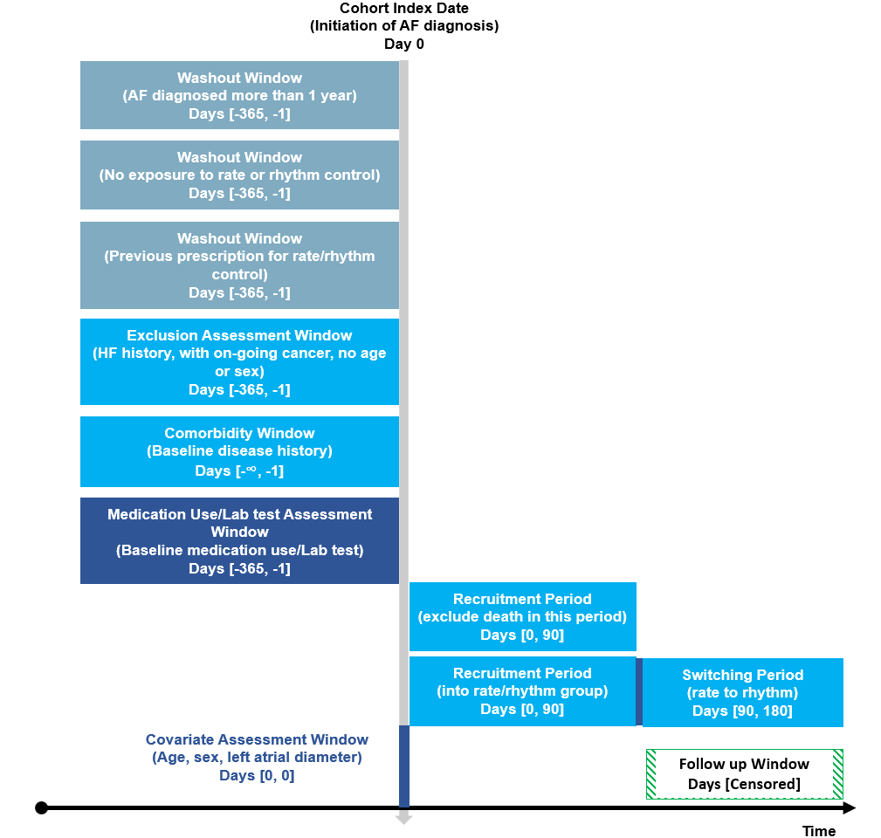
Supplemental Figure 1. Illustration of study design

