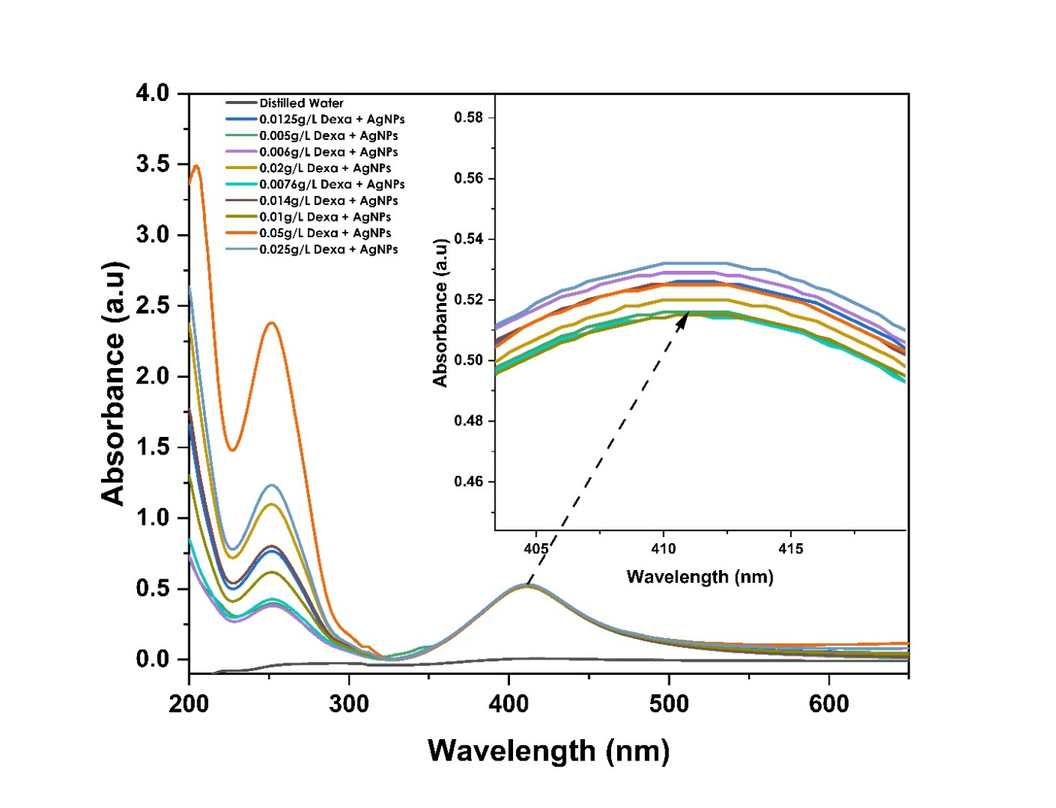
S1: Absorption Spectra of AgNPs and Dexamethasone Conjugates at 200 -700nm.
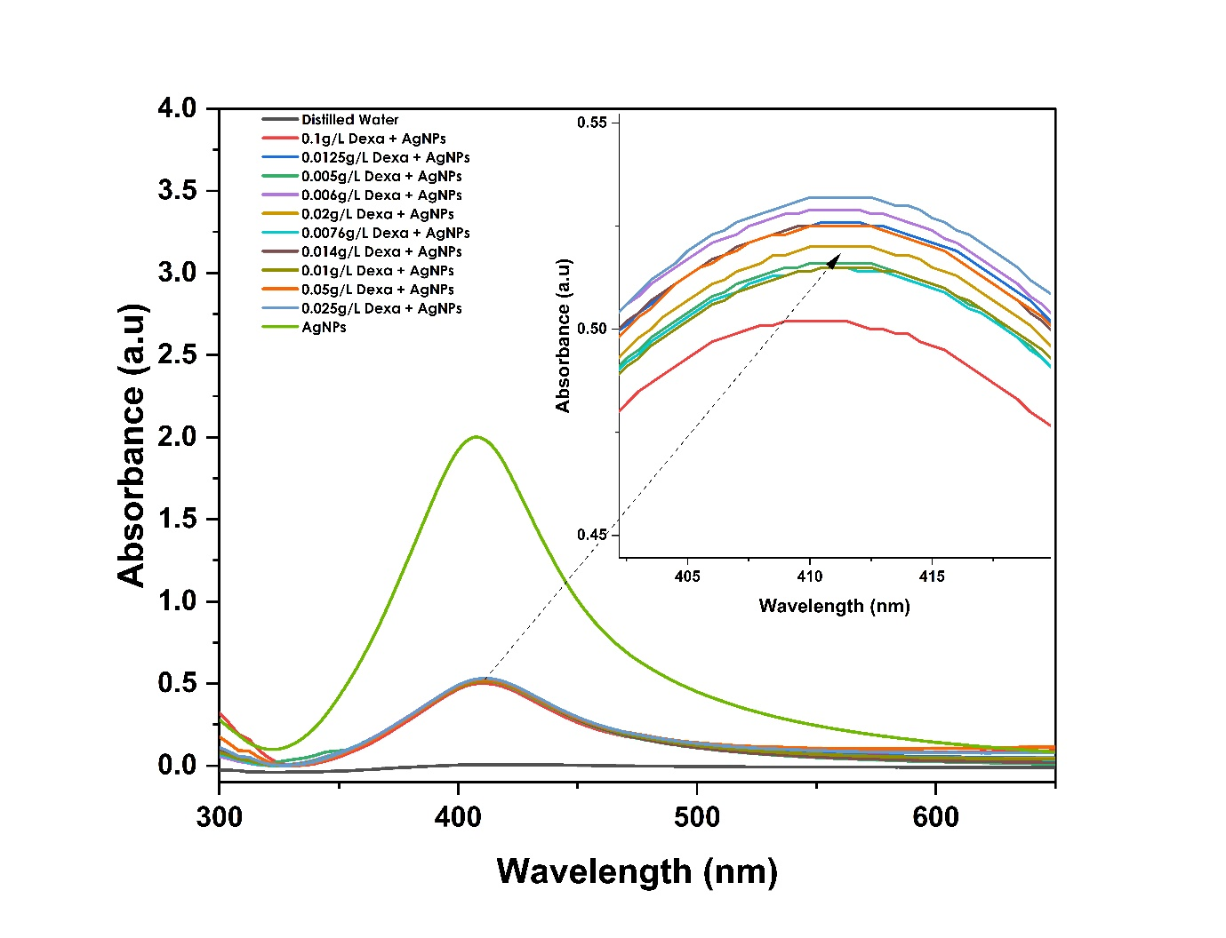
S2: Absorption Spectra of AgNPs and Dexamethasone Conjugates at 300nm-700nm.
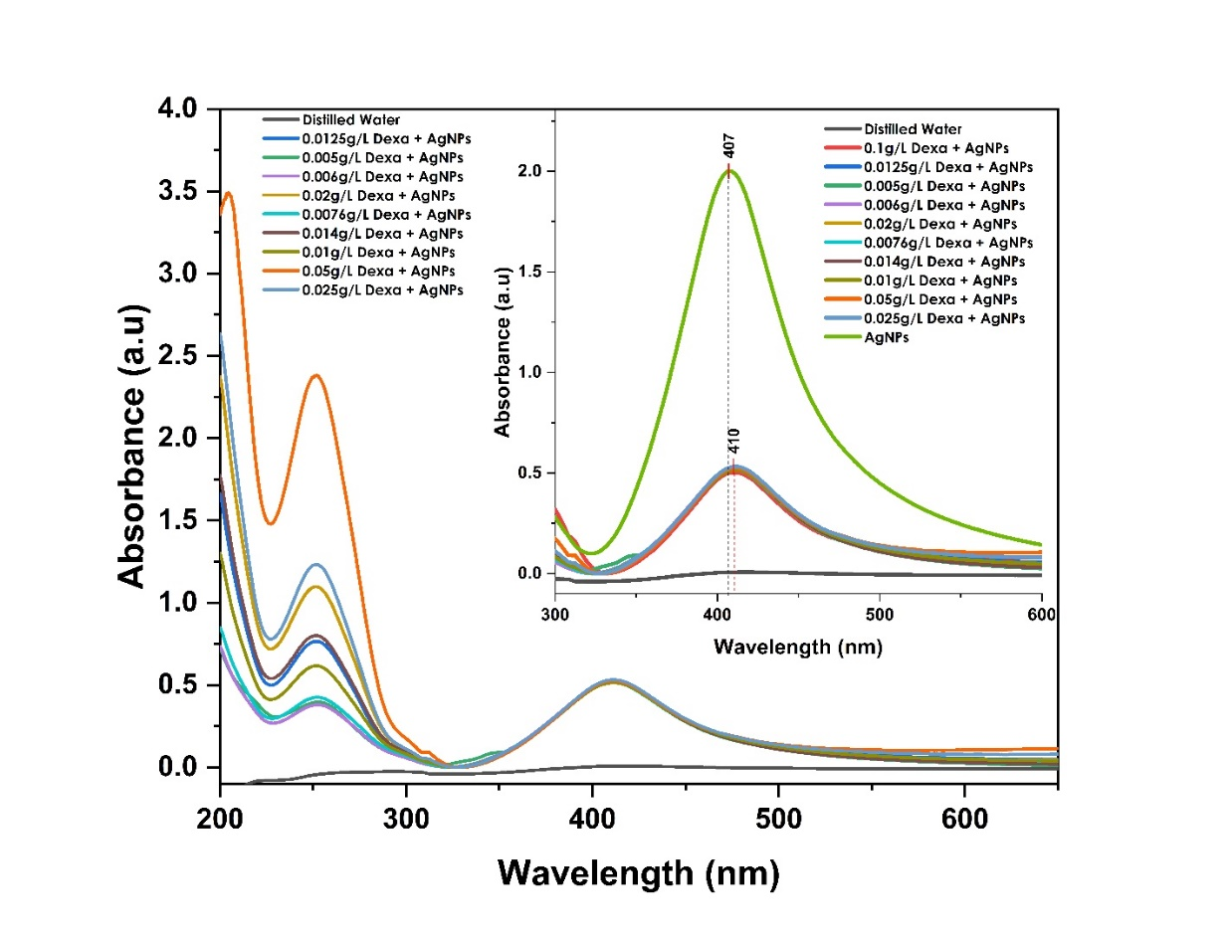
S3: Absorbance Spectra of AgNPs and Dexamethasone Conjugates at 200-700nm.

