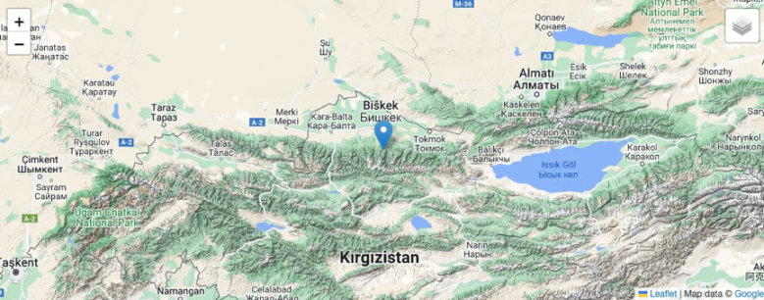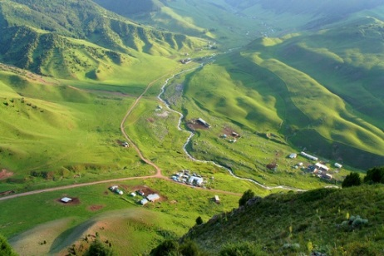
Photo 1. Map of Çunkurçak Plateau [36]

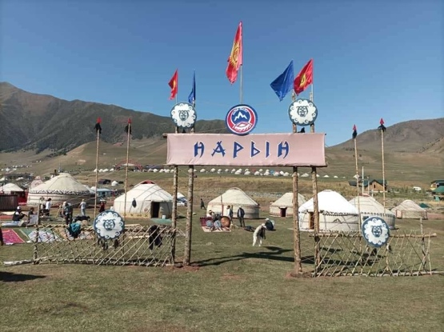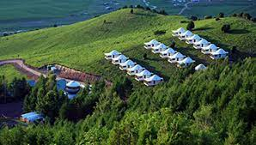
Photo 2. Supara Ethno Complex [37]

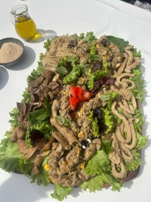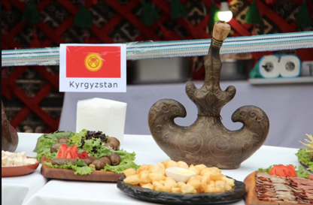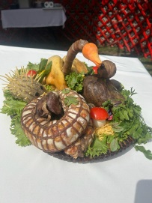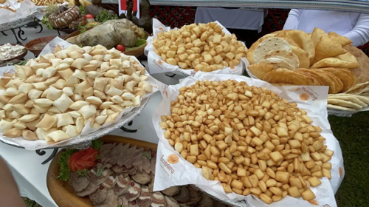

Photo 3: Ethnic meals at the Ethno-Fest [38, 39]

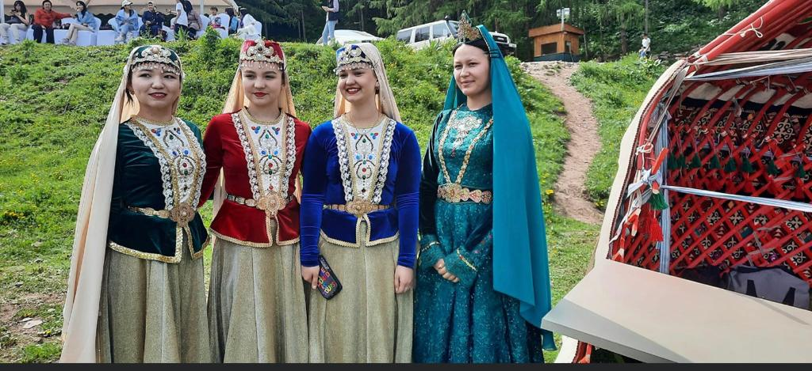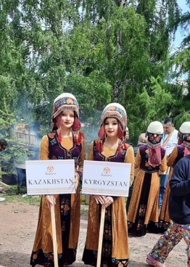
Photo 4: Ethno-Fest at Ethno-Fest [38, 39]

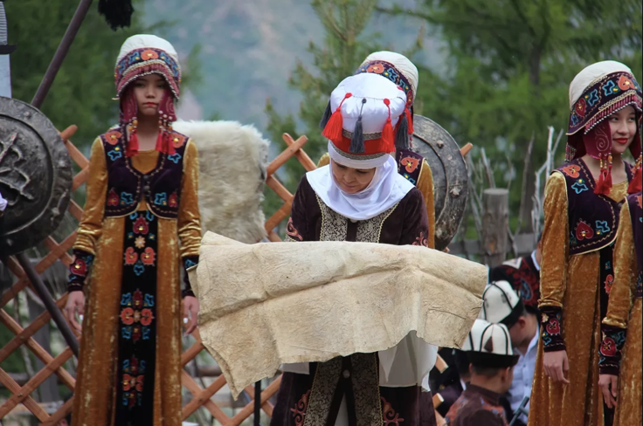
Photo 5: Ethnic crafts at Ethno-Fest [38, 39]

Photo 6: Ethnic music at the Ethno-Fest [38, 39]

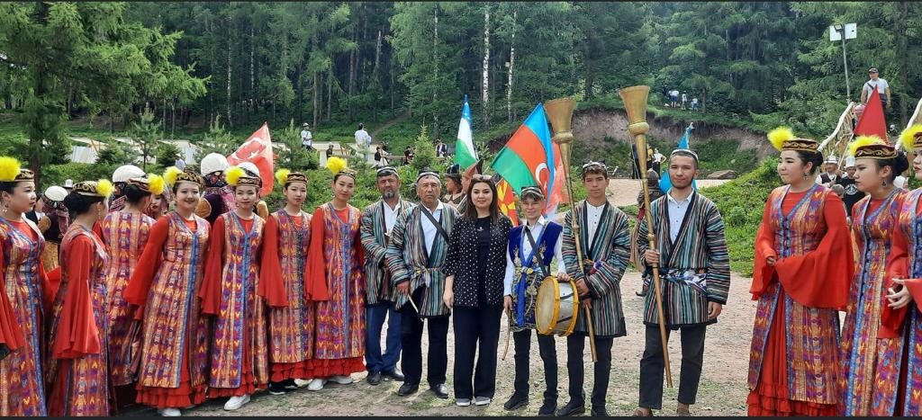
Photo 7: Ethnic musical instruments at the Ethno-Fest [38, 39]

