Title
Phlebotomines study in urban and rural areas in an endemic region of northeastern Brazil

Author information

Fernando Castro Garcia¹(0009-0007-6437-2769); Carlos Fernando Rocha dos Santos²(0009-0006-7727-962X); Aryel José Alves Bezerra³ (0000-0001-6960-7458); Thiago Emanuel Ribeiro Silva³ (0009-0003-4196-5087); Moezio de Vasconcellos Costa Santos Filho³ (0009-0000-6686-2517); Ênio José Bassi⁴(0000-0002-7956-5746); Leticia Anderson¹* (0000-0003-3884-2329)
- Centro Universitário CESMAC, Programa de Pós-Graduação Análise de Sistemas Ambientais PPGASA, Maceió, Alagoas, Brazil.
- Unidade de Vigilância de Zoonoses, Maceió, Alagoas, Brazil.
- Centro Universitário CESMAC, Biomedicina, Maceió, Alagoas, Brazil.
- Universidade Federal de Alagoas, Imunoreg – Grupo de Pesquisa Regulação da Resposta Imune, Maceió, Alagoas, Brazil.
* Corresponding author: leticia.anderson@cesmac.edu.br

Supplementary information

In this study conducted in Rio Largo, Alagoas State, Brazil, several species of sandflies have been reported for the first time. These newly identified sandfly species were captured and documented using CDC light traps, providing valuable data for the research. The images of these sandflies showcase their distinctive morphological features.

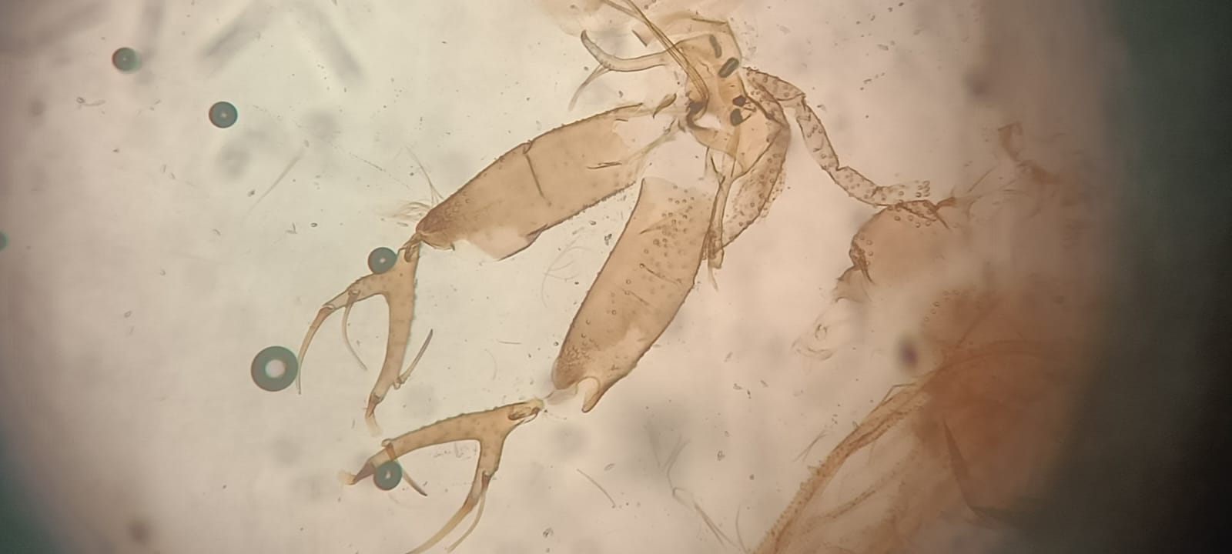
Viannamyia caprina – external genital structure of male

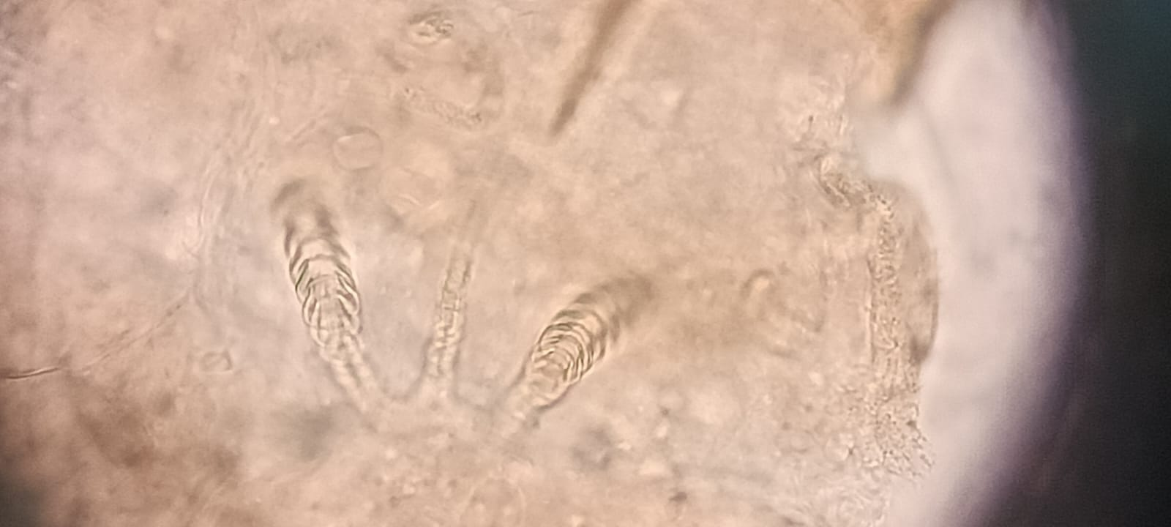
Psychodopygus carrerai carrerai – spermatheca of female specimen.

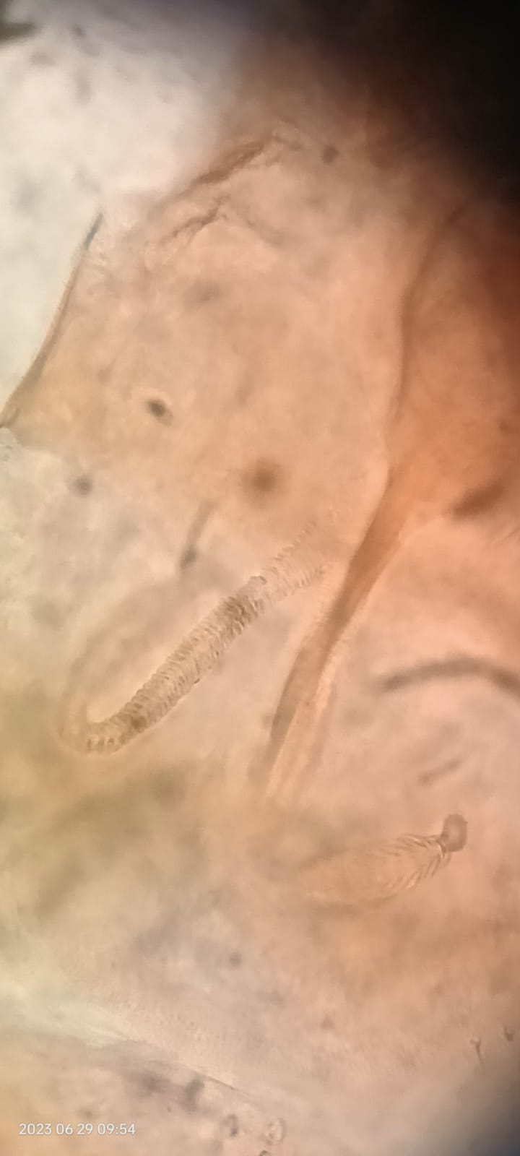
Psychodopygus complexus - spermatheca of female specimen.

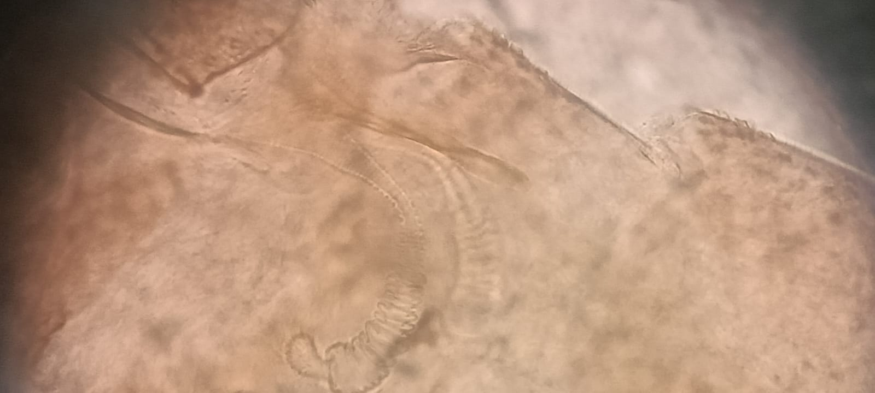
Bichromomyia flaviscutellata - spermatheca of female specimen.

