Supplement 1 PCR and sanger sequencing primers.
Gene | Primer | Direction | Sequence ‘5-----3’ | Source
COI | COIceF | Forward | ACTGCCCACGCCCTAGTAATGATATTTTTTATGGTNATGCC | Hoareau and Boissin, 2010
COI | COIceR | Reverse | TCGTGTGTCTACGTCCATTCCTACTGTRAACATRTG | Hoareau and Boissin, 2010
16S | 16SAN-R | Forward | GCTTACGCCGGTCTGAACTCAG | Zanol et al. 2010
16S | 16SarL | Reverse | CGCCTGTTTATCAAAAACAT | Palumbi et al. 1991

Supplement 2 Clades in phylogeny based on COI gene data.

Clade | Bootstrap support
Luidia alternata and larvae from Panama | 100%
Luidia avicularia | 100%
Luidia barbadensis | 96%
Luidia clathrata | 100%
Luidia lawrencei and larvae from Panama | 97%
Luidia ludwigi scotti | 100%
Luidia maculata and Eleutherozoa sp. | 96%
Luidia magnifica and larvae from Panama | 99%
Luidia senegalensis and larvae from Panama | 100%

Supplement 3 Clades in phylogeny based on 16S gene data.
Clade | Bootstrap support
Luidia alternata and larvae from Panama | 94%
Luidia avicularia | 100%
Luidia barbadensis | 97%
Luidia clathrata and larvae from Panama | 57%
Luidia hardwicki | 100%
Luidia lawrencei | 100%
Luidia ludwigi scotti | 100%
Luidia magnifica and larvae from Panama | 100%
Luidia senegalensis and larvae from Panama | 73%

Supplement 4 Comparative ratio of R to r of Luidia magnifica versus L. aspera and L. hystrix. References of specimens: L. magnifica type (Fisher 1906); L. magnifica non-type (Clark 1953); L. aspera type (Sladen 1889); L. hystrix type (Fisher 1906); L. aspera complex (CAS 164087).

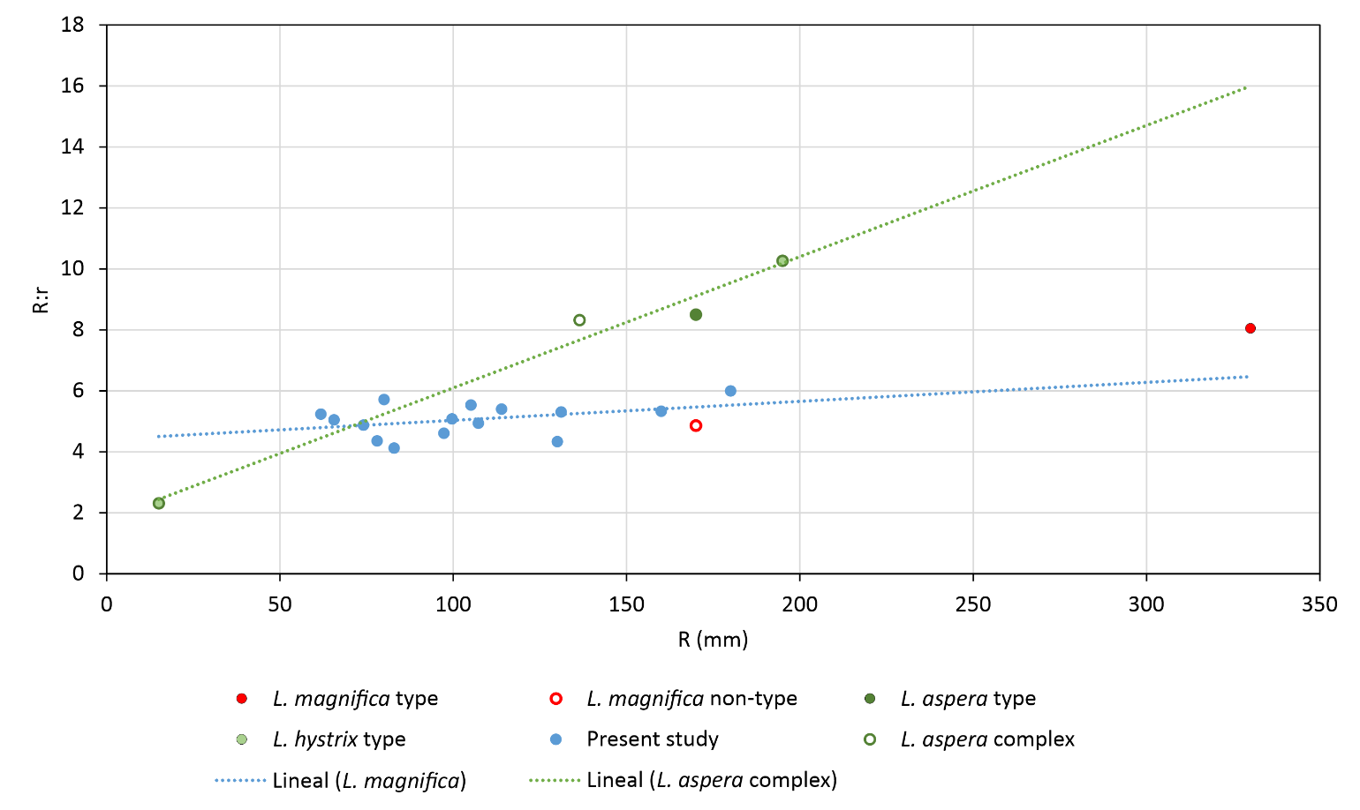

Supplement 5 Adult - Larvae clades found in COI phylogeny. Specimen Identifier and sequence accession numbers between parenthesis are included.
Clade | Adult | Larvae
1 | Luidia alternata FSBCI_122486 (OP312132), FSBCI_122491 (OP312133) | Asteroidea sp. RCMBAR224 (MN730685), RCMBAR1265 (MN730736), RCMBAR2024 (MN730689), RCMBAR2352 (MN7300752), RCMBAR2027 (MN730674)
2 | Luidia maculata MBM_E00M1 (JQ740634), MBM_E00M2 (JQ740635) | Eleutherozoa sp. COT005_L39 (KT271545), Eleutherozoa sp. COT022_L218 (KT271549)
3 | Luidia magnifica LEMA-EQ675-5 (OP312146), IE-2013-1757 (OP312147), IE-2013-1762 (OP312148) | Asteroidea sp. RCMBAR088 (MN730700), RCMBAR2223 (MN730743)
4 | Luidia lawrencei FSBCI_122518 (OP312127), FSBCI_122514 (OP312129), FSBCI_122545 (OP312128) | Asteroidea sp. RCMBAR580 (MN730764), RCMBAR1006 (MN730669)
5 | Luidia senegalensis FSBCI_122552 (OP312126) | Asteroidea sp. RCMBAR1003 (MN730728) RCMBAR2351 (MN730776), RCMBAR687 (MN730704)

Supplement 6 Adult - Larvae clades found in 16S phylogeny. Specimen Identifier and sequence accession numbers between parenthesis are included.
Clade | Adult | Larvae
1 | Luidia magnifica LEMA-EQ675-5 (OP339775), IE-2013-1757 (OP339775), IE-2013-1762 (OP339776) | Asteroidea sp. RCMBAR088 (MN730828)
2 | Luidia alternata FSBCI_122486 (OP339763), FSBCI_122491 (OP339764) | Asteroidea sp. RCMBAR086 (MN730880), RCMBAR1265 (MN730869), RCMBAR2027 (MN730800), RCMBAR2352 (MN730889), RCMBAR2024 (MN730816), RCMBAR2228 (MN730794), RCMBAR224 (MN730811)
3 | Luidia clathrata FSBCI_122496 (OP339762) | Asteroidea sp. RCMBAR2355 (MN730855), RCMBAR2353 (MN730812), RCMBAR1006 (MN730793)
4 | Luidia senegalensis FSBCI_122552 (OP339758) | Asteroidea sp. RCMBAR687 (MN730832), RCMBAR1003 (MN730861), RCMBAR2351 (MN730916)

