Examples of interdisciplinary knowledge integration visible in process and results.
Supplementary Table 2
Integration of knowledge of (different) interdisciplinary experts / literature sources about uncertain societal and (energy) technological developments…
 | …visible within process |  | … visible in final energy scenarios
A | List of descriptors (see Supplemental Material 1)  - Directly linkable  - Softly linkable  - Indirectly linkable | B | Due to the methodical enhancement to link also various context scenarios, C1 was able to integrate a big amount of descriptors (43) on different regional scales. By linking the three regional scales 5 cross-cutting future could be identified. The cross-cutting future ‘Black’ functions as trend scenario, ‘Dark green’ as transformation scenario and directly, softly or indirectly linked through the descriptors defined in the first phase of the context scenario process.
D | Descriptor definition: For the quantification of various descriptors C2 screened scenario studies to identify their range. E.g for the descriptor “Expansion of renewable energies in the electricity sector” the sources BMWi Energiedaten, Fahl et al. 2009:191, Exxon 2012:4; Nitsch et al. 2012:114 and SRU 2011:152 built the basis for the quantifications (see Weimer-Jehle et al. 2015). | C | Depending on the content to be highlighted conclusions can be drawn of how also indirect linkable descriptors have an effect on the energy transition: e.g. in a risk analysis C2 has shown that surprisingly MINT education is rather risk than supporter of the energy transition “In addition to its obvious virtues as a promoter of human resources needed to support an energy transition, the experts also described this issue as a driver of materialism, consumption oriented values, and economic growth (and related emissions), and this side of the coin played out in our analysis of cross-impact data to a surprising extent.” (Pregger et al. 2020)
F | As C1 parameterized just before energy modeling and the scenarios are therefore based on semi-qualitative factors, “the futures could be interpreted, in principle, as frameworks in which several scenarios may fit.” (Vögele et al. 2017:942). Thus, they were able to proof consistency of existing scenario studies on the household level and found that only about half of the analyzed scenarios did match a cross-cutting future (Vögele et al. 2017). | E | The quantified descriptors in C2 (e.g. GDP growth (% per year) is weak (0.6%), moderate (1.2%) or strong (1.8%) on the one hand build the basis for impact assessments during context scenario construction and on the other hand were directly linked as input parameters with energy modeling and therefore, build a bridge between context scenarios and energy modeling. Soft linking is realized with additional plausibility arguments, as they do no directly correspond to a (quantitative) model parameter, e. g. rebound effects of individual households. “In the case of a ‘moderate rebound’, the energy demand of private households (electric appliances) is 7% higher than in the case of a ‘small rebound’. In the case of a ‘strong re-bound’, energy demand for electric appliances used in private households is 15% higher than that of the ‘small rebound’ case.” (Pregger et al. 2020)
G | In the “Inertia” scenario of C2 the decreasing technology acceptance can be explained mainly through a negative attitude of the population towards the energy transition. This argument was posed by expert B and C. Expert A stated that there is no effect. If the scenario would follow the argument of expert A, the “Inertia” scenario would become inconsistent. In consequence, differing arguments can become valid according to the dynamics of a scenario. | K | C1 calculated two energy scenarios “Trend” and “Transformation” (Vögele et al. 2017), C2 calculated four energy scenarios “Market”, “Value Shift”, “Inertia”, “Target” (Pregger et al. 2020)  Energy scenarios are rather explorative than normative: C2 shows e.g. with the modeling of the “value-shift” scenario that there is no ideal solution for climate protection. It fulfills the targets, but draws a very different story concerning the development of the societal context than the “target” scenario, which is based on the normative “Leitstudie” (Pregger et al. 2013).
H | C1 created 74 (fully consistent) raw scenarios for further analysis (13 on the global, 51 on the national and 10 on the sectoral level) (Vögele et al. 2017)  C2 created 1725 (fully and nearly consistent) raw scenarios were applied for further analysis (Pregger et al. 2020) | L | C2 shows e.g. that either strong and weak GDP growth “carry the risk of strongly counteracting the energy transition” (Pregger et al. 2020, Fig. 3)  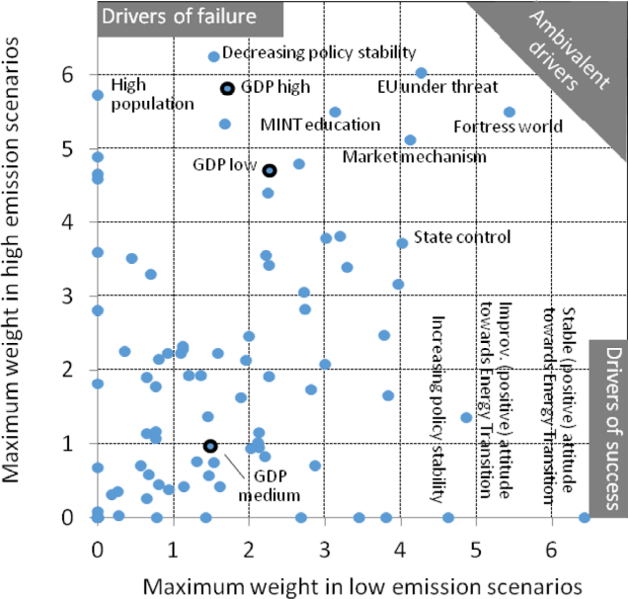
I | Considering the whole scenario set in e.g. a correspondence analysis revealed in C2 that the scenario space comprises a field between three poles of societal developments, which were interpreted as inertia, market and value shift (Pregger et al. 2020) | M | The dynamics behind a scenario, stored in the impact network, help to understand the calculations of an energy scenarios: “As the “Value Shift” scenario uses more geothermal power (with rather low efficiency), this also increases primary energy demand. The strong deployment of renewable energies is made possible by a strong acceptance of new technologies, a positive public attitude, high levels of political stability, and coordinated and multi-scale governance especially towards the use of wind power and photovoltaic installations and grid expansion. (Pregger et al. 2020)
J | Ambivalent descriptors: “For instance, further emphasizing the paradigm of market mechanisms as a political design model can play out in quite different ways for German society. Rather, in some scenarios, the main effect is the fostering of economic growth, efficiency, political leeway, and a satisfied and cooperative population. In other scenarios, main effects include social tensions, materialism, a consumption orientation, and public opinion shifting away from energy transition goals. It depends on the other features of a scenario which effects prevail.” (Pregger et al. 2020) | N | “In a world in which the market paradigm dominates on the global scale, Germany is among the countries that follow the principles of free markets and liberalization, encouraged in parts by a reinvigorating EU. The German government trusts, as a rule, in market mechanism (Figure 8), e.g. when reorganizing the electricity market. It follows market-liberal welfare principles, prefers technology-unspecific economic instruments in energy politics (where appropriate) and tolerates an education system with significant social access barriers.” (Pregger et al. 2020, Supplemental Material, Fig. 8)  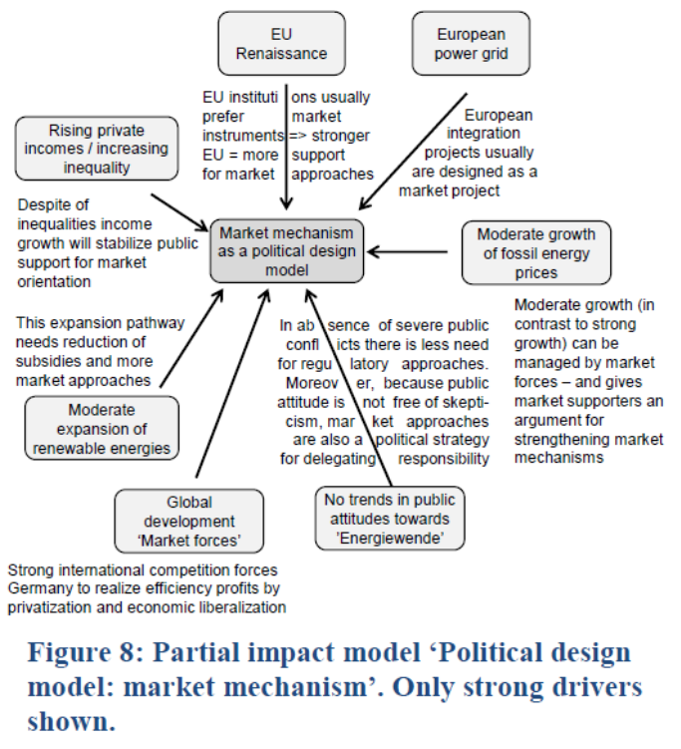

As there exists no official report on the results of C3 there are only examples listed from C1 and C2.

