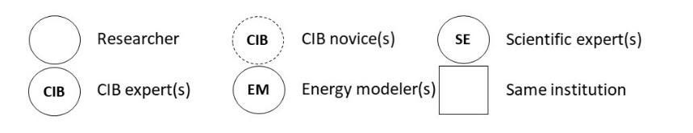
Table 1: Overview on case studies: objectives, researcher constellation, models, specific information concerning linking.
 | C1: Modeling potentials of technologies and concepts |  | C2: Integrated scenario building – national energy modeling |  | C3: Regional modeling
General objective(s) | analyze the future energy demands of private households |  | translate the motif of ‘socio-technical’ scenarios into the field of national energy transition scenarios |  | analyze the regional idiosyncrasies of the German energy transition at the level of the regional planning
Researcher constellation | 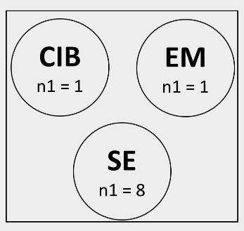 |  | 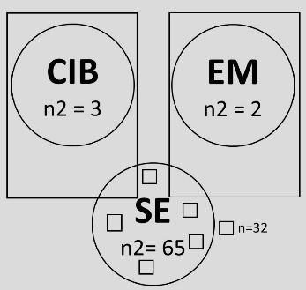 |  | 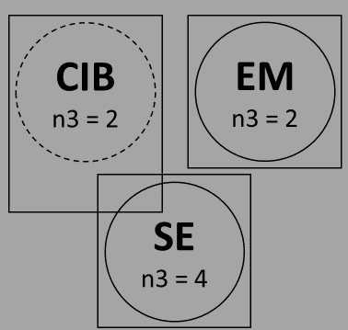
Researcher constellation | 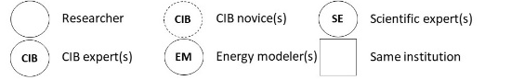
Spectrum of disciplines | - economists  - engineers  - political scientists |  | - economists  - engineers  - political scientists  - social scientists  - communication scientists  - physicists  - philosophers  - psychologists  - legal scientists  - natural scientists |  | - economists  - engineers  - CIB method experts  - philosophers
Applied model(s) | a technology-based simulation model focusing on the building sector (JEMS-BTS) |  | a technology-based national energy system model using the accounting framework Mesap/PlaNet |  | - economic input-output  - logit car ownership model  - mathematical optimization of electricity and heat supply  - life cycle assessment
Time horizon | 2030 |  | 2050 |  | 2030
Context scope | - international  - national  - sectoral |  | - international  - national |  | - national  - regional
CIB descriptors | - 8 direct linkable  - 16 soft linkable  - 18 indirect linkable |  | - 10 direct linkable  - 7 soft linkable  - 22 indirect linkable |  | - 5 direct linkable  - 3 soft linkable  - 1 indirect linkable
Consistent scenarios applied for linking | 4 scenarios |  | 4 scenarios |  | 1 scenario
Reference on case study |  | Vögele et al. (2017) |  | Pregger et al. 2020 |  | Weimer-Jehle et al. 2017, chapter 6.3 (no peer-reviewed article available)

Table 2: Process scheme of linking context scenarios with energy models in eleven steps.
Steps | Description
1. Definition of design of context scenario approach | Linking of the context scenarios with energy models needs to be conceptually developed by the project team. The objectives of the project can provide a basis for the elaboration of the specific designs.
2. Definition of context and descriptors | The process of context scenario construction begins with the definition of system elements. The questions of which level of context is adequate to represent the focused energy system (e.g., regional, national or international society) and through which descriptors this context can be represented best, are pursued in this step. The descriptors need to be identified and specified (defined) in more detail to assure that all participating actors use the same information as a basis for further analysis.
3. Definition of descriptor variants | Future uncertainty of all descriptors needs to be identified and specified (defined) in the form of at least two different future variants. The definition of variants maps the possible future space for each descriptor, defining alternatives as plausible extreme and, where appropriate, mean paths for each descriptor.
4. Quantification of descriptor variants | To enable the context scenarios to be a bridge to energy models, at least some qualitatively defined descriptors need a quantitative equivalent. The quantification of variant specifications can be realized as part of the context scenario construction or, later, during Step 9, as part of the energy modeling. Quantitative descriptors can take on threefold functions: they can function as parameters; they can be a basis for an indirect statement about parameters; or they have a rather indicative character and are therefore output-related.
5. Assessment of interdependencies between descriptors | Following the CIB methodology all descriptor variants are then assessed pairwise concerning their ability to influence the others in a promoting or a hindering way and to what extent (normally on a scale from -3 to 0 to +3). The assessments can be performed through expert statements as well as through literature review.
6. Handling of dissent | If the interdependencies between descriptor variants (Step 5) are assessed by a team (e.g., in a workshop) or by different independent experts (e.g., in interviews), a decision must be reached on how dissent is to be handled. It can be aimed at one common assessment (consent) or the parallel existence of different assessments (this trade-off and its effects are described in “Effects on interdisciplinary knowledge integration”).
7. Analysis of interdependencies | The CIB balance algorithm analyzes the pairwise assessments of promoting or hindering influences and creates consistent scenario configurations. Consistency is defined as a self-stabilizing network of future variants.
8. Context scenario selection | Step 7 can result in far more qualitative scenarios (depending on the number of descriptors and assessments between them) than can be analyzed in detail by the models. Therefore, a choice needs to be made. This selection can be implemented by internal methods provided by the CIB software or other methods, for example, as referenced in Section “Effects on interdisciplinary knowledge integration”.
9. Preparation of a set of framework assumptions | The set of quantified descriptors (Step 4) of a specific context scenario can be directly linked with energy models as framework assumptions (model parameter). Qualitative descriptor variants would need to be parameterized in this step as set of framework assumptions. Furthermore, some more descriptors can be interpreted and softly linked with the model through, for example, plausibility arguments. All other descriptors are indirectly linked through the impact network.  Additionally, it can become necessary for model structures or the set of applied models, to be adapted in order to reflect the context scenarios.
10. Calculation of energy scenarios | The framework assumptions from the context scenarios are used with the energy model and its respective energy scenarios are calculated. For this purpose, further parameters for the description of the techno-economic development paths must be defined on the side of the energy experts.
11. Integration of context and energy scenarios | A specific energy scenario (calculated with the input parameter given by a context scenario) is chosen and its hidden societal implications can be interpreted in a separate and joint product containing quantitative model results and quantitative impact diagrams.

Table 3: Detailed methodological designs of the three case studies.
Steps | C1 | C2 | C3
1. Definition of design of context scenario approach | - Discussion | - Discussion | - Discussion
2. Definition of context and descriptors | - Desk research  - Workshop  - Linking factors | - Desk research  - Interdisciplinary expert interviews  - Social theory  - Linking factors  - Expert rating | - Workshop / audio conferences  - Interview with CIB experts  - Linking factors
3. Definition of descriptor variants | - Desk research  - Workshop | - Desk research  - Interdisciplinary expert interviews | - Workshop / audio conferences
4. Quantification of descriptor variants | - Literature review | - Literature review  - Discussions between energy modelers and CIB experts | - Literature review  - Regression analysis
5. Assessment of interdependencies between descriptors | - In-house workshop | - Expert interviews | - Internal discussion between project members
6. Handling of dissent | - Finding consent in a workshop | - Written Delphi-style discussion  - Averaging the cross-impacts | - Finding consent in a workshop
7. Analysis of interdependencies | - CIB Balance Algorithm | - CIB Balance Algorithm | - CIB Balance Algorithm
8. Context scenario selection | - Discussions between energy modelers and CIB experts  - Interviews with 8 in-house experts  - Multi-Level-CIB-approach | - Discussions between energy modelers and CIB experts  - Correspondence analysis  - Scenario landscapes | - Discussions between non-CIB experts  - Linking 2 energy scenarios
9. Preparation of a set of framework assumptions | - Discussions between energy modelers and CIB experts  - Using plausibility arguments  - Parameterizing linking factors | - Literature reviews  - Using plausibility arguments  - Parameterizing linking factors | - Discussions within energy modelers  - Literature reviews  - Parameterizing linking factors  - Adding new model to model set
10. Calculation of energy scenarios | - Model runs | - Model runs | - Model runs
11. Integration of context and energy scenarios | NOT APPLIED | - Interpretation of cross-impact interrelations concerning a specific energy scenario | NOT APPLIED

Table 4: Forms of knowledge integration per process step per case study.
Steps | C1 | C2 | C3
1. Definition of design of context scenario approach in project | combining | combining | combining
2. Definition of context and descriptors | compiling | compiling | compiling
2. Definition of context and descriptors | combining | combining | combining
3. Definition of descriptor variants | compiling | compiling | compiling
3. Definition of descriptor variants | combining | combining | combining
4. Quantification of descriptor definitions | compiling | compiling | compiling
4. Quantification of descriptor definitions | -------------------- | combining | -----------------
5. Assessment of interdependencies between descriptors | combining | compiling | combining
6. Handling of dissent | combining | compiling  combining | combining
7. Analysis of interdependencies | synthesizing | synthesizing | synthesizing
8. Context scenario selection | synthesizing | synthesizing | combining
9. Preparation of a set of framework assumptions | combining | combining | combining
10. Calculation of energy scenarios | synthesizing | synthesizing | combining
11. Integration of context and energy scenarios | NOT APPLIED | synthesizing | NOT APPLIED

Full lists of descriptors can be found in the supplementary materials. All descriptors are characterized as directly, softly or indirectly linkable descriptors. The directly linkable descriptors were integrated in the analysis as such right from the outset. If the context descriptors are linkable to the model in a soft way (through plausibility arguments) or only indirectly (through the impact network) was decided in the phase of the energy scenario construction. Due to better clarity this differentiation is already presented here in the overview of the case studies.
To better visualize similarities and differences between designs, the quantification step in all three cases is considered as step 3 in the graphical presentations of this paper.
Application of Talcott Parsons system theory (structural functionalism)
The impact assessment was done by various experts. If significant differences arose between the assessments those were reflected to the experts. They got the chance to comment on the arguments of the other expert(s), change their own assessments according to the other expert(s), approximate in the direction of the others or keep their own assessments. Delphi as an expert method is described, for instance, by Martino 1993.
Due to the combination of three CIB matrices on different levels (sectoral, national, international) the approach how to combine those automatically reduces the amount of consistent scenarios and defines the selection process of scenarios (see more to Multi-level-CIB in Vögele et al. 2017).
According to geographical thematic maps, scenario landscapes were created in combination with correspondence analysis reflecting for example the positions of different variants of a descriptor on the 2 axes or the positions of societies (scenarios) including their emission assessment.
“Linking factors” are model requirements to be considered within the context scenarios to make them linkable to the models. Examples are GDP development, tertiarisation of the economy, international integration of electricity grids, development of infrastructures in power transmission and distribution, etc. depending on the specific model.

