Additional files

Additional Table 1. Association of MetS components with breast cancer-specific mortality across BMI categories
 | Breast Cancer Specific mortality
Variables | BMI<25 |  |  | BMI 25-29 |  |  | BMI≥30
Blood Pressure | N | HR* (CI 95%) | p-value | N | HR* (CI 95%) | p-value | N | HR* (CI 95%) | p-value
<130/<85mmHg | 25/162 | 1 |  | 19/100 | 1 |  | 13/67 | 1
≥130/≥85mmHg | 7/73 | 0.45 (0.18-1.12) | 0.087 | 13/98 | 0.79 (0.35-1.81) | 0.583 | 38/92 | 2.4 (1.17-4.95) | 0.017
HDL
≥50mg/dL | 22/143 | 1 |  | 14/119 | 1 |  | 26/80 | 1
<50mg/dL | 8/31 | 1.92 (0.82-4.46) | 0.132 | 11/32 | 2.4 (0.97-5.93) | 0.059 | 9/42 | 0.51 (0.21-1.21) | 0.127
Triglycerides
<150mg/dL | 24/236 | 1 |  | 21/177 | 1 |  | 29/137 | 1
≥150mg/dL | 10/13 | 5.43 (2.29-12.89) | < 0.001 | 11/28 | 2.95 (1.2-7.26) | 0.018 | 19/35 | 2.36 (1.25-4.45) | 0.008
Fasting Glucose
<110mg/dL | 27/240 | 1 |  | 31/182 | 1 |  | 29/138 | 1
≥110mg/dL | 7/14 | 1.96 (0.72-5.3) | 0.187 | 5/34 | 0.98 (0.33-2.93) | 0.975 | 22/41 | 2.48 (1.36-4.53) | 0.003
Waist Circumference
≤88 cm | 29/252 | 1 |  | 9/91 | 1 |  | 2/4 | 1
>88 cm | 6/21 | 2.71 (1.08-6.84) | 0.034 | 25/150 | 1.79 (0.77-4.16) | 0.174 | 52/183 | 0.9 (0.2-4.05) | 0.887
*HR adjusted by terms of: age (≤40, 41-60, >60), center (Pascale, Policlinico), Stage (I-IIA, IIB, IIIA-IIIC).

Additional Figure 1. Overall and breast cancer-specific survival curves
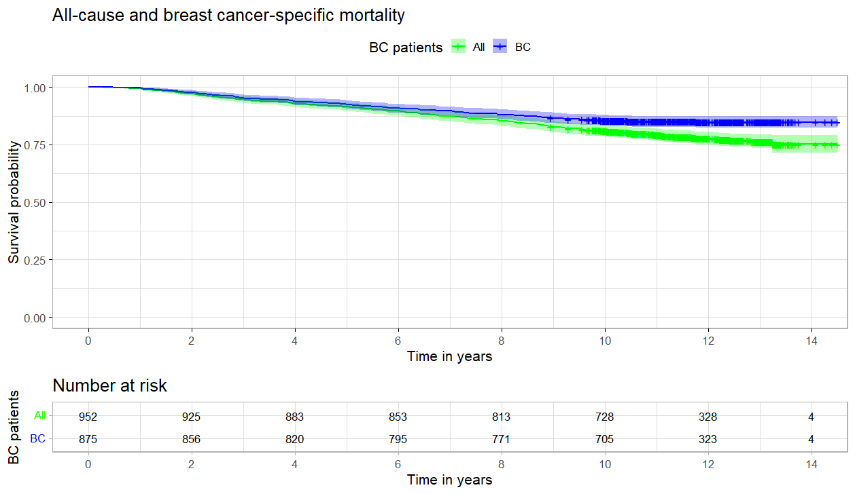

Additional Figure 2. All-cause and breast cancer-specific survival by body mass index (BMI), waist circumference (WC), waist to hip ratio (WHR), metabolic syndrome (MetS) and molecular subtypes.

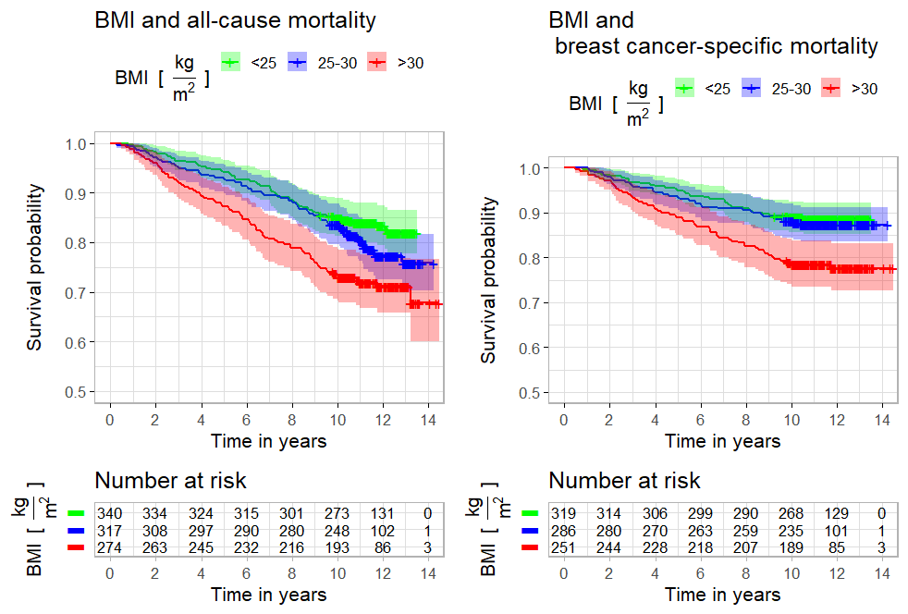

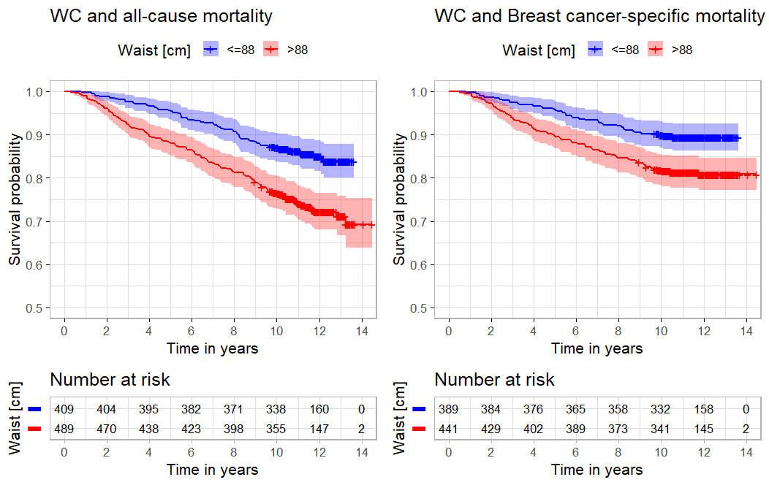

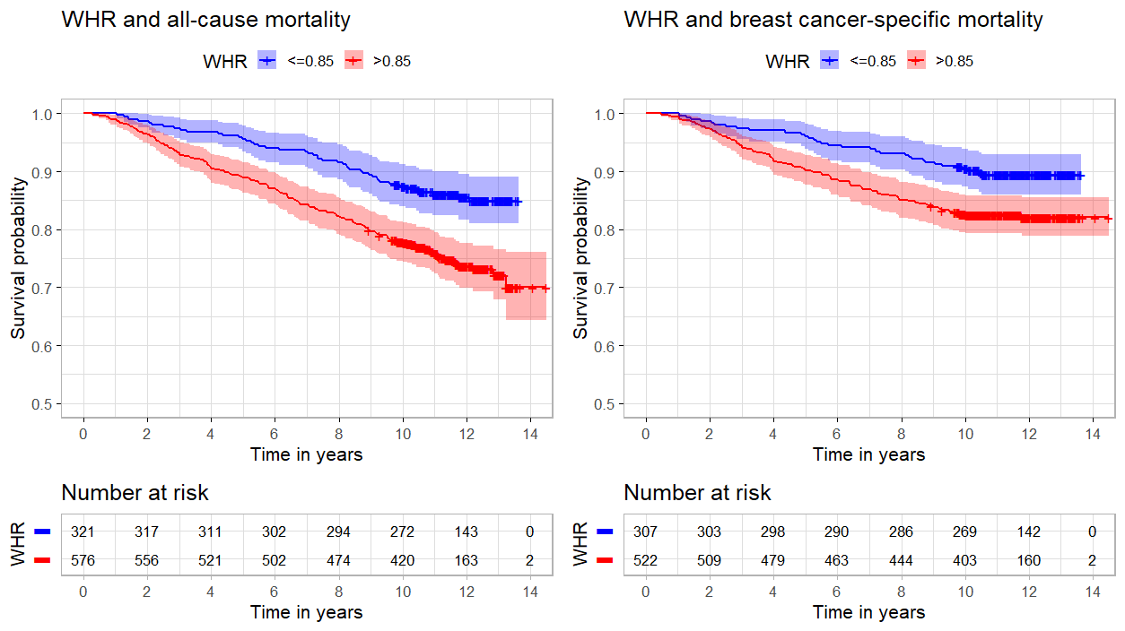

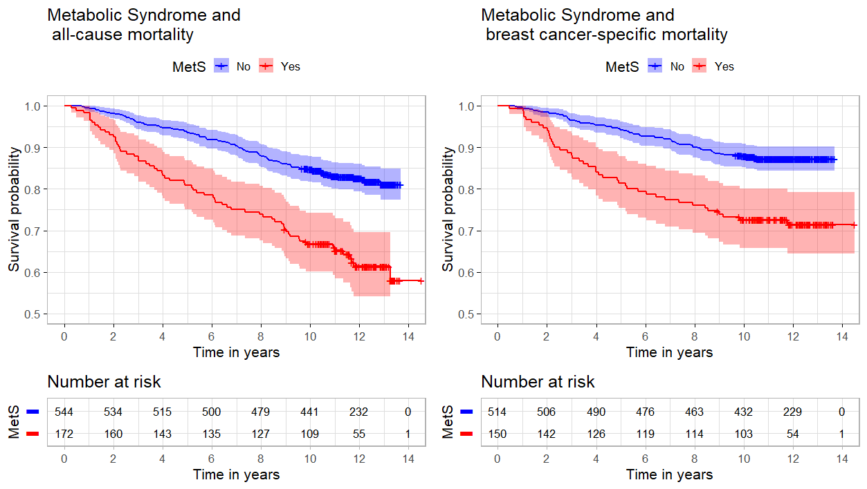

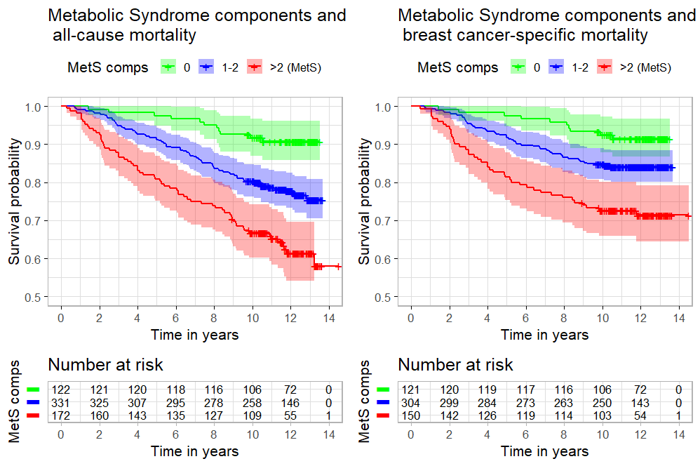

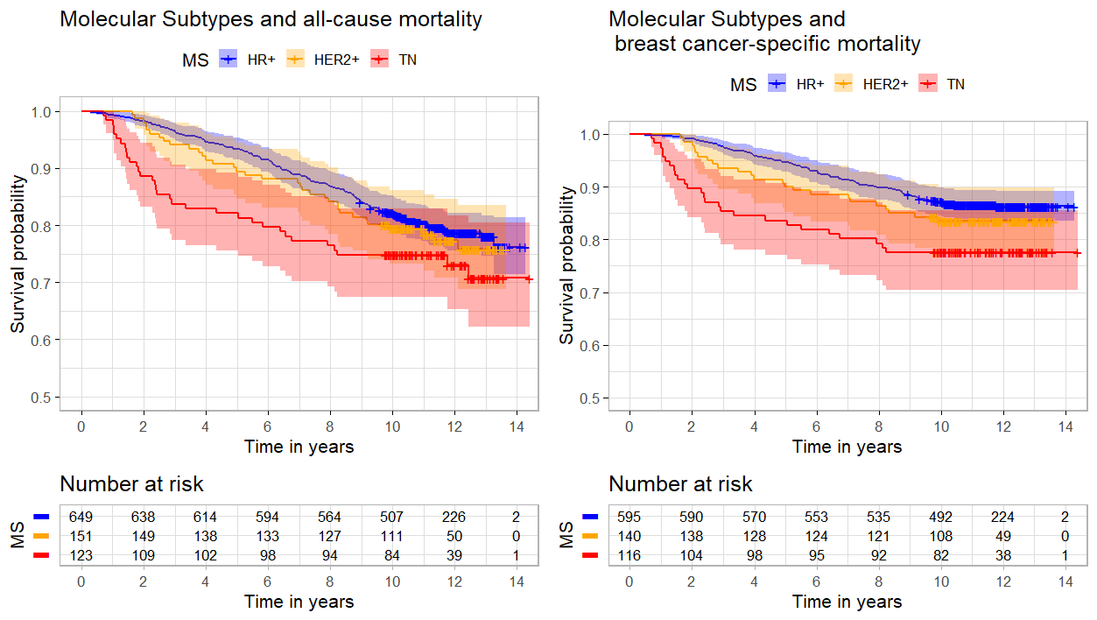

Additional Figure 3. Associations of adiposity across BMI categories in conjunction with Metabolic Syndrome (MetS) on BC-specific mortality
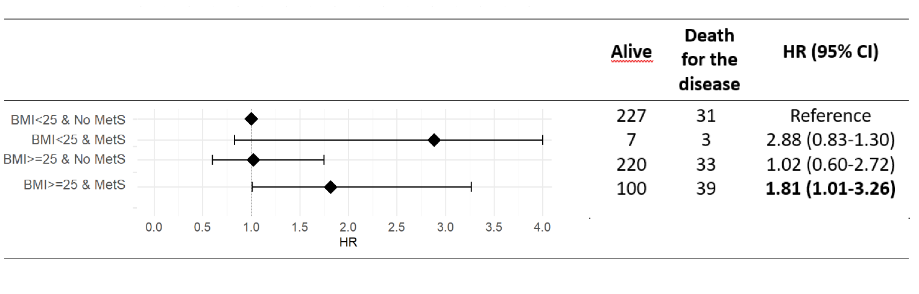
Abbreviations: HR, hazard ratio; BMI, Body Mass Index (BMI is calculated as weight in kilograms divided by height in meters squared); MetS, Metabolic Syndrome (defined according to NCEP-ATP III criteria).

