Supplementary

Supplementary Figure 1 – Population diagram

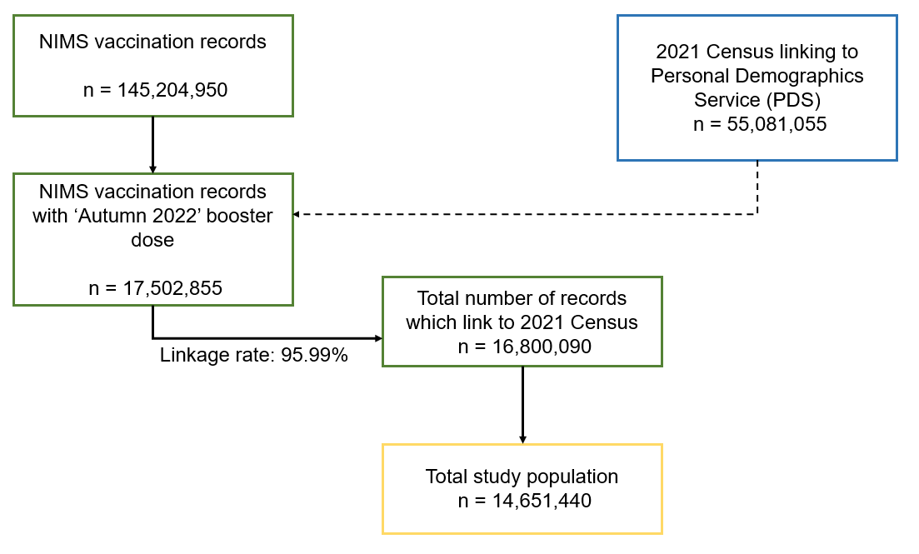

Supplementary Table 1 – Population sample flow
Stage | Total population
Total 2021 Census linking to Personal Demographics Service (PDS) | 55,081,055
Total number of NIMS records | 145,204,950
Total number of NIMS records with autumn 2022 dose | 17,502,855
Total number of NIMS records with autumn 2022 dose which link to 2021 Census | 16,800,090
Total population who were usual residents at time of 2021 Census | 16,777,280
Total population aged 50 to 100 years of age on vaccination date and alive on 1 September 2022 | 14,657,455
Total people with positive time at risk (time between 14 days after vaccination and the earliest of end of study (11 April 2023) date or date of death) | 14,651,440

Supplementary Table 2 – Z-statistics estimates for health predictors from bootstrapped estimates
Category | Z-statistic
Asthma | 1.32
Atrial Fibrillation | -0.32
Cancer of Blood or Bone Marrow | 5.96
Chronic Kidney Disease | 3.06
Congenital Heart Problem | -0.93
Chronic obstructive pulmonary disease (COPD) | 0.54
Coronary Heart Disease | 1.07
Cystic fibrosis * | 3.47
Dementia | -7.15
Diabetes: Type 1 | 0.03
Diabetes: Type 2 | -1.02
Epilepsy | -0.69
Heart Failure | 0.79
Immunosuppressed | 1.26
Learning Disability or Down Syndrome | 1.15
Prescribed leukotriene | 0.98
Liver Cirrhosis | -1.86
Lung or Oral Cancer | -0.04
Motor neurone disease /Multiple sclerosis/Myasthenia/Huntington’s/Chorea | 0.23
Parkinson’s Disease | 0.36
Peripheral Vascular Disease | -1.58
Prior Fracture *** | -1.16
Pulmonary Hypertension or Fibrosis | 2.45
Rheumatoid Arthritis or Systemic lupus erythematosus (SLE) | 2.77
Schizophrenia | 0.13
Severe mental illness | 0.21
Stroke ** | -0.07
Thrombosis or pulmonary embolus | 0.34

* - Cystic fibrosis, bronchiectasis or alveolitis, ** - Stroke or transient ischaemic attack (TIA), *** - Prior fracture of hip, wrist, spine, or humerus

Supplementary Table 3 – Health conditions associated with COVID-19 and non-COVID-19 death from model estimates not adjusted for all other health conditions
Category | HR for COVID-19 death (95% CI) | HR for non-COVID-19 death (95% CI)
Asthma | 1.21 (1.1 - 1.33) | 1.07 (1.05 - 1.09)
Atrial Fibrillation | 1.6 (1.5 - 1.71) | 1.58 (1.56 - 1.6)
Cancer of Blood or Bone Marrow | 3.58 (3.14 - 4.07) | 1.9 (1.83 - 1.97)
Chronic Kidney Disease | 1.55 (1.46 - 1.65) | 1.38 (1.36 - 1.4)
Congenital Heart Problem | 1.37 (0.78 - 2.41) | 1.59 (1.43 - 1.78)
Chronic obstructive pulmonary disease (COPD) | 2.51 (2.35 - 2.69) | 2.3 (2.27 - 2.34)
Coronary Heart Disease | 1.43 (1.32 - 1.53) | 1.33 (1.31 - 1.35)
Cystic fibrosis * | 2.5 (2.17 - 2.88) | 1.65 (1.59 - 1.72)
Dementia | 2.83 (2.63 - 3.04) | 3.66 (3.61 - 3.71)
Diabetes: Type 1 | 1.66 (1.48 - 1.85) | 1.68 (1.65 - 1.72)
Diabetes: Type 2 | 1.46 (1.37 - 1.55) | 1.51 (1.49 - 1.53)
Epilepsy | 1.81 (1.41 - 2.33) | 2.05 (1.95 - 2.15)
Heart Failure | 2.34 (2.18 - 2.52) | 2.19 (2.15 - 2.23)
Immunosuppressed | 2.62 (2.34 - 2.93) | 1.88 (1.83 - 1.93)
Learning Disability or Down Syndrome | 5.49 (4 - 7.53) | 4.72 (4.42 - 5.04)
Prescribed leukotriene | 1.79 (1.69 - 1.89) | 1.61 (1.59 - 1.63)
Liver Cirrhosis | 3.52 (2.6 - 4.77) | 4.48 (4.23 - 4.73)
Lung or Oral Cancer | 3.82 (3.03 - 4.8) | 3.66 (3.48 - 3.84)
Motor neurone disease /Multiple sclerosis/Myasthenia/Huntington’s/Chorea | 3.44 (2.14 - 5.54) | 3.15 (2.84 - 3.5)
Parkinson’s Disease | 3.08 (2.64 - 3.59) | 3.18 (3.08 - 3.29)
Peripheral Vascular Disease | 1.85 (1.61 - 2.13) | 2 (1.94 - 2.06)
Prior Fracture *** | 1.37 (0.95 - 1.97) | 1.62 (1.51 - 1.74)
Pulmonary Hypertension or Fibrosis | 4.09 (3.46 - 4.83) | 2.9 (2.78 - 3.03)
Rheumatoid Arthritis or Systemic lupus erythematosus (SLE) | 2.26 (1.95 - 2.62) | 1.52 (1.47 - 1.58)
Schizophrenia | 2.5 (1.89 - 3.31) | 2.45 (2.31 - 2.6)
Severe mental illness | 1.67 (1.52 - 1.83) | 1.66 (1.63 - 1.69)
Stroke ** | 1.56 (1.43 - 1.7) | 1.6 (1.58 - 1.63)
Thrombosis or pulmonary embolus | 2.53 (0.82 - 7.85) | 1.97 (1.49 - 2.59)

* - Cystic fibrosis, bronchiectasis or alveolitis, ** - Stroke or transient ischaemic attack (TIA), *** - Prior fracture of hip, wrist, spine, or humerus

