Association between hyperthyroidism, subacute thyroiditis and twenty common cancers: A bidirectional mendelian randomization study

Supplemental Figure.1~24

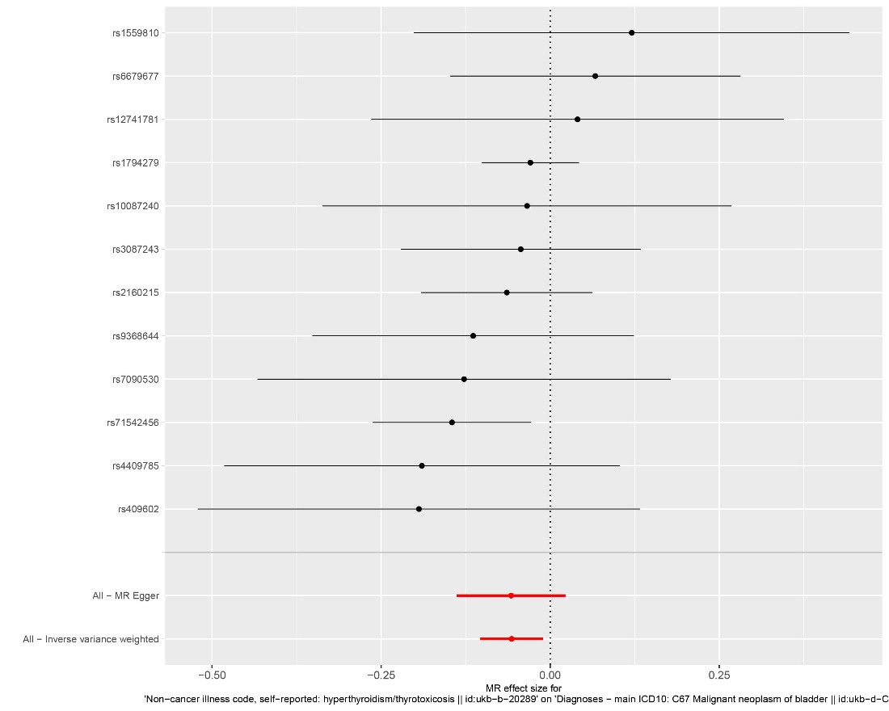
Supplemental Figure.1 Forest plot of the causal effect of hyperthyroidism on bladder cancer.

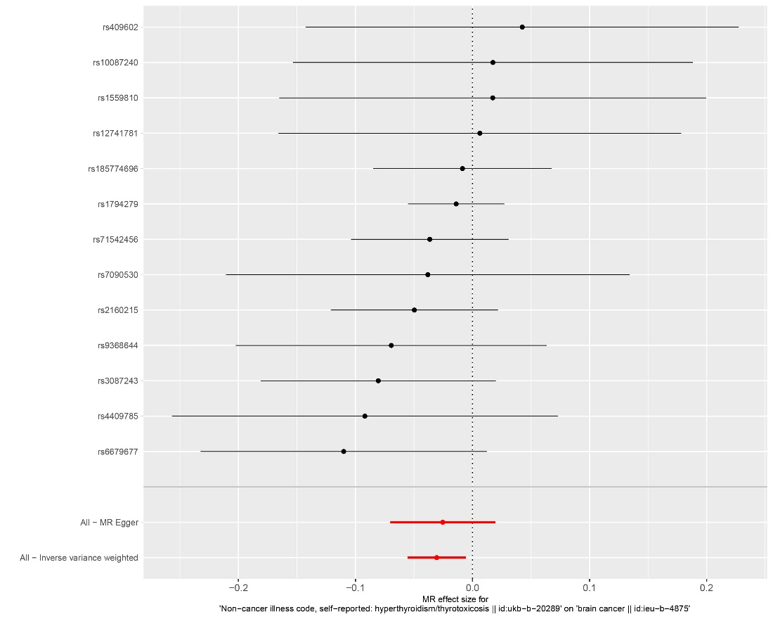
Supplemental Figure.2 Forest plot of the causal effect of hyperthyroidism on brain cancer.

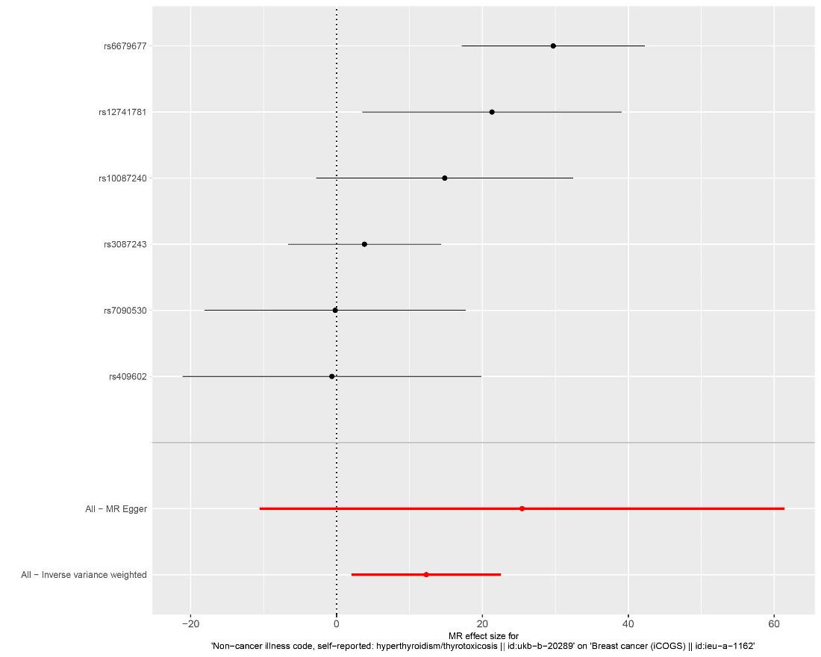
Supplemental Figure.3 Forest plot of the causal effect of hyperthyroidism on breast cancer.

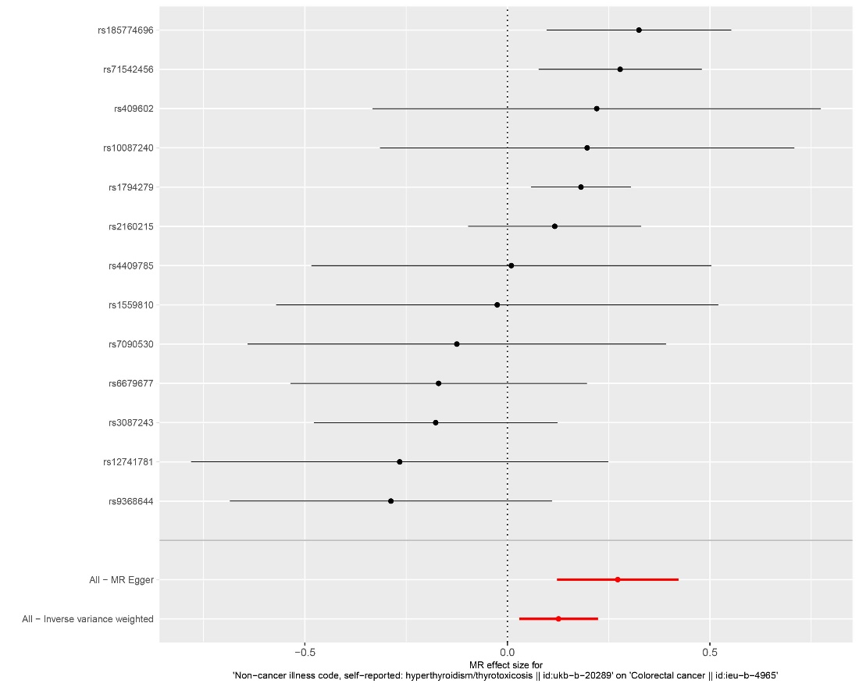
Supplemental Figure.4 Forest plot of the causal effect of hyperthyroidism on colorectal cancer.

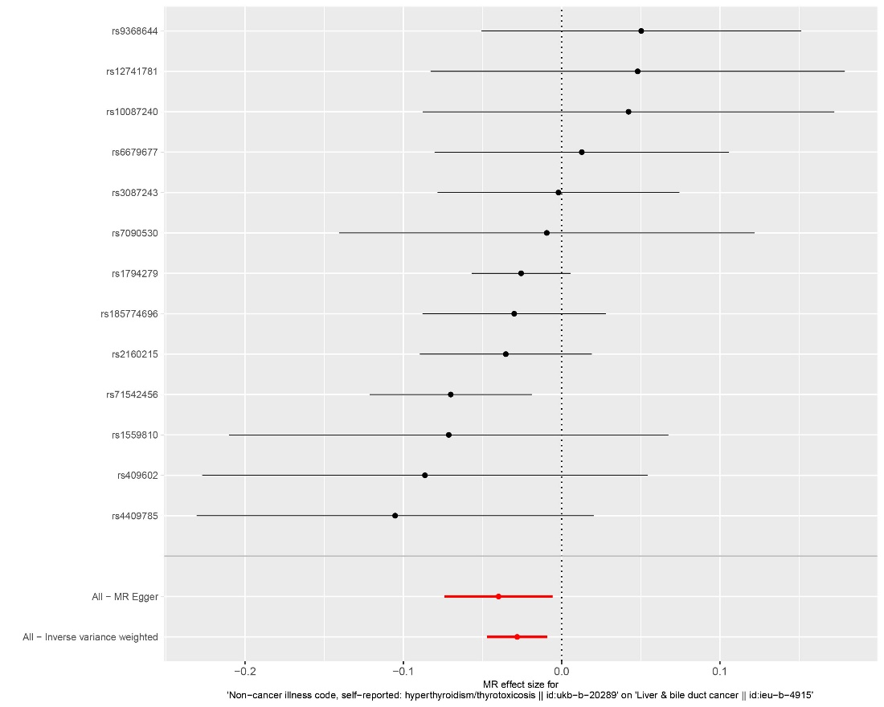
Supplemental Figure.5 Forest plot of the causal effect of hyperthyroidism on liver and bile duct cancer.

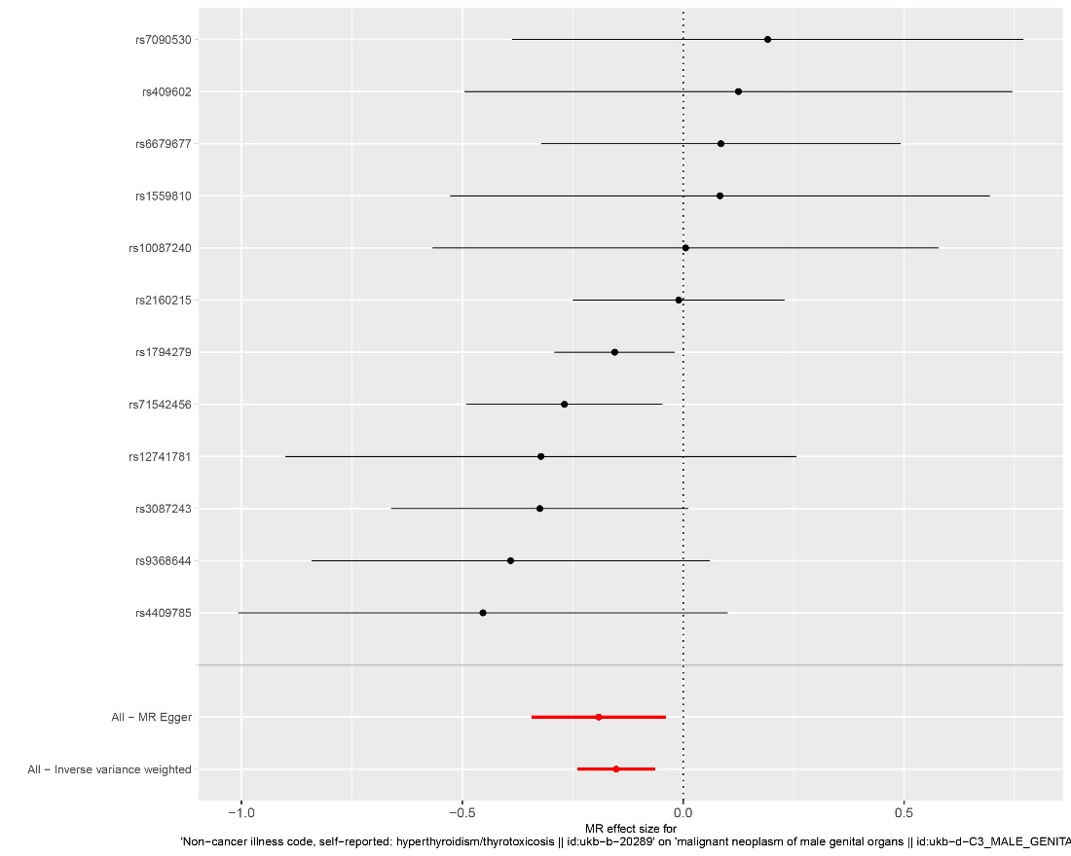
Supplemental Figure.6 Forest plot of the causal effect of hyperthyroidism on malignant neoplasm of male genital organs.

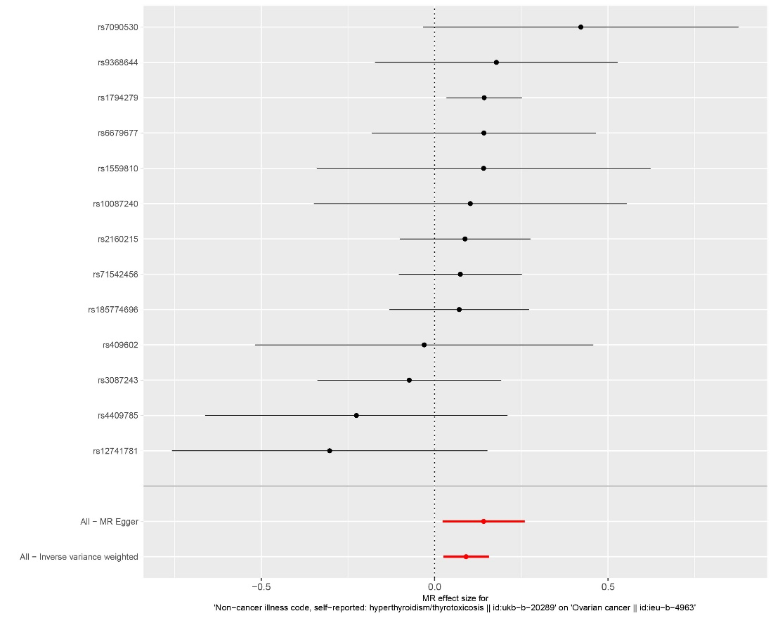
Supplemental Figure.7 Forest plot of the causal effect of hyperthyroidism on ovarian cancer.

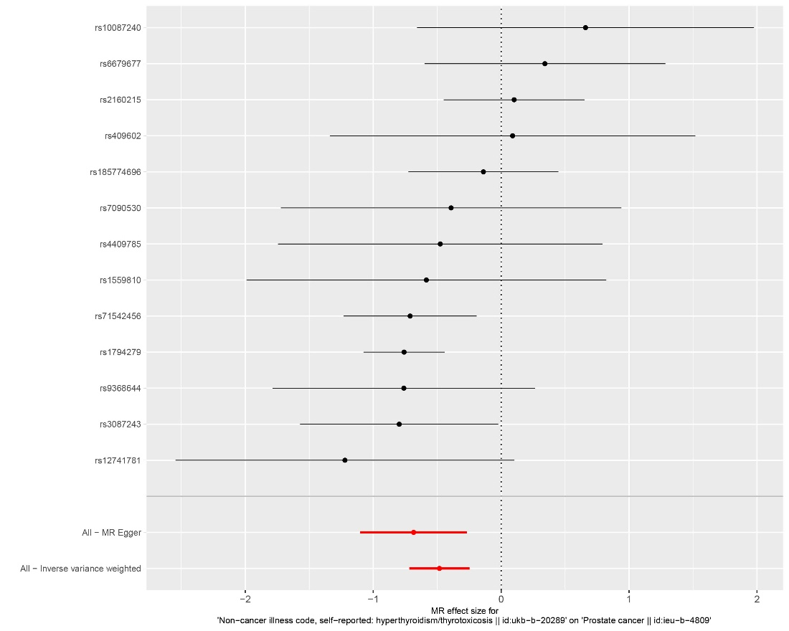
Supplemental Figure.8 Forest plot of the causal effect of hyperthyroidism on prostate cancer.

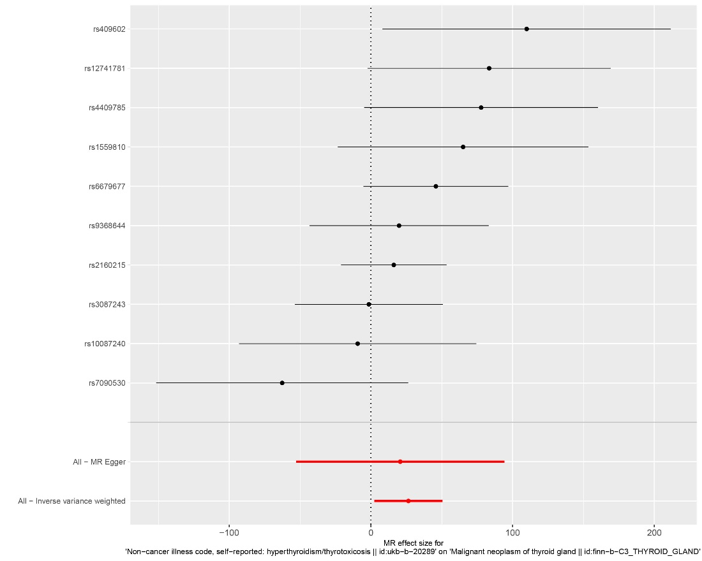
Supplemental Figure.9 Forest plot of the causal effect of hyperthyroidism on thyroid cancer.

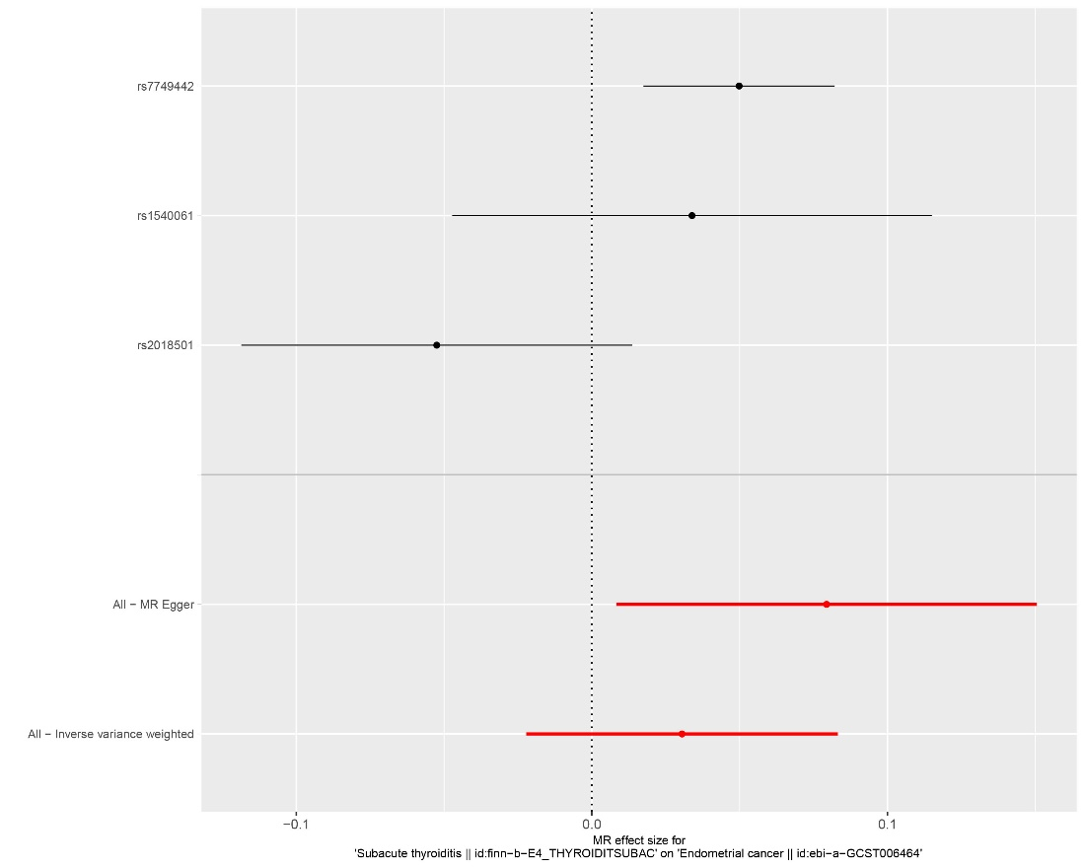
Supplemental Figure.10 Forest plot of the causal effect of subacute thyroiditis on endometrial cancer.

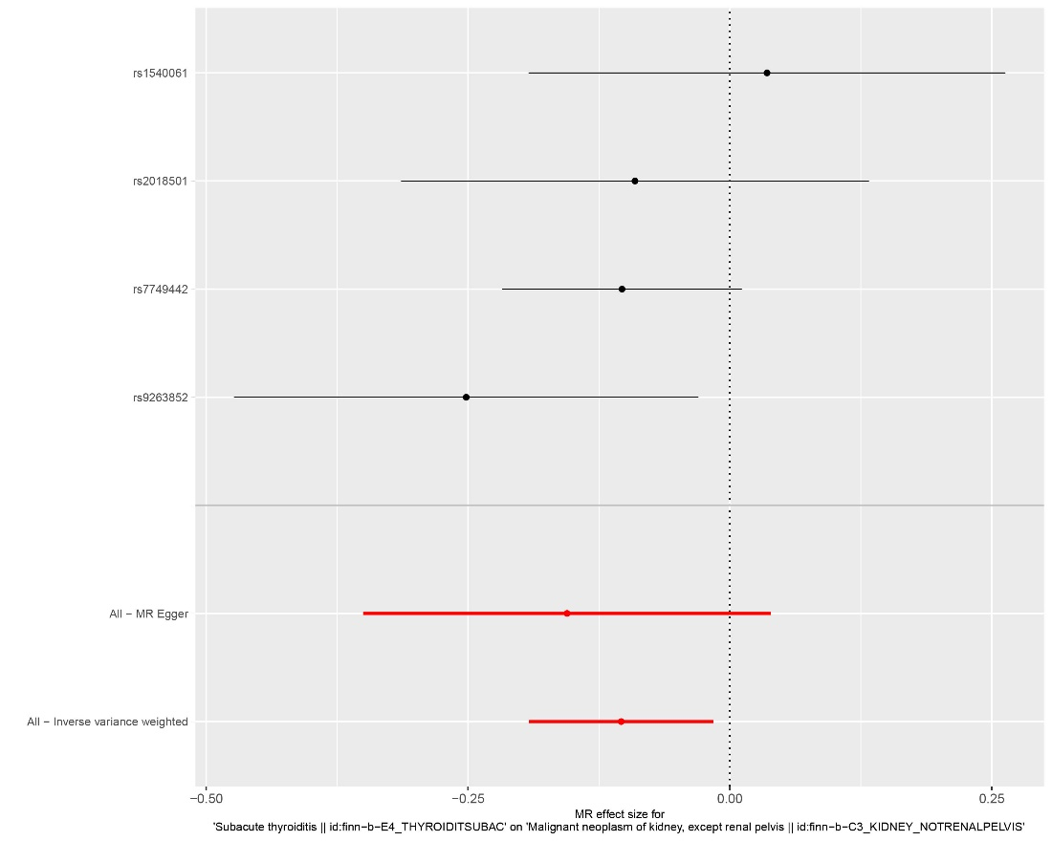
Supplemental Figure.11 Forest plot of the causal effect of subacute thyroiditis on kidney cancer.

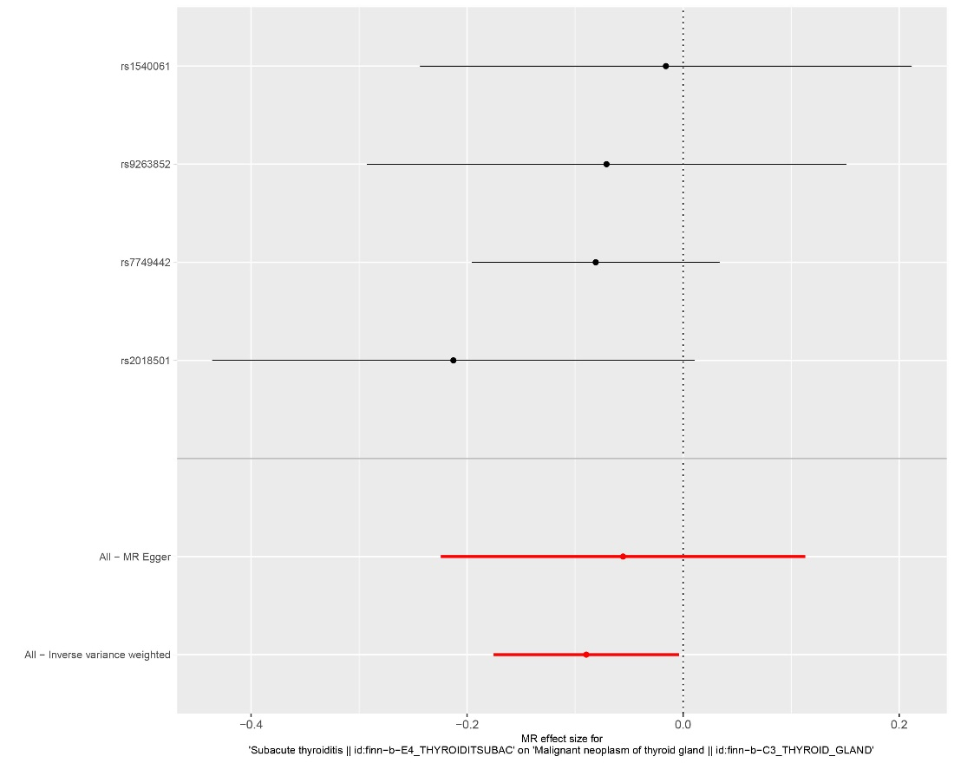
Supplemental Figure.12 Forest plot of the causal effect of subacute thyroiditis on thyroid cancer.

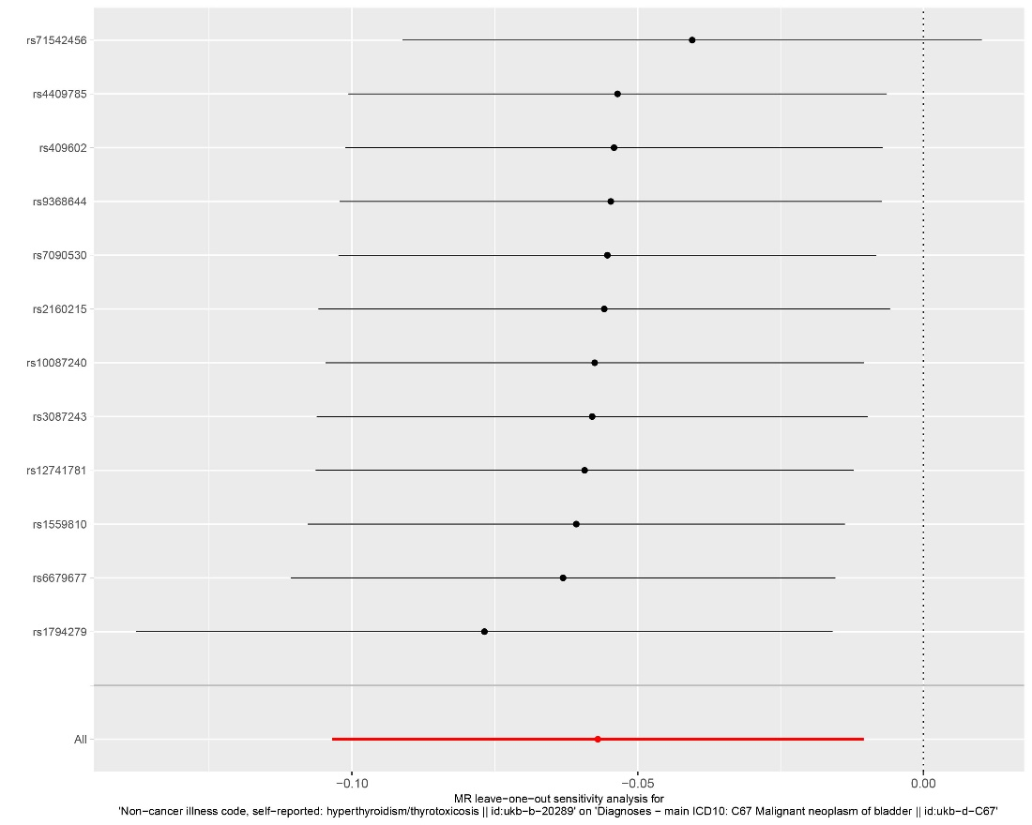
Supplemental Figure.13 Leave-one-out analysis of hyperthyroidism on bladder cancer.

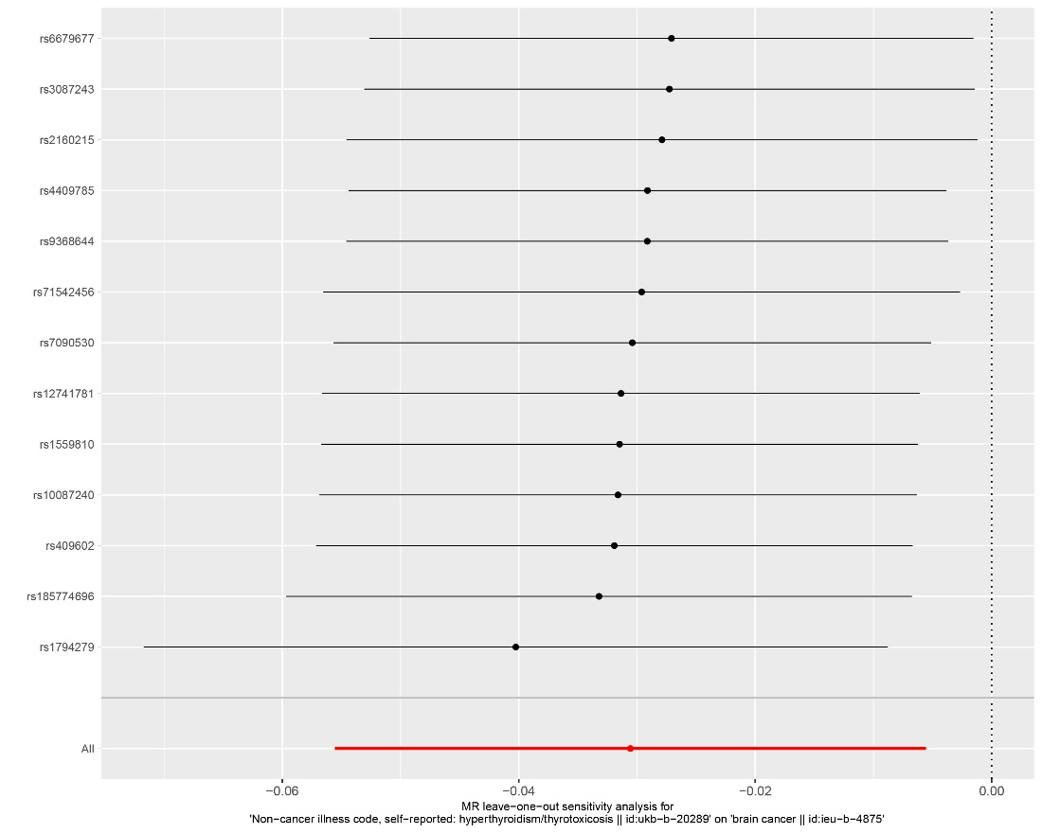
Supplemental Figure.14 Leave-one-out analysis of hyperthyroidism on brain cancer.

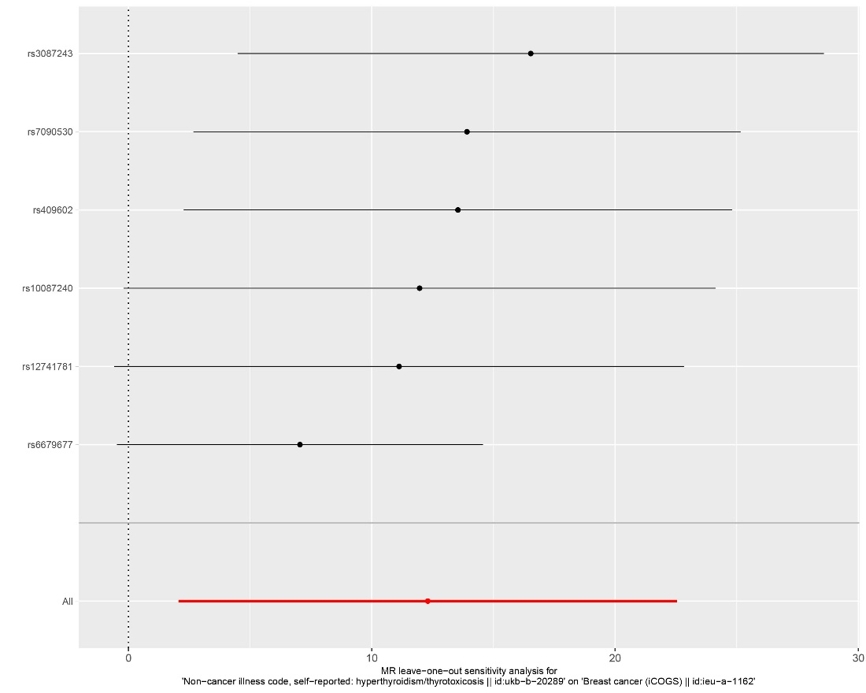
Supplemental Figure.15 Leave-one-out analysis of hyperthyroidism on breast cancer.

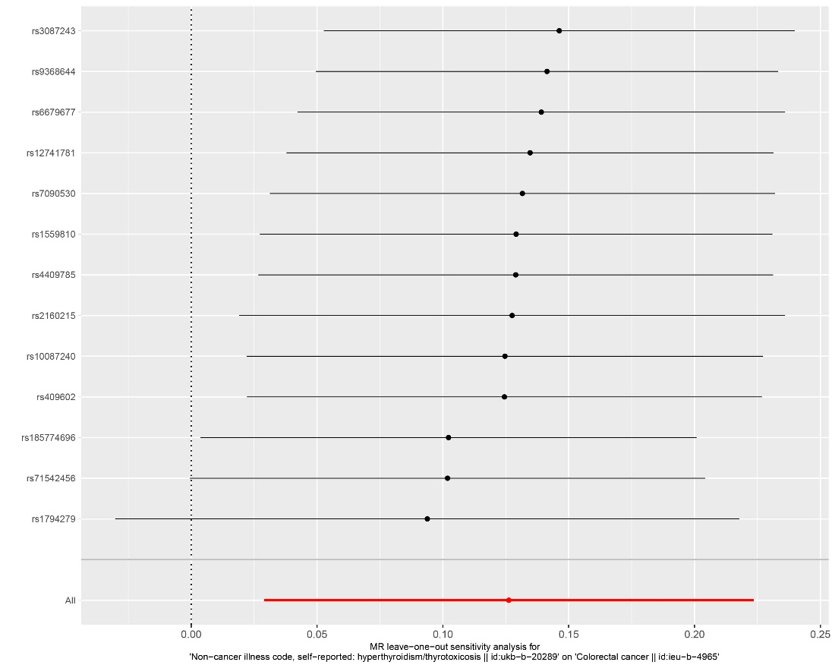
Supplemental Figure.16 Leave-one-out analysis of hyperthyroidism on colorectal cancer.

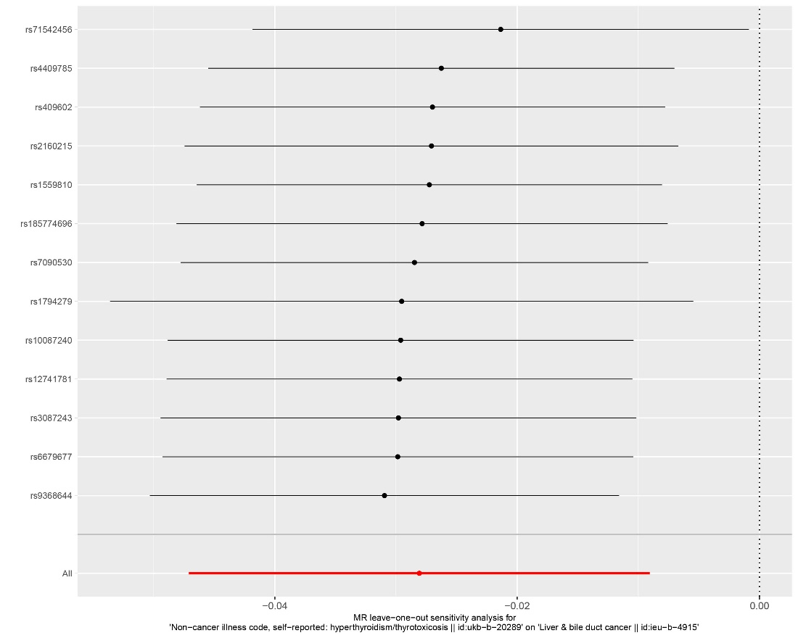
Supplemental Figure.17 Leave-one-out analysis of hyperthyroidism on liver and bile duct cancer.

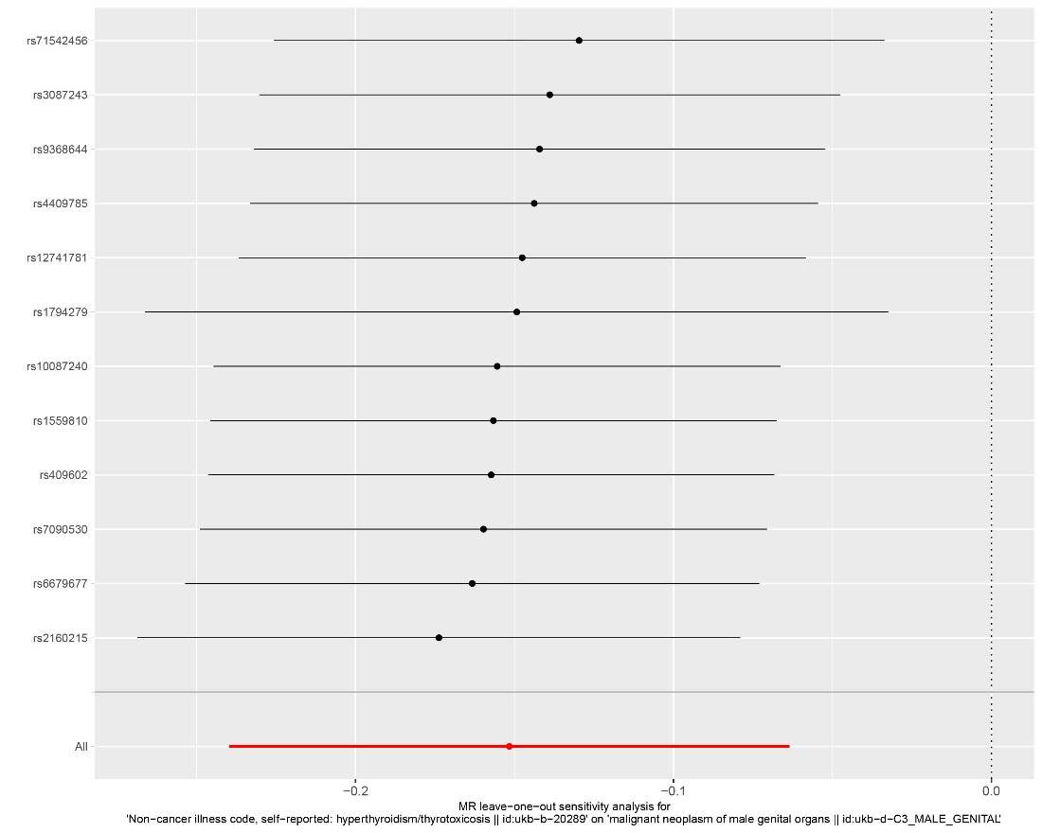
Supplemental Figure.18 Leave-one-out analysis of hyperthyroidism on malignant neoplasm of male genital organs.

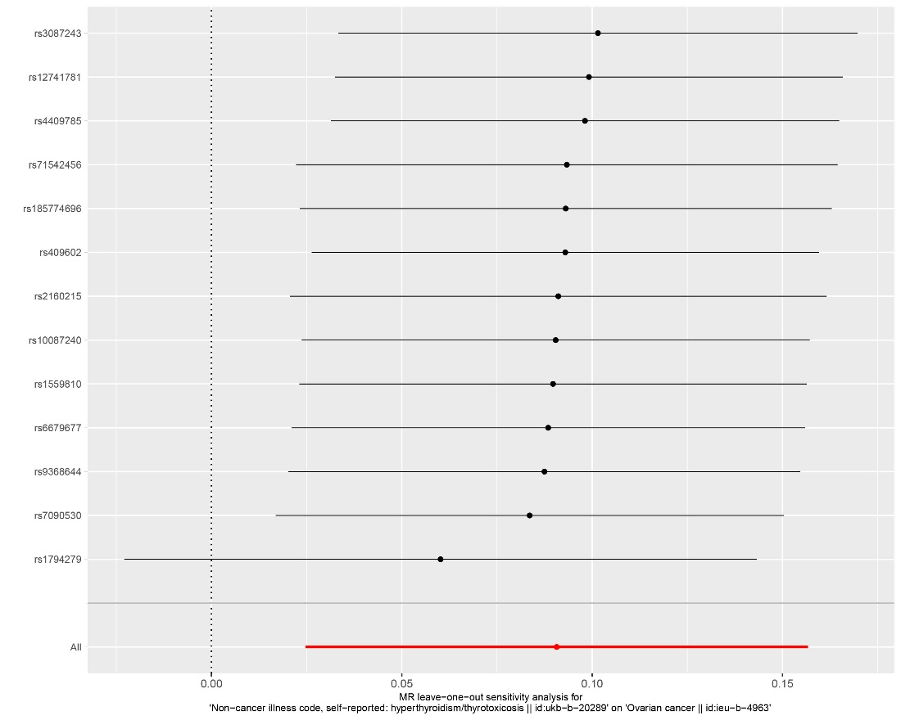
Supplemental Figure.19 Leave-one-out analysis of hyperthyroidism on ovarian cancer.

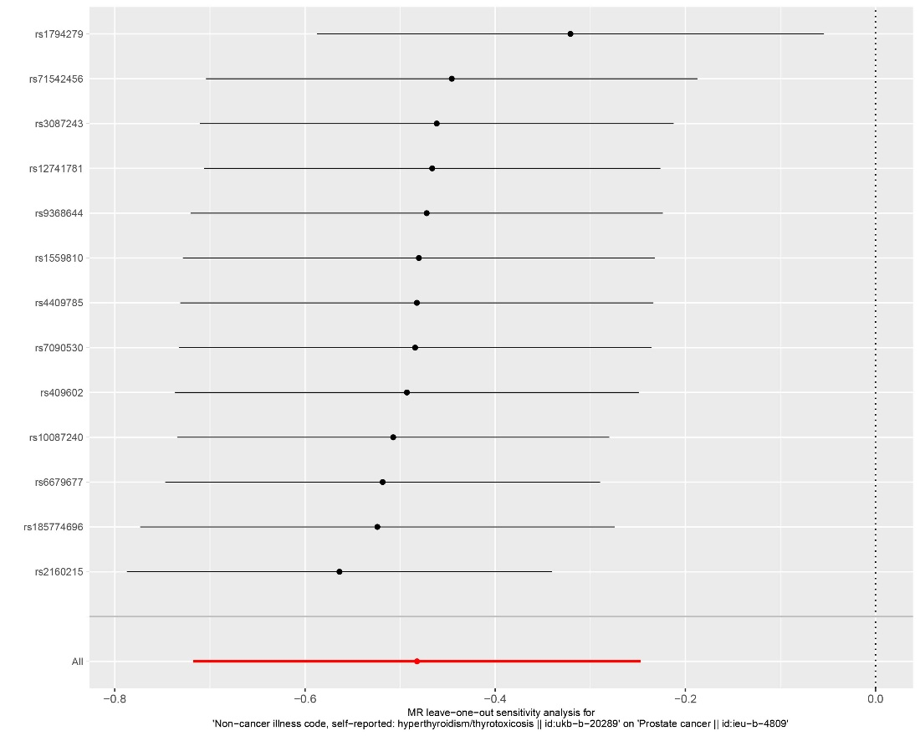
Supplemental Figure.20 Leave-one-out analysis of hyperthyroidism on prostate cancer.

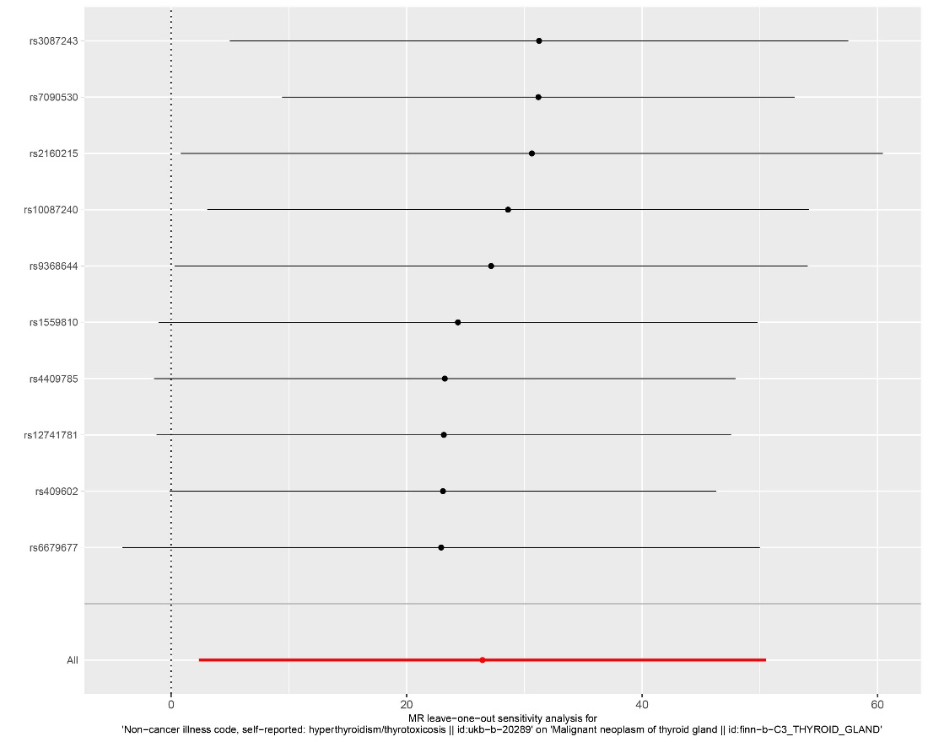
Supplemental Figure.21 Leave-one-out analysis of hyperthyroidism on thyroid cancer.

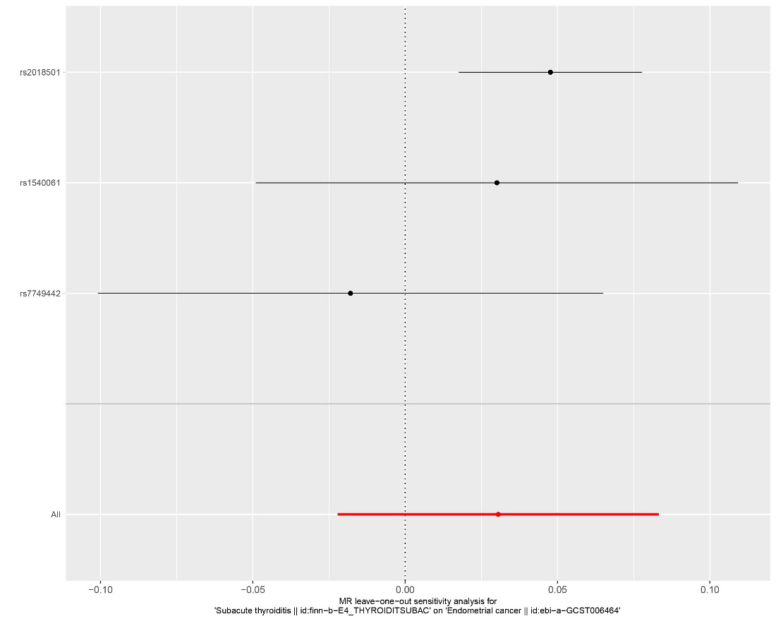
Supplemental Figure.22 Leave-one-out analysis of subacute thyroiditis on endometrial cancer.

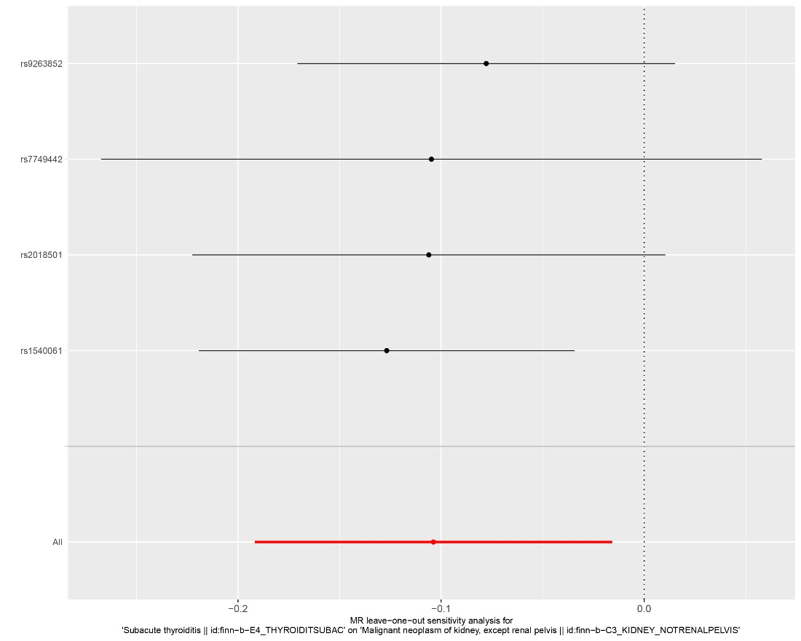
Supplemental Figure.23 Leave-one-out analysis of subacute thyroiditis on kidney cancer.

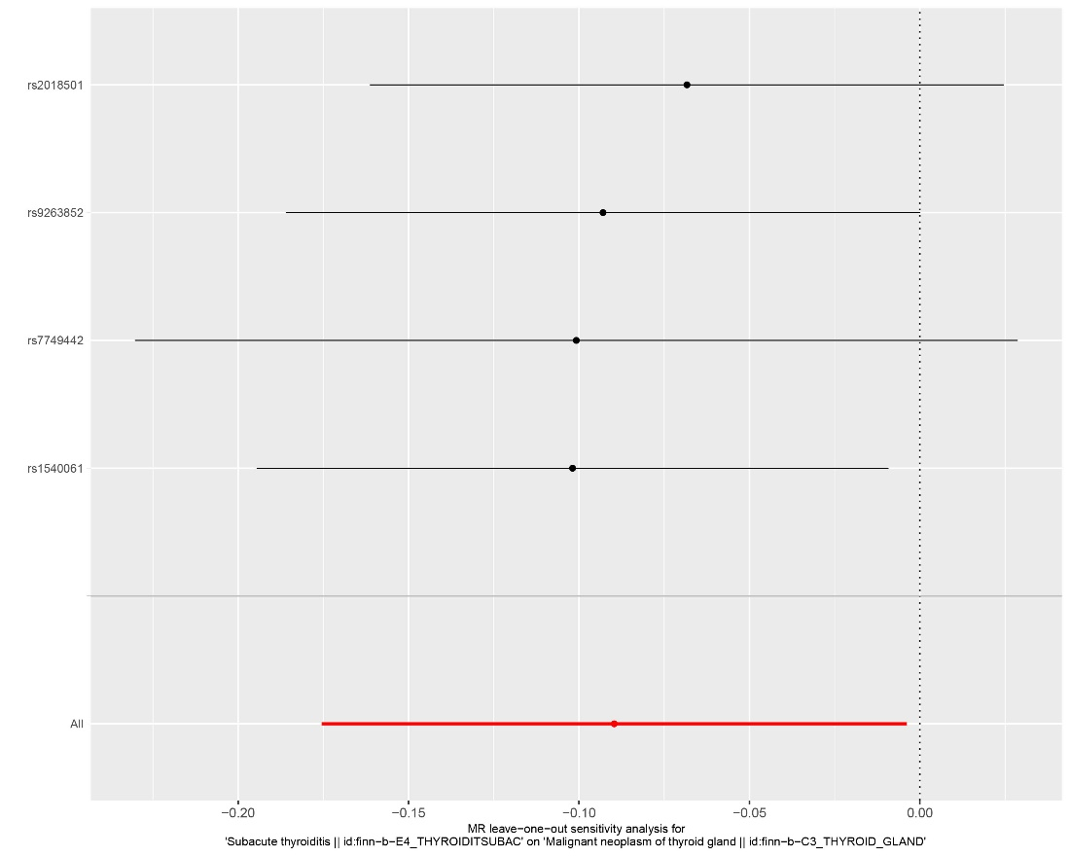
Supplemental Figure.24 Leave-one-out analysis of subacute thyroiditis on thyroid cancer.

