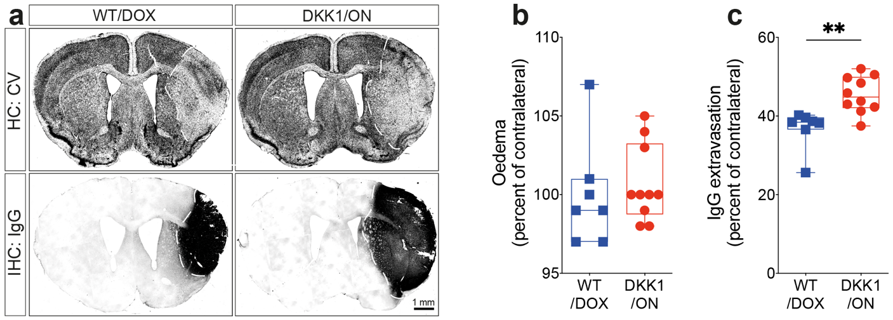
Extended data Fig. 1. Early induction of DKK1 aggravates structural damage after stroke. a, Representative images of cresyl violet histology showing the lesion surrounded by white dashed lines and immunohistology showing IgG extravasation surrounded by white dashed lines in the brain of WT/DOX and DKK1/ON mice 1 week after MCAo (ischemic stroke onset). b, Analysis of brain oedema size (percent of contralateral) WT/DOX and DKK1/ON mice 1 week after stroke. c, Analysis of IgG extravasation (precent of contralateral) in WT/DOX and DKK1/ON mice 1 week after stroke. For graphs, data are boxplot with min/max. Data are boxplot with min/max (center line = median, box limits = 25th to 75th percentiles, whiskers = min/max values, and symbols = individual mice). For the experiments (n=7-10 animals/group). **P<0.01 DKK1/ON compared to WT/DOX mice (c, Mann-Whitney test).

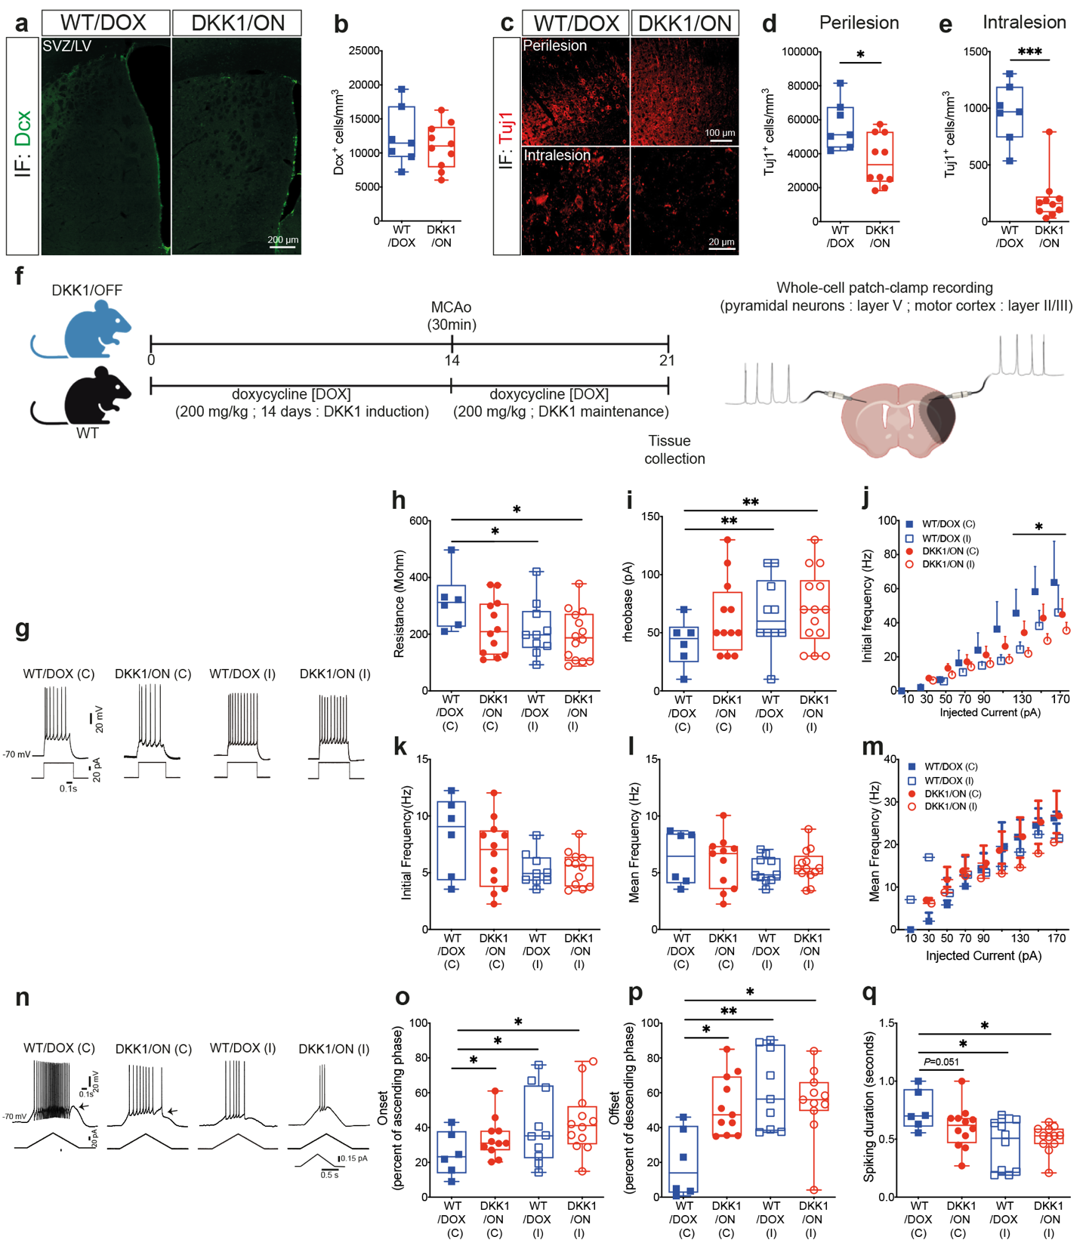
Extended data Fig. 2. DKK1 induction prior to stroke impairs neuronal differentiation and neuronal activity. a, Representative fluorescence images of Dcx-immunolabeled NPCs in the SVZ/LV of the ipsilateral hemisphere of WT/DOX and DKK1/ON mice 1 week after MCAo (ischemic stroke onset) (doxycycline, 200 mg/kg for 14 days). b, Stereological analysis of the density of Dcx⁺ cells in the SVZ/LV ipsilateral hemisphere. c, Representative fluorescence images of Tuj1-immunolabeled immature neurons in the perilesional and intralesional regions in WT/DOX and DKK1/ON mice 1 week after stroke. d, Stereological analysis of the density of Tuj1⁺ cells in the perilesional region 1 week after stroke. e, Stereological analysis of the density of Tuj1⁺ cells in the intralesional region 1 week after stroke. f, A schematic illustration of the experimental design of DKK1 induction using doxycycline (200 mg/kg for 14 days) prior to subjecting mice to ischemic stroke using MCAo (DKK1/OFF: DKK1 inducible mice without doxycycline; WT/DOX: WT mice with doxycycline; DKK1/ON: DKK1 inducible mice with doxycycline), as well as the experimental design related to neuronal electrophysiological activity. g, Examples of firing patterns of intact and injured neurons in the brain of WT/DOX and DKK1/ON mice in response to steady-state depolarization at 70 pA 1 week after stroke. h, Analysis of the input resistance of neurons 1 week after stroke. i, Analysis of the rheobase of neurons 1 week after stroke. j, Analysis of the initial firing frequency of neurons 1 week after stroke. k, Analysis of the initial frequency in contralateral and ipsilateral neurons in WT/DOX and DKK1/ON mice 1 week after MCAo (ischemic stroke onset). l, Analysis of the mean frequency in contralateral and ipsilateral neurons in WT/DOX and DKK1/ON mice 1 week after stroke. m, Analysis of the mean frequency in contralateral and ipsilateral neurons in function of injected current in WT/DOX and DKK1/ON mice 1 week after stroke. n, Examples of firing pattern of intact and injured neurons in the brain of WT/DOX and DKK1/ON mice in response to an ascending and descending current-ramp with a peak at 0.15 pA. Arrow points after depolarization potential (ADP) at the offset of the firing period 1 week after stroke. o, Analysis of the onset of the occurrence of the first action potential during the ascending phase of the current ramp 1 week after stroke. p, Analysis of the offset of the occurrence of the last action potential of neurons during the descending phase of the current ramp 1 week after stroke. q, Analysis of the duration of the firing period of neurons during the current ramp 1 week after stroke. Data are boxplot with min/max (center line = median, box limits = 25th to 75th percentiles, whiskers = min/max values, and symbols = individual mice). For immunofluorescence experiments (n=7-10 animals/group). For electrophysiological experiments (n=3 animals/group; number of cell: 6 WT/DOX(C), 11-12 DKK1/ON(C), 10 WT/DOX(I), 12-14 DKK1/ON(I)). *P<0.05/**P<0.01/***P<0.001 (d, unpaired t-test, e, Mann-Whitney test, h, i, j, o, p, q, Shapiro-Wilk test followed by Friedman test on the 4 groups and followed by Mann-Whitney tests with Dunn’s correction for multiple comparisons).

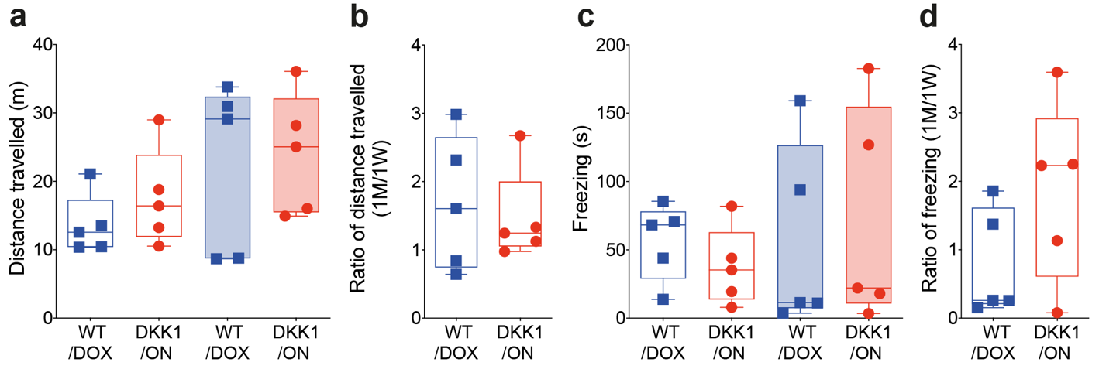
Extended data Fig. 3. Delayed DKK1 post-stroke induction does not affect locomotion in the open field test. a, Analysis of distance travelled in the open field box in WT/DOX and DKK1/ON mice 1 week and 1 month after MCAo (ischemic stroke onset). b, Ratio of the distance travelled in the open field in WT/DOX and DKK1/ON mice at 1 month over 1 week after stroke. c, Analysis of the freezing time in the open field box in WT/DOX and DKK1/ON mice 1 month after stroke. d, Ratio of freezing time in the open field box in WT/DOX and DKK1/ON mice at 1 month over 1 week after stroke. For graphs, data are boxplot with min/max. Data are boxplot with min/max (center line = median, box limits = 25th to 75th percentiles, whiskers = min/max values, and symbols = individual mice). For all experiments (n=5 animals/group).

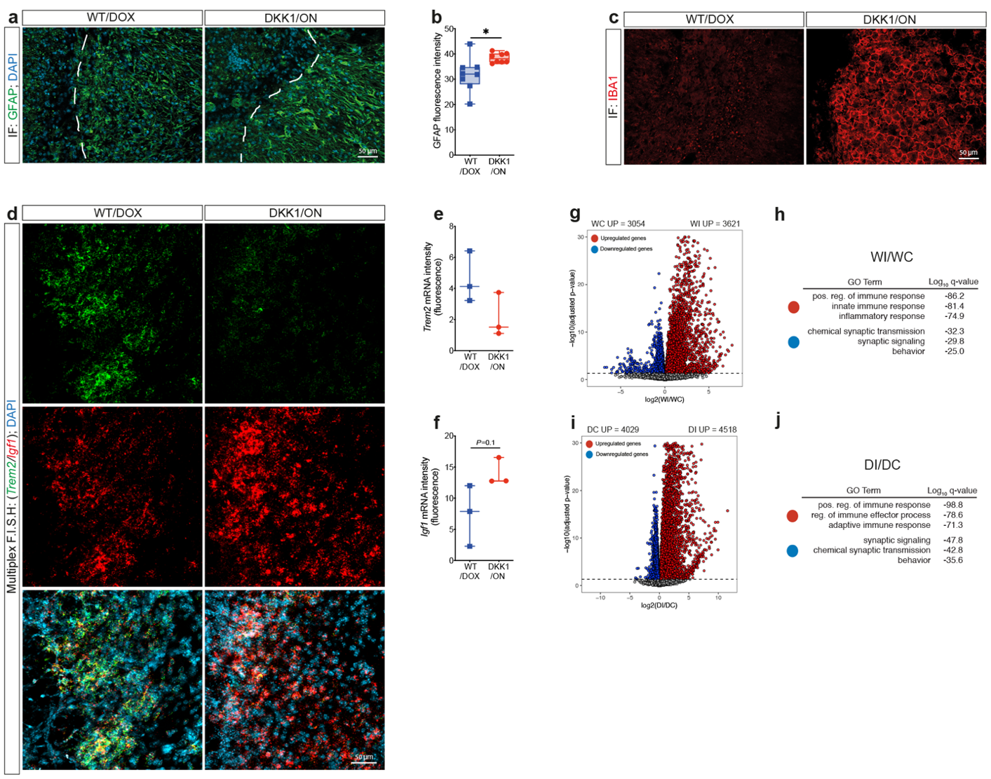
Extended data Fig. 4. Ischemic stroke modulates the transcriptomic profiles of the brain tissue. a, Representative fluorescence images of the GFAP⁺ astroglial scar in the ipsilateral hemisphere in WT/DOX and DKK1/ON mice 1 month after MCAo (ischemic stroke onset). b, Analysis of GFAP fluorescence intensity at the lesion site 1 month after stroke. c, Representative fluorescence images of IBA1⁺ cells in the intralesional region in WT/DOX and DKK1/ON mice 1 month after stroke. d, Representative RNAscopeTM multiplex FISH images showing the expression profile of Trem2 and Igf1 mRNA in the intralesional site of WT/DOX and DKK1/ON mice 1 week after stroke. e, Analysis of Trem2 mRNA and f, Igf1 mRNA expression in the intralesional site of WT/DOX and DKK1/ON mice 1 week after stroke. g, Volcano plots of RNA-seq data comparing the ipsilateral lesioned and contralateral intact brain tissue of WT/DOX mice. DEGs identified by DESeq2 (FDR-adjusted p-value ≤ 0.01) are color-coded. h, Summary tables of GO terms enrichment associated with genes differentially expressed depicted in g. i, Volcano plots of RNA-seq data comparing the ipsilateral lesioned and contralateral intact brain tissue of DKK1/ON mice. Differentially expressed genes (DEGs) identified by DESeq2 (FDR-adjusted p-value ≤ 0.01) are color-coded. j, Summary tables of GO terms enrichment associated with genes differentially expressed depicted in i. Data are boxplot with min/max (center line = median, box limits = 25th to 75th percentiles, whiskers = min/max values, and symbols = individual mice). For immunofluorescence experiments (n=8 animals/group). For RNAscope™️ multiplex FISH and RNA-seq experiments (n=3 animals/group). *P<0.05 (b, unpaired t-test, f, Mann-Whitney test).

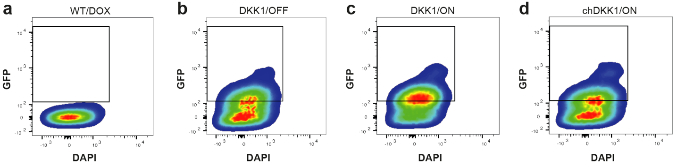
Extended data Fig. 5. Validation of chimerism validation in chDKK1 mice. a, Flow cytometry analysis of rtTA-EGFP⁺ cells (GFP) in the blood circulation of, a) WT/DOX, b, DKK1/OFF, c, DKK1/ON and d, chDKK1/ON mice.

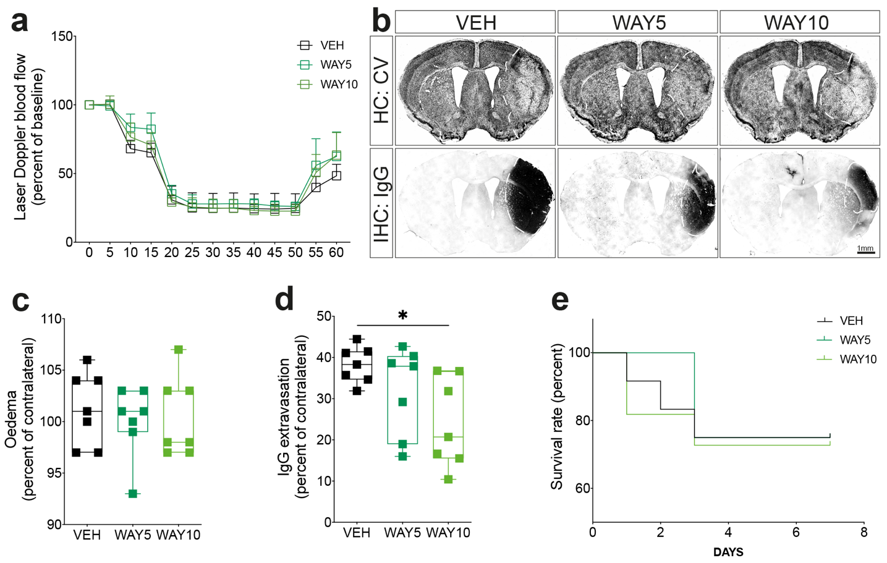
Extended data Fig. 6. DKK1 subacute neutralization reduces brain damage after stroke.
a, Analysis of the laser Doppler blood flowmeter (LDF) measurements during MCAo procedure (ischemic stroke induction) in VEH-, WAY5- and WAY10- treated. b, Representative images of cresyl violet histology showing the lesion surrounded by white dashed lines and immunohistology showing IgG extravasation surrounded by white dashed line in the brain of VEH-, WAY5- and WAY10- treated mice 1 week after MCAo (ischemic stroke onset). c, Analysis of Analysis of brain oedema size (percent of contralateral) in VEH-, WAY5- and WAY10- treated mice 1 week after stroke. d, Analysis of IgG extravasation (percent of contralateral) in VEH-, WAY5- and WAY10- treated mice 1 week after stroke. e, Kaplan-Meier estimate of the survival rate until 1 week after stroke. Data are boxplot with min/max (center line = median, box limits = 25th to 75th percentiles, whiskers = min/max values, and symbols = individual mice), superimposed symbols at mean with connecting line or staircase with ticks. For all experiments (n=7 animals/group). **P<0.01 WAY10-treated compared to VEH-treated mice (d, one-way ANOVA test followed by Tukey’s test).

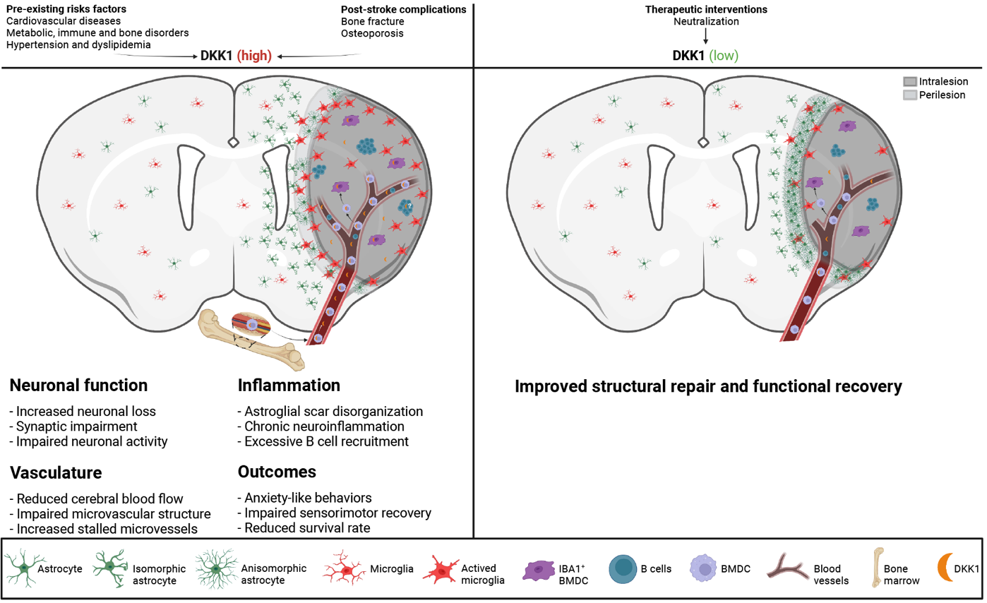
Extended data Fig. 7. Schematic illustration of DKK1 turnover and role in stroke pathobiology and therapy. After ischemic stroke, DKK1 is mainly elevated in the blood circulation and penetrating the intralesional site via infiltration of BMDCs. Elevated level of DKK1 aggravated infarct size, exacerbated sensorimotor impairment and promote anxiety-like behavior. This is notably due to an unresolved neuroinflammation and glial scar disorganization. Pharmacological deactivation of DKK1 ameliorated structural and functional recovery, notably by a stimulation of neurorestorative and neovascularization processes.

