Ropivacaine-loaded hydrogels for prolonged relief of chemotherapy-induced peripheral neuropathic pain and potentiated chemotherapy

Supplementary material

Figure S1
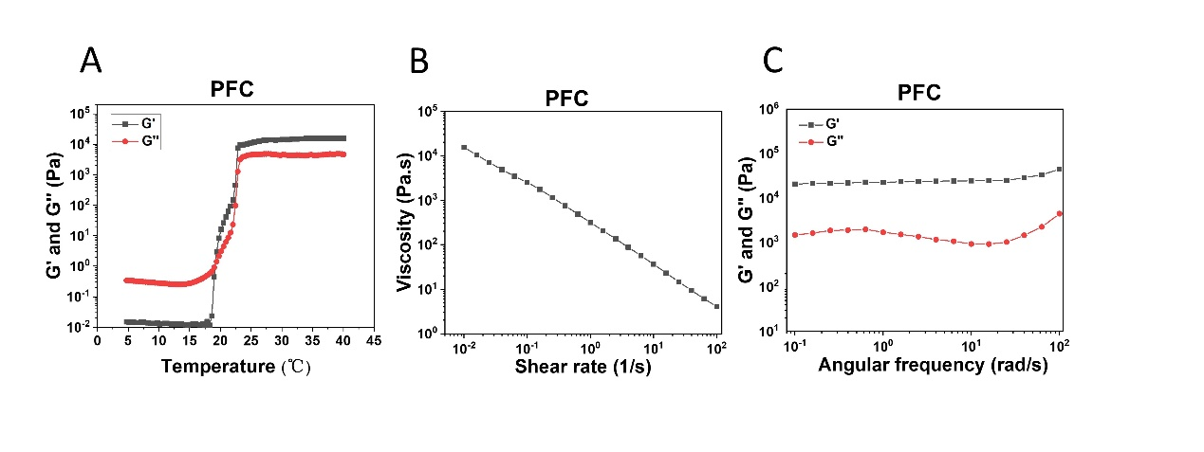
Figure S1. Characterization and properties of PF127 hydrogel loaded with cisplatin (PFC). (A) Temperature-dependent rheology of PFC aqueous dispersion. (B) The shear-thinning behavior of PFC by steady-shear rheology. (C) Frequency-dependent rheology of PFC hydrogel at 37 °C.

Figure S2
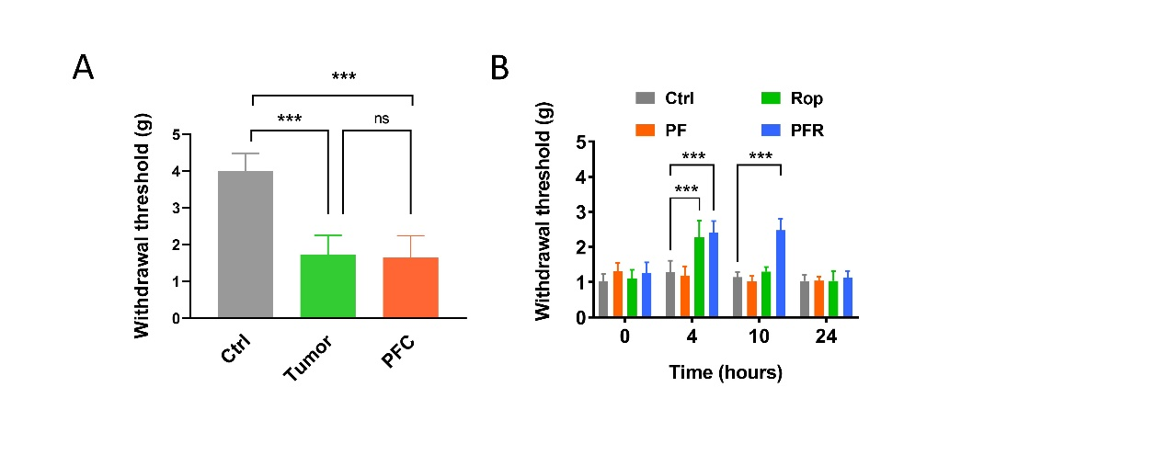
Figure S2. (A) Mechanical withdrawal threshold in wild type mice (Ctrl), tumor-inoculated mice and tumor-inoculated mice treated with PFC. (B) Mechanical withdrawal threshold in tumor-inoculated mice was measured at 0, 4, 10, and 24 h after different treatments. Ctrl: Saline; PF: PF127 hydrogel; Rop: ropivacaine; PFR: ropivacaine loaded PF127 hydrogel.

Figure S3
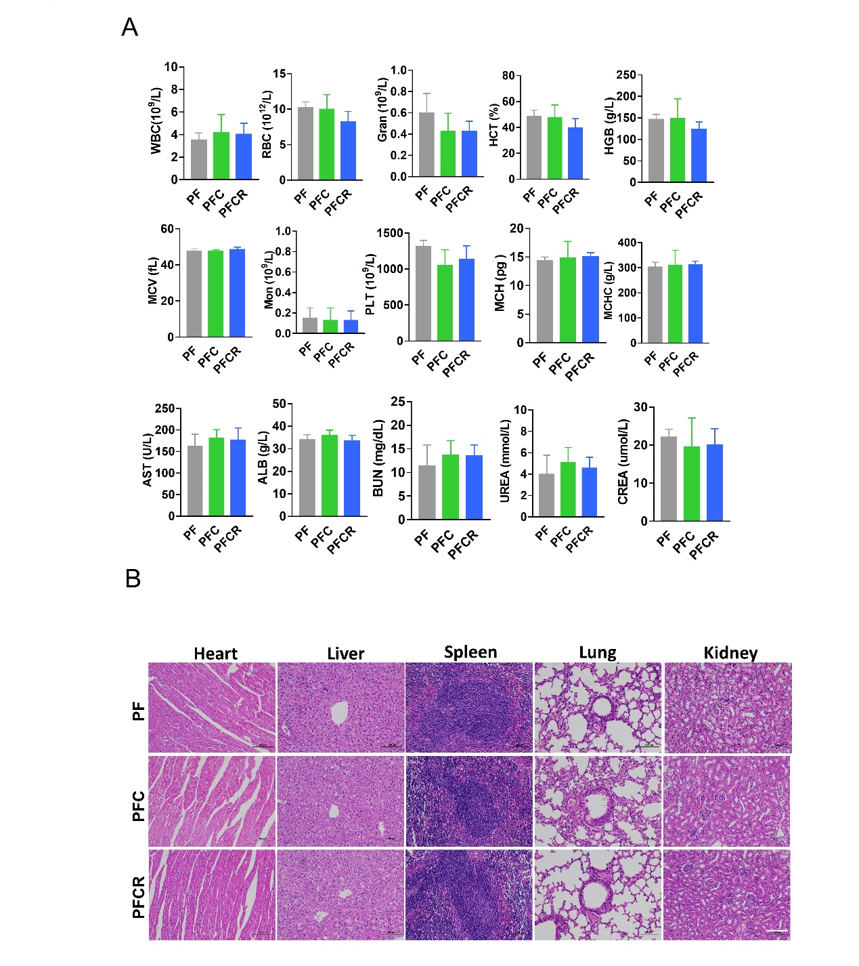
Figure S3. Assessment of systemic toxicity of PF127 hydrogel loaded with cisplatin and ropivacaine (PFCR) in mice. (A) The serum levels of WBC, RBC, Gran, HCT, HGB, MCV, Mon, PLT, MCH, MCHC, AST, ALB, BUN, UREA, CREA in mice teated with different hydrogels for 14 days. (B) H&E staining images of the main organs of in mice teated with different hydrogels for 14 days, scale bar = 1mm.

